***Background:***

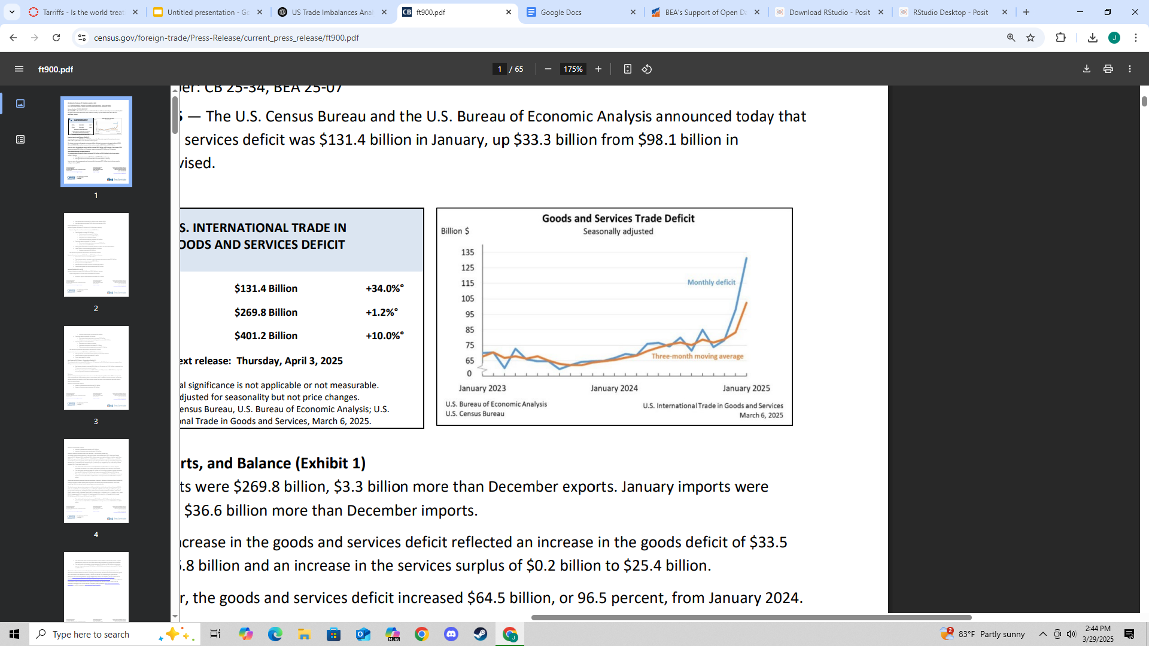

There are recent trends in U.S. international trade shown in the picture above provided by census.gov. This also highlights a substantial increase in the trade deficit. In February 2025, the U.S. recorded a goods and services trade deficit of $131.4 billion, marking a significant 34.0% rise from the previous month. This occurred despite an increase in both exports and imports, with exports rising modestly by 1.2% to $269.8 billion and imports climbing by 10.0% to $401.2 billion. The chart visually reinforces this trend, illustrating a substantial increase in the monthly trade deficit. The data signals a year-over-year increase in the deficit by 96.5% compared to January 2024, raising important questions about the growing imbalance in U.S. trade and its potential economic implications.

***Why is the U.S. international trade drastically imbalancing?***

One of the main reasons why the U.S. international trade is imbalancing is due to unfair advantages other countries have over them. Tariffs and policies play a huge role in shaping justice and imbalances between two countries. However, since we know that the imbalance is drastic, there may be unfair attributes to these policies and tariffs. To determine this unfairness, let's look at the bilateral trade balances between the US and other countries.

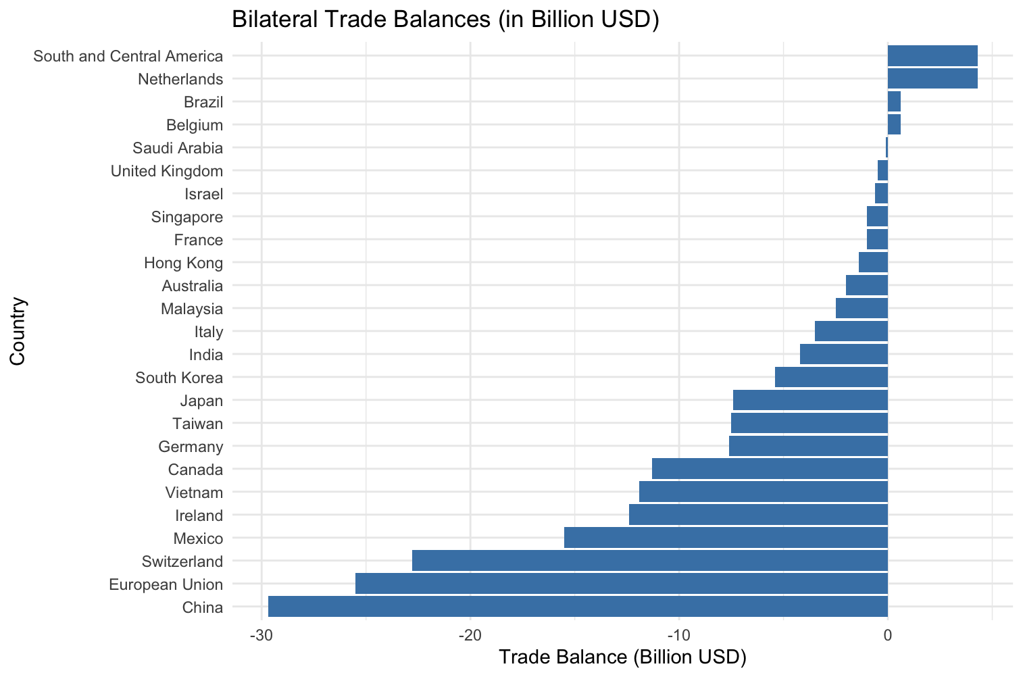

This graph that I made on R shows the U.S. trade balances with their international partners, distinguishing between countries where the U.S. has trade surpluses and those with significant deficits. The chart illustrates that the largest trade deficits are with China at -$29.7 billion, the European Union as a whole at -$25.5 billion, and Switzerland. These imbalances indicate that the U.S. imports considerably more from these regions than it exports to them. On the other hand, the U.S. maintains surpluses with regions like the Netherlands and South and Central America, both at +$4.3 billion. With this in mind, trade policy, competitiveness, and global supply chains, particularly regarding why some trade relationships are so heavily lopsided. Now we can break down global trade among the largest deficits starting with China.

***China and The United States***

Starting with the imports and exports from China and The United States and vise versa, I can create a graph that illustrates the three main products that have disparities

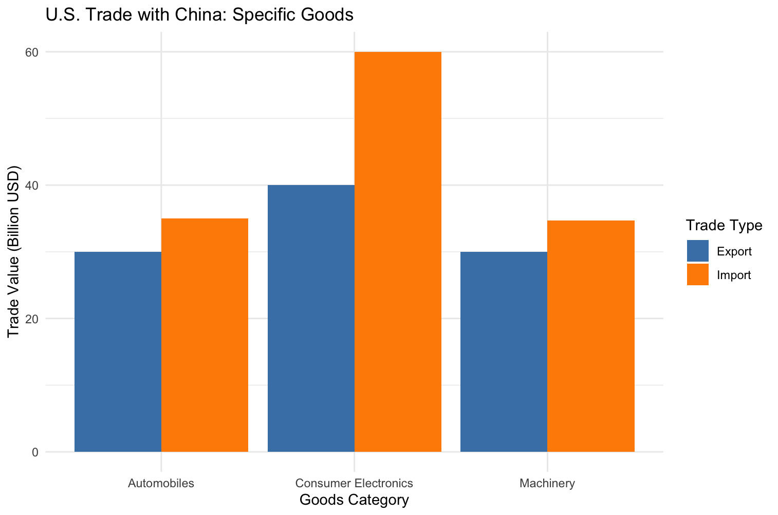

The main disparities consist of automobiles, consumer electronics, and machinery. While trade in automobiles and machinery reflects relatively modest imbalances, with gaps of $5 billion and $4.7 billion, the most significant disparity is found in consumer electronics. U.S. imports of consumer electronics from China reach $60 billion, whereas exports only total $40 billion, resulting in a $20 billion trade gap. This indicates a high reliance on Chinese consumer electronics in the U.S. market, likely driven by China’s cost-effective production and established global supply chains.

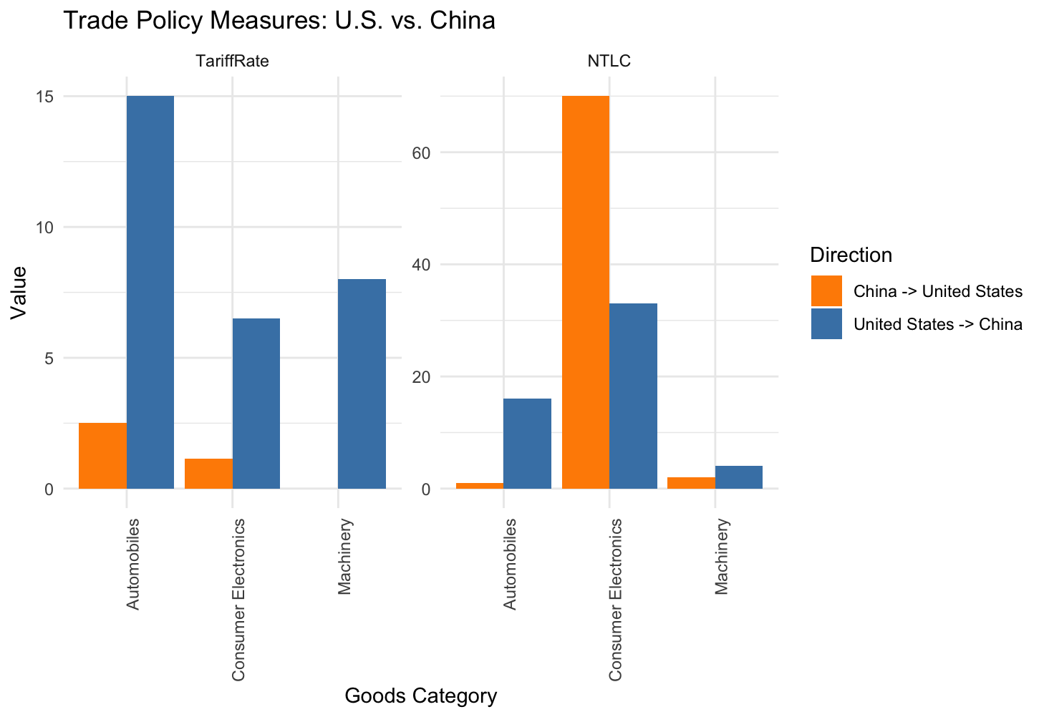

Using ITC’s market access map, I was able to determine the difference in tariffs between the U.S. in china. For the Harmonized System (HS) Codes, I used 8703 for motor cars, 85 for consumer electronics, and 84 for machinery, which all have the most disparities. I found that China creates tariffs that are almost 5 times higher than the U.S. For example, the tariff rate from U.S. exports to China is 15%, while the NTLC is 16. NTLC is a policy not regarding tariffs that plays a role on the price of the export. China exports to the U.S. on the other hand, only has a tariff rate of 2.5% which is 6 times less. The U.S. exports face much higher tariffs than Chinese exports, suggesting a potential disadvantage for U.S. producers. Similarly, Consumer electronics from the U.S. to China’s tariff rate is 6.5% compared to 1.14%, and Machinery’s tariff rate to China is 8% compared to 0%. In this situation the U.S. does not even supply a tariff so China can export their goods at the original cost which is unfair to the U.S.. also, While U.S. goods face moderately high tariffs, Chinese consumer electronics face significantly higher non-tariff restrictions.

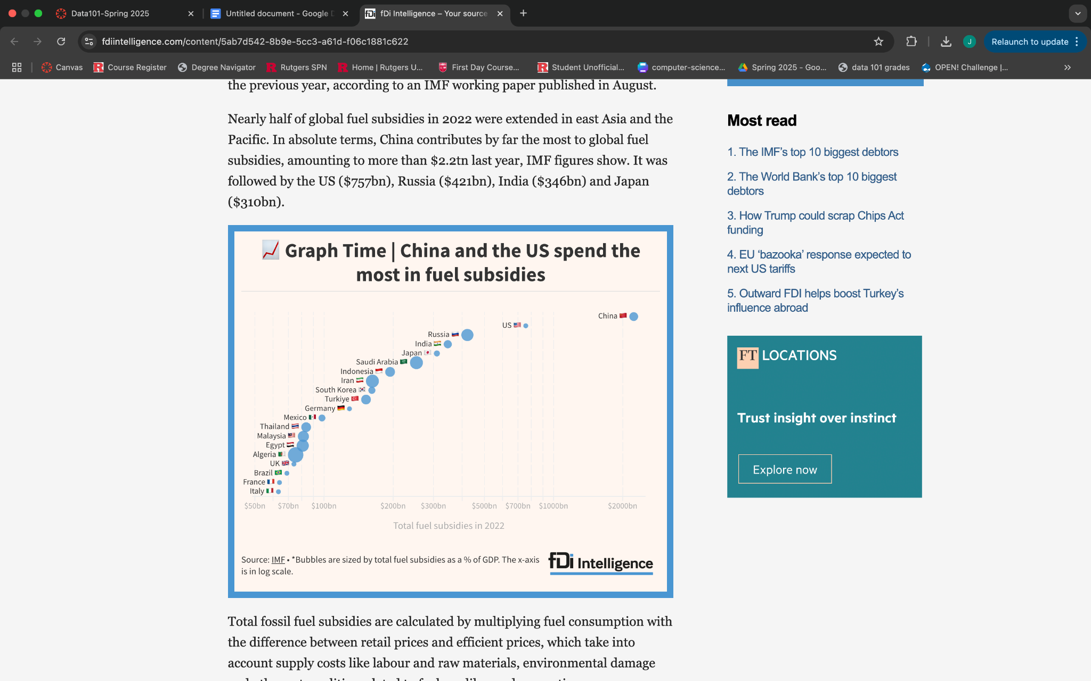

However, while investigating the subsidies that go along with these imports, I found that in the graph provided by fdi intelligence, China dominates with the highest fossil fuel subsidies. This means that the government is paying for gasoline and diesel to make it more affordable for the consumers and businesses. Because China subsidizes fossil fuels, the cost of running factories and transporting goods is lower. This gives Chinese car manufacturers an edge because they can produce vehicles more cheaply than those in countries that don’t offer similar subsidies, like the U.S. or European countries. This is also the reason why tariffs to China are so high. Since China has the advantage, they don't need imports from other countries if they could manufacture them themselves.

***EU and The United States***

I created the graphs in R for U.S. and EU imports/exports/policies

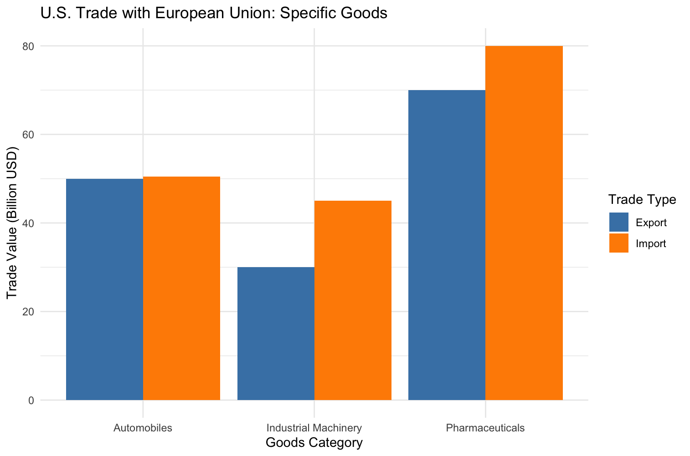

This graph provides an analysis of U.S. imports and exports across three key goods categories: automobiles, industrial machinery, and pharmaceuticals. While trade in automobiles appears nearly balanced, with only a slight U.S. import surplus of $0.5 billion, a more noticeable disparity exists in pharmaceuticals, where imports exceed exports by $10 billion. However, the most significant trade imbalance is observed in industrial machinery, with a $15 billion gap favoring EU exports to the U.S. This indicates a potential competitive advantage or policy-driven trade dynamic in the EU's favor within this sector. Tariff structures, along with non-tariff barriers such as regulatory standards or subsidies, can significantly affect the flow of goods between trading partners.

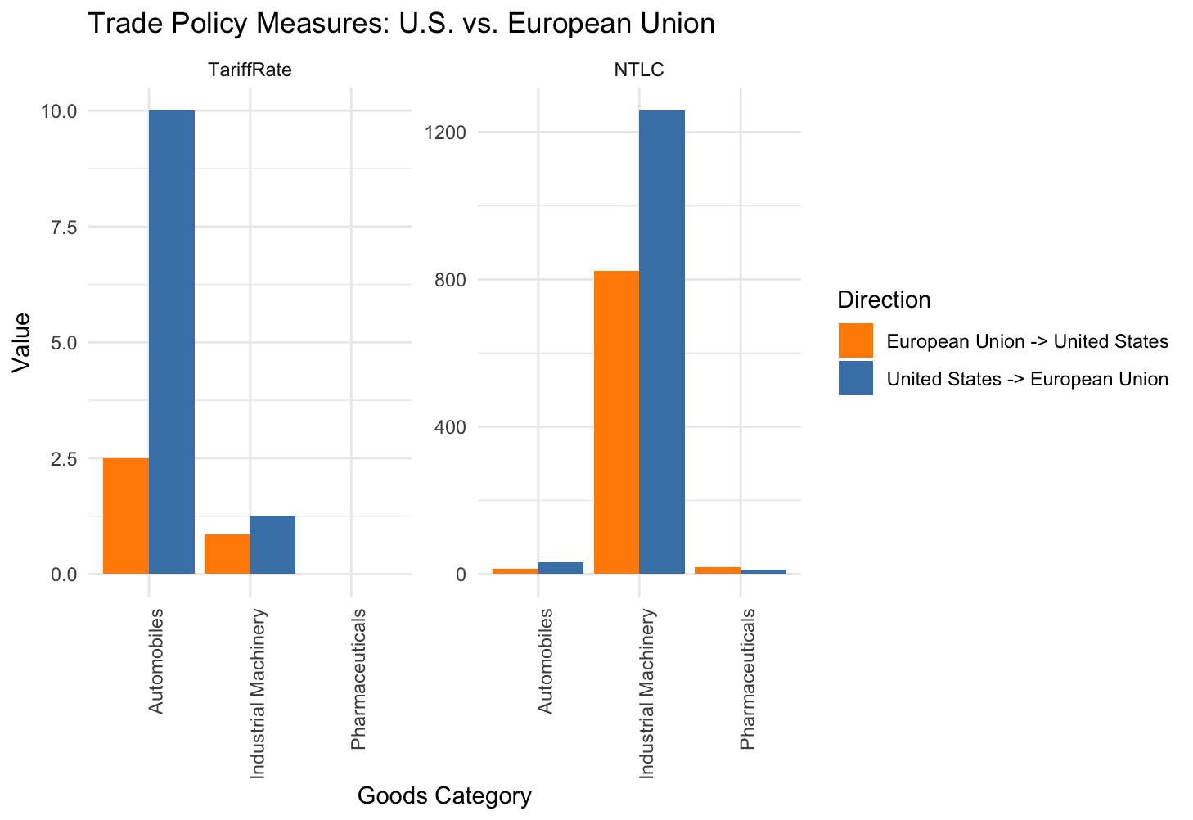

Using the Harmonized System (HS) Codes, 8703 for motor cars, 84 for machinery, and 3006 for pharmaceuticals, I was able to find tariff disparities between the U.S. and EU. Starting with automobiles, The U.S. exports to China with a tariff rate of 10% with 32 NTLCs while China exports to the U.S. only at 2.5% and 15 NTLCs. That said, the U.S. exports are subject to higher tariffs and more non-tariff barriers compared to EU exports, which indicate inequity. Another disparity is in industrial machinery where the U.S. to China’s tariff rate is 1.26 with 1258 NTLCs while China to the U.S. is 0.85% with 824 NTLCs. Since the NTLC is at a large difference, the United States industrial machinery might face more complex restrictions. However, for pharmaceuticals, the Tariffs are equal at 0% but have a slightly higher NTLC on EU exports. This shows that the U.S. has fair trades along some items even though there are differences in the imports and exports between the two countries.

***Switzerland and the United States***

I created the same two graphs in R studio

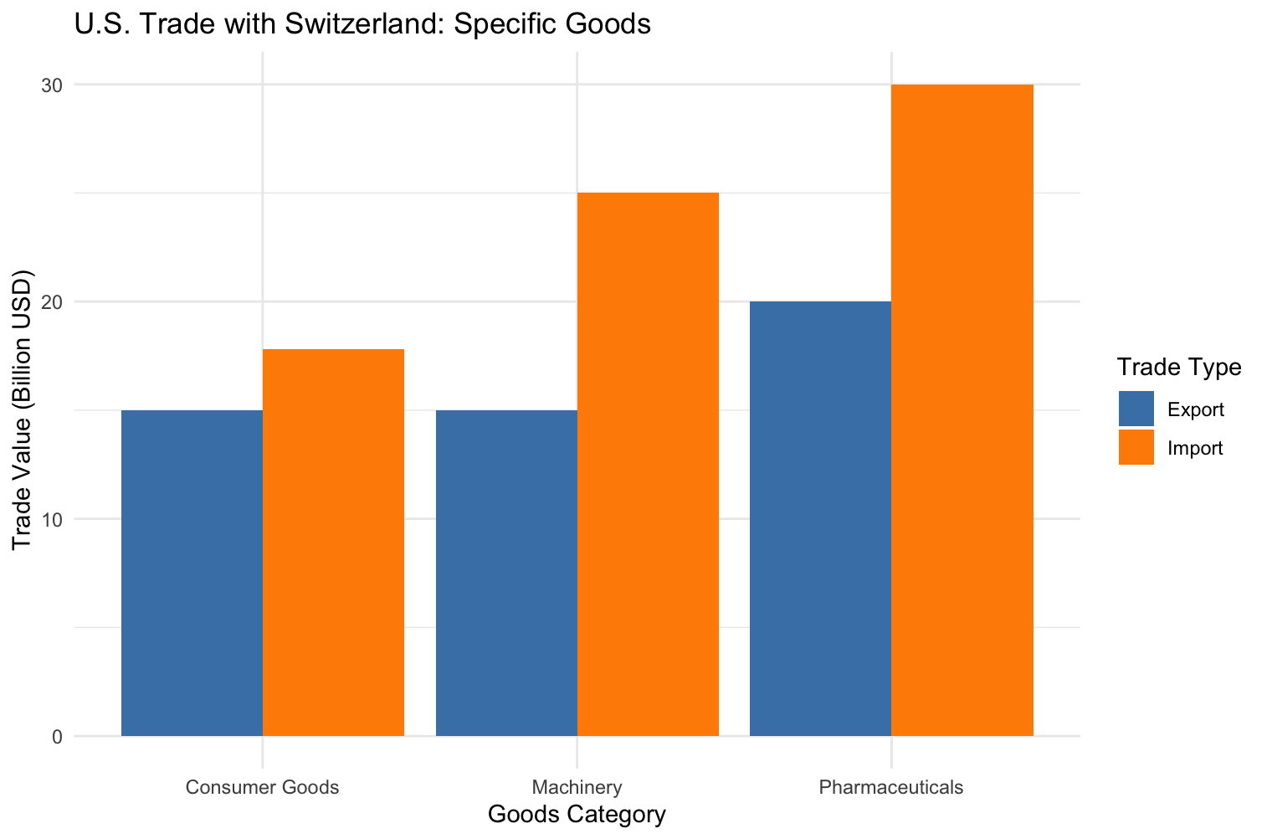

This graph focuses on the imports and exports of consumer goods, machinery, and pharmaceuticals. While consumer goods show a relatively minor trade imbalance, imports exceed exports by just $2.8 billion. The pharmaceutical and machinery sectors reveal more significant gaps. Machinery imports from Switzerland surpass U.S. exports by $10 billion, and a similar disparity appears in pharmaceuticals. These imbalances suggest that Switzerland maintains a strong export position in high-value, innovation-driven sectors. Switzerland, not being part of the European Union, negotiates its own trade agreements, which may include preferential tariff arrangements or lower barriers on U.S. imports than what U.S. exporters face. These policy dynamics can skew trade flows while evaluating the impact of tariffs and non-tariff measures on bilateral trade balances.

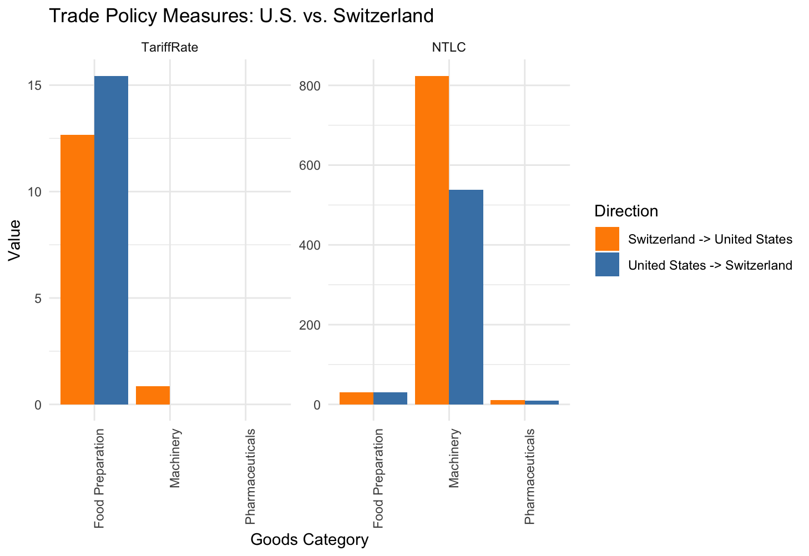

Using the Harmonized System (HS) Codes, 2106 food preparations, 84 for machinery, and 3006 for pharmaceuticals I was able to find the disparities among the trade tariffs and NTLCs. For food preparation, the U.S. exports to Switzerland at a tariff rate of 15.44% with an NTLC 31, while Switzerland exports to the U.S. at 12.67% with the same NTLC count. This shows a trend in the U.S. exports that face higher tariffs among all products to other countries. However, while looking at the machinery, U.S. exports to Switzerland at 0% with NTLC at 538 while the tariff rate back is 0.85% with NTLC of 824. Unlike the other products that the U.S. supplies to other countries, Switzerland to U.S. exports have higher tariffs. This places U.S. producers at an advantage.

***Is The U.S. Treated Unfairly?***

After analysing tariffs between the U.S. and areas like China, European Union, and Switzerland, I can confidently say that the U.S. are treated **unfairly**. The data clearly signifies that American exports face higher tariffs and more non-tariff trade barriers than the imports the U.S. accepts from these same partners. For instance, the United States exports to China have steeper tariffs across all industries including consumer electronics, automobiles, and industrial machinery, some of which are six times higher than the tariffs imposed by the U.S. on Chinese imports. Non-tariff measures also increase the cost and complexity of selling American goods abroad. This creates an uneven distribution of goods where foreign exports are beneficial. When it comes to the European Union, there exists a similar pattern. Even in cases where tariffs are equal, such as pharmaceuticals, non-tariff barriers remain disproportionately high, making it more difficult for U.S. companies to compete. Also, while Switzerland has slightly more balanced policies in certain areas, U.S. exports still face higher average tariff rates in sectors like food and pharmaceuticals. This does not suggest a trade imbalance caused by market forces, it is caused by structural issues rooted in policy dynamics. Although the U.S. is offered an open access to its market, it is not receiving equal treatment in return. This creates an economic environment that favors foreign producers leading to the unfair treatment to the United States.

*Websites Used*

[*https://www.census.gov/foreign-trade/Press-Release/current_press_release/ft900.pdf*](https://www.census.gov/foreign-trade/Press-Release/current_press_release/ft900.pdf)

[*https://www.macmap.org/en/query/compare-market?reporter=All&partner=842&product=842952*](https://www.macmap.org/en/query/compare-market?reporter=All&partner=842&product=842952)

[*https://www.fdiintelligence.com/content/5ab7d542-8b9e-5cc3-a61d-f06c1881c622*](https://www.fdiintelligence.com/content/5ab7d542-8b9e-5cc3-a61d-f06c1881c622)