**Project One**

Justin Starr

Department of STEM

CS 470 – Full Stack Development II

Professor George Johnson

October 13, 2024

**Project One**

**Part One – The Questions API**

Creating the Questions resource with GET method:

Creating the Questions resource with POST method:

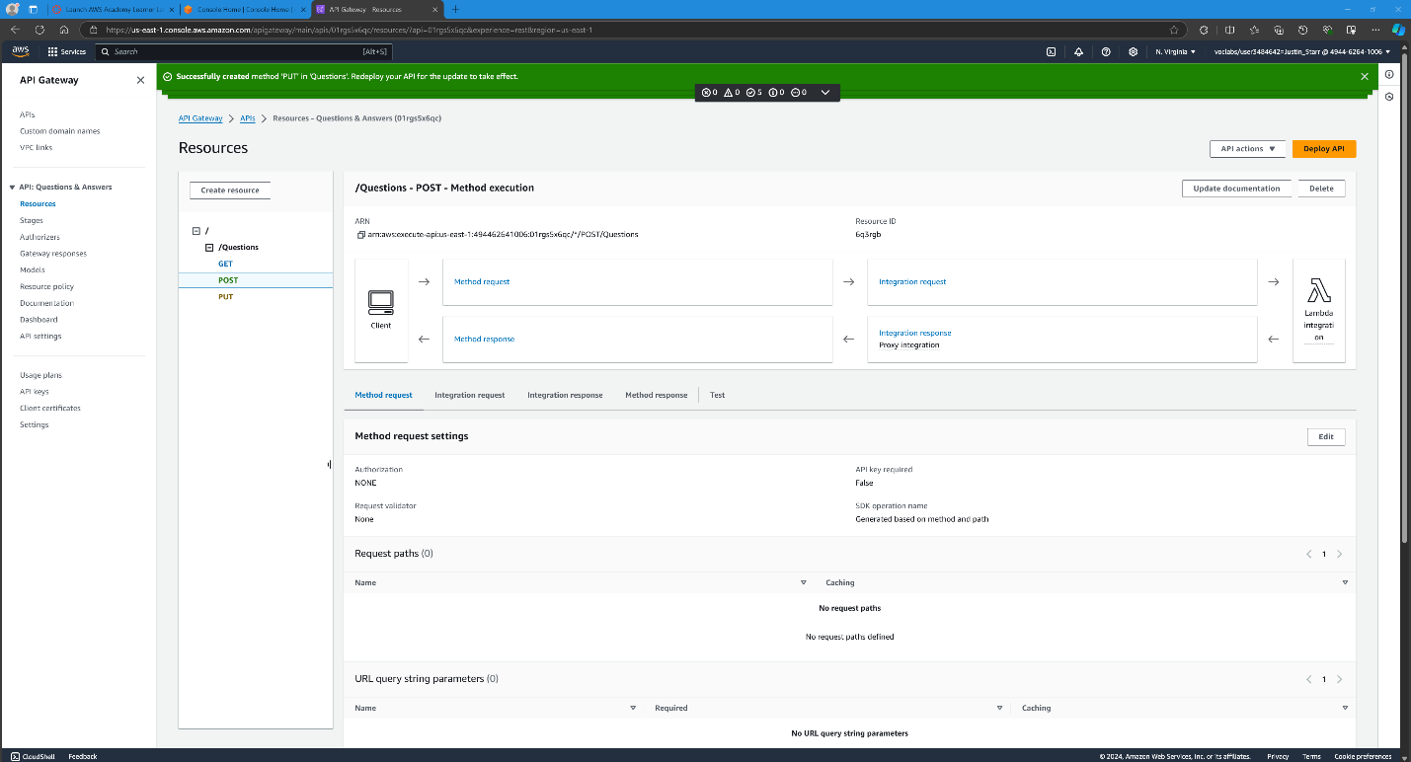

Creating the Questions resource with PUT method:

Creating the Questions sub-resource /{id} GET method:

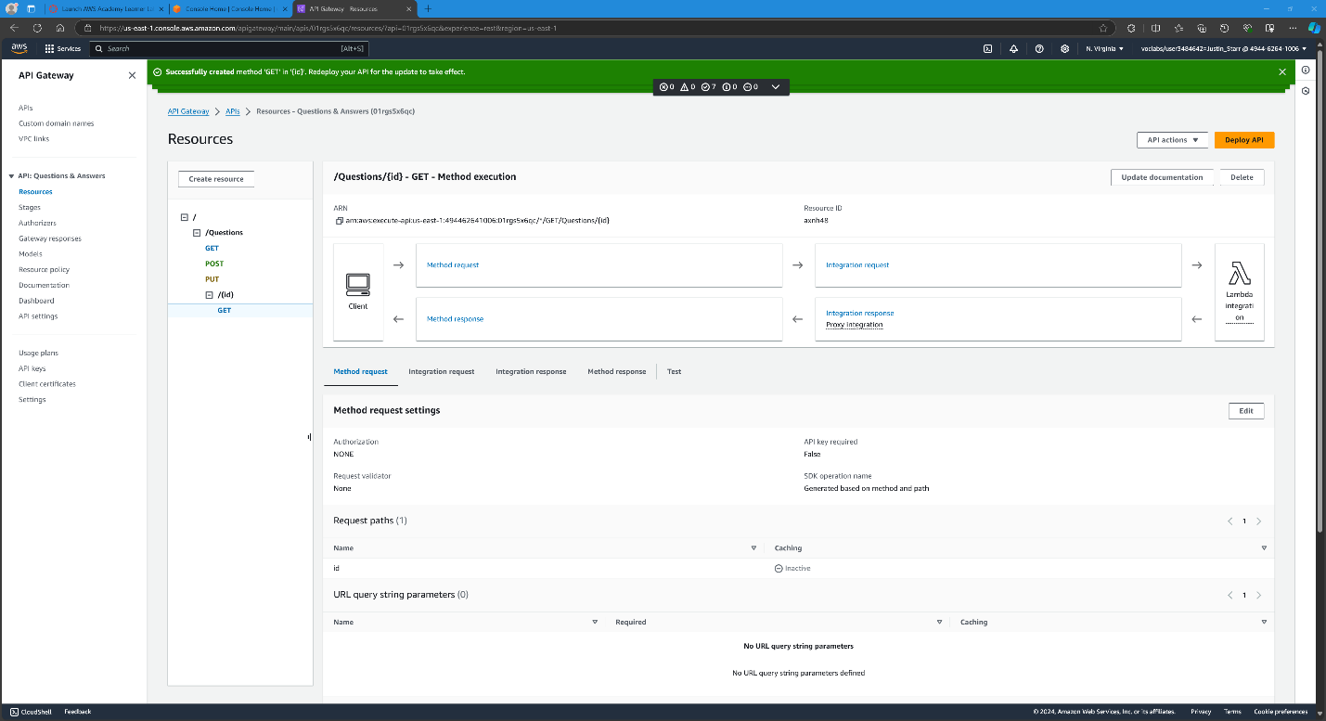

Creating the Questions sub-resource {id} DELETE method:

Creating the Questions sub-resource {id} PUT method:

Creating the Questions sub-resource findOne GET method:

**Part Two – The Answers API**

Creating the Answers resource:

Creating the Answers resource GET method:

Creating the Answers resource POST method:

Creating the Answers resource PUT method:

Creating the Answers sub-resource {id}:

Creating the Answers sub-resource {id} GET method:

Creating the Answers sub-resource {id} DELETE method:

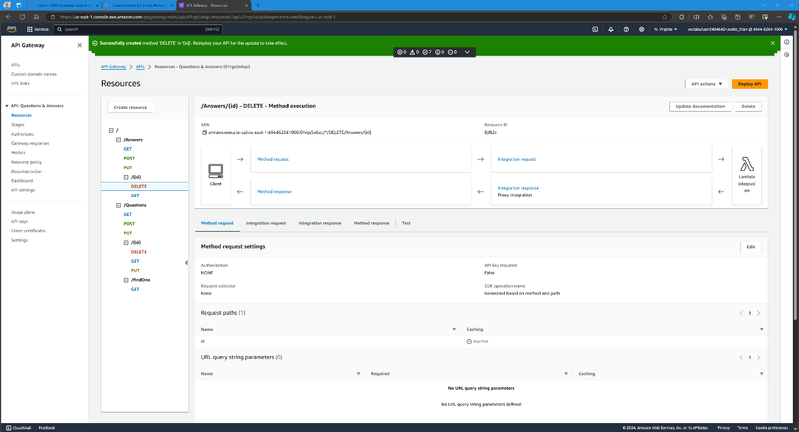

Creating the Answers sub-resource {id} PUT method:

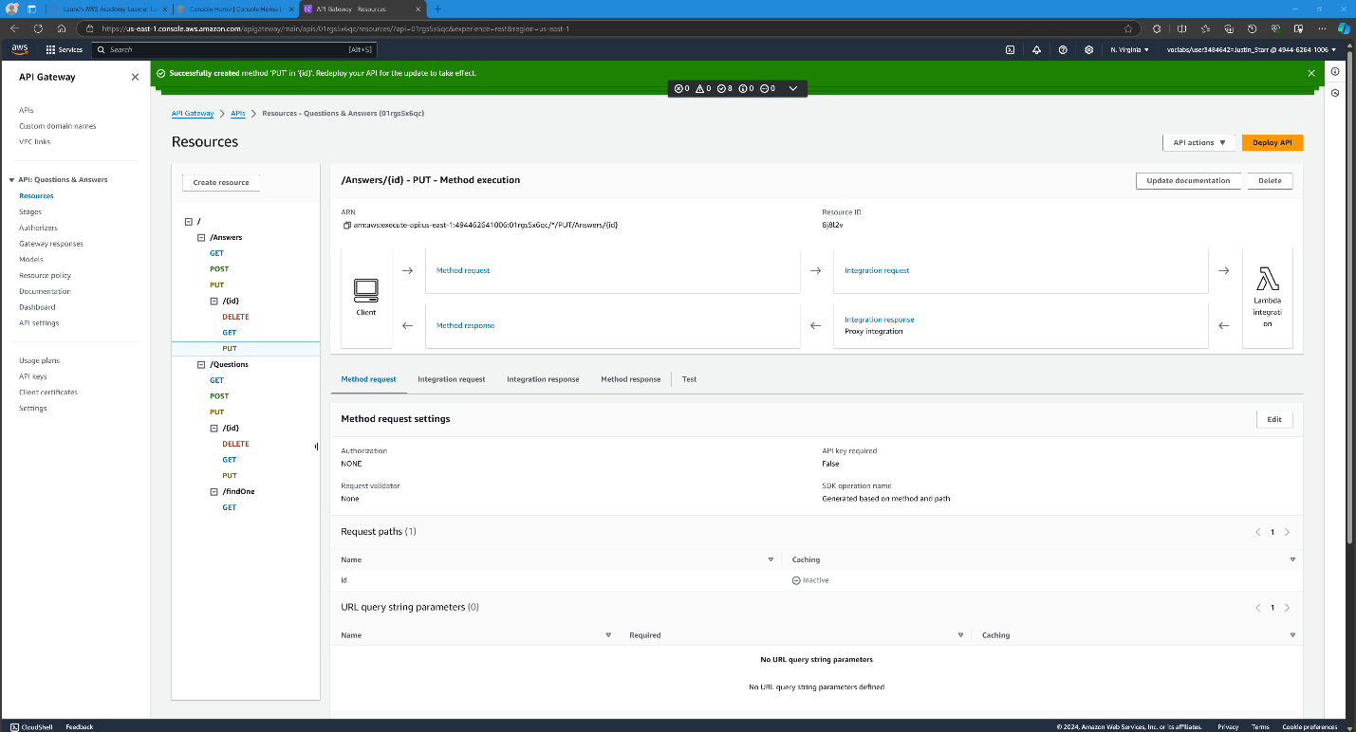

**Part Three – Supporting CORS (Cross-Origin Resource Sharing)**

Creating Questions resource OPTIONS method:

Creating Questions resource OPTIONS method response headers:

Assigning values to header responses for Questions resource:

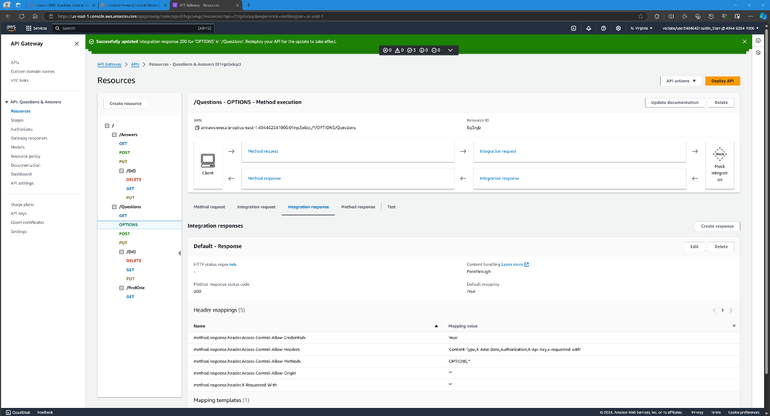

Created Answers resource OPTIONS method with response headers:

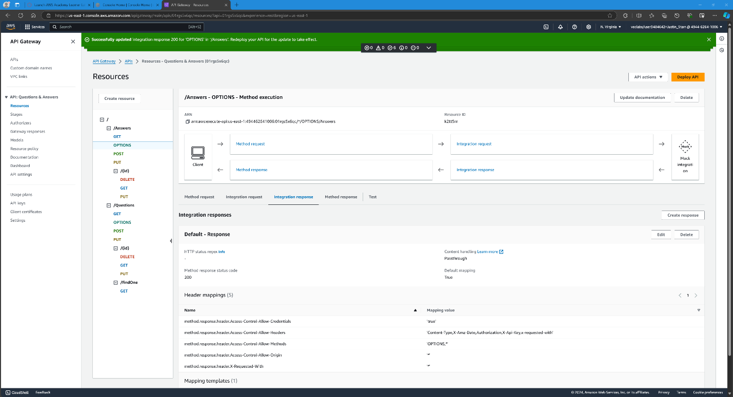

Created Answers sub-resource {id} OPTIONS method with response headers:

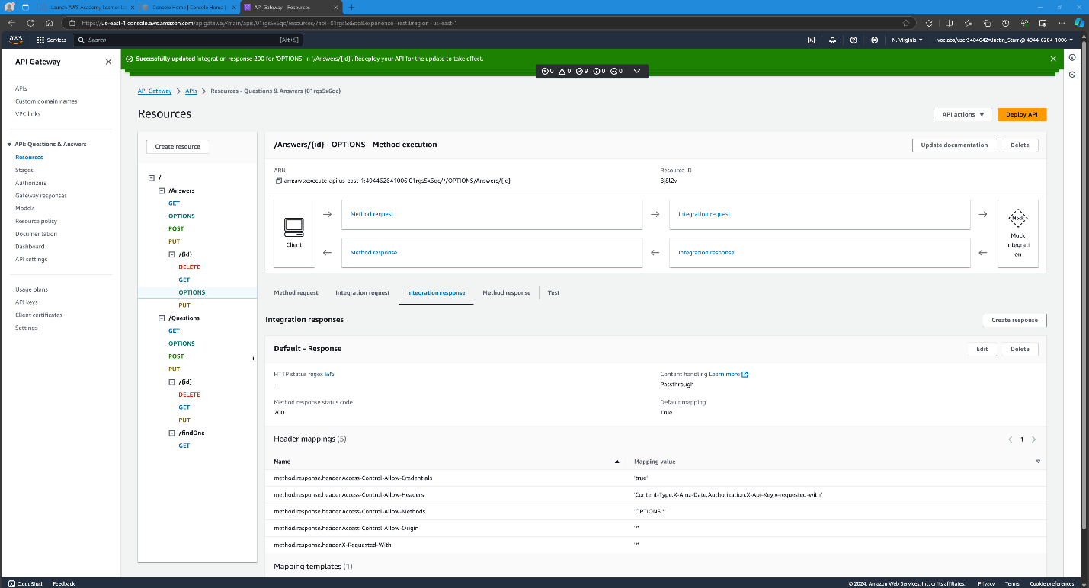

Created Questions sub-resource {id] OPTIONS method with response headers:

Created Questions sub-resource findOne OPTIONS method with response headers:

**Part Four – Deployment**

Deployment of the api stage named api:

Screenshot showing API Questions endpoint:

Screenshot showing API Answers endpoint:

**Part Five – Modifying the Angular Application**

Modifying the main.ts file for lafs-web application:

Modifying the environment.prod.ts file for the lafs-web application:

Re-building the lafs-web application:

Uploading files to my S3 bucket:

**Part Six – Testing the Application**

Angular application running on the front end:

Adding a test question on the front end:

Angular front end showing the newly added test question:

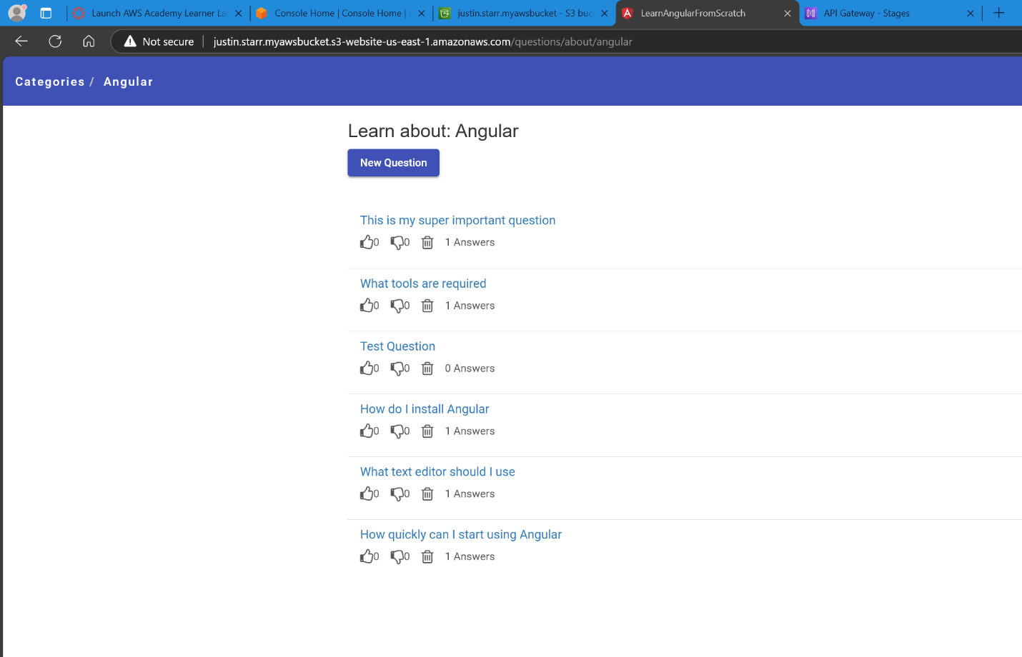

Making an answer for the newly created test question:

Test question showing one new answer:

Editing the newly created test question answer:

Test question answer edited:

API URL / Endpoint: backend of the project running:

<https://01rgs5x6qc.execute-api.us-east-1.amazonaws.com/api>

<https://01rgs5x6qc.execute-api.us-east-1.amazonaws.com/api/Questions>

<https://01rgs5x6qc.execute-api.us-east-1.amazonaws.com/api/Answers>

S3 URL / Endpoint: Frontend of the project hosted on S3:

<http://justin.starr.myawsbucket.s3-website-us-east-1.amazonaws.com/>