**Interpreting UML Diagrams**

Justin Starr

Department of STEM, Southern New Hampshire University

CS 255 – System Analysis and Design

Professor Kim-Marie Foss

April 9, 2023

# Interpreting UML Diagrams

UML Activity Diagrams alongside UML Sequence Diagrams can both be utilized for interpreting system designs. For this short paper, both a UML activity and a sequence diagram will be interpreted for a specific use case that corresponds to an ATM (Automated Teller Machine), the functionality it represents, deficiencies that possibly exist with the current design, and how it can be improved.

First, we begin by analyzing the UML Activity Diagram. The use case that is depicted is the use case: Withdraw Funds. It starts with a starting node (beginning point) where the user or customer begins to interact with the ATM. The ATM will verify whether or not the PIN (personal identification number) is correct or not. If the PIN is incorrect, which is Identified by a decision symbol (hollow diamond symbol), the ATM terminates further actions aside from moving to the endpoint/end node. If the PIN is correct, the system asks the user for the amount they wish to withdraw. Again, another decision is made by the system as to whether or not the requested amount is available to the user based on the user’s available account balance. If the amount requested by the user is available, the system continues by dispensing the amount of money requested. It then generates a receipt, prints the receipt, and then traverses to the end node, where the system terminates or ends the execution of the transaction. If the requested amount is higher than the available balance, the system takes a different action (does not dispense money); however, it does still generate a receipt, prints the receipt, and again terminates or ends the use case at the end node.

Next, we look at the UML sequence Diagram. Here we see some similarities between the two diagrams; however, the sequence diagram is looking more specifically at the interactions between the various types of users that interact with the system and at which points of the processes or functions within the use case these interactions occur. In the UML Sequence Diagram, we see that the user interacts with the ATM by inputting a card into the machine, and the ATM responds by asking the user for their PIN. The user enters their PIN, which is received by the ATM, and sends the PIN to the bank to be verified. According to this system design, it shows that if the PIN is validated, it responds to the ATM that the PIN is valid and asks the customer to input the desired amount of money they would like to receive. The user inputs their desired amount of money, which is sent back to the ATM; then, according to the design, the ATM dispenses the amount requested by the user/customer.

Upon analyzing the system design, multiple deficiencies have been identified. As asked specifically, two deficiencies I have identified are as follows:

* One, according to the UML Activity Diagram, the diagram does not determine whether or not the ATM itself has enough funds to dispense to the customer. Just because the customer or the user has enough money to retrieve the desired amount, the system diagram should not imply that the ATM always contains enough money to be retrieved. Also, in regards to this diagram alone, and knowing how ATMs function, the system should also ask whether or not the customer, in fact, wants a receipt printed. The ATM should always generate some form of internal report; however, for optimization and cost-efficiency purposes, the system should not always print the record if the customer/user chooses.
* Second, we can evaluate the UML Sequence Diagram. This diagram, while basic, shows a high level of detail as it pertains to the who or what interacts with each particular aspect of the system. One deficiency noticed is that first, the diagram does not show what happens if, for instance, the user inserts a type of card that the ATM does not accept or recognize. Also, the design does not show the process of what happens, specifically if the PIN is not valid, or similarly, what would happen if the ATM did not contain a sufficient amount of money the customer/user is able to have dispensed.

The following page is an updated UML Activity Diagram that incorporates the deficiencies I described.

**UML Activity Diagram**

[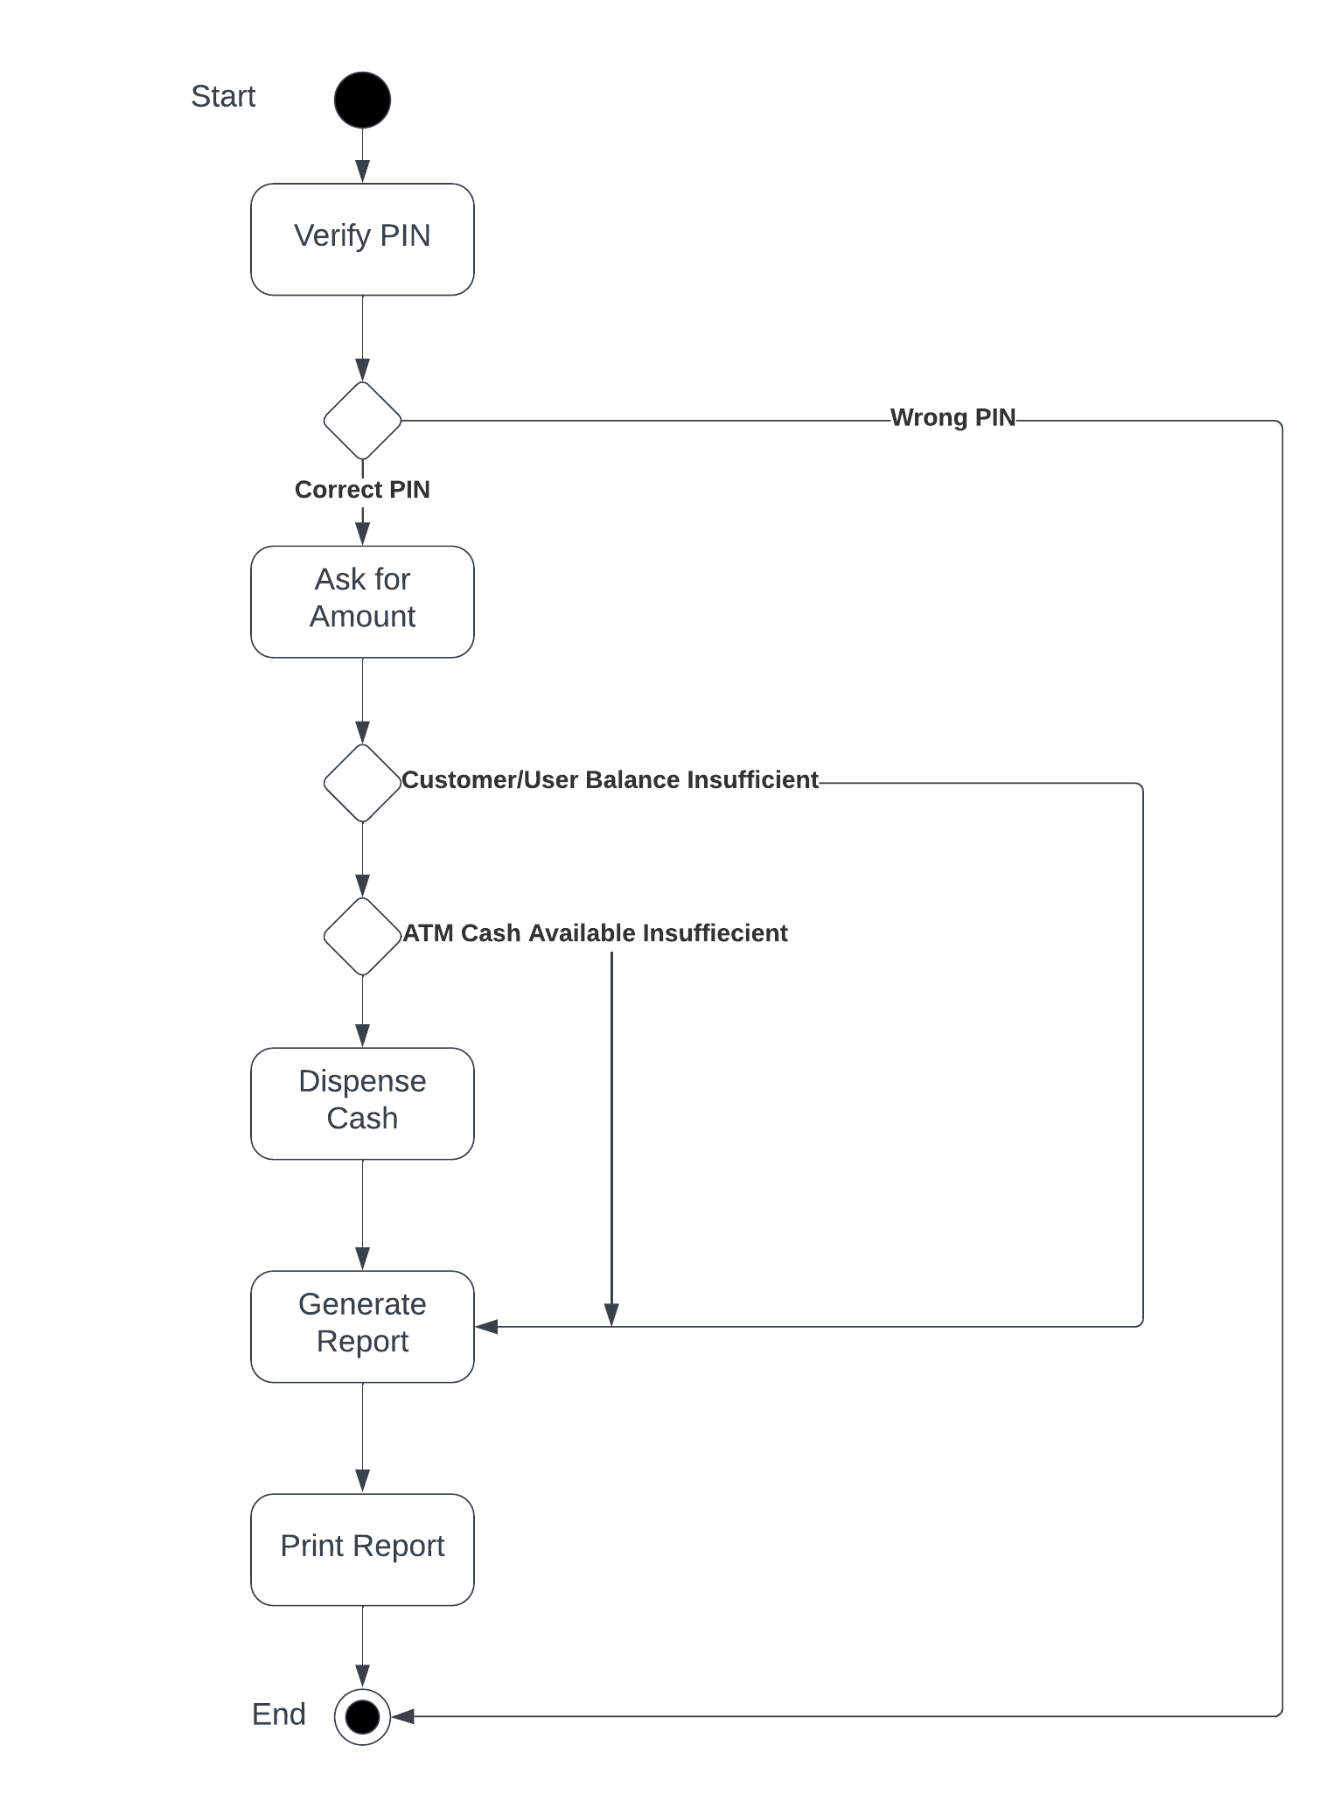](https://lucid.app/lucidchart/03a9dbed-58e7-4bdb-8edb-c32a7994edb0/edit?crop=content&page=0&signature=3bb7a4d1e5e6cafa66c9b4df72f5ba42224d2059be1c9bcd21527ddb995afd40)