Project 2 README

1) Team Members emails roles

Jerson Guansing [jguansi1@umbc.edu](mailto:jguansing@umbc.edu) database additions, javascript functions

Joe O'Malley [om4@umbc.edu](mailto:om4@umbc.edu) CSS changes, adding a few php functions

Justin Sternberg [justins3@umbc.edu](mailto:justins3@umbc.edu)validation fixing, html additions

2) Location:

http://userpages.umbc.edu/~jguansi1/project2/

3) Project Description:

Create pages which will allow a student to enter their currently taken CMSC courses,

display what they can take next semester, and save the results.

4) What did we add:

* validation of courses to ensure you could not add a course without the prerequisites
* added javascript functionality

5) What did we improve:

* Look of the site (CSS)

6) DB setup:

Courses:

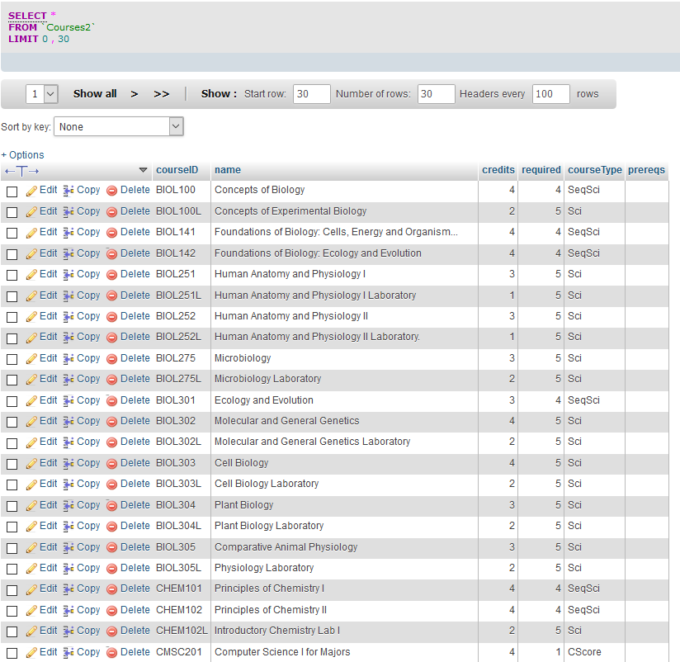

Students:

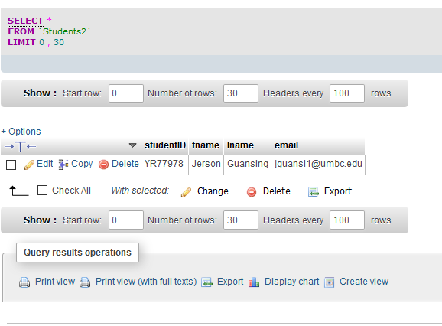7) Database Dump:

8) Languages used and where:

HTML:

Javascript:

PHP:

SQL: