Predictive Maintenance

Justin T. Nguyen, Kyle Abaya
Shiley-Marcos School of Engineering
AAI 500: Applied Probability and Statistics for AI

Introduction
Unplanned equipment downtime can disrupt production lines and cost manufacturers money. Taking a proactive approach by predicting failure before it happens allows manufacturers to schedule maintenance rather than waiting for failure to happen. This project aims to predict machine failure from sensor readings using the AI4I 2020 Predictive Maintenance Dataset (AI4I 2020 Predictive Maintenance Dataset, 2020), a synthetic dataset that simulates industrial sensor data. It contains 10,000 records and 12 features (Type, Air temperature, Process temperature, Rotational speed, Torque, Tool wear, Machine failure, TWF, HDF, PWF, OSF, RNF) with "Machine Failure" is the target variable.

Additional information on the features:
- Type &mdash; consisting of letters L for low (50% of all products), M for medium (30%), H high (20%) as product quality variants
- Air temperature (K)
- Process temperature (K)
- Rotational speed (rpm)
- Torque (Nm)
- Tool wear (min) - The quality variants H/M/L (Type) add 5/3/2 minutes of tool wear
- Machine failure - label indicates for any of the following modes are true:
  - Total Wear Failure (TWF): The tool will be replaced of fail at a randomly selected tool wear time between 200 minutes to 240 minutes.
  - Heat Dissipation Failure (HDF): Heat dissipation causes a process failure, if the difference between air- and process temperature is below 8.6 K and the tool's rotational speed is below 1380 rpm.
  - Power Failure (PWF): The product of torque and rotational speed (in rad/s) equals the power required for the process. If this power is below 3500 W or above 9000 W, the process fails.
  - Overstrain Failure (OSF): If the product of tool wear and torque exceeds 11,000 min Nm for the L product variant (12,000 M, 13,000 H), the process fails due to overstrain.
  - Random Failures (RNF): Each process has a chance of 0.1% to fail regardless of its process parameters.
If at least one of the above failure modes is true, the process fails and the 'machine failure' label is set to 1.

The dataset is highly imbalanced with machine failures making up only 3.39% of records which means accuracy alone would be a misleading evaluation metric. The dataset contains no missing values, so no cleaning required. Because this dataset is synthetic, it may not fully represent real industrial sensor readings which could limit a model trained on it.
References
AI4I 2020 Predictive Maintenance Dataset [Dataset]. (2020). UCI Machine Learning Repository. https://doi.org/10.24432/C5HS5C.

Tables
Table 1
Table Title
Column Head | Column Head | Column Head | Column Head | Column Head
Row Head | 123 | 123 | 123 | 123
Row Head | 456 | 456 | 456 | 456
Row Head | 789 | 789 | 789 | 789
Row Head | 123 | 123 | 123 | 123
Row Head | 456 | 456 | 456 | 456
Row Head | 789 | 789 | 789 | 789

Note: Place all tables for your paper in a tables section, following references and footnotes. Start a new page for each table, include a table number and table title for each, as shown. All explanatory text appears in a table note that follows the table, like this one. Use the Table/Figure style, available on the Home tab, in the Styles gallery, to get the spacing between table and note. Tables in APA format can use single or 1.5 line spacing. Include a heading for every row and column, even if the content seems obvious. A default table style has been set up for this template that fits APA guidelines. To insert a table, on the Insert tab, click Table.

Figures Title
Figure 1.
Include all figures in their own section, following references, footnotes, and tables. Include a numbered caption for each figure. Use the Table/Figure style for easy spacing between figure and caption.

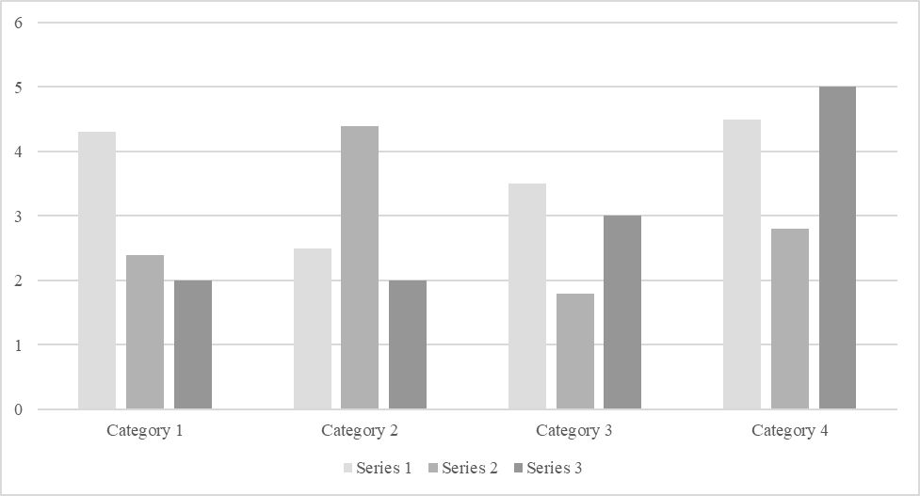

For additional information on APA Style formatting, please consult the APA Style Manual, 7th Edition.

