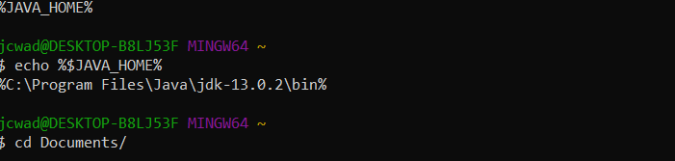

**Lab Questions**

1. Calculate the sum of all the homework grades and divide that number by 10
2. For every letter in the message, count 5 letters to the right of that letter and replace the old letter with the letter you have shifted to. If you are shifting and you reach the end of the alphabet, continue counting right the remaining amount from A.
3. Determine how far each letter of “Puzzles are fun” is from the coded message to the left and that is the right shift of the Caesar cipher
4. Mentally count the number of numbers my brother gives me and, on the chalkboard, write the sum of all the numbers my brother gives me as I go. Then divide the number on the board by my mental count of numbers.
5. 15, 46, 70, 106, 160, 80, 40, 20, 10, 5, 16, 8, 4, 2, 1
6. 6, 10, 5, 16, 8, 4, 2, 1
7. **A screenshot of a cell phone

   Description automatically generated**
8. **A screenshot of a cell phone

   Description automatically generated**

