Email Report

Justin Wininger

2024-08-02

# Introduction

This is a report of 365 marketing email campaigns containing almost 290,000 individual emails sent by PGI Partners, Inc. and Endowment Development Services, Inc. since 2008. This report will look at several statistics of each campaign, including open rate and click-to-open rate. This report will almost exclusively use the median instead of the mean. The median, being resistant to outliers, is a much better representation of the “typical” case.

# Plots

Below are several plots that display different relationships between click-to-open rate and open rate, as well as subject lines and day of the week. Most of these plots will be box-and-whisker plots, where every line is significant. Any dot is an outlier, and the smaller lines at the very bottom and top represent the minimum and maximum, respectively, excluding outliers. The lines at the bottom and top of the box represent the first and third quartiles (25th and 75th percentiles, respectively), the lime colored line represents the median, and the white text is the actual median.

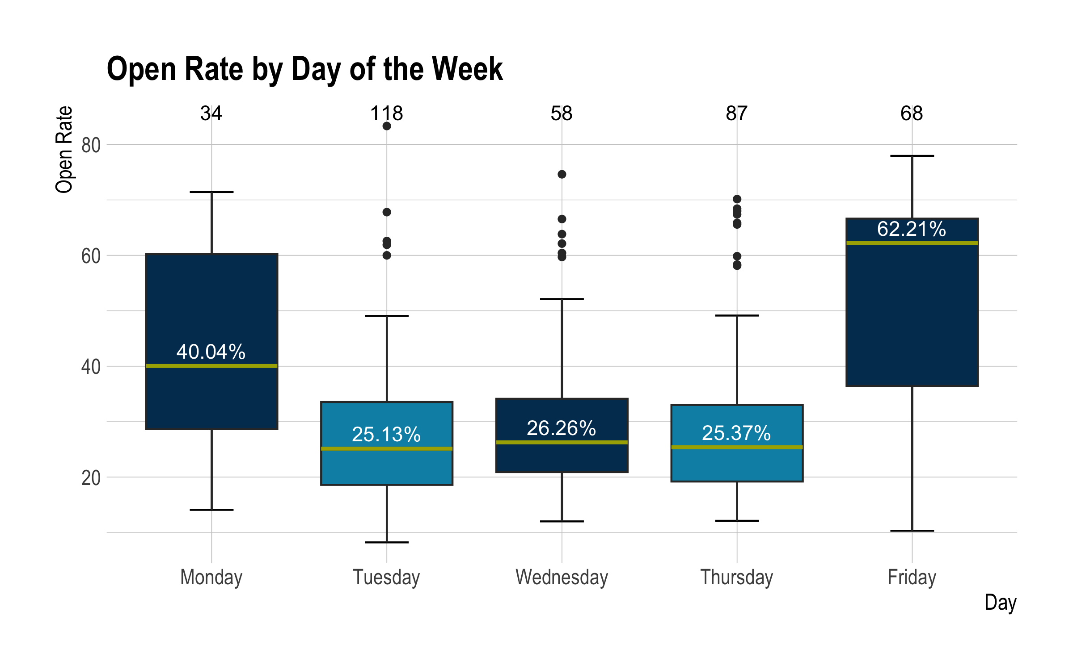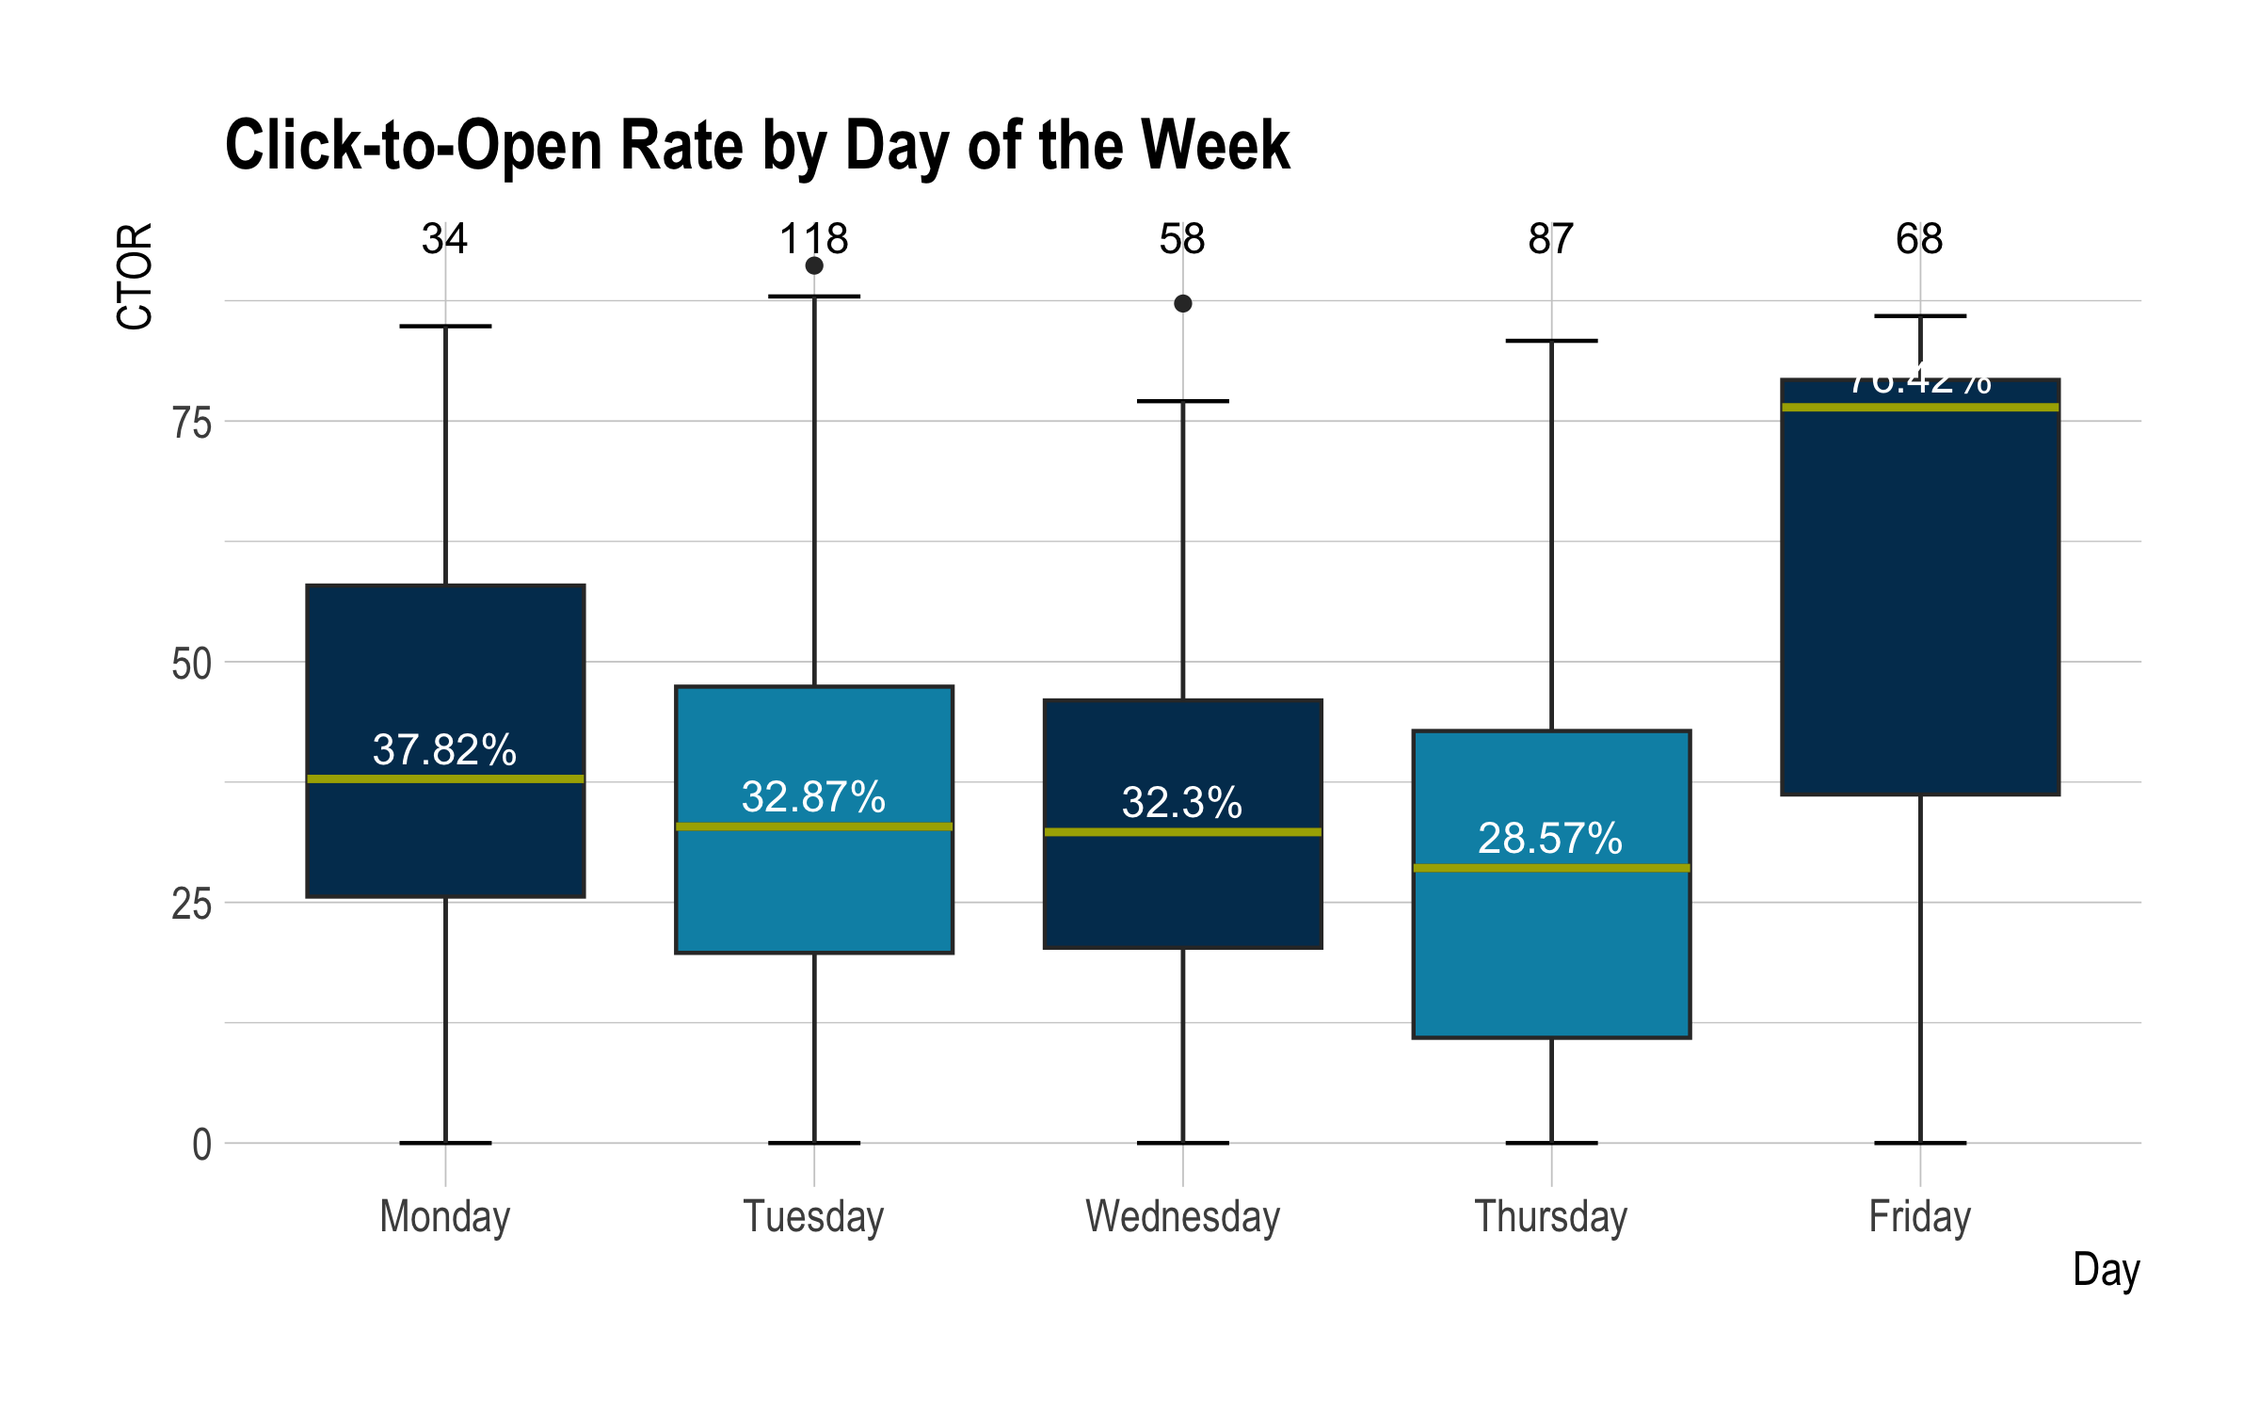

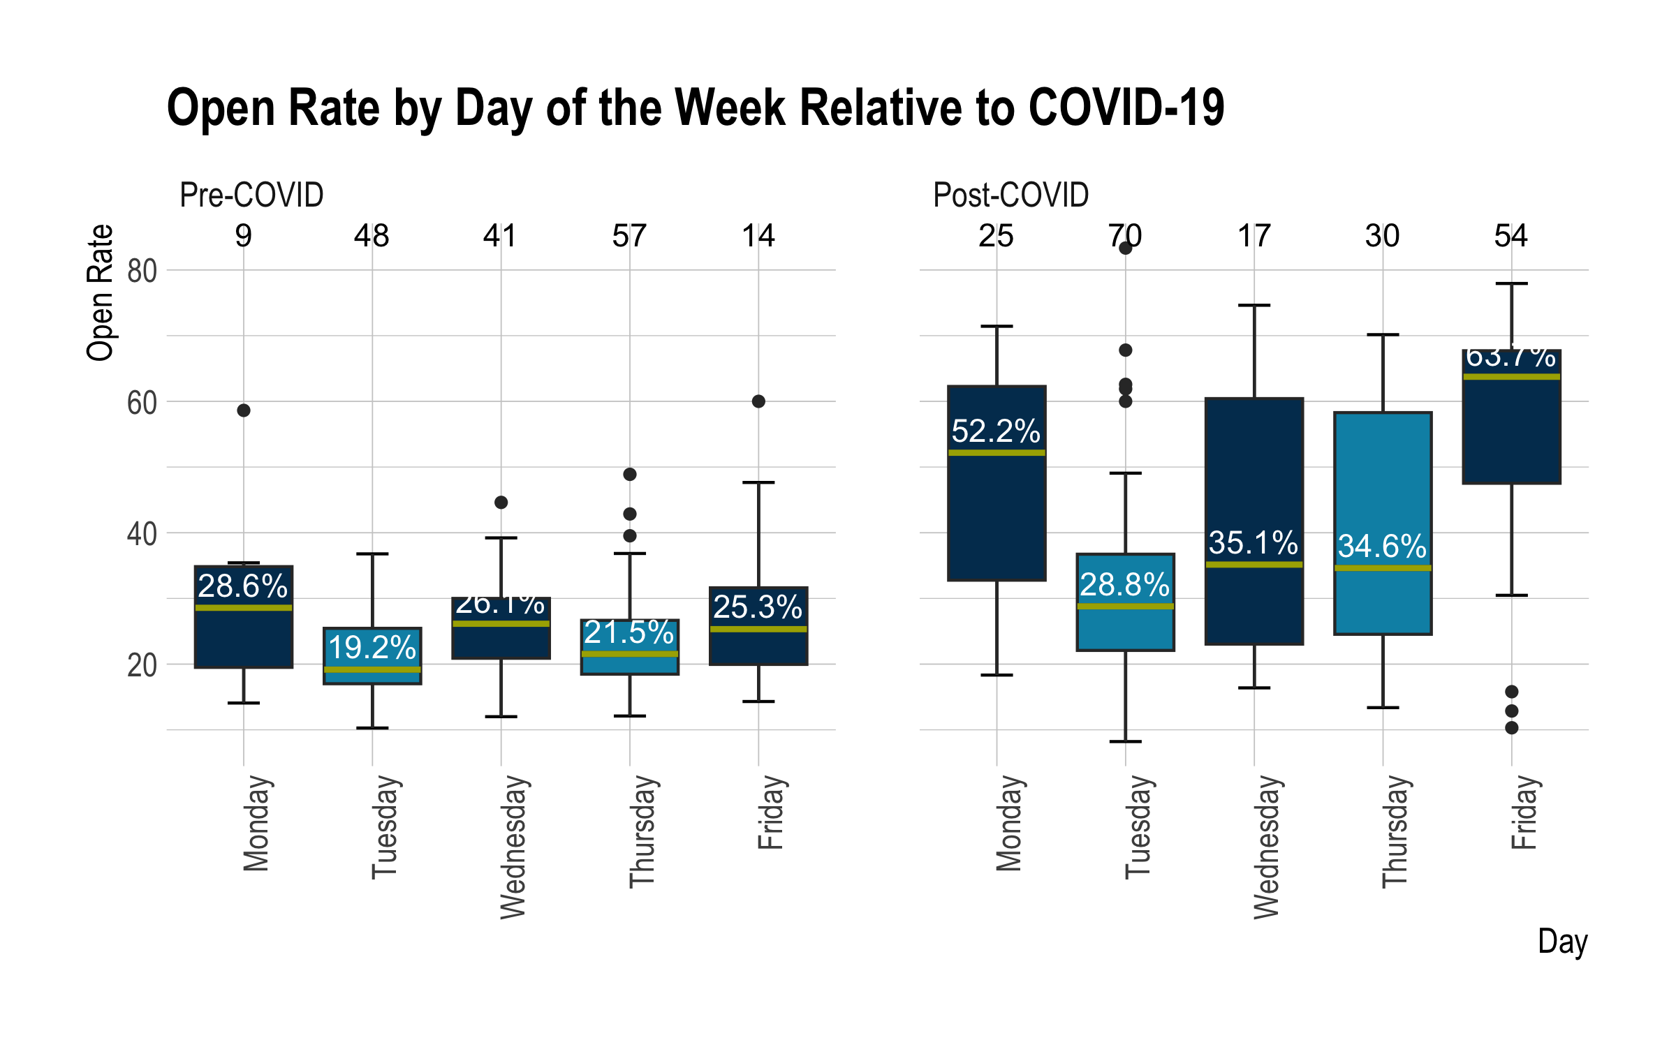

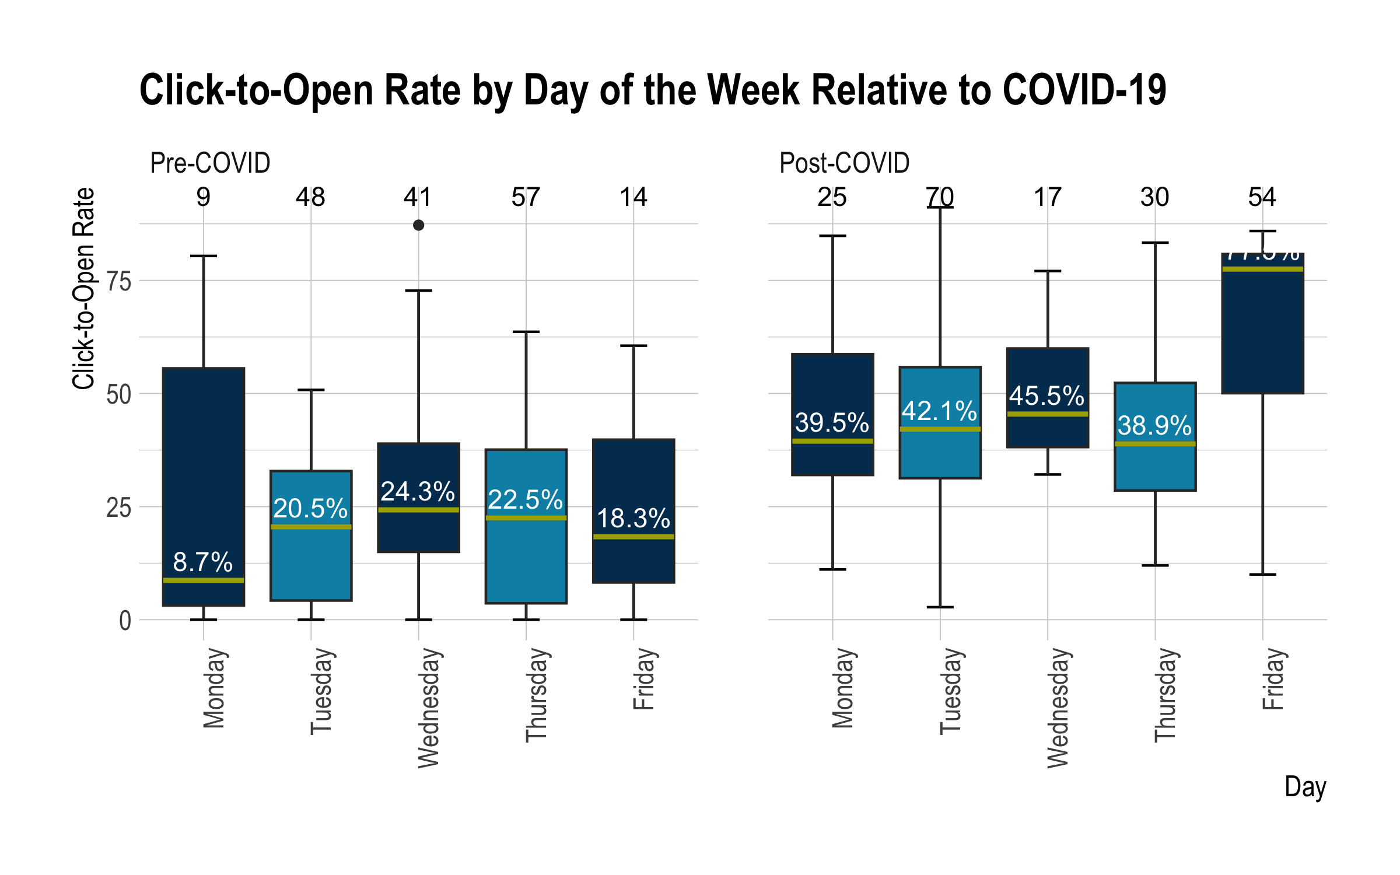

Friday seems to be far and away the best day to send emails, full stop. Monday is a good second option, but Friday is the leader in open and click-to-open rates by a large margin.

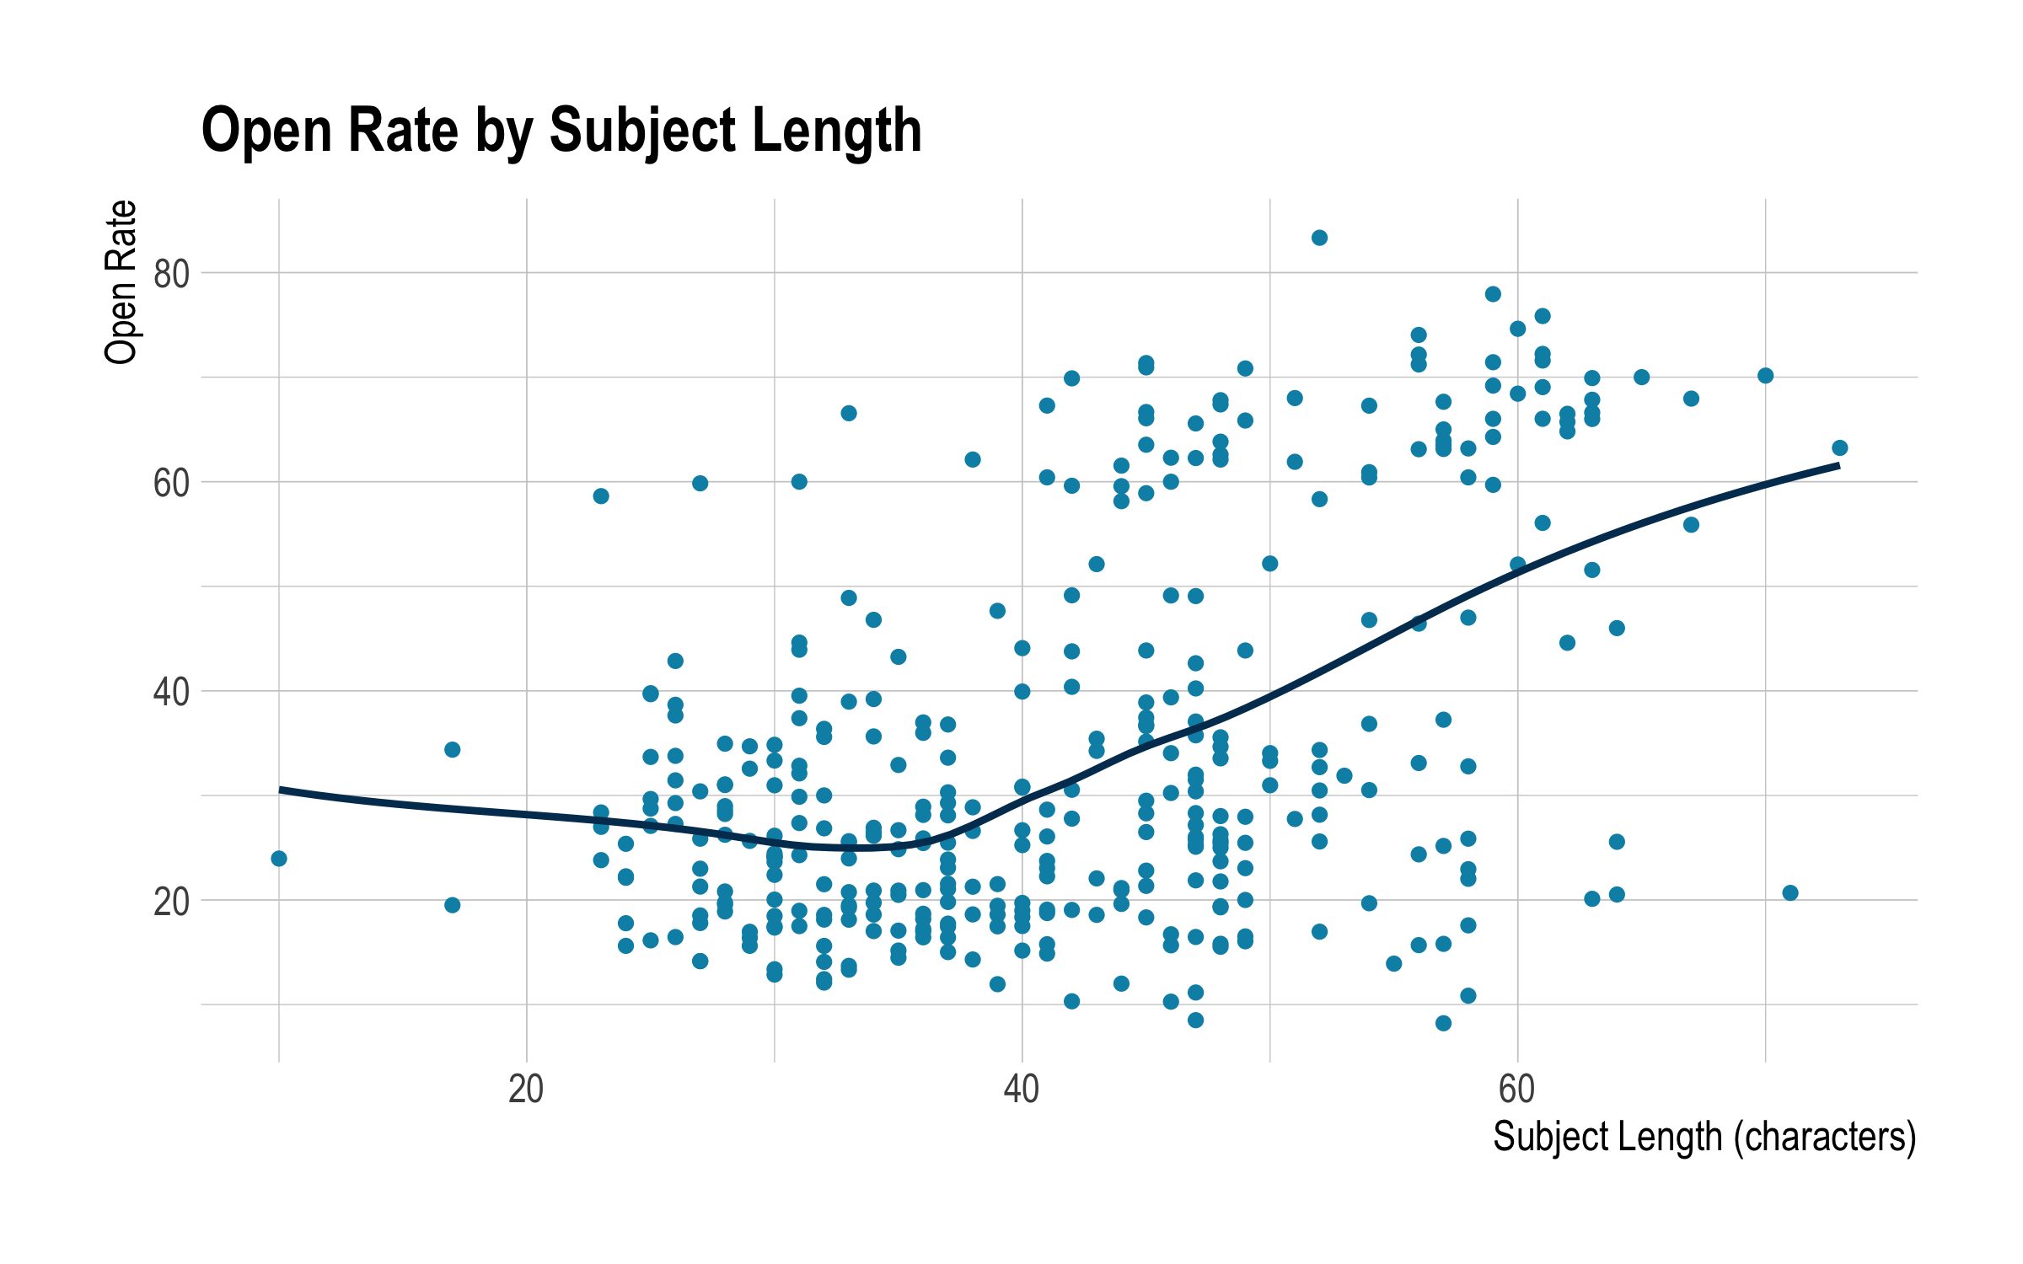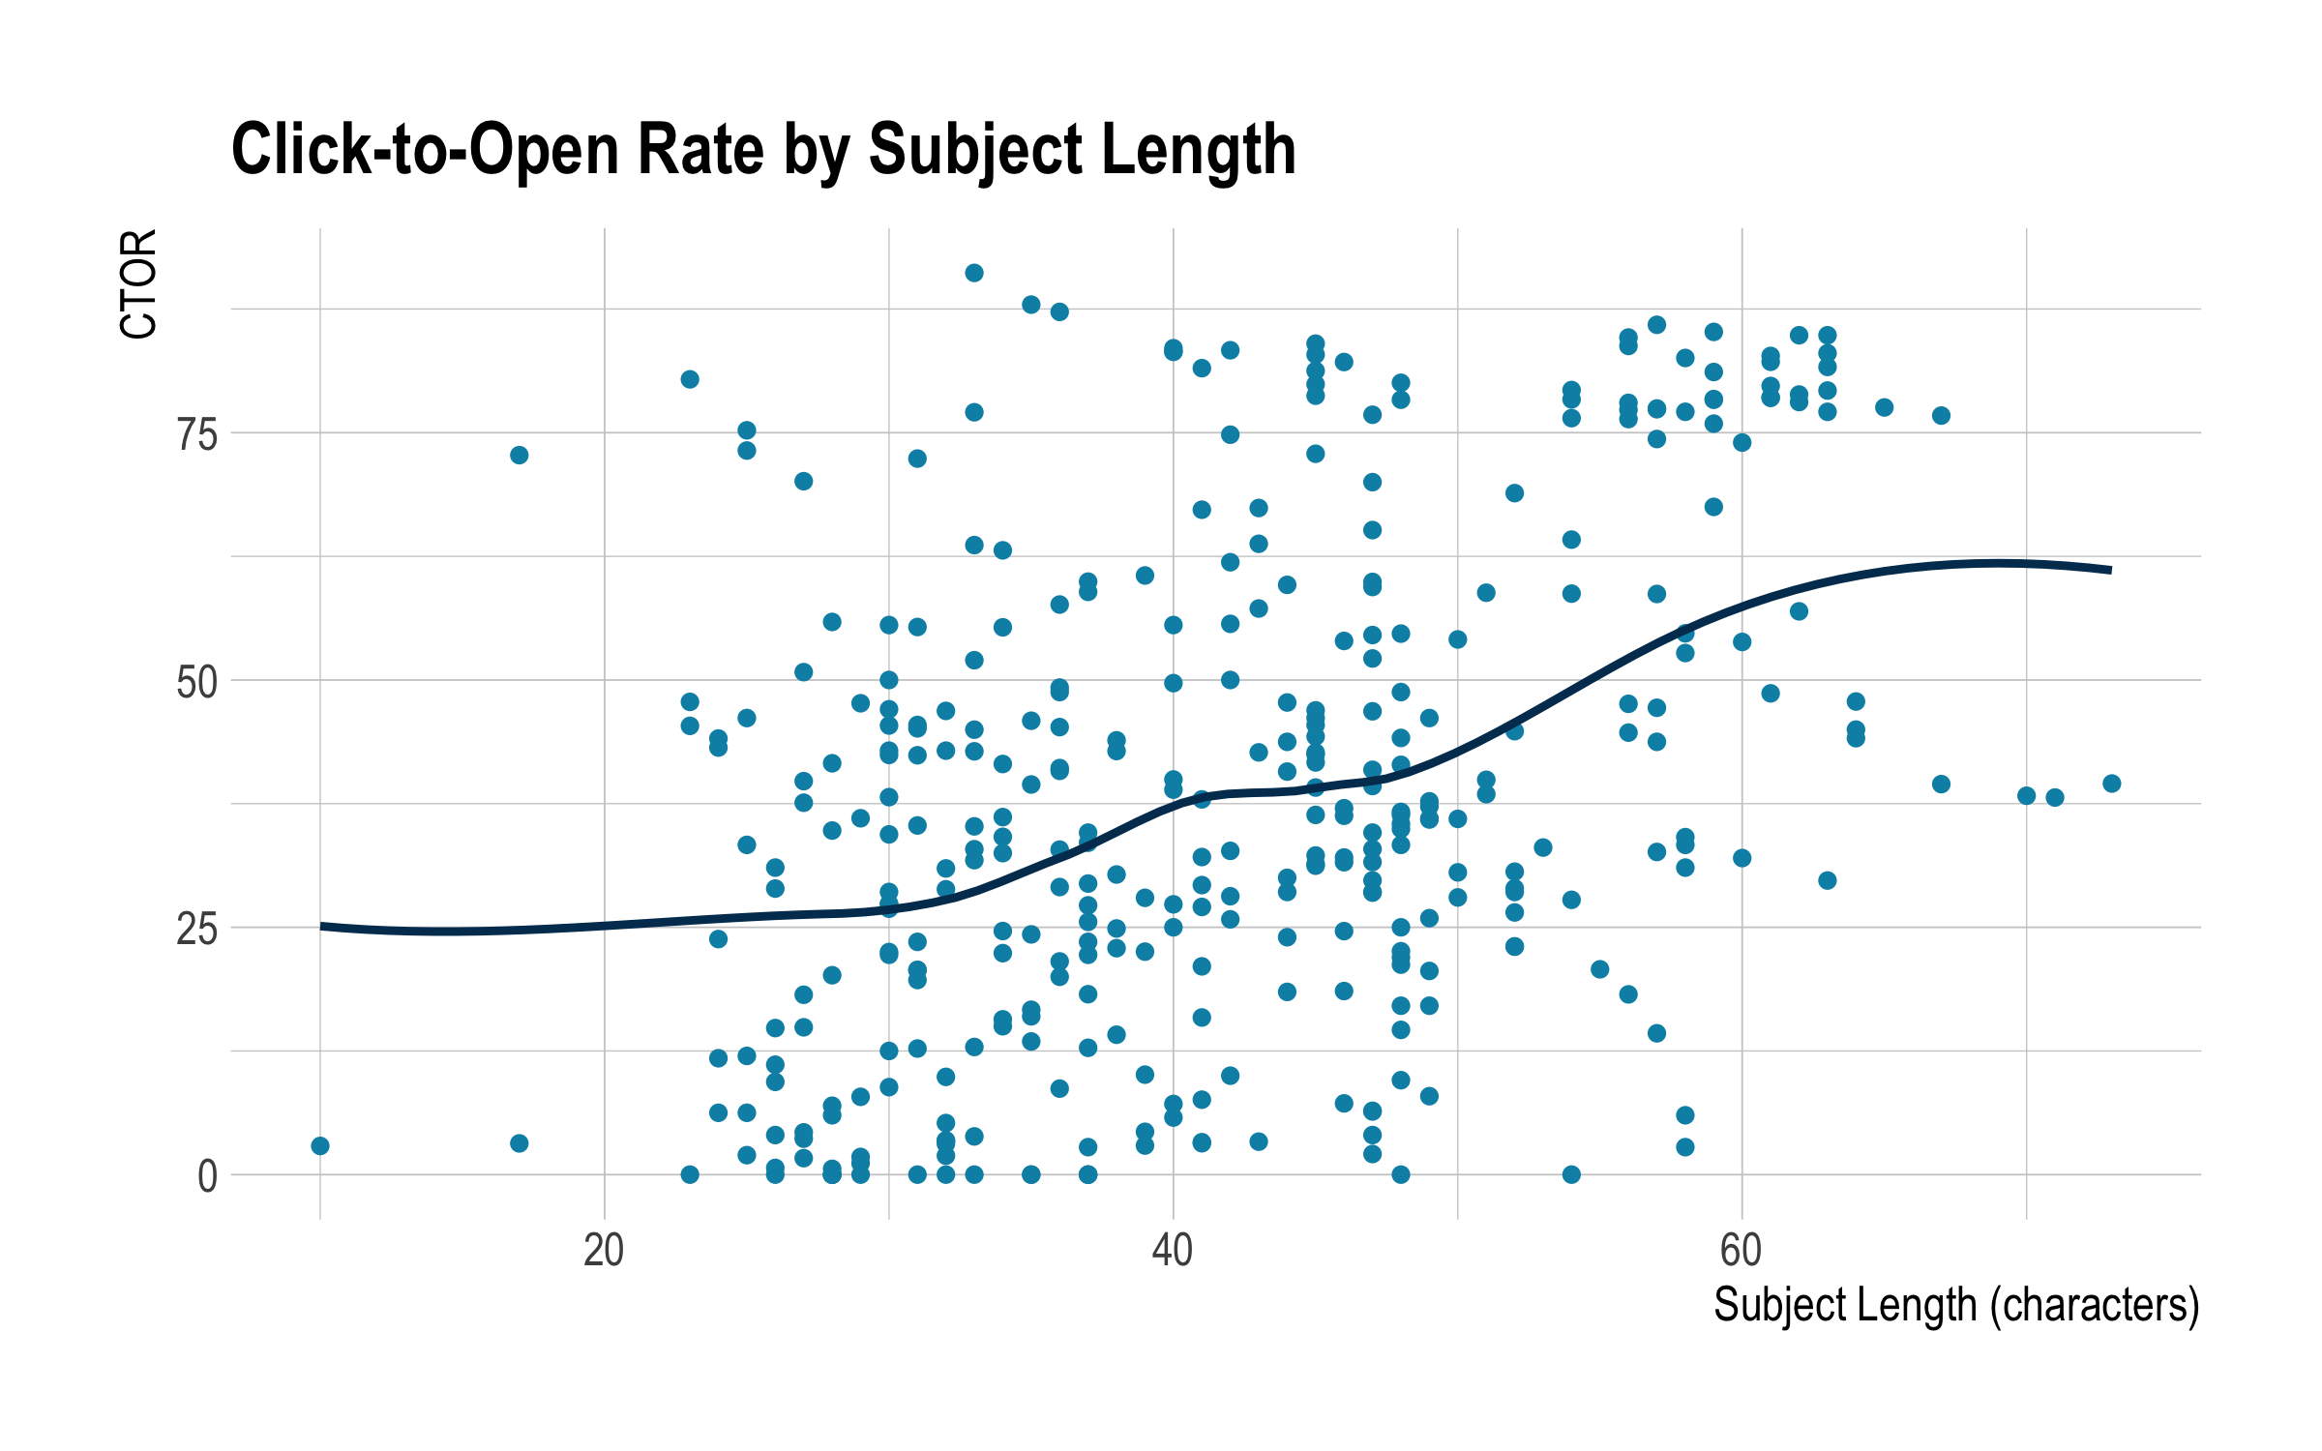

In general, as subject length increases, so do open and click-to-open rates. Both those relationships are statistically significant. It is important to stay within the bounds of the data, however. A ten thousand character subject would not go over that well. The data seem to show that subject lines between 40 and 70 characters perform the best for both open and click-to-open rates.

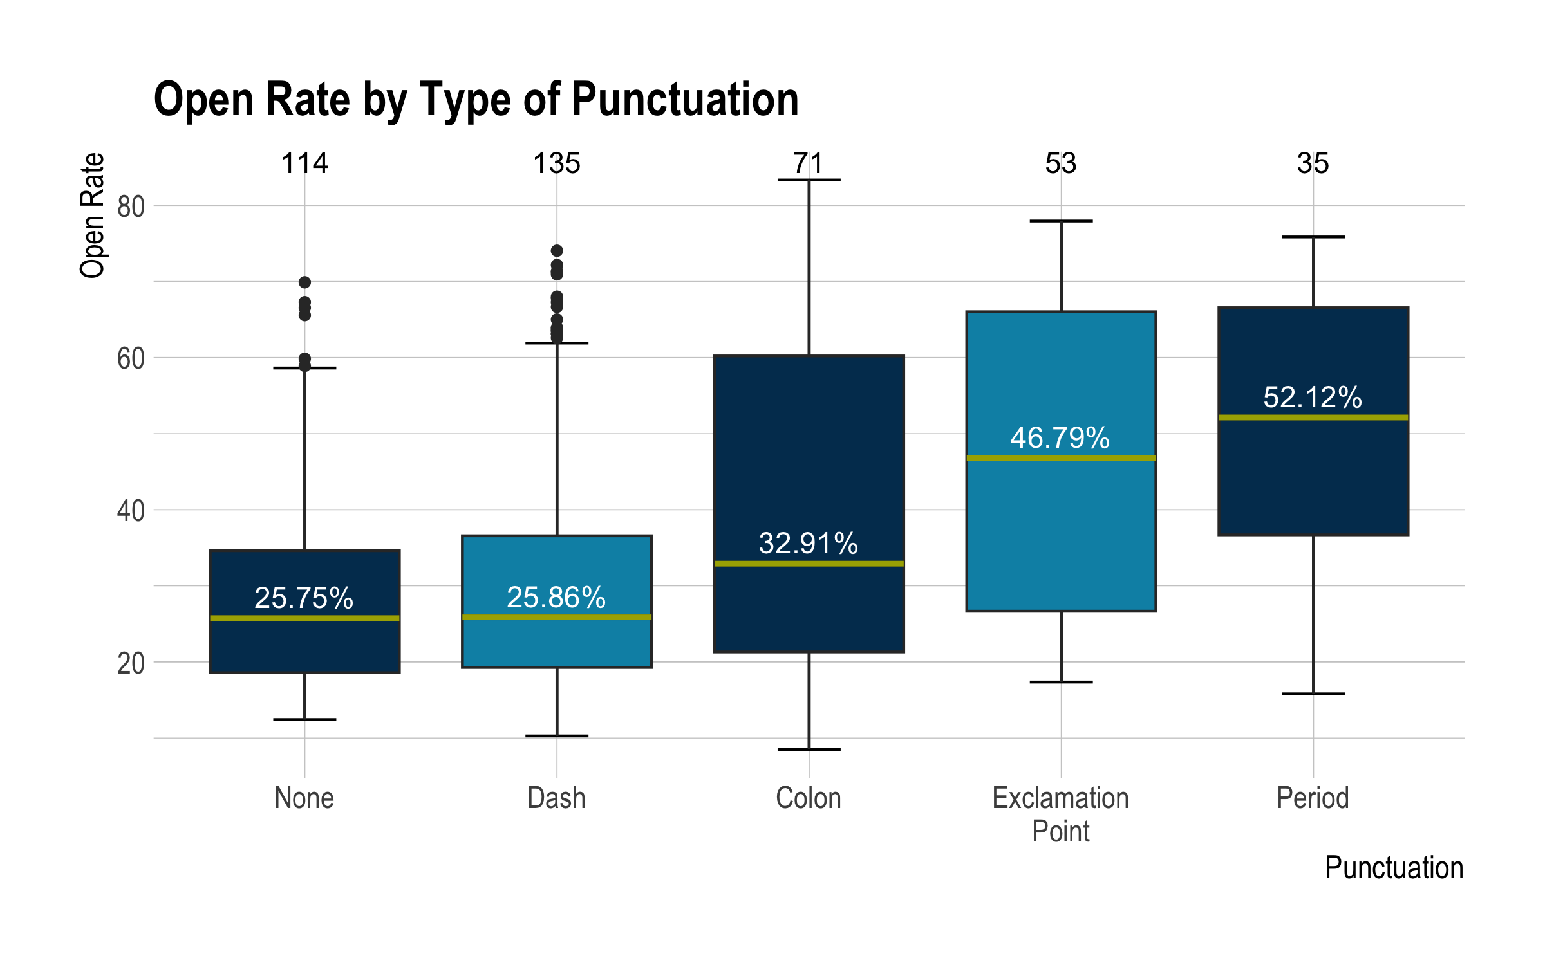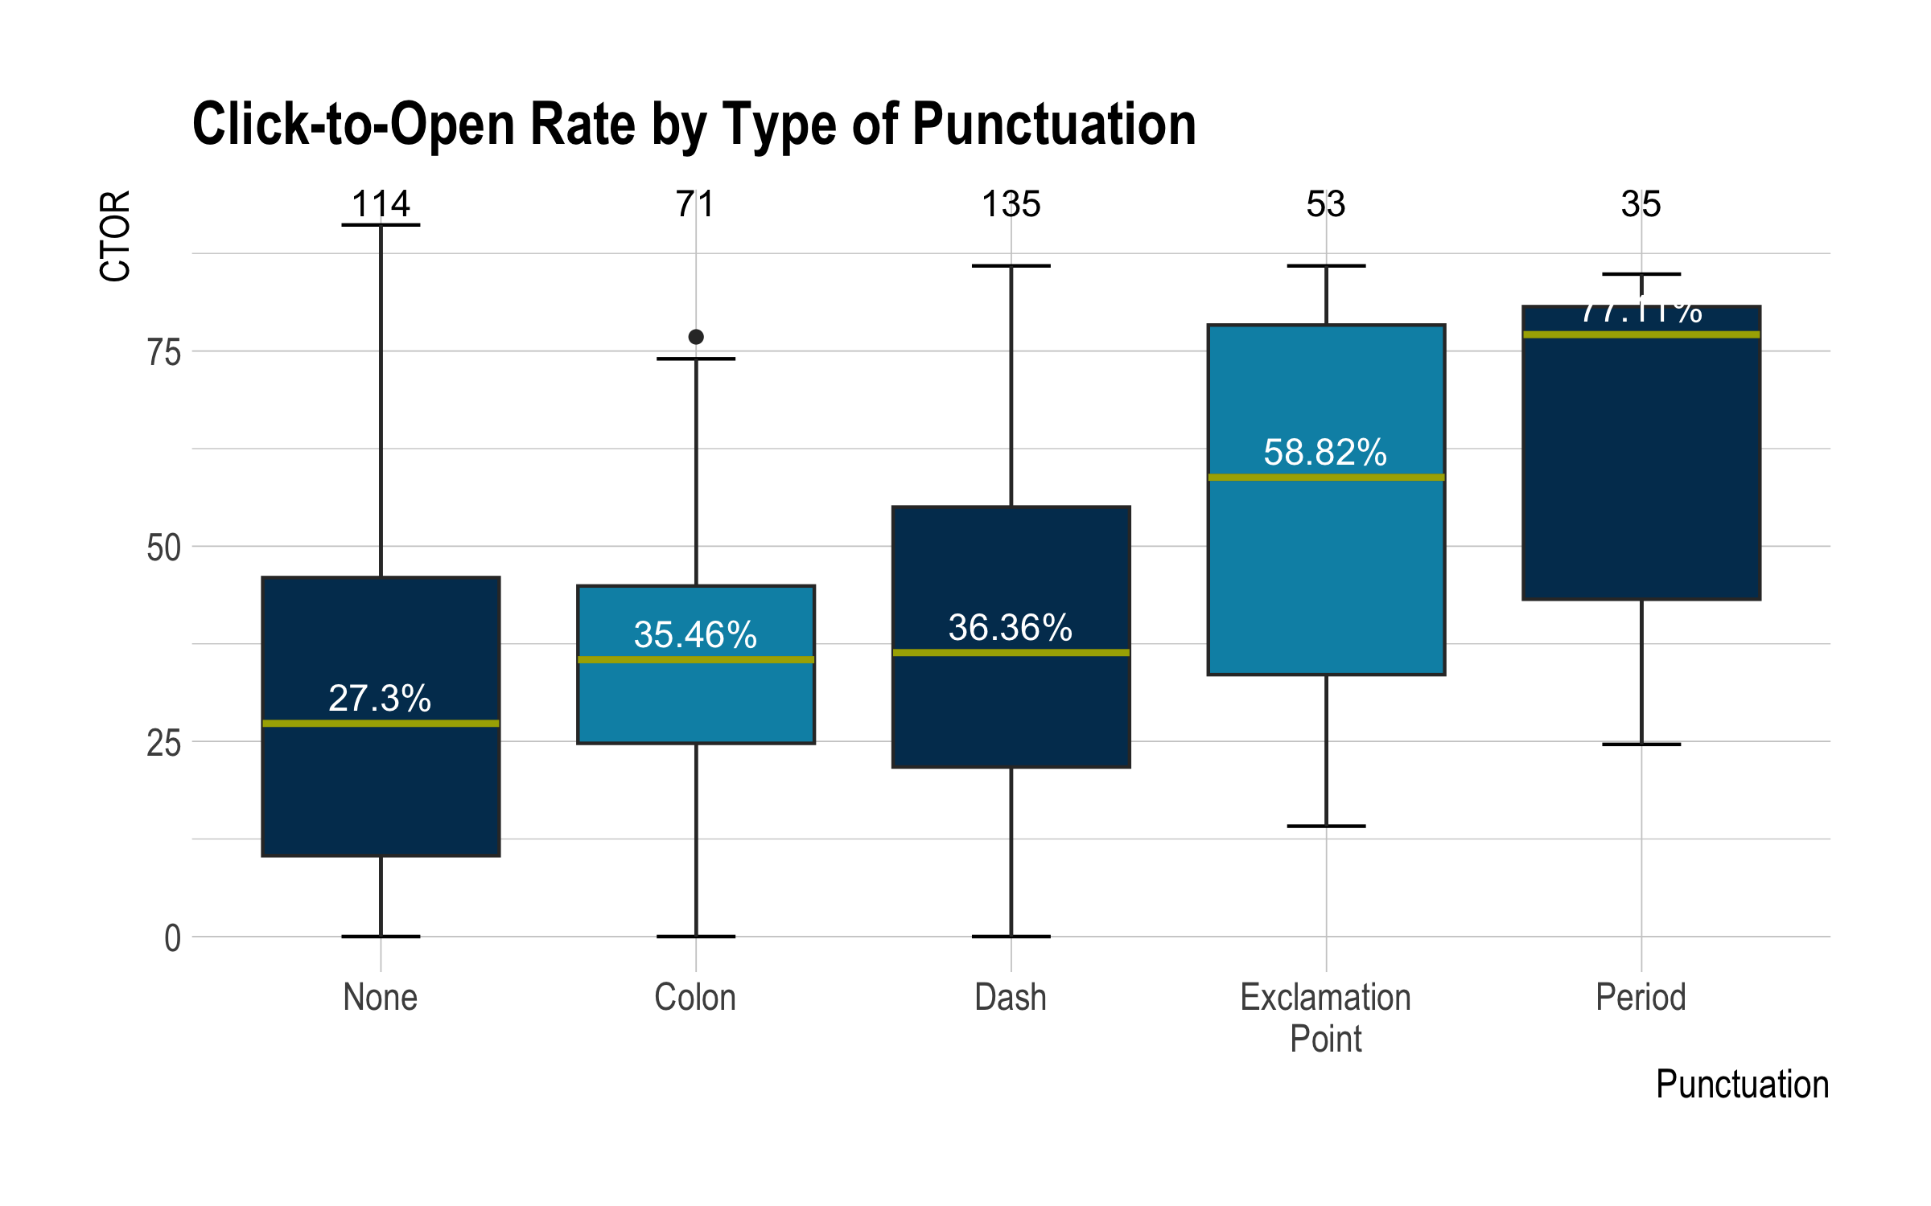

The plots on punctuation double dip on data. For example, a subject line with a colon and period would be counted twice, once in each box. So, just because period has the highest median open and click-to-open rates does not mean one should exclude every other type of punctuation.

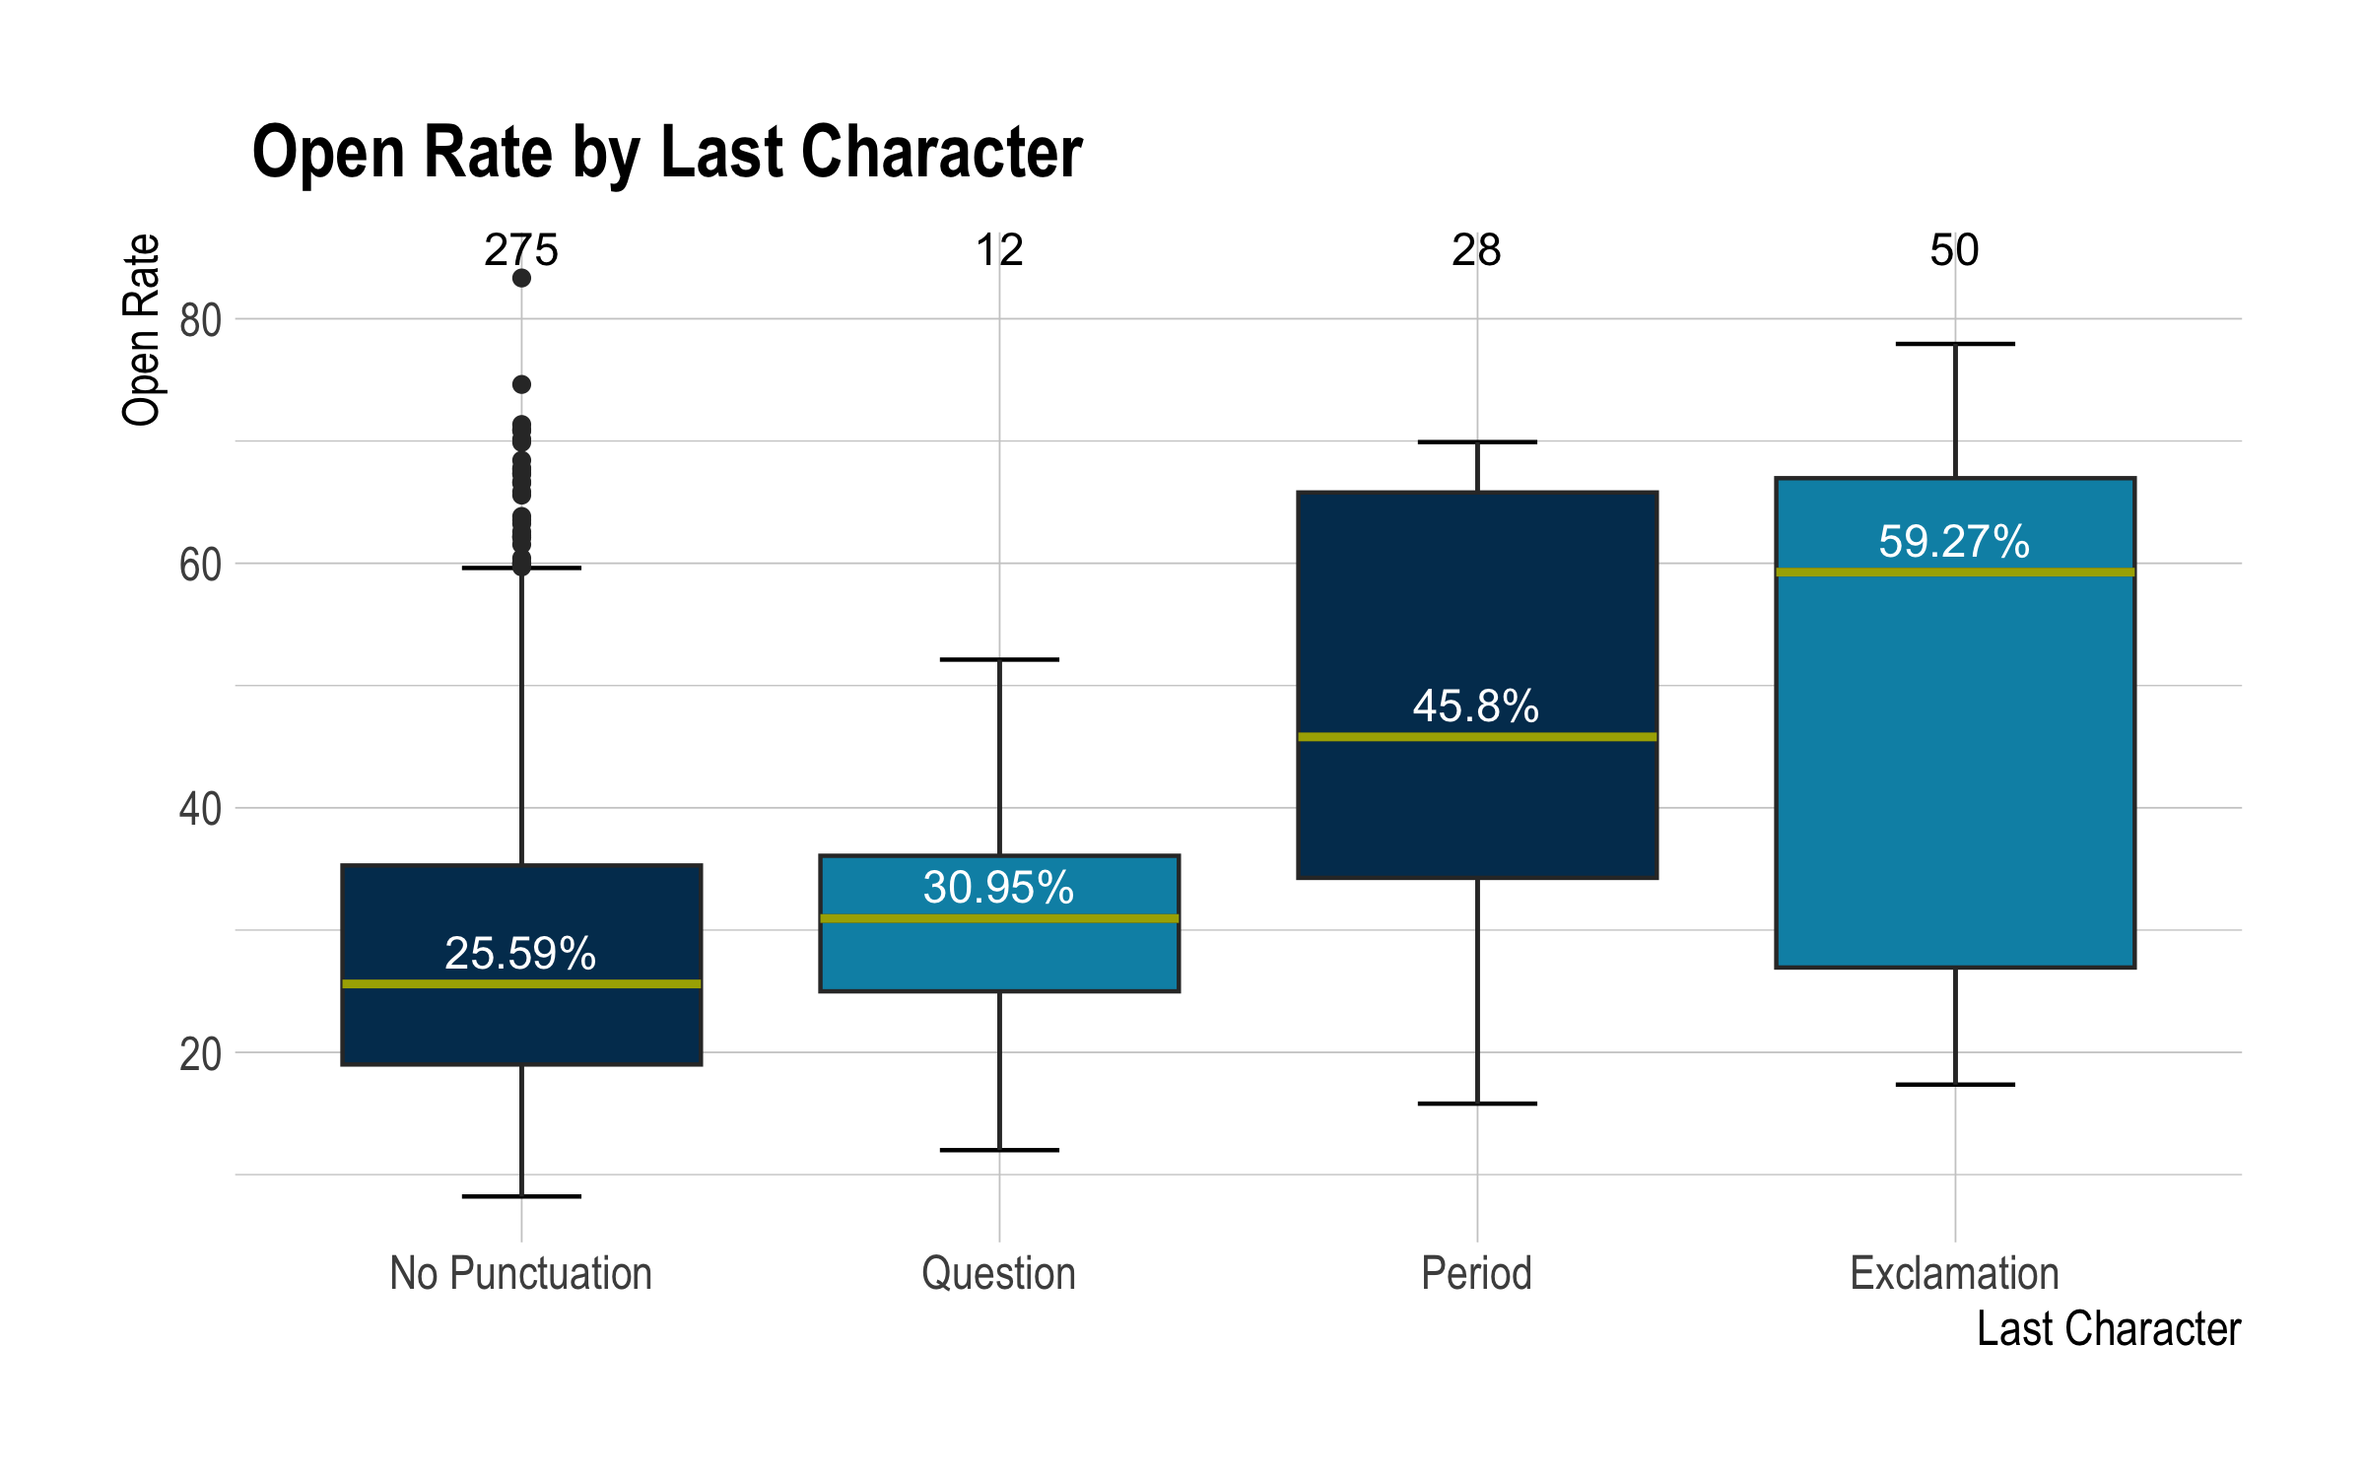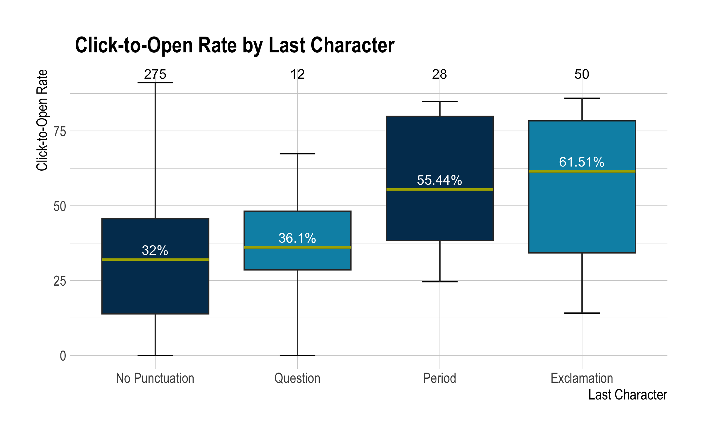

Looking at the last character in the subject line, exclamation points appear to do really well. They lead in both open and click-to-open rate.

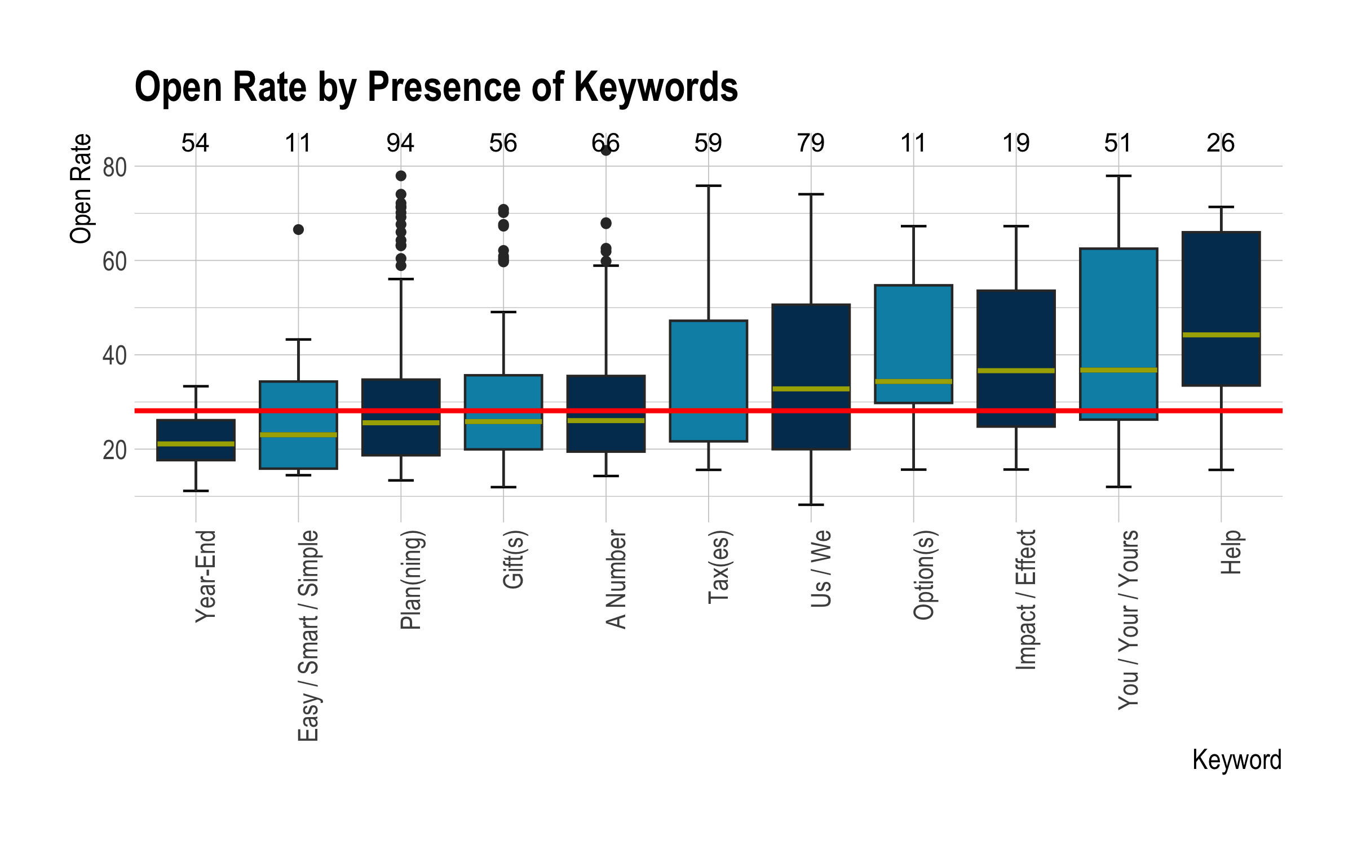

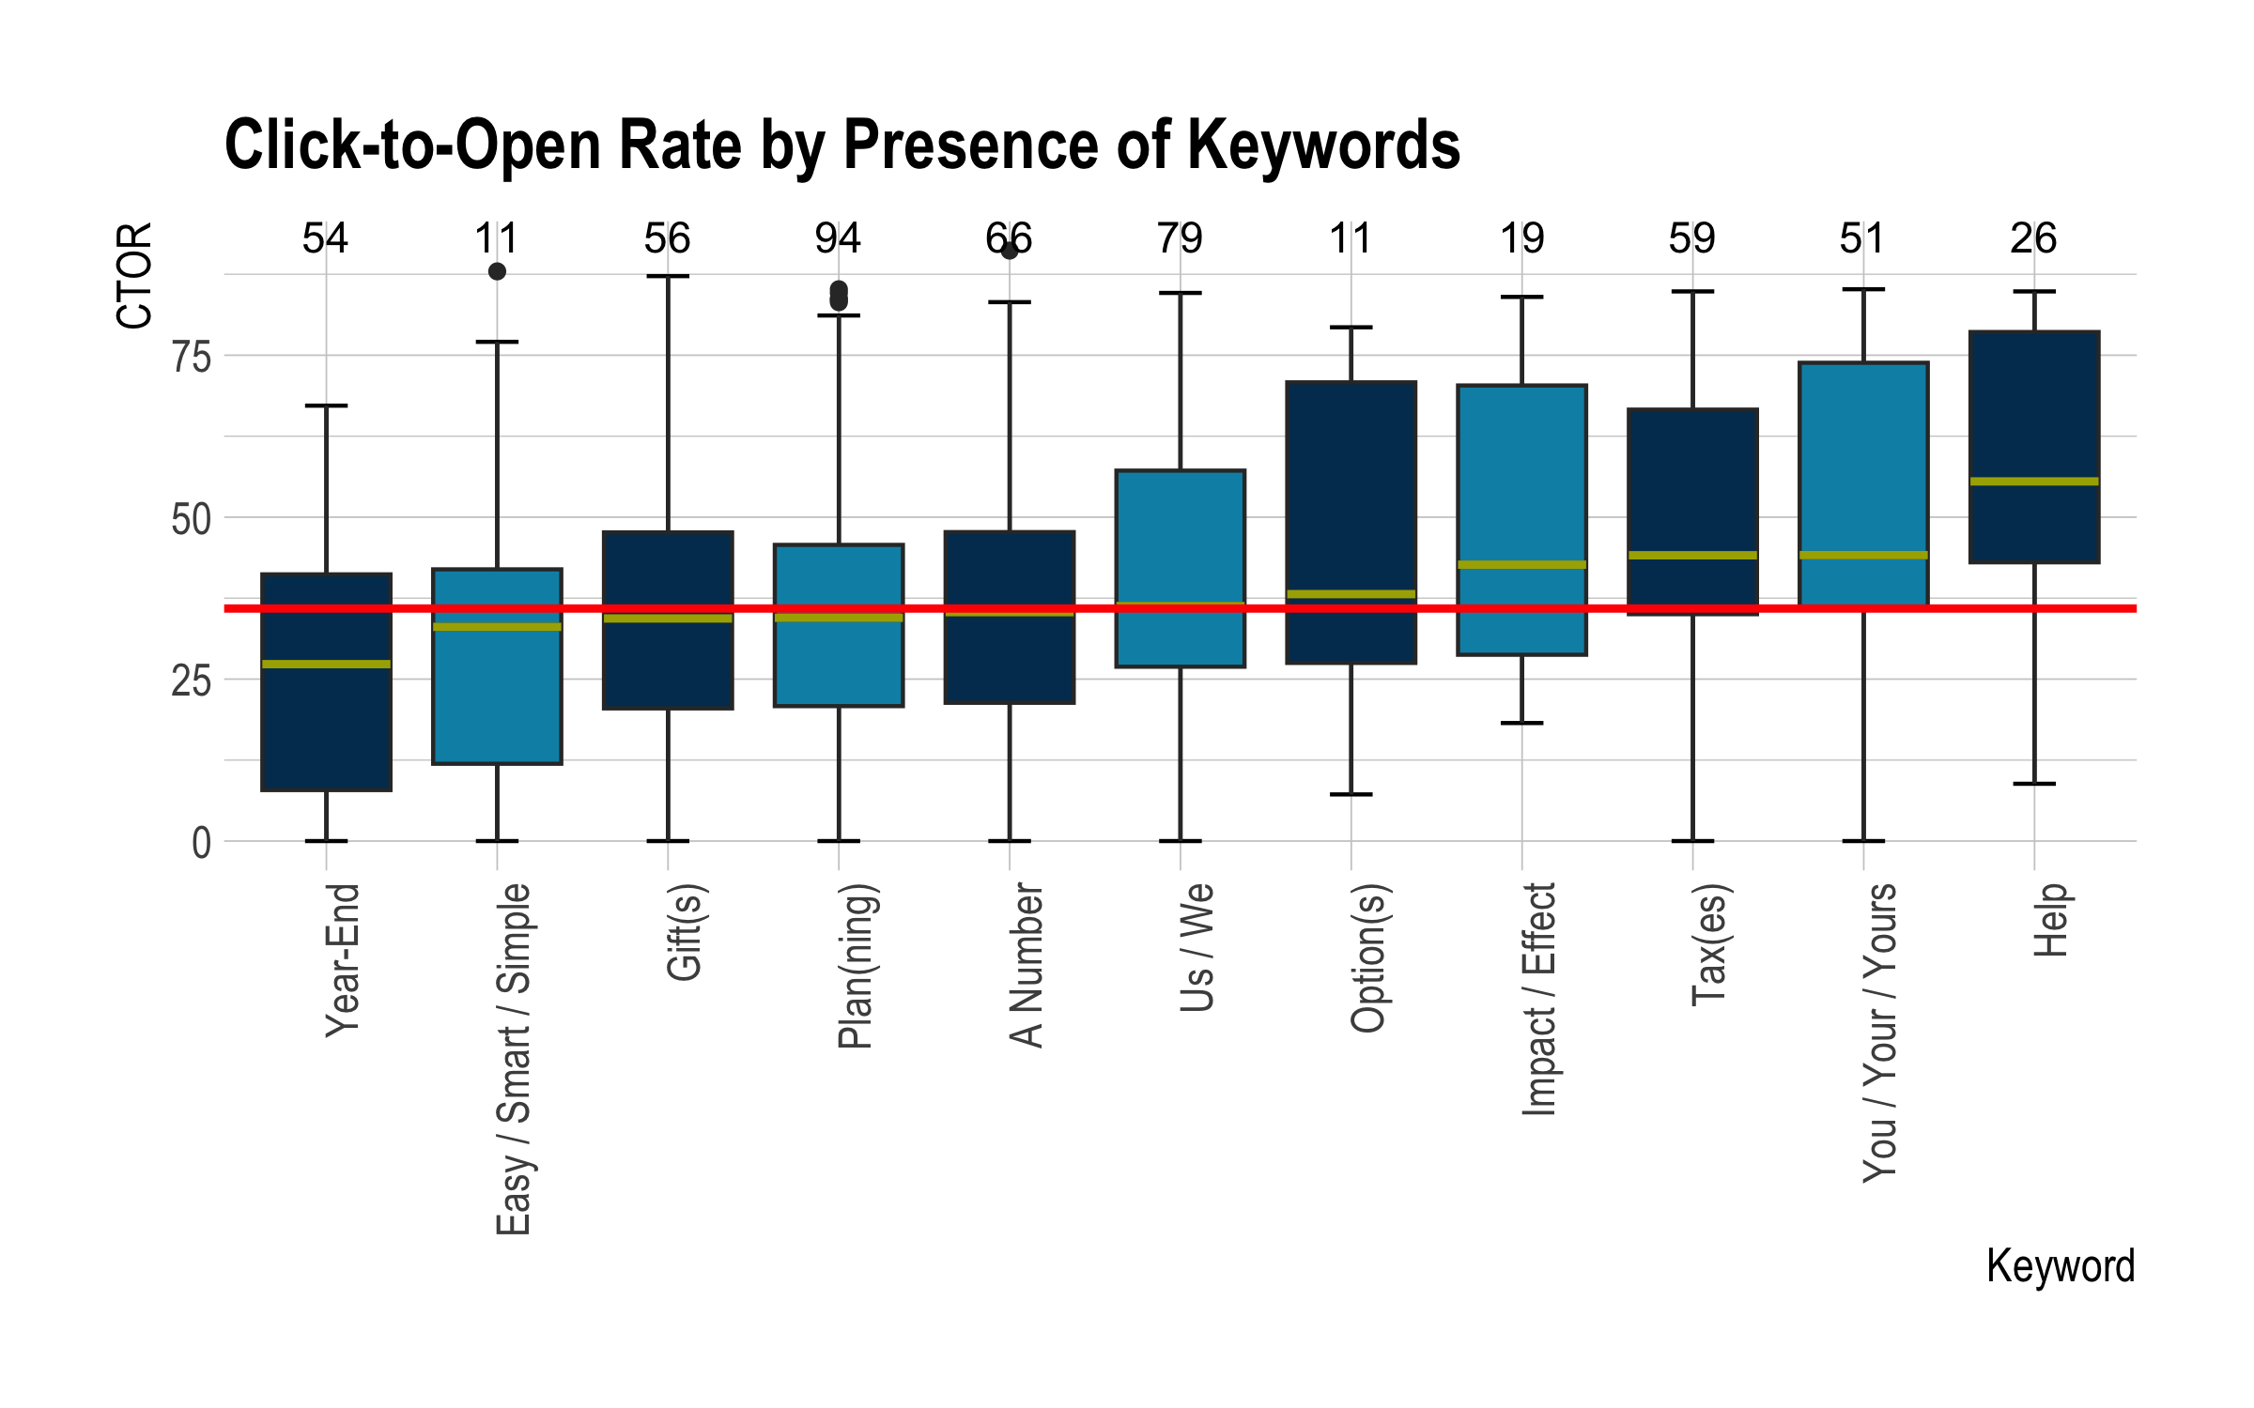

The keywords plot is interesting. For the sake of clutter, the white median text was removed, but a solid red line was added. This red line represents the median open or click-to-open rate for the respective plot. Some keywords like Help or Year-End stay in the same spot for open and click-to-open rate, while others move slightly. None, however, completely flip sides. In general, the same keywords are good for both open and click-to-open rate.

# Conclusion

In order to maximize effectiveness, one should send on a Friday, with a subject line between 40-70 characters, use punctuation, but not dashes if looking for open rate, end with an exclamation point or a period, but preferably an exclamation point, and use keywords like Help, You/Your/Yours, and Impact/Effect. A table with all that information in a more concise way is below.

| Maximize | Day | Subject Length | Punctuation? | Last Character | Keywords to Use | Keywords to Avoid |
| --- | --- | --- | --- | --- | --- | --- |
| Open Rate | Friday | 40-70 characters | Yes, except dashes | Exclamation Point | Help, You, Impact/Effect | Year-End, Easy |
| Click-to-Open Rate | Friday | 40-70 characters | Yes | Exclamation Point | Help, You, Tax | Year-End, Easy |