CPT205 Computer Graphics - Assessment 1 Report

Basic information
Name: Xingjian Wu
ID Number: 2361742
Programme: Information and Computing Science
Module Title: Computer Graphics
Module Code: CPT205
Assignment Title: Assessment 1 – 2D Modelling Project

Introduction
This project implements an interactive 2D greeting card to celebrate the 20th anniversary of Xi'an Jiaotong-Liverpool University (XJTLU). The program utilizes OpenGL freeglut library to create a visually appealing card with animations, interactive elements, and XJTLU-themed graphics.

Card design and features
This electronic greeting card design starts from the folding cards that are commonly found in our daily lives. It designs a 2D interactive greeting card with XJTLU elements and celebrating its 20th anniversary from four aspects: visual elements, animation effects, interactive functions, and congratulatory messages.

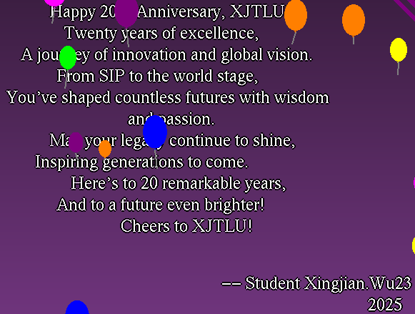
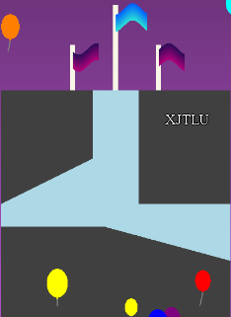
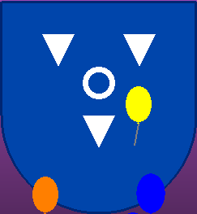

During the element drawing process, this greeting card used basic shapes such as polygons, lines, ellipses, and semi-circles to draw other XJTLU elements.
In terms of visual element design, I chose the gradient purple with XJTLU characteristics as the background and on the cover. Distinctions were made in the direction of the gradient, and I also drew the school emblem and the projection diagram of our school's most representative central building to enhance the XJTLU feature of the greeting card.
In terms of animation effects, clicking the mouse and the randomly generated balloons of various sizes and colors that appear from the bottom of the greeting card add a dynamic beauty to the card. This greeting card also distinguishes the cover page from the inner background. By clicking the keyboard F on the cover page, an animation of the card's cover unfolding and moving horizontally is triggered, revealing the congratulatory words inside.
In terms of interaction, this greeting card adopts two interaction methods: keyboard and mouse. One is to randomly generate balloons by clicking the mouse, and the other is to trigger the cover expansion animation by pressing the designated keys on the keyboard. This meets the needs of various interaction methods for electronic greeting cards.

Readme
Program Operation Instructions:

Operation Steps
Extract the submitted compressed file
Open the project in Visual Studio or run the executable file directly
After the program starts, display the cover of the greeting card
Press the F key to open the greeting card to view the full content
Click on the greeting card with the mouse to create a balloon

User Interaction Guide
Initial State: The greeting card is closed, showing the cover and operation prompts
Open the greeting card: Press the F key to make the cover slide open
Create a balloon: Click the left mouse button (small balloon) or the right mouse button (large balloon) at any position on the greeting card
Use the W/E keys to zoom the view
Exit the program: Press the Q key
If the keyboard buttons do not respond when pressed, please switch the input method to the English input method.

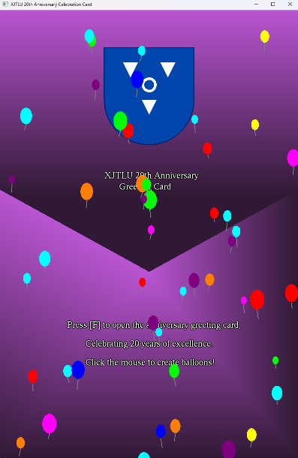
Program execution and electronic greeting card display
After double-clicking to open the exe file, what comes into view is the cover of our greeting card. With the rising balloons and text display, it is clearly shown that this is a greeting card for celebrating the 20th anniversary of XJTLU.


The blue shield-shaped logo on the front cover is my simple school emblem that I drew. It represents that this greeting card is for XJTLU.

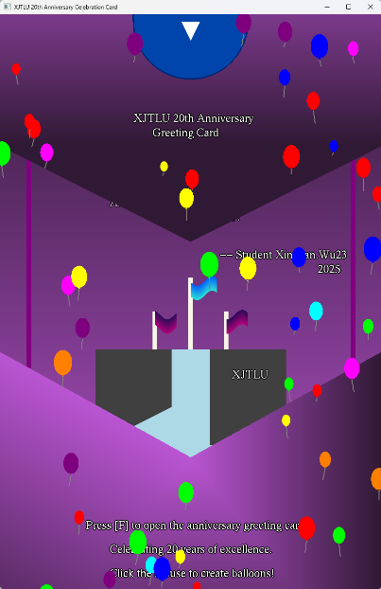
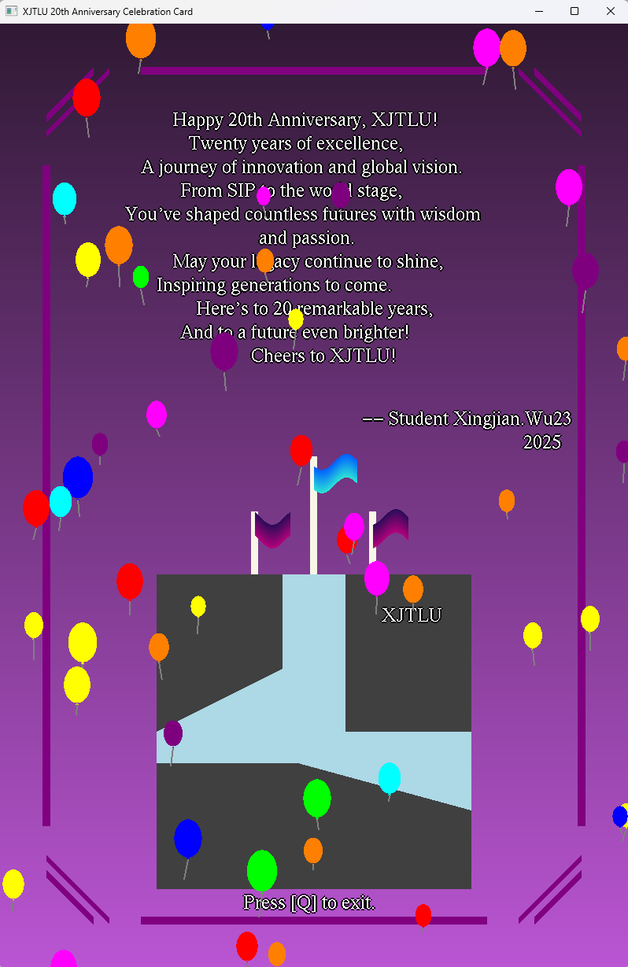
According to the instructions, press the key F on the keyboard to make the greeting card surface move up and down and unfold. The inside of the greeting card is shown.

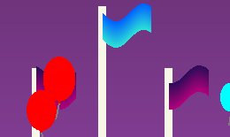
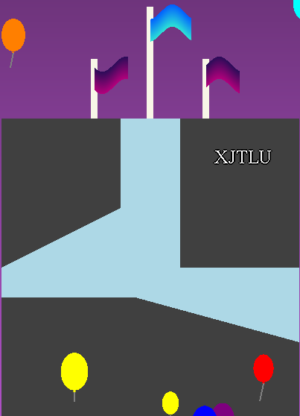
At the top of the greeting card is the congratulatory message, below which is the projection of the XJTLU central building that I drew, and in the middle, the three flagpoles' flags will oscillate in a trigonometric pattern.



In the mouse interaction section, pressing the left mouse button will generate a small balloon, while pressing the right mouse button will generate a large balloon.

Conclusion
This is an interactive electronic greeting card that I have designed for the 20th anniversary celebration of XJTLU.

