Predicting Metaphorical Verb Usage with Machine Learning
INFO 4604 — Portfolio Project 1 | VUA Metaphor Dataset
1. Dataset
I chose the VUA metaphor dataset because I am interested in natural language processing and machine learning. Each row represents a target verb used in a sentence, with a binary label indicating whether the verb is used literally or metaphorically. The working dataset contains 15,516 examples and six original columns: text_idx, sentence_idx, verb, sentence, verb_idx, and label.
2. Feature Engineering
2.1 Class balance
The target is moderately imbalanced: 11,187 examples (72.10%) are literal and 4,329 (27.90%) are metaphorical. Because a majority-class model could achieve 72.1% accuracy without identifying any metaphors, I do not rely on accuracy alone when evaluating the classifier.
2.2 Feature histograms and outlier review
I engineered four numerical features: sentence length, target-verb length, relative verb position, and verb frequency. IQR checks flagged some long sentences, long verbs, and highly frequent verbs, but these were valid linguistic observations rather than data-entry errors, so I retained them.
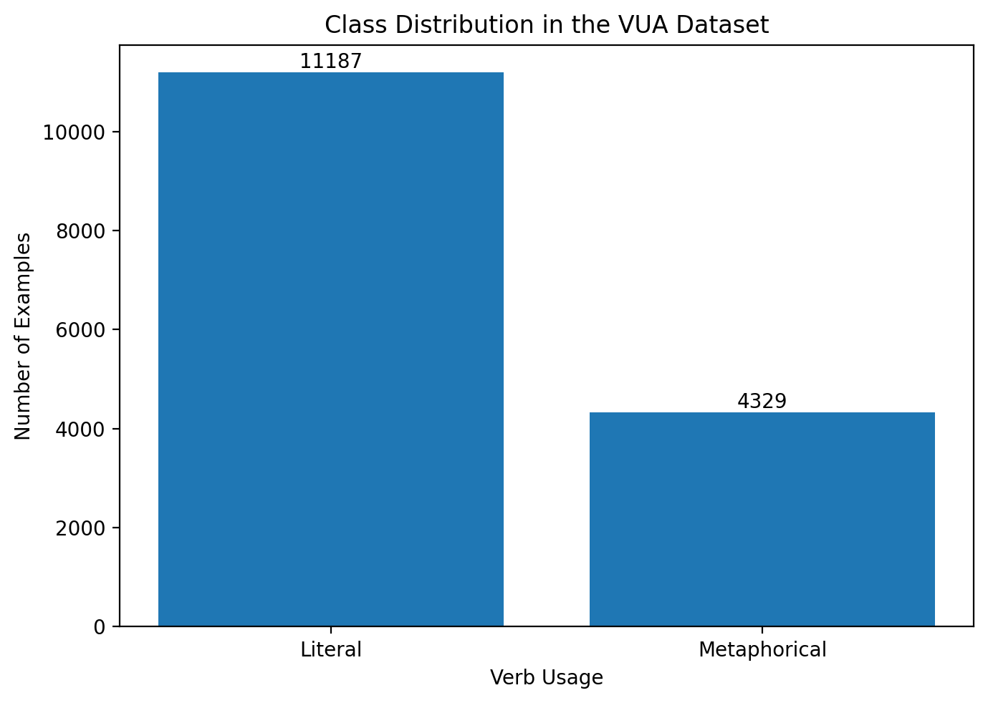  Figure 1. Class distribution. | 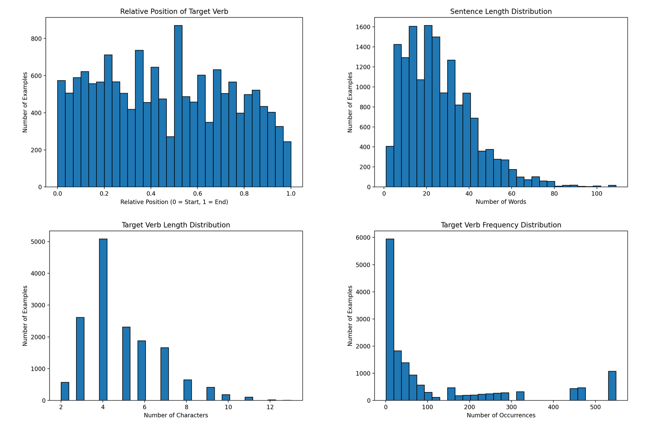  Figure 2. Engineered feature histograms.
The distributions show a right-skewed pattern for sentence length and verb frequency, while relative position spans the sentence. The extreme values were kept because they reflect valid language use rather than corrupted records.

2. Feature Engineering (continued)
2.3 Missing values  I checked every column for missing data. No missing observations were present, so imputation was not necessary.  2.4 One-hot encoding  Verb identity is categorical and has no natural ordering, so I used one-hot encoding rather than ordinal encoding. To control dimensionality, I kept the 50 most frequent verbs and grouped less frequent verbs into an OTHER category.  2.5 Correlated columns  I checked Pearson correlations among the numerical features. The largest absolute relationship was between verb length and verb frequency (r = -0.55), below the 0.80 threshold used for high correlation. Therefore, no numerical feature was removed for redundancy. | 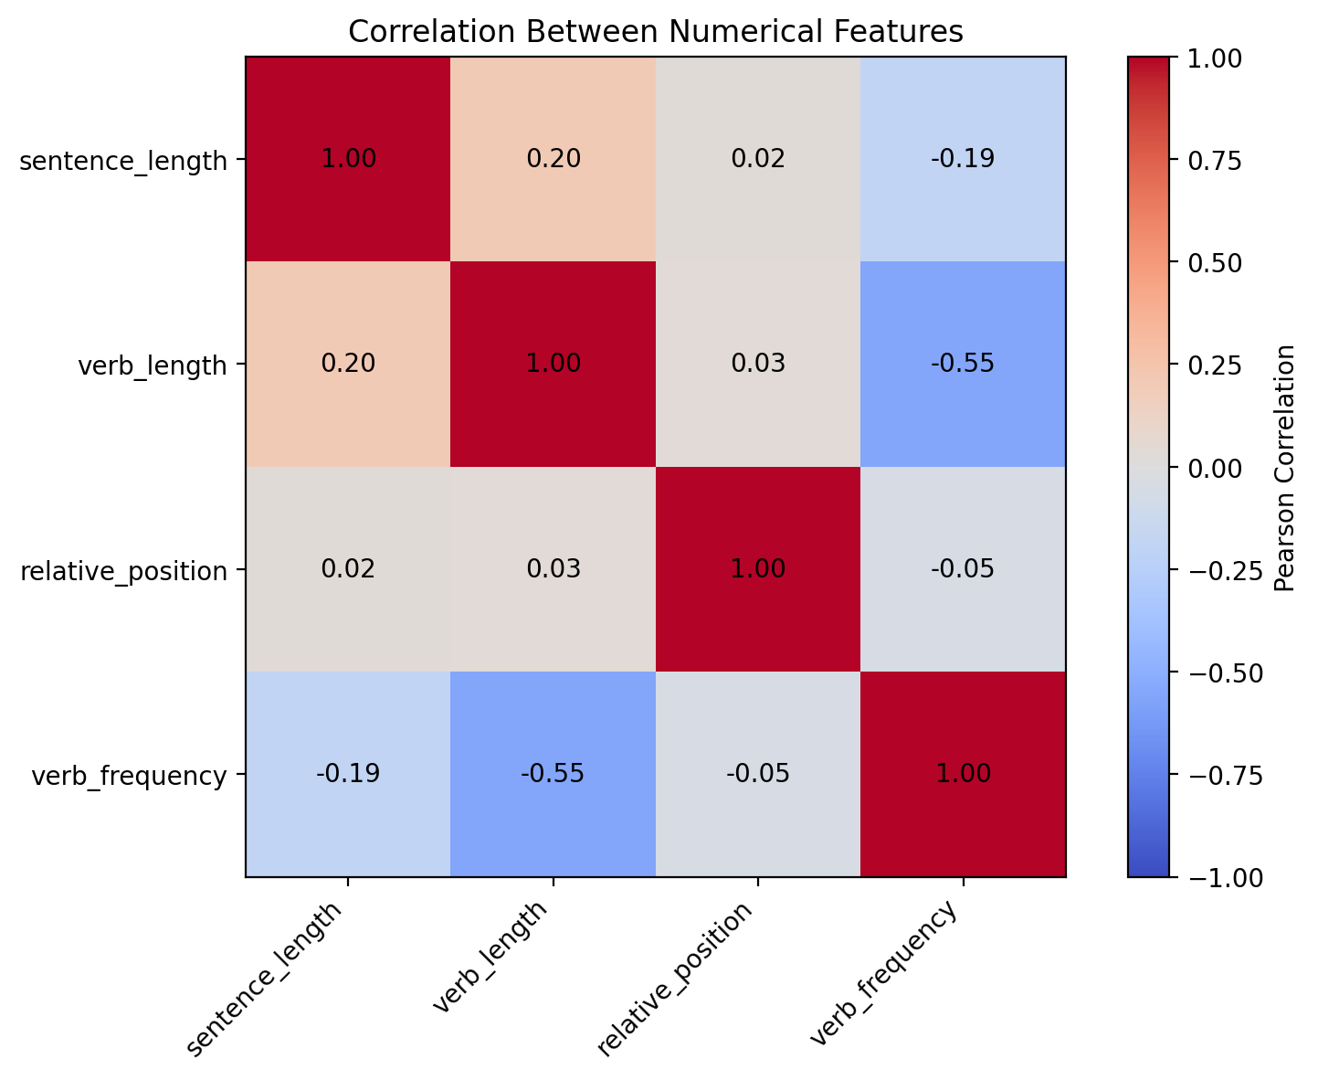  Figure 3. Correlation matrix for numerical features.
3. Clustering Without Using y
I standardized the four numerical features and applied KMeans with three clusters. The metaphor label was not used to create the clusters. After clustering, I compared the clusters with the labels only for interpretation. The group dominated by short, very frequent verbs had the lowest metaphor rate (22.33%), while the group with longer sentences, less frequent verbs, and later sentence positions had the highest rate (31.04%).
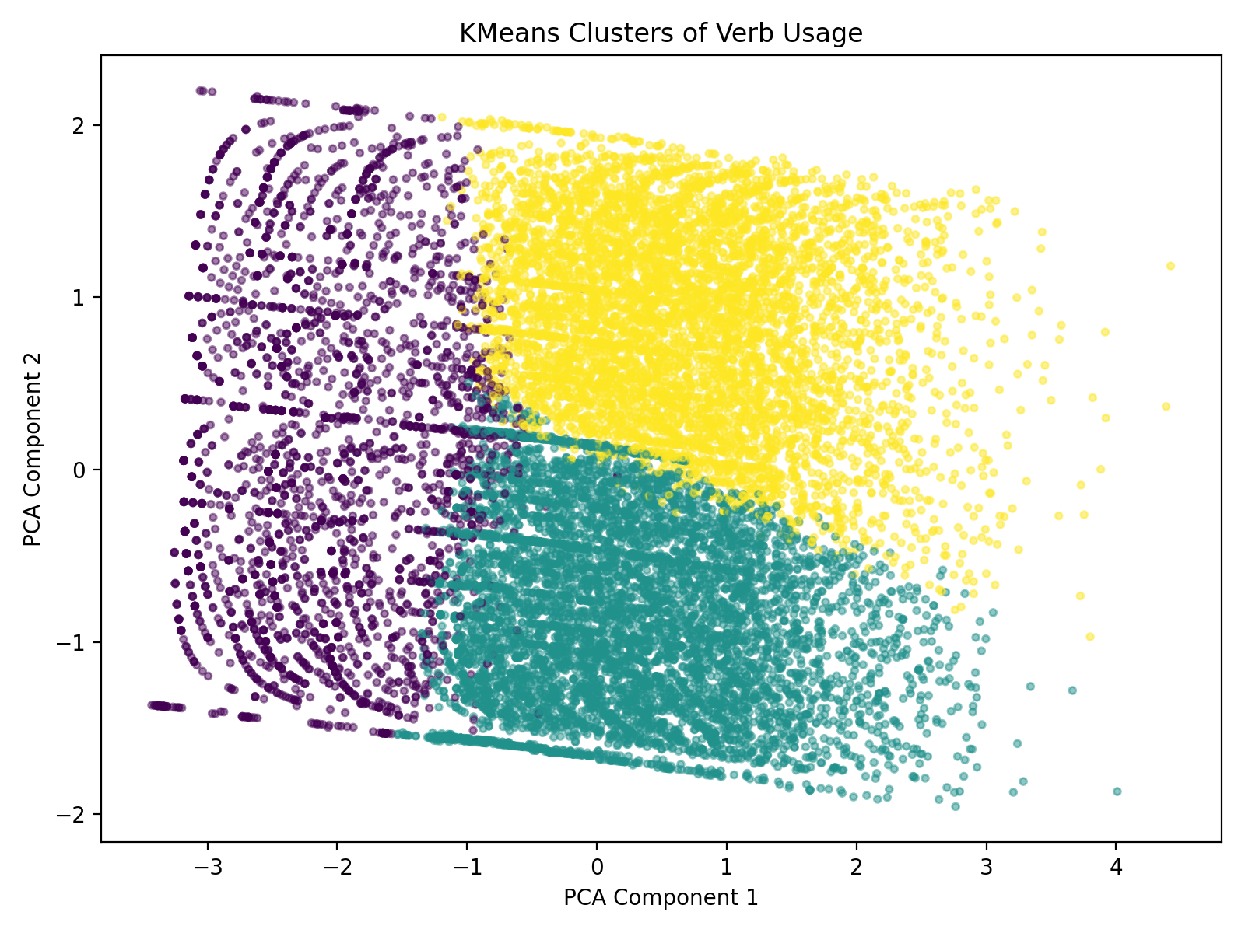
Figure 4. KMeans clusters visualized in two dimensions using PCA.
4. Train/Test Split
I used a stratified 80/20 split: 12,412 examples for training and 3,104 for testing. Both sets preserve the original class distribution of 72.1% literal and 27.9% metaphorical. The test set was kept separate from feature-frequency calculations and model training to avoid data leakage.

5. Classification Algorithm
Because the target is binary (literal vs. metaphorical), I selected Logistic Regression as an interpretable classification baseline. The model uses the four numerical features plus one-hot encoded verb categories. Class weights were balanced to reduce the effect of the 72.1/27.9 class imbalance.
6. Train | Fit the preprocessing pipeline and Logistic Regression model on the 12,412 training examples only.
7. Test | Generate predictions for the 3,104 held-out test examples.
8. Measure | Evaluate accuracy, precision, recall, F1 score, and the confusion matrix.
Test-set results
Accuracy | Precision | Recall | F1 Score
57.6% | 37.2% | 75.2% | 49.8%
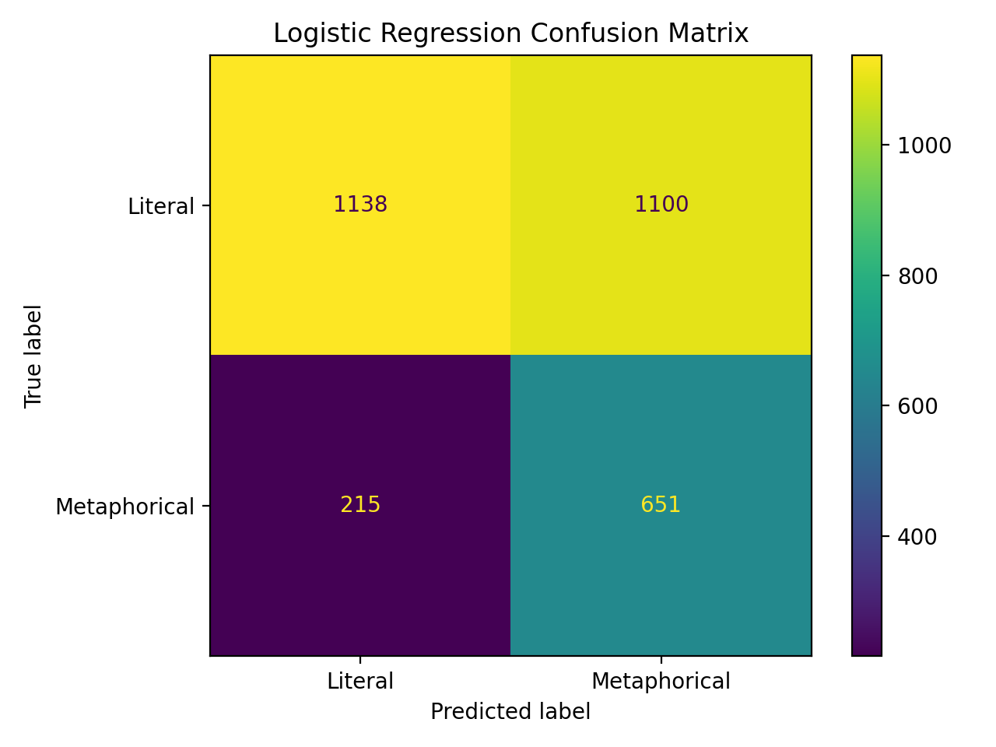
Figure 5. Logistic Regression confusion matrix on the test set.
The classifier correctly identified 651 of 866 metaphorical examples, giving a recall of 75.2%. However, it also labeled 1,100 literal examples as metaphorical, which reduced precision to 37.2%. The model therefore favors finding more metaphors at the cost of more false positives.
9. Summary
This project showed that simple structural and lexical features contain useful information about metaphor usage, but they are not sufficient for highly accurate detection. The clustering analysis revealed meaningful differences in metaphor rate across naturally formed usage patterns, and the classifier captured many metaphorical examples despite a substantial false-positive rate.
The main lesson is that model quality cannot be judged from accuracy alone when classes are imbalanced. Recall, precision, F1, and the confusion matrix reveal the trade-off much more clearly. A future version could add richer sentence-context features while preserving the same careful train/test and evaluation workflow.

