James Gallmeister

Queries and Answer Sets for HW3:

1. select firstname, lastname from employees where not (country='USA') and date_part('year', current_date) - date_part('year', hiredate) >= 5 order by firstname asc;

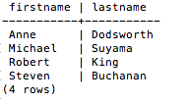

1. select productid, productname, unitsinstock, unitprice from products where unitsinstock > 1 and unitsinstock <= reorderlevel;

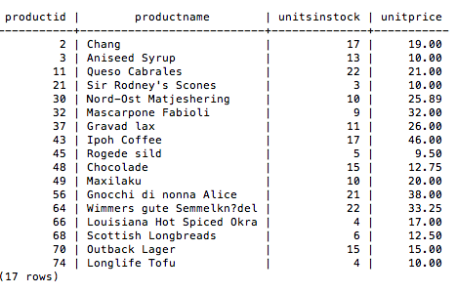

1. select productname, unitprice from products where unitprice = ( select min(unitprice) from products) or unitprice = ( select max(unitprice) from products);

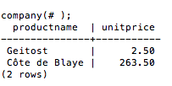

1. select productid, productname, unitprice*unitsinstock as Total_Inventory_Value from products where unitprice*unitsinstock > 1000 order by unitprice*unitsinstock desc;

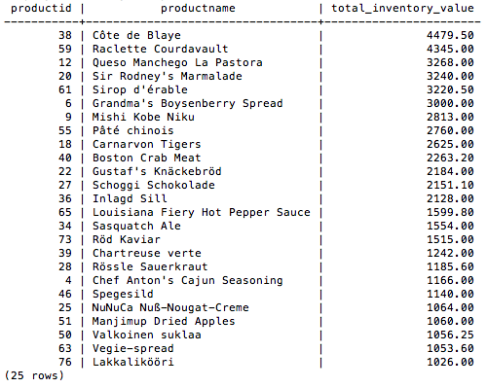

1. select shipcountry, count(distinct orderid) from orders where (date_part('month', shippeddate) = 10 and date_part('year', shippeddate) = 2013) and not shipcountry = 'Germany' group by shipcountry;

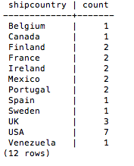

1. select customerid, shipname from orders group by customerid, shipname having count(distinct orderid) >= 10;

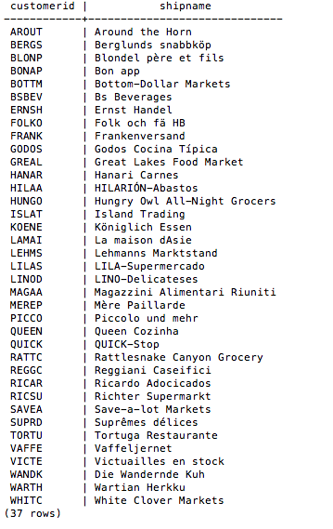

1. select supplierid, sum(unitsinstock*unitprice) from products group by supplierid having count(distinct productid) >= 5;

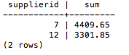

1. select companyname, productname, unitprice from suppliers left join products on suppliers.supplierid = products.supplierid where country = 'USA' or country = 'Germany' order by companyname;

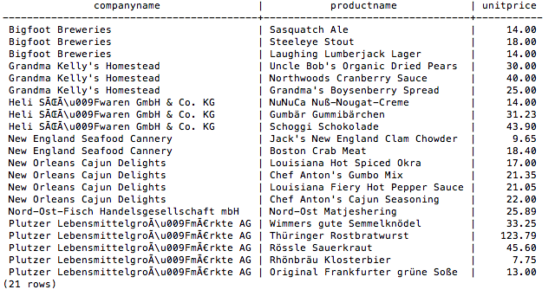

1. select lastname, firstname, title, extension, count(distinct orderid) from employees e, orders o where e.employeeid = o.employeeid group by e.employeeid having count(distinct orderid) > 50 order by lastname, firstname desc;

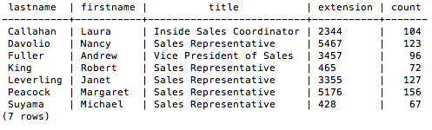

1. select c.customerid, companyname from customers c left join orders o on c.customerid = o.customerid where o.customerid is NULL;

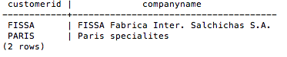

1. select s.companyname, s.contactname, c.categoryname, c.description, p.productname, p.unitsonorder from suppliers s, products p, categories c where s.supplierid = p.supplierid and p.categoryid = c.categoryid and p.unitsinstock = 0;



1. select productname, s.companyname, s.country from products p, suppliers s where s.supplierid = p.supplierid and (quantityperunit like '%bags%' or quantityperunit like '%bottles%') group by productname, s.companyname, s.country;

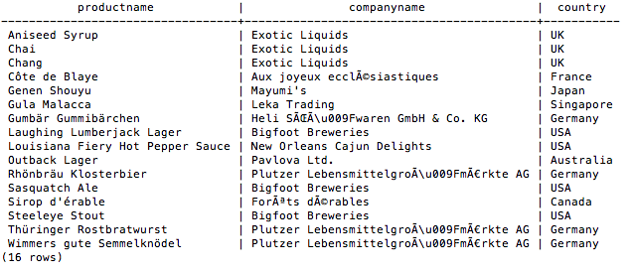

1. create table if not exists Top_items (itemID int not null, itemCode int not null, itemName varchar(40) not null, inventoryDate timestamp not null, supplierID int not null, itemQuantity int not null, itemPrice int not null, primary key (itemID));
2. insert into Top_items (itemID, itemCode, itemName, inventoryDate, supplierID, itemQuantity, itemprice) select productid, categoryid, productname, current_timestamp, supplierid, unitsinstock, unitprice from products where products.unitsinstock*products.unitprice > 1500;
3. delete from top_items ti using suppliers s where s.supplierid = ti.supplierid and (s.country = 'USA' or s.country = 'Canada');
4. alter table top_items add column inventoryvalue decimal(9,2);
5. update top_items set inventoryvalue = itemprice * itemquantity;
6. drop table top_items;