Project Report

Introduction

Shop web application is a site designed to manage the items in any shop, whether big or small in size. It helps shop attendants to keep a record of the items they have in stock. The database consists of one table “shop_items” which stores the items sold in the shop. Each item has a unique id, an item name, and a short description of the item.

The main aim of developing the application is to keep track of all the items sold in the shop. This helps any new attendant to check from the database of items in case they are not sure whether the shop sells the items. The web application was developed using Angular.js for the front-end and node.js for the back-end. To manage the communication between the back-end and front-end, Express.js is used.

The records of the application are stored in the MySQL database. For versioning and backup storage, the application is pushed to give GitHub. To make sure the pages are attractive to the eye CSS styles were applied. Form validations are also present to achieve better interactions with the user of the application.

Illustrations of work done

To help in the implementation of the software, the initial idea was first designed on paper. The sketch helped determine how the system would look like as well as knowing what is necessary. The first step in achieving the success of the project was to gather all the requirements needed for the project. An editor was first installed on the personal laptop which would help in writing the codes. It was then necessary to familiarize myself with javascript programming languages and the frameworks involved in the project; which are node.js and angular.js as well as have sufficient knowledge of MySQL database. Time scheduling was then necessary to ensure the project is completed as per the time given.

I started by creating the forms. These forms are for adding and updating records of items in the shops. The forms consist of two fields, one being the item name and the other being the item description field. Validations are done on submission of the form and in case of any errors, error messages were displayed to the user in red color for easy identification of the incorrectly filled input fields. An illustration of the add and update record form is as below

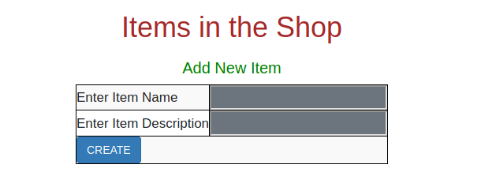

Fig 1 Add Item Form

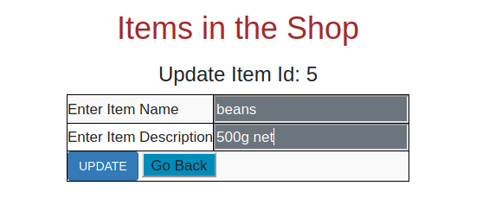

Fig. 2 Update Item Form

After designing the add and update forms and ensuring they are working properly, the main page was designed. This is where all the records existing from the database are fetched and displayed to the user. The page consists of a table with the items in the shop. The table has an action column on the right which has the edit and delete buttons. When the edit button is clicked, the edit form is pre-filled with the record to be edited which the user can update, and click the update button which saves the records. When the delete button is clicked, the record in the clicked row is deleted. The table with records is as shown below.

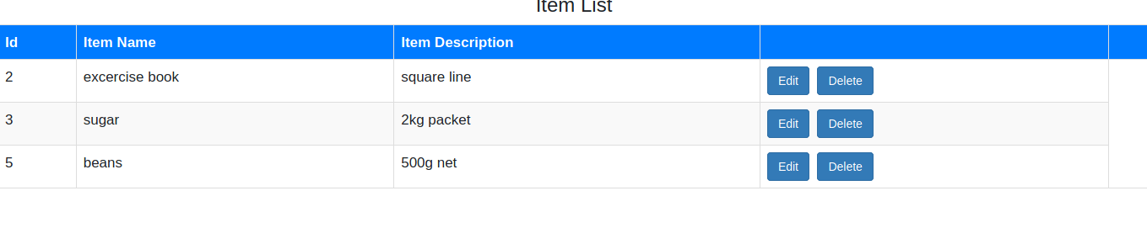

User Manual

The whole project is in one zip file. To access and run the application, follow the steps below.

1. Download the zip file from GitHub.
2. Extract/ Unzip the compressed file.
3. A folder will be generated on the personal machine.
4. Inside the folder are server and client folders. For each of the folders “npm install”
5. Change the database configurations of the server to suit your machine
6. After running the install command, run “npm start”.
7. The server runs on localhost://3000 while the client runs on localhost://4200

Team working concepts

To achieve the success of any project, team working is very important. What can be achieved by a team in many cases could be better than what is achieved by an individual. It is believed so because many ideas are brought together and having discussions is likely to speed up the project delivery as well as give have a perfect output.

The success of this project if it was to be done by a team would be determined by the concepts below;

Good communication among the team members – Communication is vital for the success of a project. When members communicate well among themselves and have regular discussions about the project, good work is likely to be done.

Clarity of strengths of each individual – In a team, it's important to note down the strengths that everyone brings to the team. This helps in the division of tasks. In this project, if we had a front-end team very good at Angular.js and a back-end team good at Node.js, every team concentrating on their part would likely yield good results.

Common goals- For a team to achieve its goal, members need to have a common goal. Developing a shop web application is the goal of this project. When team members share similar goals achieving better results is very easy.

Clarity of tasks and roles of each individual in the group – Division of tasks is the importance of teamwork. Achieving goals when tasks are divided is easier than working together since other team members may be lazy around. When every member is clear about what they should contribute to the project and doing it to perfection, the project would achieve great success. The division of tasks should be according to the strengths of each individual.

Collaboration- A team that works together achieves great goals together. Collaboration is a very important team working concept. When each team member has the mentality that the role they play helps other team members to grow, each team member brings their strengths and knowledge collectively to the table thus coming to a great solution to the problems.

**REFERENCES**

Green, B., & Seshadri,S. (2016).AngularJS

Hootegem, G., Benders, J., & Delarue, A. (2018). Teamworking: looking back and looking forward

Iglesias ,E., & Meesangnil,W. (2017). Mobile website development: From site to app - Wiley Online Library

Kang, H., & Yang, H. Factors in team effectiveness: Cognitive and demographic similarities of software development team members

Lu, J., &Zhang, C. (2019). Website development and evaluation

Mardan, A., & Corrigan,M. (2018). Practical Node. Js

Teixeira, P. (2018). Professional Node. js: Building Javascript based scalable software

Williamson,K. (2015). Learning AngularJS: a guide to AngularJS development