ENHANCED PROFESSIONAL STUDENT LOGBOOK
Student Name: ___Justine kimai
Admission Number: ___BIT/2024/49628__
School/Faculty: _______computing and informatics
Program: _______information Techgnology__
Academic Year: _____25/26
Semester: ________may_________
Lecturer: _Michael Nyoro_____
Phone Number: _____0102113721____

Week1 introduction to mobile computing
I decided to use android studio to develop my app, below are the provided screenshots of the android studio setup
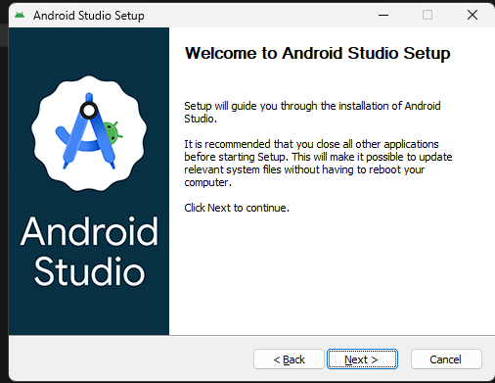

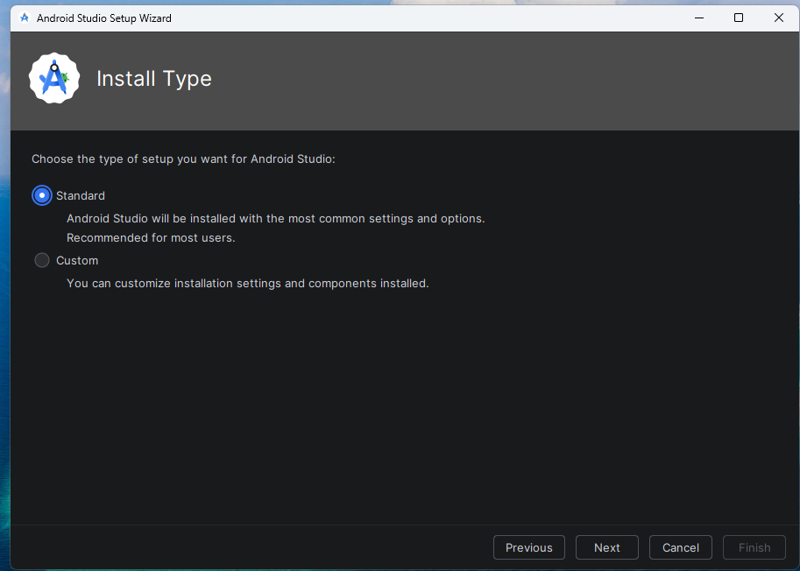
I chose to set up the standard version of android studio, because of its common settings that are mostly recommended to users.
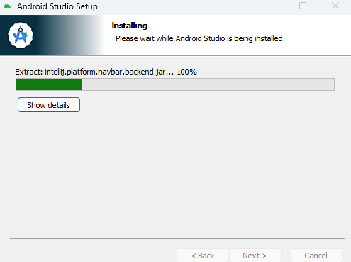
The above screenshots is a prove of the download process of android studio.
Personal reflection
I had a good experience downloading and setting up android studio, due to the wizard that provided seamless and smooth steps that I followed to setting it up correctly.

Week 2: mobile development environment
I chose to use the empty set activity template to write my project as shown below:

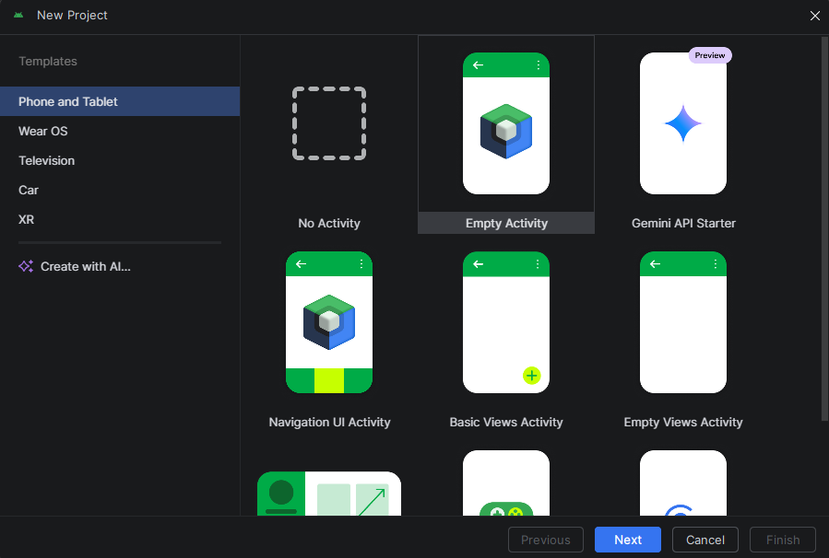

I then named my project “jango” saved it and chose kotlin as the language I would use in my project as shown below:

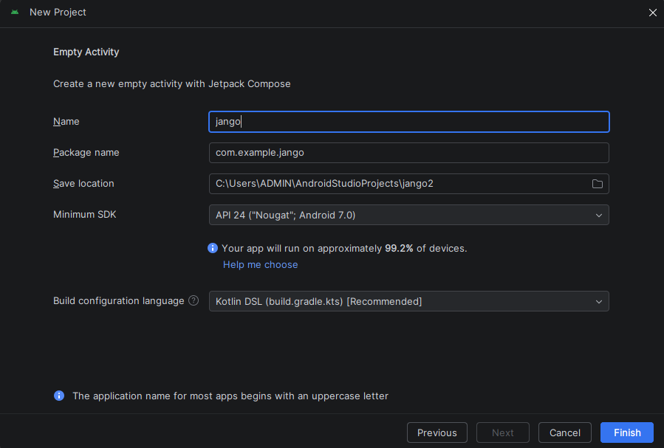

Tools used: android studio
Personal reflection
I had a great experience interacting with android studio for the first time it was easy to create the project since it has clear steps outlined.

Week 3:user interface design (using figma)

The photo below shows the design of my hotel mobile app indicating three fields that will be used to key in user data in order to be allowed access to login into the app.

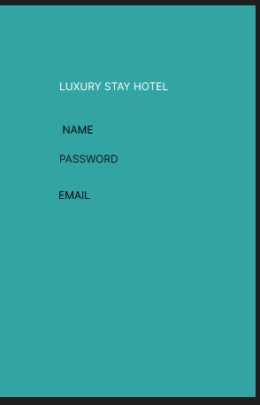
This is the name section
This is the password section
This is the email section
Were the user can be contacted on to verify their email address

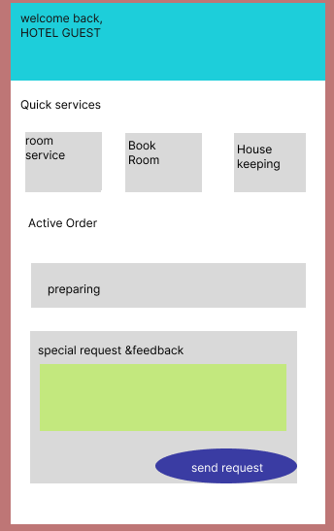
This is the button that sends the request
This is the field where the user gives their feedback
This section shows the state of the request initiated by the user.
The above figure is the second page of the app where the user is directed after logging in and its used to: book a room, request for room service, housekeeping, showing the state of the requests and it allows the user to give feedback of the experience they have had with the app.

Tools/software used
I used figma to design the pages of my app
Personal reflection:
I really had fan learning how to use figma to design my pages, at first I really had a hard time treversing the different properties but eventually I did it.

Week 4:Event handling and user interaction
The Luxury hotel app has a user interaction field that allows the users to send special requests and give feedback to the hotel management.

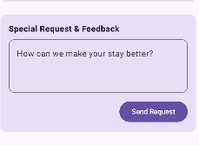
The app also incorporates event handling in the save changes button in the my profile page as shown below:
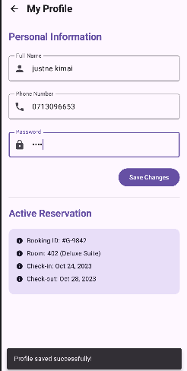
My app is able to detect the systems action in this case it detects when the users change there details and gives the message” profile saved successful” and it updates the data on my database

I used android studio to incooporate the features
Personal reflection:
I really didn’t know about the event handling feature but came to know it thru this project
It was exciting learning about it.
Week 5&7 Data management
I have proof of the series of steps I used to link my app to the firebase real time database as follows:

I first connected my android studio project with the firebase real time data base as shown below as the first step as shown belo and added the real time database to my firebase as shown in the first 2 screenshots:

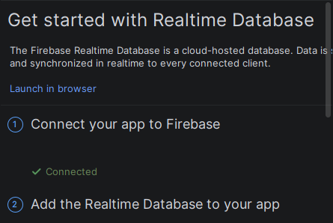
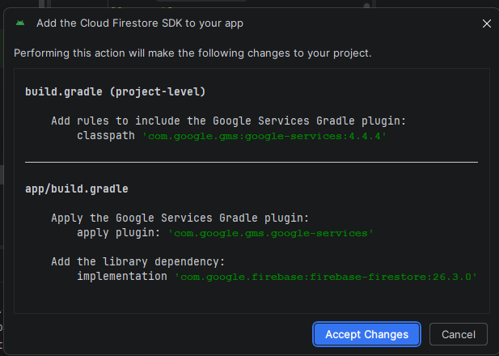

I the set up the rules as true to allow realtime updating of user data as shown below:
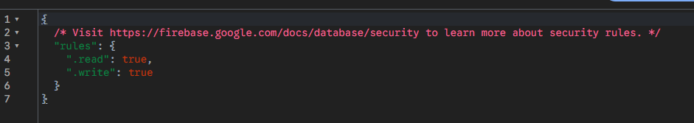

I then followed the rest of the rules and final my app is able to store the data of the users login credentials and there profiles as shown below:

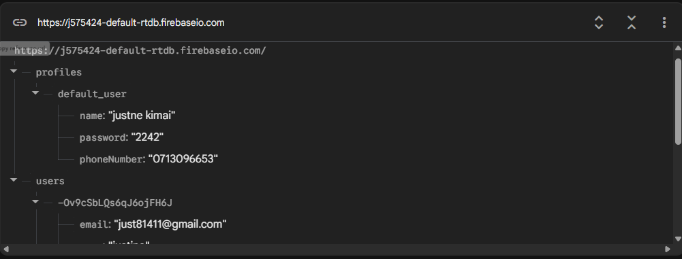

I used the real time firebase and android studio.
I found the linking part pretty hard after a long time it final accepted now the app is functioning well and is able to store users data very well.
Week 6: Networking and API’s
I configured my app with a communication API that sends data to the users emails showing there room details that they booked.

Week 5&7 Data management
I have proof of the series of steps I used to link my app to the firebase real time database as follows:

I first connected my android studio project with the firebase real time data base as shown below as the first step as shown belo and added the real time database to my firebase as shown in the first 2 screenshots:




I the set up the rules as true to allow realtime updating of user data as shown below:


I then followed the rest of the rules and final my app is able to store the data of the users login credentials and there profiles as shown below:



I used the real time firebase and android studio.
I found the linking part pretty hard after a long time it final accepted now the app is functioning well and is able to store users data very well.

