**Bestlink College of the Philippines**

**“INTEGRATION OF DISBURSEMENT AND ACCOUNTS PAYABLE MANAGEMENT WITH INTELLIGENCE BUDGET ESTIMATION FOR THE CAPSTONE TRANSPORTATION NETWORK VEHICLE SERVICE: FINANCE WITH INTELLIGENT BUDGET ESTIMATION SYSTEM”**

**In Partial Fulfilment**

**Of the Requirements for the ITE4**

**MEMBERS:**

**BACAN, TIFFANY JOY**

**BUEN, SHINE CHRISTINE JOY A.**

**MALTO, MARIA BIANCA J.**

**REYES, JUSTINE FRANCIS T.**

**CHAPTER 1**

**1.1 INTRODUCTION**

**BACKGROUND OF THE PS**

The traditional taxi business like ABC Taxi Company has long been a pillar of urban transportation, providing essential services to communities and facilitating the movement of people and goods. However, this system introduces an advanced approach to budgeting and expense tracking by leveraging intelligent estimation techniques. The project is specifically focused on the Disbursement and Accounts Payable Management submodule, which plays a crucial role in streamlining financial processes related to outgoing payments, tracking expenditures, and managing financial obligations.

The system combines automated budgeting with real-time expense tracking, allowing for more accurate budget forecasts and efficient resource allocation. By integrating the Disbursement and Accounts Payable module, this solution aims to reduce manual errors, save time, and enhance decision-making for financial teams. The intelligent budget estimation system helps finance departments plan proactively, maintain cash flow stability, and respond more effectively to financial demands. Ultimately, this project seeks to create a comprehensive, user-friendly solution that supports the operational and financial needs of TNVS companies.

**PURPOSE OF INTEGRATION**

This integration allows for better data accuracy, as information entered in one part of the system is accessible across other modules, reducing errors and ensuring consistency. Integration also improves decision-making by giving finance teams a comprehensive view of real-time financial data, which aids in budgeting, tracking payments, managing cash flow, and forecasting expenses. Overall, integration streamlines processes, saves time, enhances resource allocation, and supports proactive financial management. Our aim is to create a seamless connection between various financial processes, enabling them to work together efficiently and effectively. By integrating submodules, such as Disbursement and Accounts Payable Management with the Intelligent Budget Estimation System, the goal is to automate data flow and reduce the need for repetitive manual input across different parts of the financial operation.

**WHO WILL BENEFIT FROM IT**

The integration of disbursement and accounts payable with an intelligent budget estimation system will benefit several groups:

**Finance Teams:** Integration simplifies and automates financial tasks, reducing time spent on manual entries, ensuring data accuracy, and providing real-time insights for more strategic financial planning and budgeting.

**Management and Decision-Makers:** They gain a clearer, consolidated view of financial data, which supports better forecasting, cash flow management, and budget allocations. This helps them make well-informed decisions quickly and effectively.

**Human Resources (HR) Department:** The automated system helps HR by facilitating timely payments for employee expenses and ensuring compliance with payment policies, streamlining payroll, reimbursements, and other financial HR-related tasks.

**Logistics Teams:** For departments involved in operations like dispatching and vehicle management, the system aids in budget allocation, providing clarity on available funds, and helping manage operating costs for things like fuel, maintenance, and repairs.

**Stakeholders and Investors:** With a reliable financial system in place, stakeholders and investors gain confidence in the organization’s financial stability, transparency, and long-term planning.

**1.2 CONCEPTUAL FRAMEWORK**

**SUBSYSTEM**

This illustrates the integration of the Disbursement Management System and Accounts Payable Management System for streamlined financial operations. It shows key processes, from request initiation, automated approvals, and payment processing to vendor management, invoice matching, and payment scheduling. The systems work together to provide accurate financial tracking, reconciliation, and reporting, enhancing transparency and efficiency in managing payments and expenses.

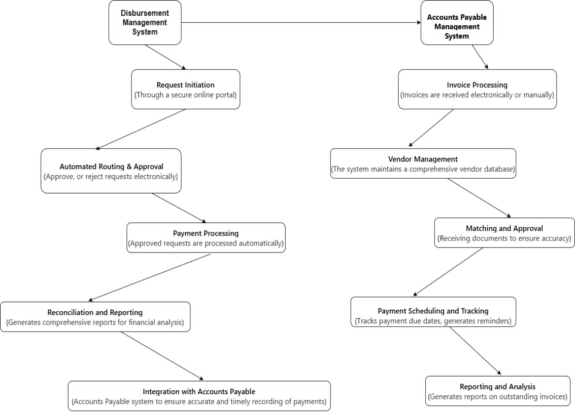

**WHOLE SYSTEM**

This flowchart demonstrates the integration between the Disbursement Management System and Accounts Payable Management System within the TNVS: Finance with Intelligent Budget Estimation System. It outlines key processes such as initiating payment requests, automated approvals, and vendor management, all leading to accurate payment scheduling, reconciliation, and reporting. This integrated approach ensures efficient tracking of financial transactions, improves data accuracy, and supports streamlined payment processing for enhanced financial control.

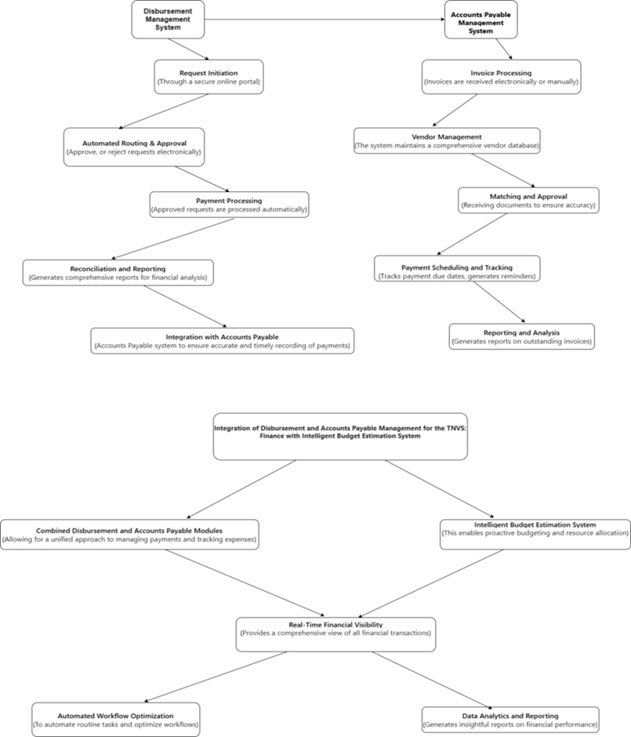

**1.3 SCOPE AND LIMITATION**

**FOR THE INTEGRATED SYSTEM**

This study explains the Accounts Payable and Disbursement Management System for Transportation Network Vehicle Services (TNVS) is a tool designed to make managing payments to drivers and vendors easier, faster, and more accurate. It automates important tasks like processing invoices, scheduling payments, and tracking expenses. By automating these processes, the system helps TNVS companies ensure that payments are on time, match agreed rates, and stay compliant with tax and regulatory requirements. It also connects with other financial software, so information stays consistent across systems.

However, there are some limitations. The system relies on accurate data from other sources, so any data errors can lead to payment mistakes. Some companies may also need costly customizations for unique needs. Integrating with external platforms, like banks, can sometimes be tricky, especially for real-time updates. The system might struggle to keep up with very high transaction volumes during busy times, and regular maintenance is needed to keep it secure and working smoothly. Plus, employees need proper training to use it effectively. These limitations mean that companies should plan carefully, provide training, and have ongoing support to get the most out of the system.

**CHAPTER 2**

**2.1 SYSTEM OVERVIEW**

**DESCRIPTION OF SYSTEMS MODULE**

The Disbursement and Accounts Payable Management Module in the TNVS: Finance with Intelligent Budget Estimation System is built to make managing payments and expenses easier and more accurate. This module automates tasks related to paying suppliers, employees, and other partners, helping ensure payments are made on time while minimizing errors.

With features for real-time tracking, this module allows finance teams to see all outstanding payments, manage cash flow, and prioritize expenses based on the company's budget and goals. It also uses data from past payments to estimate future expenses, helping teams plan budgets more accurately. The module is designed to be user-friendly, enabling quick access to review, approve, and record payments securely.

By connecting with the budget estimation system, this module gives the organization a complete view of finances, improving decision-making, efficiency, and transparency.

**RELATED LITERATURE**

McKinsey & Company (2020) emphasized the importance of automated disbursement systems in the Transportation Network Vehicle Services (TNVS) sector has been widely documented in the literature, which underscores their role as essential tools for managing the vast volume of financial transactions inherent to this industry (McKinsey & Company, 2020). As TNVS companies often handle thousands of payments daily, ranging from driver compensations to reimbursements for fuel and maintenance expenses, the sheer frequency and complexity of these transactions demand a streamlined approach. Automated accounts payable and disbursement systems address this need by significantly reducing the time required to process each transaction, allowing TNVS providers to ensure timely payments and avoid bottlenecks that can disrupt operational flow. Moreover, automated systems minimize human error—an especially valuable benefit in environments where even minor errors can lead to payment delays, inaccurate amounts, or issues in vendor and driver satisfaction. Automated processes bring consistency and reliability to payment operations, fostering trust and transparency with drivers and service partners. This improved accuracy also has downstream benefits for financial reporting, as centralized and automated records make it easier for TNVS companies to monitor expenses, ensure compliance, and respond quickly to audits. Ultimately, these automated disbursement systems not only enhance operational efficiency but also contribute to a scalable financial infrastructure capable of supporting the rapid growth and dynamic demands of the TNVS industry.

Accenture (2021) Optimized payment scheduling within accounts payable (AP) systems is a crucial capability that enables Transportation Network Vehicle Services (TNVS) companies to manage their financial commitments more strategically, based on available cash flow and contractual obligations. Effective AP systems are designed to support a structured and flexible approach to payment scheduling, allowing TNVS companies to coordinate payments in a way that aligns with cash inflows, which is essential to maintaining financial stability, particularly in high-volume and fast-paced operational environments (Accenture, 2021). Studies have highlighted that advanced scheduling features within AP systems help TNVS providers improve their working capital management, as they can time payments to maximize available resources without jeopardizing vendor or driver relationships. For example, with optimized scheduling, TNVS companies can prioritize critical payments, defer less urgent ones, and balance cash flow to avoid shortfalls, thus enhancing liquidity.

Furthermore, payment scheduling capabilities also allow TNVS companies to manage and forecast cash flow needs more effectively, offering visibility into upcoming liabilities and empowering financial teams to plan accordingly. By providing a structured approach to timing payments, AP systems not only prevent cash flow issues but also contribute to better financial planning and forecasting accuracy, which is critical as TNVS companies often work with multiple drivers, fuel vendors, and maintenance providers, each with their own payment terms and schedules. The flexibility to adjust payment timing according to the company’s financial position and inflows also means that TNVS providers can negotiate better terms with vendors, optimize interest or fee costs, and make data-informed decisions to enhance overall financial efficiency. In this way, payment scheduling functions within AP systems are not merely operational tools but also serve as strategic assets that support both short-term liquidity and long-term financial health in the TNVS sector.

**2.2 SYSTEM DIAGRAM**

This system diagram outlines the workflow for managing accounts payable, starting from purchase requisition to vendor interactions and payment processing. Key steps include selecting vendors, creating purchase orders, maintaining vendor contracts, and verifying invoices. Once invoices are received, the system processes payments, communicates with vendors, and handles vendor reconciliations. The diagram also shows steps for reporting and analyzing data, storing documents, and conducting audits, which contribute to effective financial control and compliance within the accounts payable process.

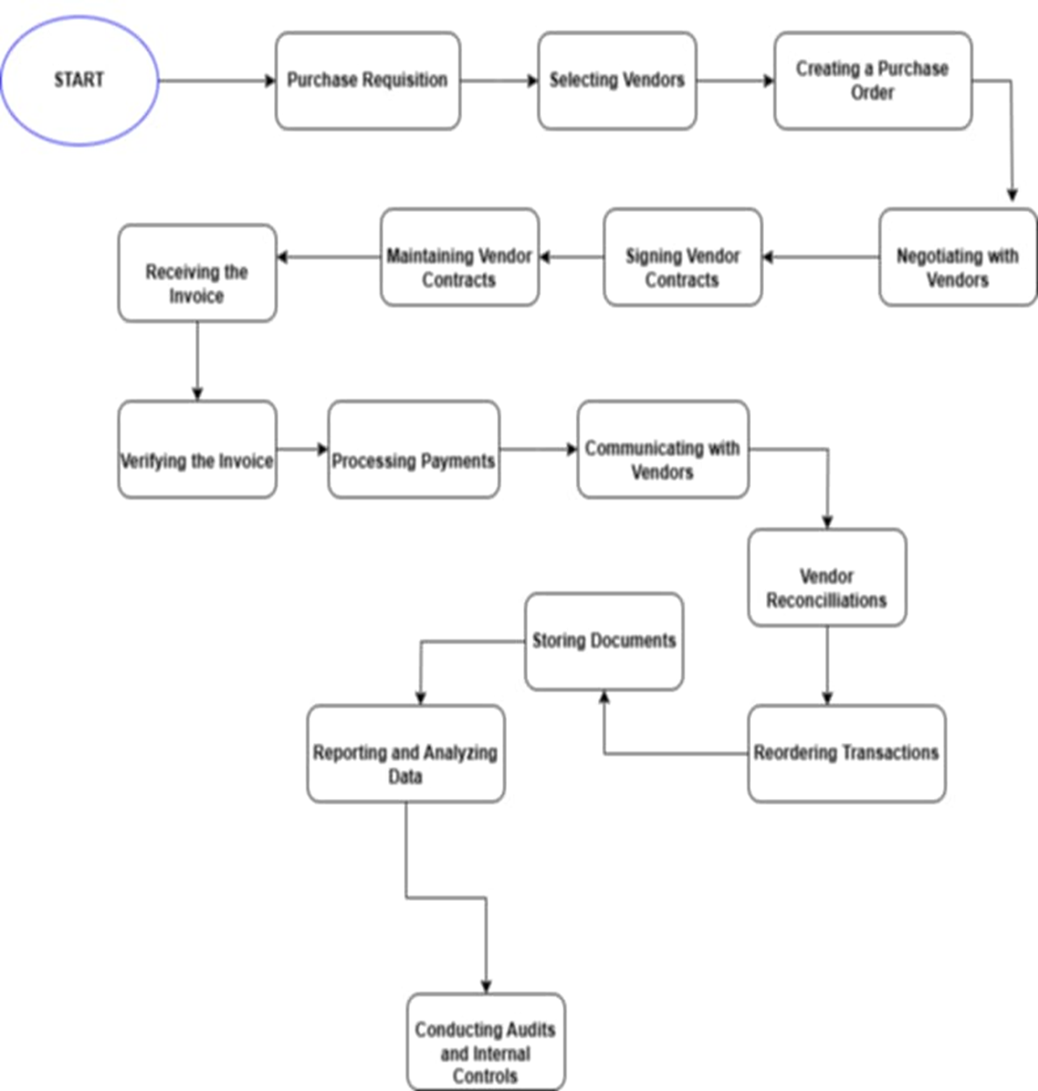

This diagram focuses on the disbursement request process integrated with an intelligent budget estimation system. It begins with receiving a disbursement request, validating invoices, and checking budget availability. If a request exceeds the budget, it’s flagged for manual approval. Approved requests proceed to disbursement, where payments are recorded and issued. The system then updates the intelligent budget estimation to reflect the new disbursement, helping to maintain an accurate, real-time view of financial allocations for future planning.

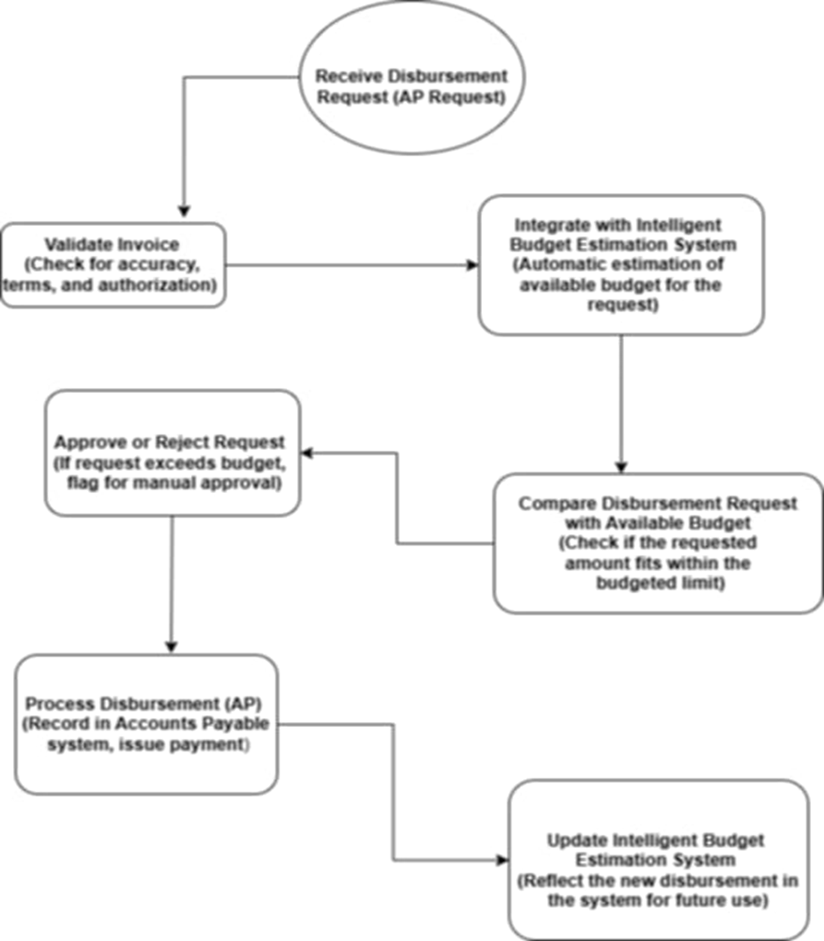

**2.3 DEFINITION OF TERMS (20 ITEMS)**

**Disbursement-** a payment made in the course of achieving a result substantial disbursement for research and development, expense, cost, expenditure and outlay.

**Reimbursement-** the act of paying back money to someone who has spent it for you or lost it because of you, or the amount that is paid back.

**Bottleneck-**is a situation that stops a process or activity from progressing.

**Expenditure-**is money spent on something. Expenditure is often used when people are talking about budgets

**Accounts Payable-**is the money a company owes its vendors, while accounts receivable is the money that is owed to the company, typically by customers.

**TNVS-** Transportation Network Vehicle Services refers to a TNC-accredited private vehicle owner, which is a common carrier, using the internet-based technology application or digital platform technology transporting passengers from one point to another, for compensation.