“Parol”

The Philippines symbol of Christmas season. Commonly made using paper, capiz shells, bamboo sticks and plastics. It is said that it represents the “northern star” that the three wise men followed leading them to the birth of Christ.

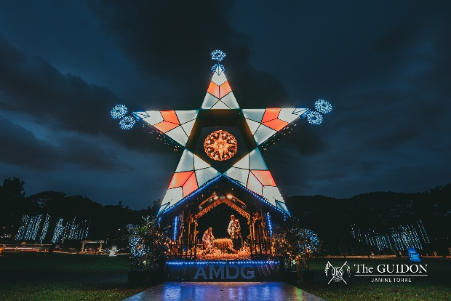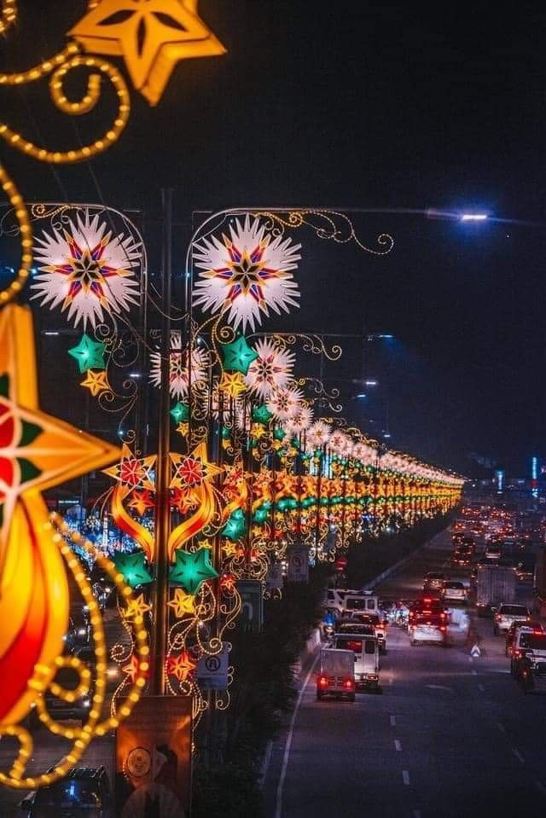Filipino Christmas is characterized by enormous decorations specially on public such as highways, malls, parks, etc.

Traditionally, parol is a star shaped Christmas ornament with 5-6 pointed sides. However, as the time past by, various designs has been emerged such as circular, sphere.

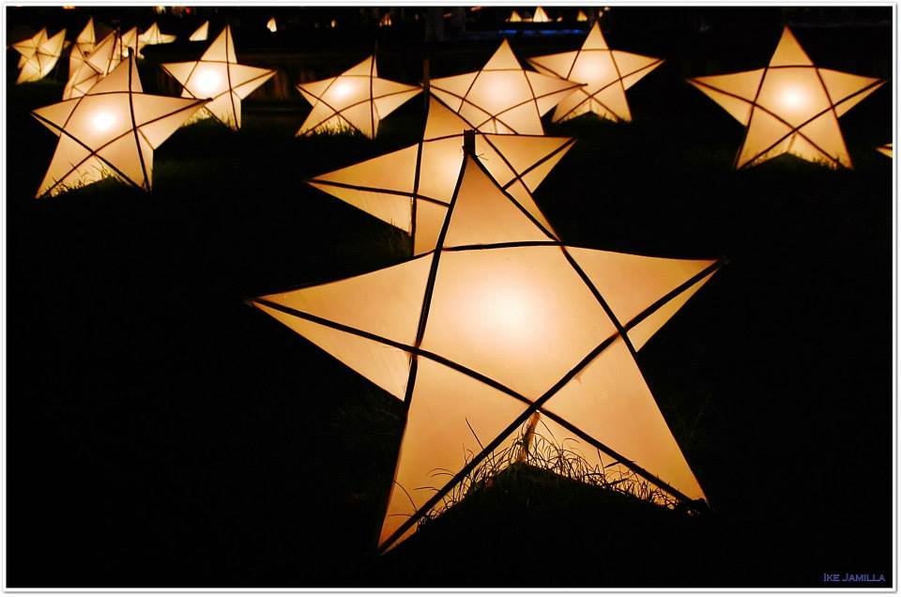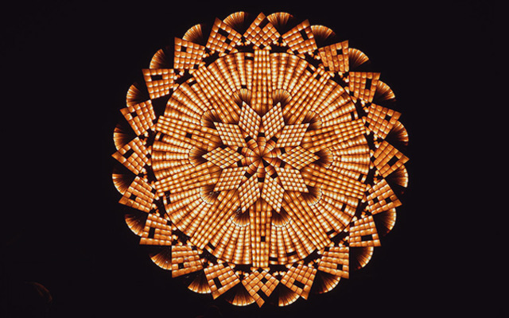

San Fernando, Pamapanga celebrates Parol Festival annually every mid-December. It displays illuminating giant lanterns up to 20feet.

