INITIAL CAPSTONE UX AUDIT
Week 1 testing workbook | ITE 4 – Web Systems and Technologies 2
Project details | Complete before testing
Capstone title | AidLink: A Centralized Digital Assistance Management System for Davao City
Name / Group; Section / Block | Justine M. Pleños, Allyson M. Manulat, Micko Jay Niño P. Llanos, and Jennilyn M. Parason
Instructor; Date submitted | Ms. Christine Marie D. Ordaneza, LPT - September 10, 2026
Testing date(s); Facilitator / Observer | September 9, 2026
App build; Website version / commit | App: 1.0.5 (build 6); Website: 0.0.1 — development version
Test server address; Network used | http://10.182.85.58:5000

Purpose and use
Audit both the applicant mobile app and the LINGAP web administration system before observing users. This workbook adapts the teacher’s three-part template and its proof-of-audit appendix. It contains planned checks, not completed testing results.
Complete Part 1 while using the running system. Log confirmed issues in Part 2, plan user sessions in Part 3, and attach actual evidence in Appendix A. Leave signatures and results blank until the activity is completed.

Prepare a repeatable test session
Use a test server, fictional applicant/patient profiles, and clearly marked sample documents. Prepare staff accounts, an active training facility, and separate requests for approval and denial. Keep the phone and website connected to the same test backend.
Have a valid document set, a sample guarantee letter, an unsupported file, and an oversized file ready. Do not use real IDs, medical records, passwords, or live applicant decisions in screenshots.
Scope: Home, Requests, Facilities, Alerts and Account in the app; Overview, Assistance requests, Requestors, Facilities and Administrator Account screens on the web. Test setup and recovery checks are facilitator activities.

PART 1: AUDIT CHECKLIST
Usability and core functionality.
Dimension | AidLink / LINGAP checklist item | Check | Notes / evidence ID
Usability | U1 • App: A first-time applicant can find the new-request flow from Home. | ✓
Usability | U2 • App: Patient identity and relationship fields can be completed without confusing the patient with the account holder. | ✓
Usability | U3 • App: The applicant can choose the appropriate assistance type and understand which documents to attach. | ✓
Usability | U4 • App: The review screen lets the applicant check information and understand consent before submission. | ✓
Usability | U5 • Web: Staff can locate the intended application and distinguish review, approval and denial actions. | ✓
Functionality | F1 • Both: Valid sign-in works; incorrect credentials give useful feedback; sign-out ends access to the session. | ✓
Functionality | F2 • App: Required fields and invalid dates are identified; correcting an error allows progress. | Partial | Required fields are checked, but the request form allows an invalid date to pass validation. This may result in incorrect patient information. See I01, Appendix A1.
Functionality | F3 • App: Documents can be selected/replaced; unsupported or oversized files get understandable feedback. | ✓
Functionality | F4 • App → web: Submission creates one matching request with a reference, assistance type and document links. | ✓
Functionality | F5 • Web: Review/denial requires remarks; approval requires remarks and a valid guarantee-letter file. | ✓
Accessibility | A1 • Both: Labels, instructions and status text remain readable against their backgrounds. | ✓
Accessibility | A2 • Both: Pending, Under Review, Approved and Denied can be understood without relying only on color. | ✓
Accessibility | A3 • Web: Keyboard users can reach controls in logical order and identify the focused item. | ✓
Accessibility | A4 • Web: Request dialogs can be used and closed with the keyboard, with focus returned sensibly. | ✓
Accessibility | A5 • App: A screen reader announces navigation, form labels, important icons and validation feedback. | ✓
Accessibility | A6 • Both: Buttons and links can be selected accurately; document/QR alternatives have meaningful labels. | ✓
Responsiveness | R1 • App: Larger system text leaves request forms, review dialogs and navigation readable and usable. | ✓
Responsiveness | R2 • Web: At phone, tablet and laptop widths, navigation and request actions remain reachable. | ✓
Responsiveness | R3 • Web: At 200% browser zoom, dialogs, tables and file controls remain usable without clipped actions. | ✓
Content Quality | C1 • Both: Assistance descriptions, field labels and required-document names use clear, consistent language. | ✓
Content Quality | C2 • Both: Status messages distinguish submission, review and approval; instructions do not promise cash release. | ✓
Content Quality | C3 • Both: Errors explain what happened and a useful next action, without unexplained technical terms. | ✓
Functionality | F6 • Web → app: Review, approval and denial changes appear on the matching applicant request after refresh. | ✓
Functionality | F7 • App: Approved requests show the correct guarantee letter and QR/verification ID; document links open. | ✓
Functionality | F8 • App: Opening an alert shows the correct request and updates its read state; another account’s alerts are not shown. | ✗ | The notification feature is not yet available in the app, so opening alerts, checking read status, and verifying account-specific notifications could not be tested. See I02, Appendix A1.
Functionality | F9 • Both: Searches and filters return the expected request; no-match and empty states are understandable. | ✓
Functionality | F10 • App: Losing connection shows useful feedback; reconnecting/refreshing recovers without a misleading success message. | ✓
Functionality | F11 • Web → app: After a test requirement change, a fresh app request shows the configured requirements or a mismatch is logged. |  | Not Tested

PART 2: LIST OF AT LEAST 5 ISSUES
# | Issue description / steps | Dimension | Likely impact on real user |  | Suggested fix (optional)
I01 | Screen / check ID: App request form / F2.  Steps: Enter an10/01/0001 in the birthdate field and try to continue.  Actual: The form allows the applicant to proceed.  Expected: The form should reject the invalid date and explain how to correct it. | Functionality |  | Incorrect patient birthdates may be submitted, requiring corrections and potentially delaying request processing. | Validate birthdates before allowing the applicant to continue. Reject impossible and future dates and display a clear error message.
I02 | Screen / check ID: App notifications / F8.  Steps : Look for a way to receive and open request notifications.  Actual: The notification feature is unavailable in the tested app.  Expected: Applicants should be able to view their own notifications, open the related request and see which alerts are unread. | Functionality |  | Applicants must manually check their requests and may miss status changes or important updates. | Implement account-specific notifications linked to the correct request, with read and unread indicators.
I03 | Screen / check ID:  Steps / actual / expected:
I04 | Screen / check ID:  Steps / actual / expected:
I05 | Screen / check ID:  Steps / actual / expected:

Audit summary — strongest areas and areas needing follow-up
________________________________________________________________________________
________________________________________________________________________________

PART 3: USER OBSERVATION / FEEDBACK PLAN
3a. Planned participants
Participant role / target | Why appropriate | Planned tasks
P01–P03: 3 adult applicant-role users | Include different levels of smartphone confidence and a first-time user. They reflect the application, tracking and facility-information workflow. | M1–M4; shorten the set if needed.
P04–P05: 2 staff-role users | Prefer LINGAP/CMO personnel who review requests. If unavailable, identify substitutes as role-playing testers and state the limitation. | W1–W4.
P06–P10: optional additional users | Expand to 5–10 total as recommended in the teacher’s template. Include relevant accessibility needs when feasible and voluntary. | Repeat the same core tasks.

3b. Neutral observation questions
1. What do you think you can do on this screen?
2. What would you do next, and what do you expect to happen?
3. What tells you whether the request or decision was saved?
4. Which part, if any, was unclear, and what did you expect instead?

3c. Testing tool / method
Use moderated, in-person think-aloud sessions with one facilitator and one note-taker. Plan about 25–35 minutes per participant, including consent and feedback. Pilot the task set once; use the same core tasks for comparable participants. Record time, independent completion, assistance, errors, successes and direct quotes.
Use screen captures or photos only with consent. Record accessibility/resizing checks separately from user opinions. An optional browser audit report supports the manual audit but does not replace observation. Record the tool, version, date and tested screen if used.

Read at the start
“We are testing the system, not you. Please use the supplied fictional information and say what you are thinking. You may skip a task or stop at any time. I will usually let you try first, and I will record any help I give.”
Task outcomes: Independent / Assisted / Incomplete / Not attempted. Begin timing after reading the task; stop when completed or the participant stops. Record hints instead of counting assisted work as independent.

PART 3: APP TASK CARDS
Read only the scenario aloud. The facilitator notes define preparation and completion checks.

M1 — Start an applicant session
Using the supplied fictional identity, create an account and sign in. Show where you would begin asking for assistance.
Facilitator only: Prepare a unique test email and an available server. Observe label understanding, validation, password entry, confirmation and the route to a new request. Success: participant reaches an authenticated Home screen without a hint.

M2 — Submit an assistance request
The fictional patient needs Hospital Assistance. Enter the supplied patient information, attach the sample requirements, explain the need, review the information and submit. Tell us how you know it was sent.
Facilitator only: Prepare all documents shown for this assistance type. Observe patient/relationship fields, file selection or replacement, review and consent. Success: one request is submitted and the participant can find its reference number and Pending status. Record the reference for web testing.

M3 — Find a decision and approval documents
Find the supplied request and explain its current status. For the approved example, show the document and verification information you would present at the facility.
Facilitator only: Prepare separate Pending, Under Review, Approved and Denied examples for this applicant. Observe search/filter use and status interpretation. Success: correct request found; approved guarantee letter and QR/verification ID located. Opening a document must be observed, not assumed.

M4 — Find an update and assigned facility
Find the latest update about your request. Then show where you would go for the approved request and find the facility address and available contact information.
Facilitator only: Prepare a notification and an approved request with an assigned active facility. Success: relevant update and matching facility details found. Directions may open a map; do not place a real call. Finish by asking the participant to sign out.
Record outcome, elapsed time, hints, quotes and evidence in the Week 2 Observation Record. Do not coach the route through the interface.

PART 3: WEB TASK CARDS
Read only the scenario aloud. The facilitator notes define preparation and completion checks.

W1 — Locate and review an application
Sign in with the supplied staff account. Find the request with the supplied reference, inspect the applicant details and supporting documents, and explain what you would review.
Facilitator only: Provide an Administrator or Super Admin test account and the reference from M2. Success: the matching record and its documents are found. Note use of Overview, Assistance requests and Requestors, and any confusion between applicant and patient details.

W2 — Record review and approval
For the approved training case, record that review has started. Then record the approval using the supplied decision note, sample guarantee letter and designated training facility.
Facilitator only: Use a Pending training request, a PDF/JPG/PNG letter no larger than 10 MB, and an eligible active facility. Observe required remarks and file feedback. Success: Under Review then Approved is saved with the letter; the chosen facility is shown. Facility assignment is currently optional; select one for this scenario.

W3 — Record a denial
A separate fictional application did not satisfy the stated training requirements. Record the supplied denial explanation and check that the decision was saved.
Facilitator only: Use a different Pending or Under Review request. Success: Denied and the decision note appear in the request/audit trail. Ask what the applicant would need to understand next; do not imply a resubmission feature exists.

W4 — Maintain facility information
Find the designated training facility, correct its supplied contact details and verify the saved information. Then find the required-document list for the supplied assistance type.
Facilitator only: Prepare a training facility and replacement contact details. Success: the intended record is updated and the correct requirements list is located. Optional developer follow-up: change one requirement and check a fresh app request for consistency; restore the test configuration afterward.
Record outcome, elapsed time, hints, quotes and evidence in the Week 2 Observation Record. Do not coach the route through the interface.

PART 3: FACILITATOR TEST SETUP
Shared test data and app-to-web checks
Preparation item | Record your testing value
Fictional applicant / patient | Account name: __________________ Patient name: __________________  Unique test email: __________________ Relationship: ________________
Assistance and sample files | Core task: Hospital Assistance  Patient details sheet: __________ Requirement files: ________________
Separate decision cases | Approval request reference: _____________________________________  Denial request reference: _______________________________________
Staff and facility | Staff role: __________________ Training facility: __________________  Sample guarantee letter: ________________________________________
Additional state examples | Pending: __________________ Under Review: _____________________  Approved: _________________ Denied: __________________________
Test environment | Phone server URL: _________________ Web URL: _________________  Do not record account passwords in this workbook.

H1 Verify the complete handoff (facilitator only)
1. Submit M2 in the app. Record the reference and submission time. Open that reference in the web system and compare patient/applicant details, assistance type and documents.
2. In the web system, save Under Review, then approve using the sample letter and training facility. Record the decision time; refresh the app and record when each status becomes visible.
3. Open the app’s guarantee letter and QR/verification display. Check the assigned facility and related alert. Confirm that refreshing does not change the approval’s verification ID.
4. Deny a different training request and verify the matching app status. Sign out and use a second test applicant account to check that the first applicant’s requests and alerts are not shown.

H2 Recovery and configuration (optional follow-up)
Briefly disconnect the phone during a safe read or sample submission, record the message, reconnect and retry. Check for duplicate submissions. Change a training document requirement on the web and compare a fresh app request. Record discrepancies as issues and restore the training configuration.

APPENDIX A: PROOF OF AUDIT ACTIVITY
A1. Screenshot evidence — issues I01–I03
Attach actual captures for Part 2 issues. Match each image to its issue ID and include a short caption describing the visible problem.
Issue I01: insert screenshot / photo | Evidence details
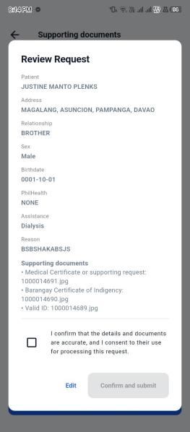 | Evidence ID: I01  Caption / task: The request form accepted the invalid date ‘0001-10-01’ and allowed the applicant to continue.  Date / time: Sept. 09, 2026 - 8:14 PM  App / web version: AidLink app 1.0.5 (build 6)

Issue I02: insert screenshot / photo | Evidence details
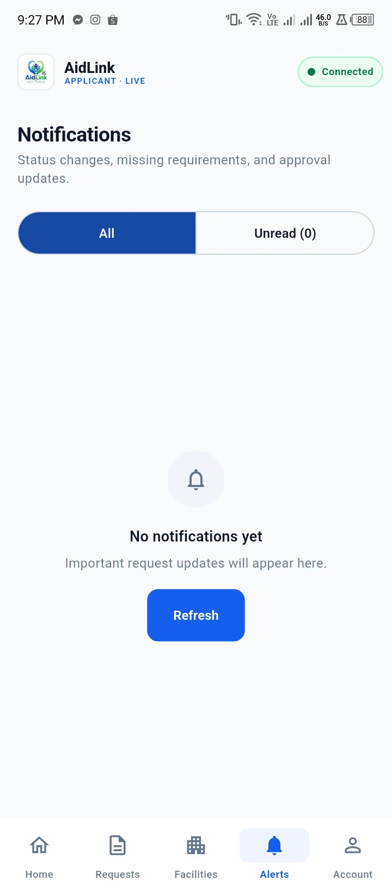 | Evidence ID: I02  Caption / task:The Notifications screen displays “No notifications yet” while the app is connected.  Date / time: Sept. 09, 2026 - 9:27 PM  App / web version: AidLink app 1.0.5 (build 6)

Issue I03: insert screenshot / photo | Evidence details
[Paste actual issue screenshot here] | Evidence ID: __________________  Caption / task: _________________  Date / time: ___________________  App / web version: ______________

APPENDIX A: PROOF OF AUDIT ACTIVITY
A1. Screenshot evidence — issues I04–I05
Issue I04: insert screenshot / photo | Evidence details
[Paste actual issue screenshot here] | Evidence ID: __________________  Caption / task: _________________  Date / time: ___________________  App / web version: ______________

Issue I05: insert screenshot / photo | Evidence details
[Paste actual issue screenshot here] | Evidence ID: __________________  Caption / task: _________________  Date / time: ___________________  App / web version: ______________

A2. Automated tool report (optional)
Tool / version / date | Screenshot or attachment reference | Score / summary and limitations
___________________ | [Insert actual report or evidence filename] | ____________________________  Screen tested: ________________

A3. Certification of authenticity
I certify that I personally conducted this audit on my own Capstone application on the date(s) indicated above.
Printed name: __________________________________ Signature: _________________________
Date signed: ____________________
Sign only after completing the audit. Supporting basis: the teacher’s Week1_Initial_Capstone_UX_Audit.docx and the local AidLink app/web source files. Expected checks are not evidence of successful behavior.

