SAP Mobility 101

Setup Work Environment

# Objective of Exercise

## Set up Eclipse

The objective of this exercise is to set up a development environment for SAPUI5 Programming in eclipse.

## Note

* We recommend that you use a chrome browser for testing.

# Task 1: Download Java runtime Environment (JRE)

Before downloading, first check your computer system to see what system type you have on your computer: Start>(type system Information into your search field) select System Information:

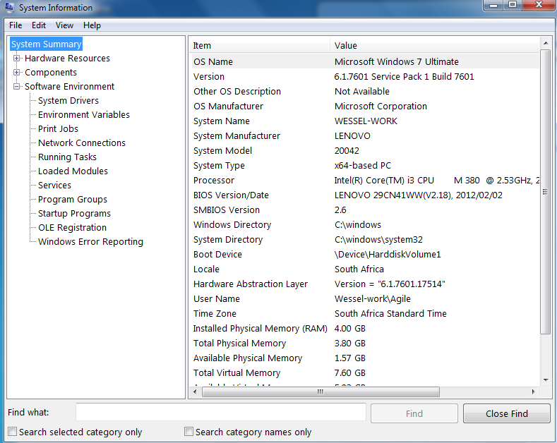

In this case the system is win32 x64-based, thus the eclipse-SDK to download would have the extension: win32-x86_64.

The following list of files has been provided:

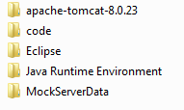

Eclipse needs java runtime Environment (JRE) it can be downloaded from this site: <http://www.oracle.com/technetwork/java/javase/downloads/index.html>,

Or from the folder Java RuntimeEncironment for those with windows x64.

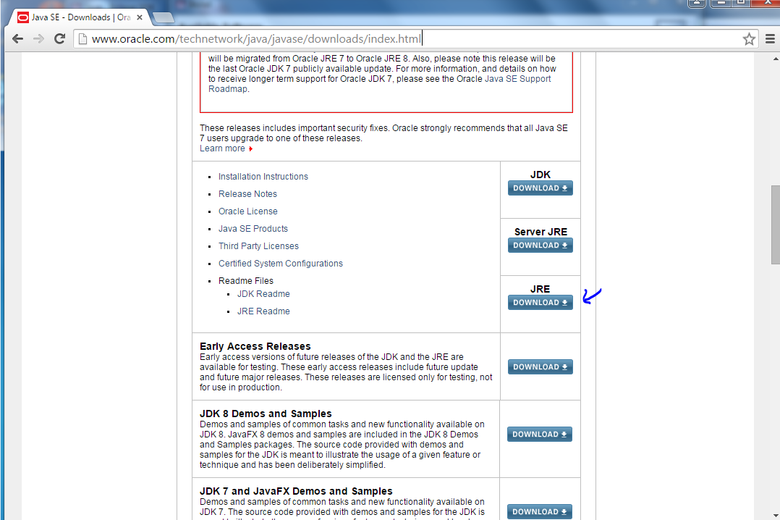

Make sure you have the latest development kit 7.*

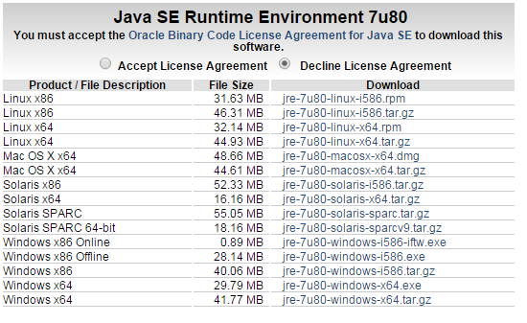

Or from the package:

Install JRE on your computer:

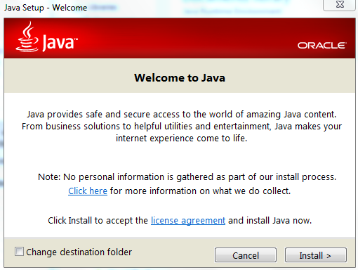

Click install.

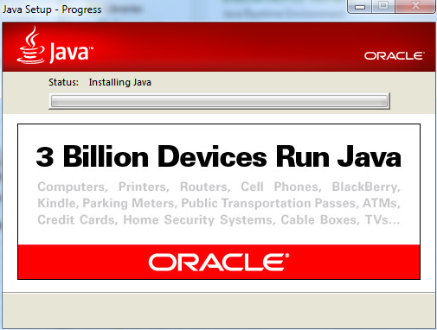

Wait for java to install.

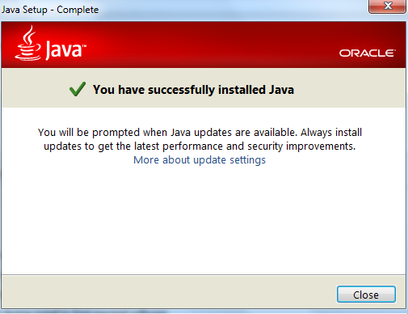

Click close.

# Task 2: Install Eclipse LUNA

Open the folder named Eclipse

Extract the folder named: eclipse-java-luna-SR1-win32-x86_64

Open the directory: Eclipse4.2.2/eclipse, inside you will find an application named eclipse, open this application, for future use, create a shortcut on your desktop to this application:

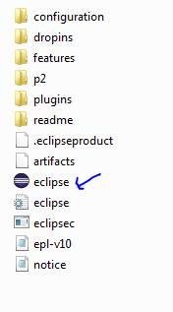

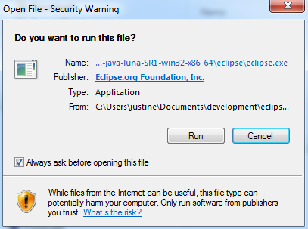

Click Run

The following screen will appear if eclipse is starting:



Enter a workspace of you choice into the following window or use the default folder created by eclipse, click OK:

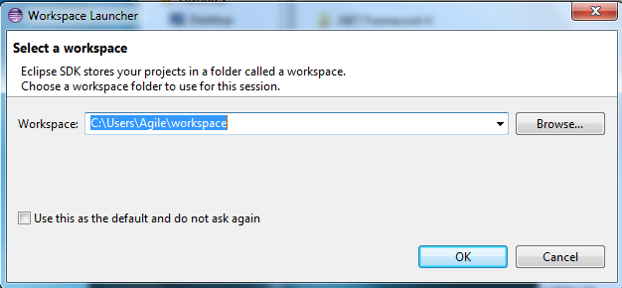

Eclipse will open in the following welcome screen:

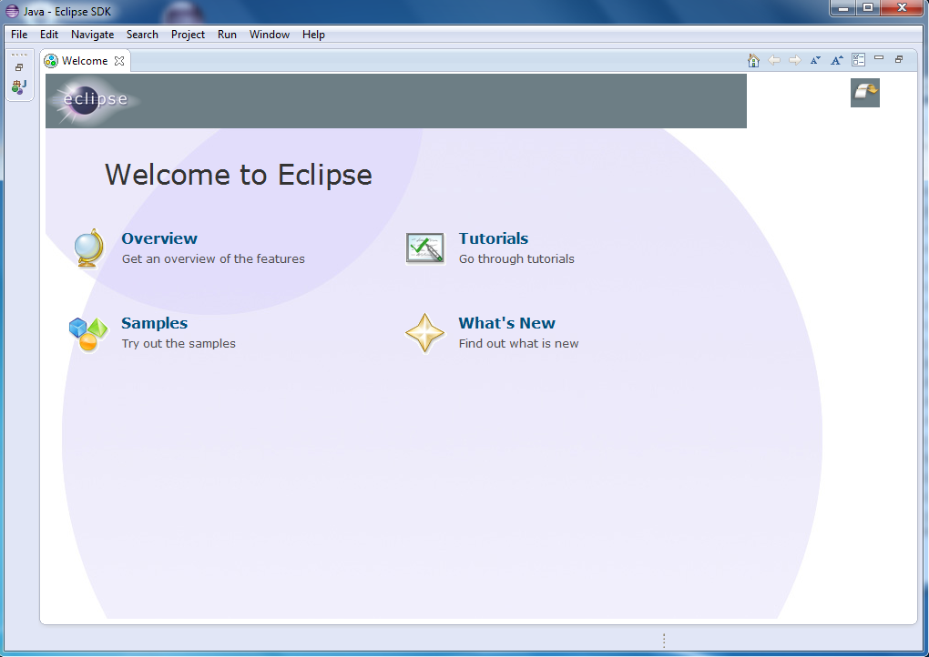

Close the welcome screen, eclipse should now look like this:

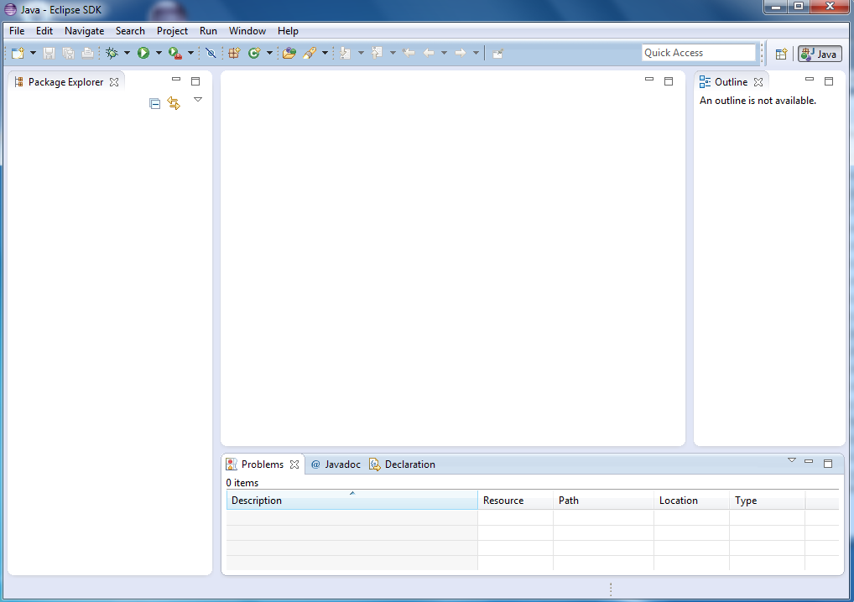

The Package explorer will show you the files and libraries available in your workspace.

The Outline will have a summary of the classes and methods in your program.

At the bottom of the screen is your console, and in the middle is where your code will appear.

# Task 3: Install UI Development Toolkit for HTML5

In you eclipse menu pane, go to Help>Install New Software, the following screen will appear:

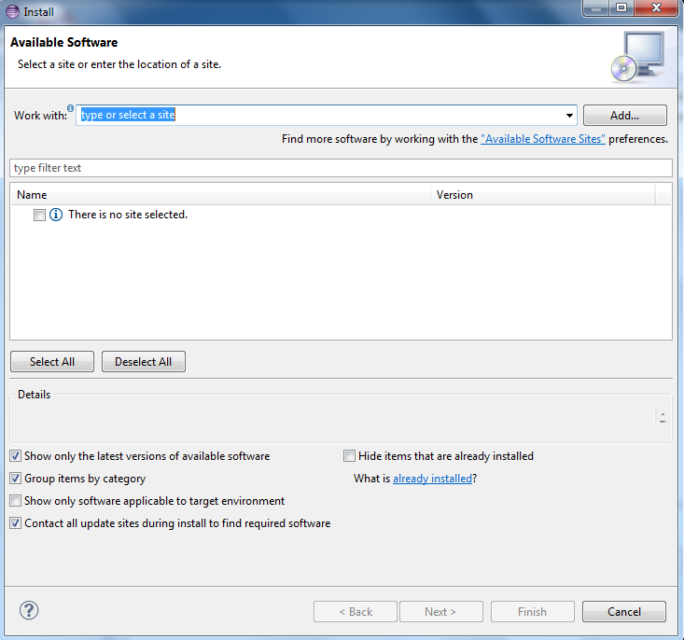

Click Add:

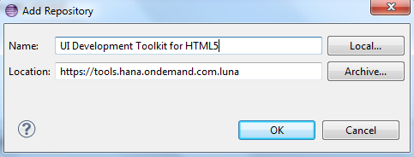

Enter the following into the Add Repository window:

Name: UI Development toolkit for HTML5

Location: <https://tools.hana.ondemand.com/luna>

Press ok:

The following list of plugin options will be provided:

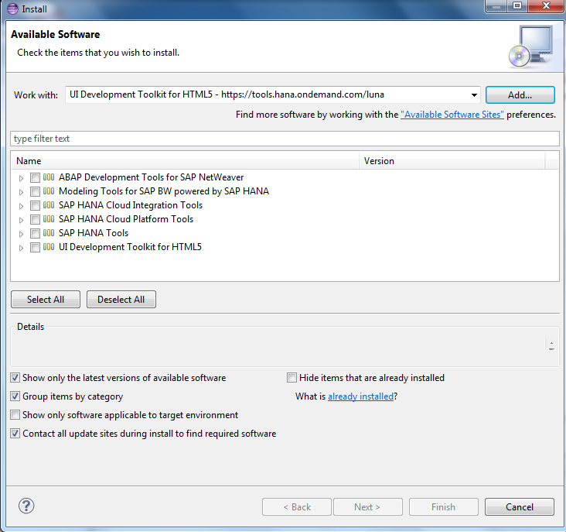

Select: UI Development Toolkit for HTML5

>UI development toolkit for HTML5 (Developer Edition)

>SAPUI5 ABAP Repository Team Provider (Developer Edition)

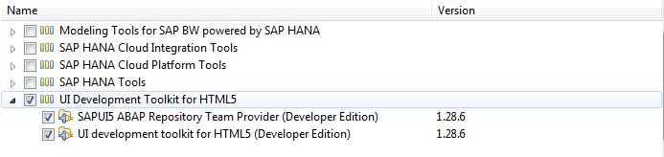

Click next.

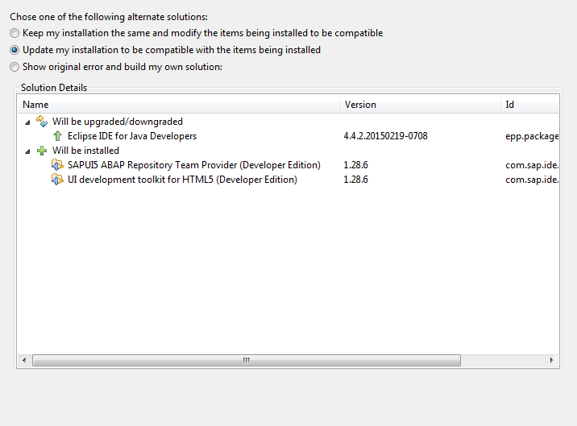

Click next

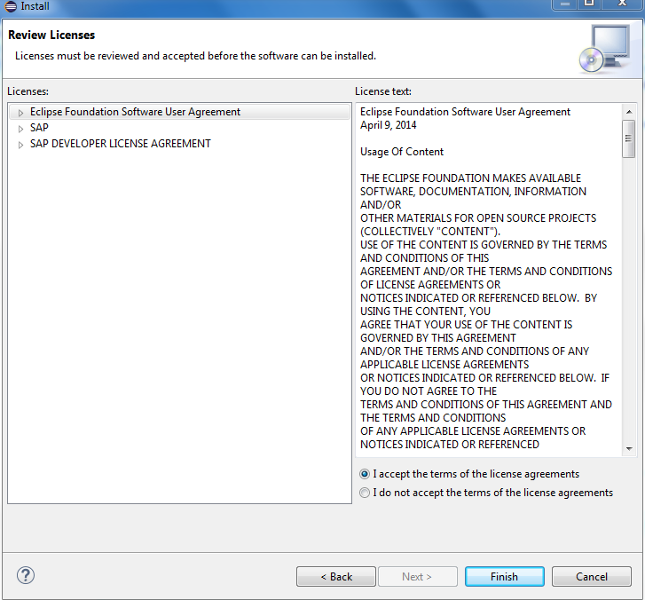

Accept the license agreement:

Click finish.

The software will now install.

Restart eclipse for changes to take effect.

# Task 4: Install Tomcat

First download the apache_tomcat v7. Zip file from this site:

<http://tomcat.apache.org/download-70.cgi>

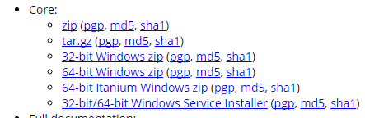

Or from the package.

Unzip the package in a reasonable location. E.g. c: //. It works better directly on the drive and not under subfolders.

## Set variables:

In your start menu, right click on Computer> Properties:

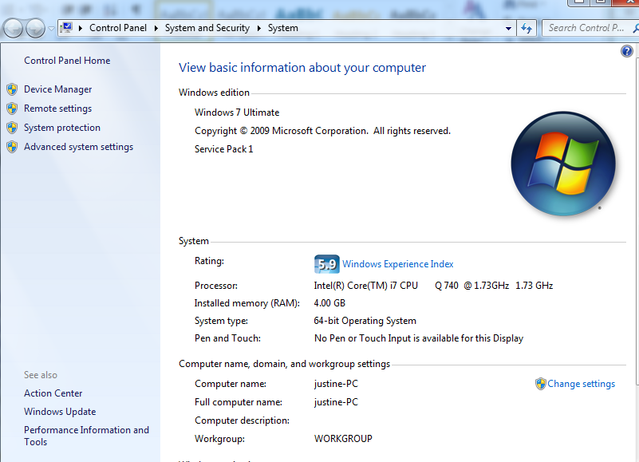

Select advanced system Settings:

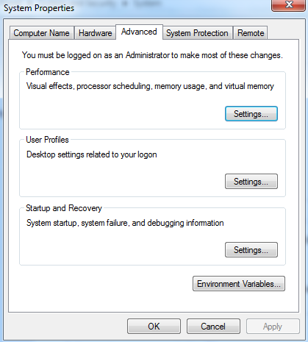

Select the advanced tab and then “Environment Variables”:

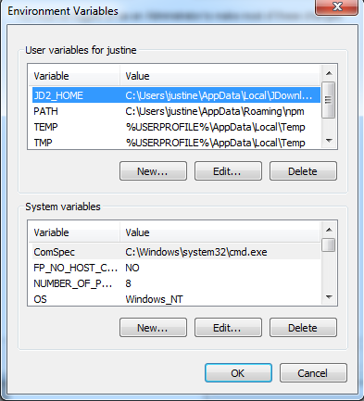

Under “System variables”, select new:

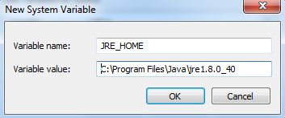

Set your first System variable JRE_HOME to the directory where your jre 1.8 java files are stored, click ok.

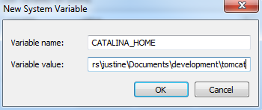

Set your second System Variable to the location where you’ve extracted your tomcat file.

In Eclipse, in your menu pane, go to Help>Install new Software

Click add:

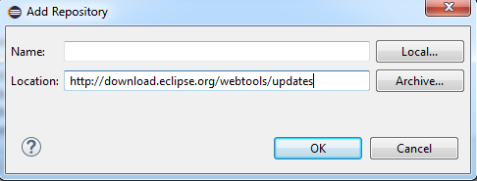

Add the following:

Name: Luna

Location: <http://download.eclipse.org/releases/luna>

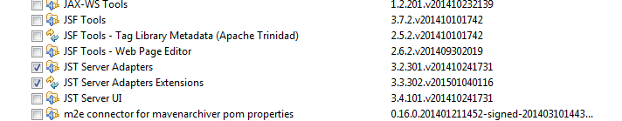

Select: JST Server Adapters and JST Server Adapters Extension.

Click next:

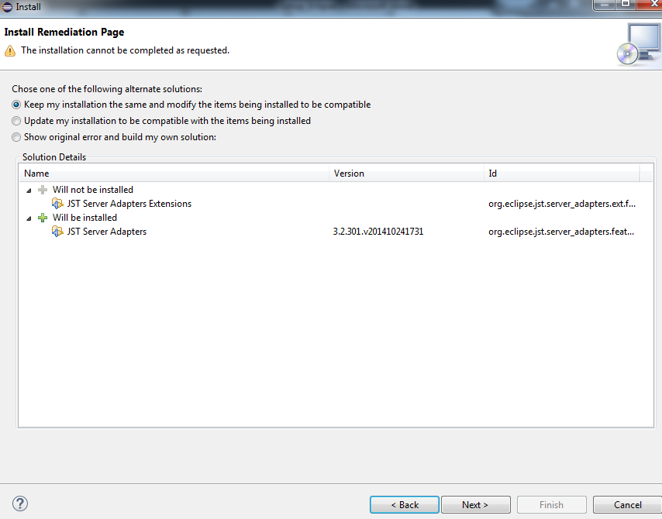

Select “Update my installation to be compatible with the items being installed”.

Click next:

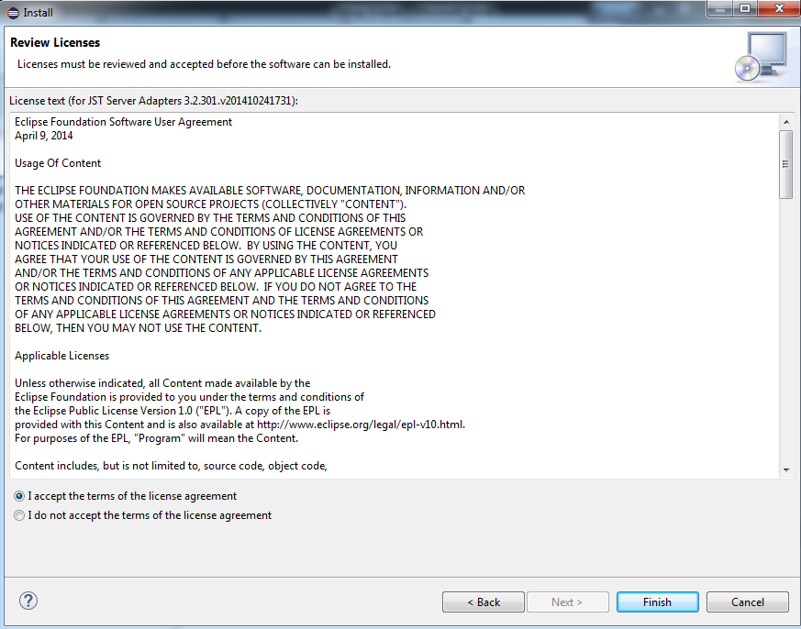

Accept the license agreement.

The software will install, eclipse will restart.

Go to window>preferences>servers>runtime Environment

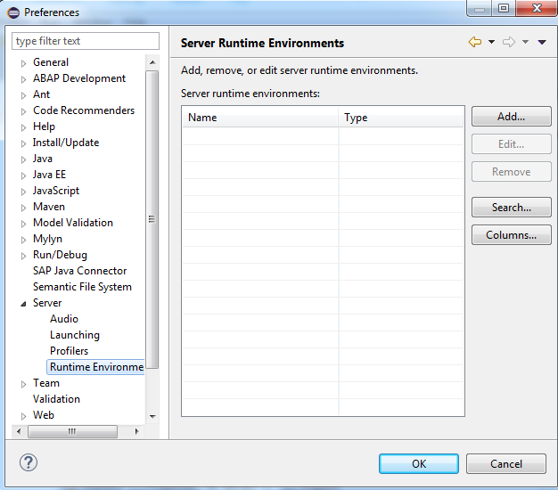

Click Add

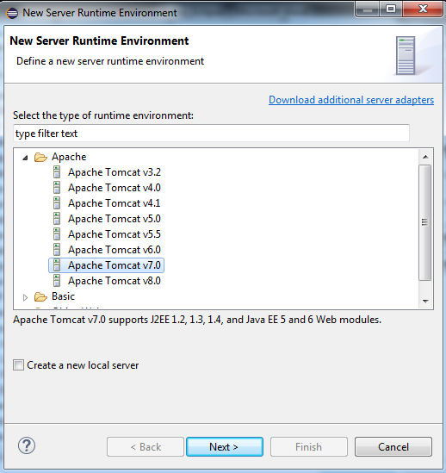

Select tomcat v7 and click next;

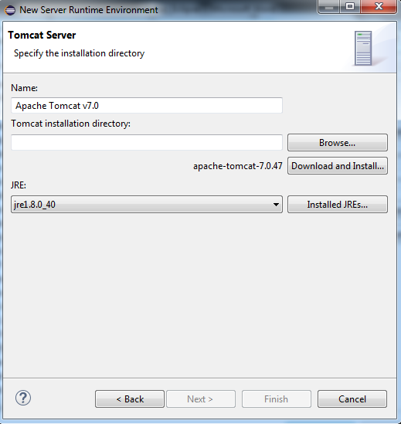

Select the JRE: jre1.8.0_40

Specify an installation directory on your drive: e.g. C://tomcat

Click ‘Download and Install..’

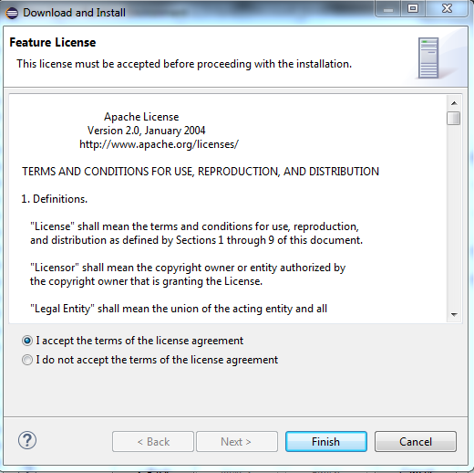

Accept license agreement.

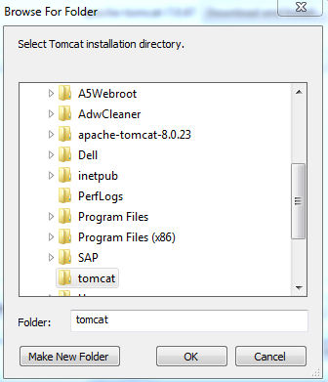

Select the installation directory again.

In your publishing directory, enter the directory address to the tomcat folder you’ve extracted, click finish.

# Task 5: Select web browser

In window>Preferences, go to General>web Browser:

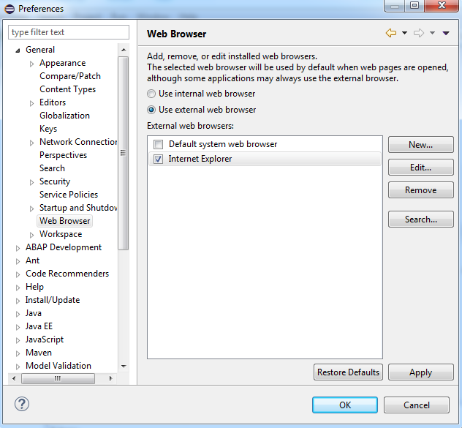,

Select “use external web browser”.

If Chrome is listed here as a web browser, select chrome, else, clicks new:

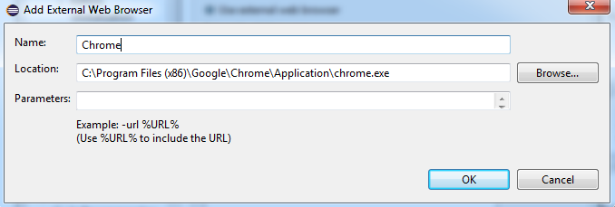

Enter the location of your local chrome browser exe file.

Click OK.

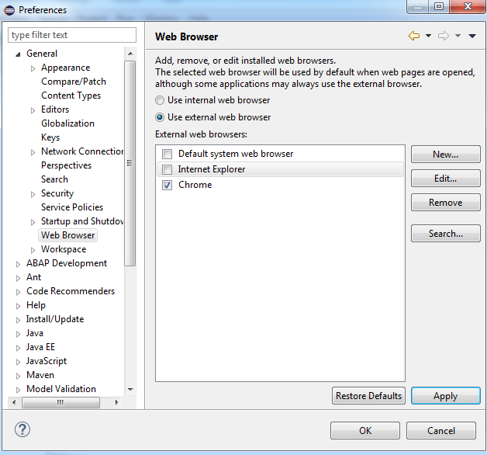

Click Apply and then OK.

In the Eclipse menu click on Help>About Eclipse SDK

The following screen will appear:

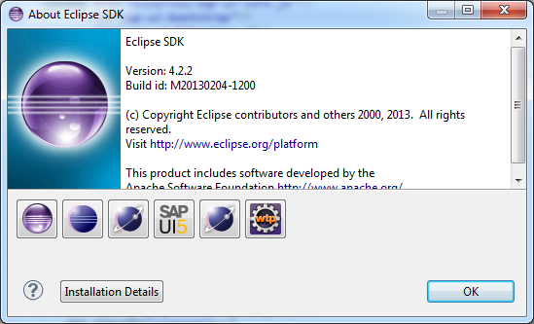

This screen contains details on all the plugins that should be installed to your computer.

# Task 6: run Tomcat

When you have created the base files of your eclipse project, refer back to this section.

In the eclipse menu pane, go to Window>Show View> Servers:

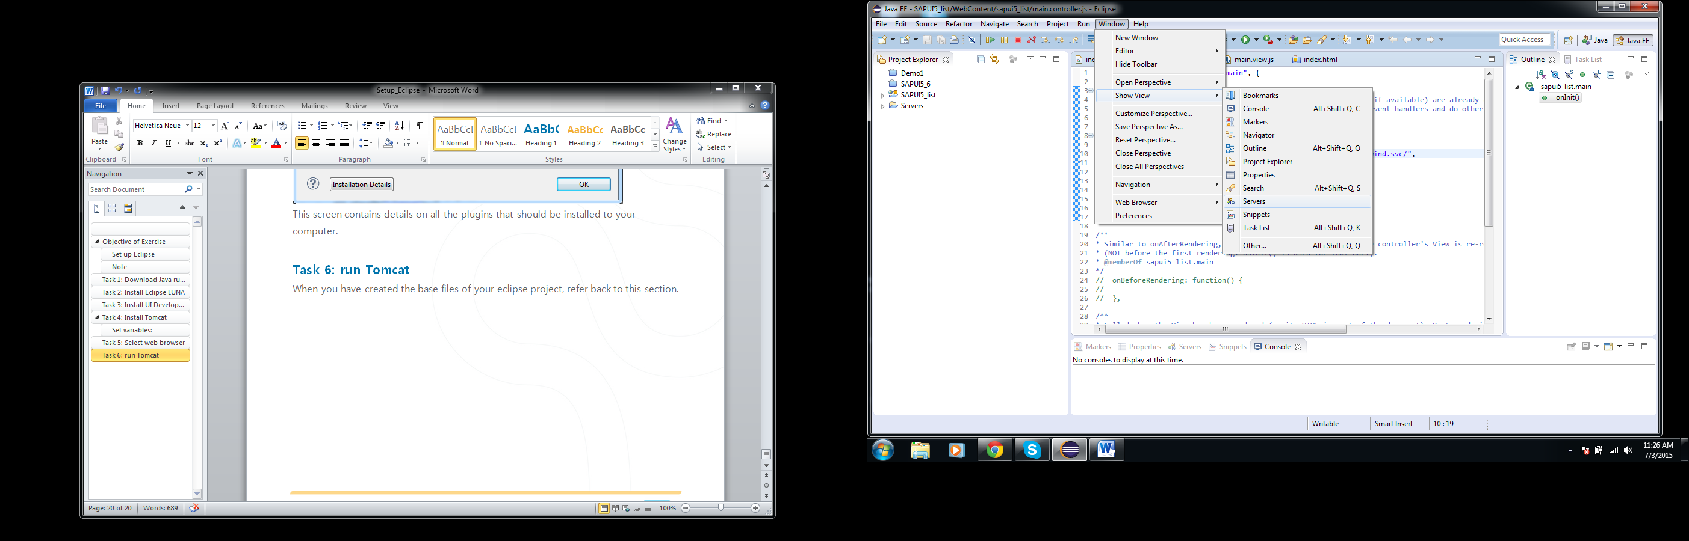

At the bottom of the screen a window showing all servers will show, the first time there will be a link indicating that there are no servers. Click this link to add a new server:

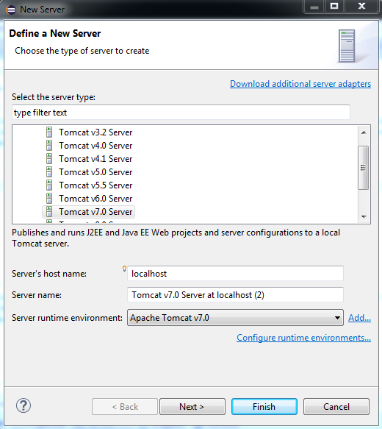

Select the Tomcat server v7.0. , Click next

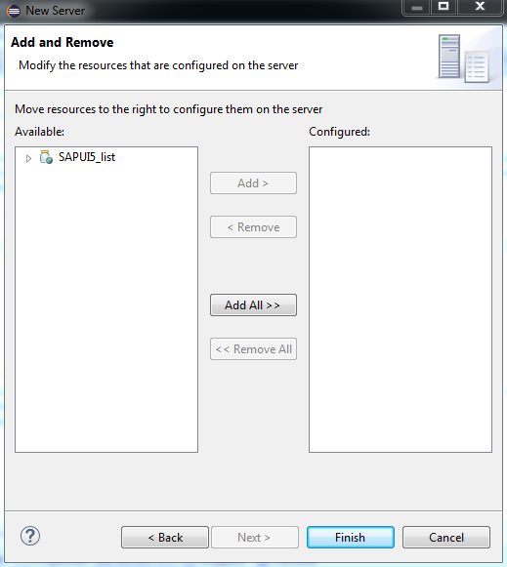

Add the current eclipse project to the right column and click Finish.

The select sever will appear at the bottom of the screen: 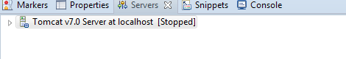

# Task: 7 Run Application

Right click on the top folder of your application, select Run As> Run Configurations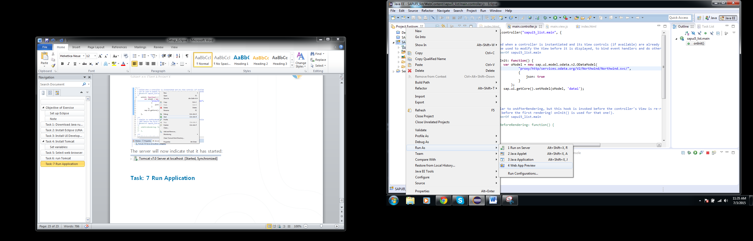

The following screen will appear:

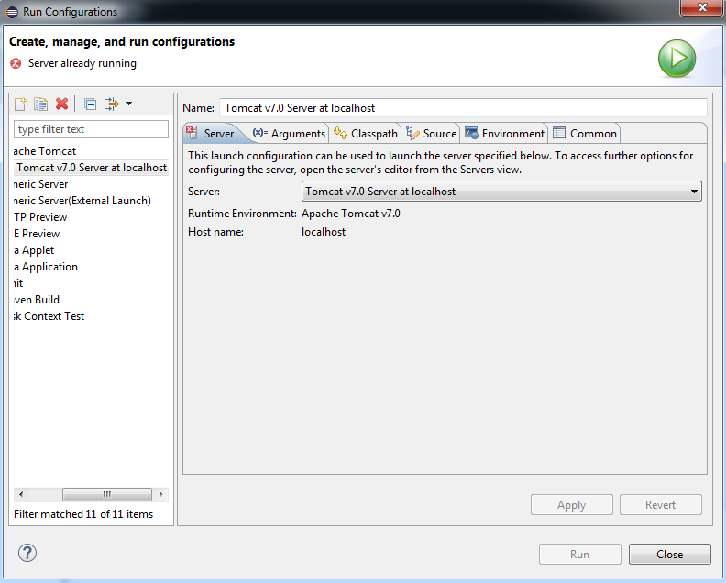

Click apply and then Run.

If the server does not start by itself, right click on this server and select Start:

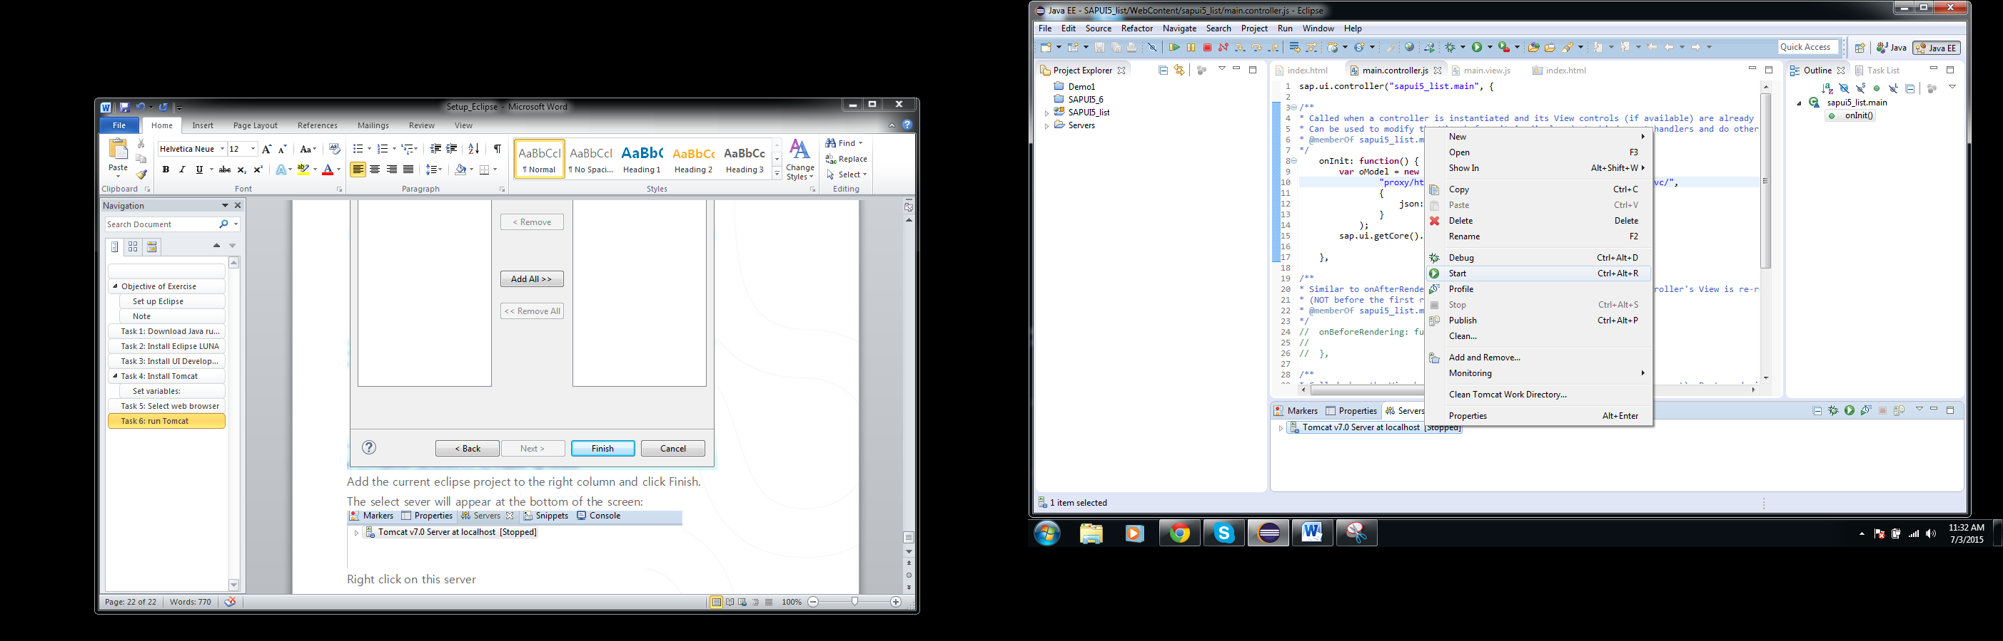

The server will now indicate that it has started: 

Run the application by Right clicking on the top folder of your application in Project explorer>Run As> Web App Preview.

The following preview will open in eclipse (content of the page may differ):

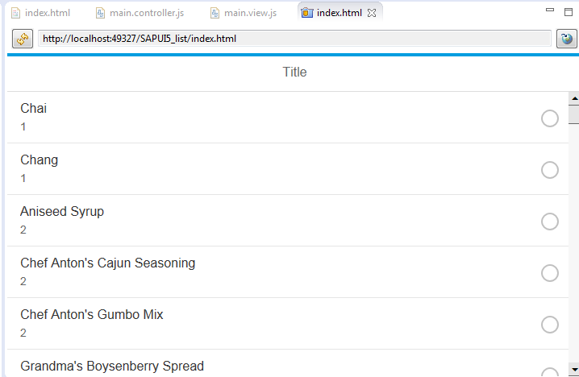

Copy the URL in your browser, change the local host port code to 8080:

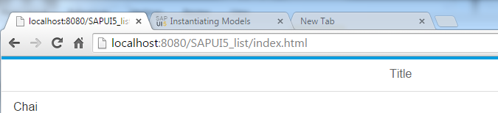

The project will now run in your browser, you only have to refresh the page after you have saved the project for changes to take effect.

Task 6 and 7 should be repeated for all the different programs you are running.

REMEMBER: the server should be started and the address copied into your chrome browser every time you are opening your eclipse tutorial. You will not be reminded of this every time.