SAP Mobility 101

Tutorial 2 and 3 – create a Simple HTML file containing JavaScript handling Variables and Control structures.

# Objective of Exercise

## Build an example application

The objective of this exercise is to build an HTML page that uses JavaScript and handles variables.

## Note

* We recommend that you use a chrome browser for testing
* Any text editor will work for this example such as notepad or notepad++

Tutorial 2

Variables and transferring variables.

# Task 1: Create the multiply function

Add a function to your script1.js file:

function multiply(a, b){

var answ = a * b;

return answ;

};

# Task 2: Call the function when a button is pressed

In the button1() function, add a line that calls the multiply function, and the prints the result as an alert.

function button1(){

var answer = multiply(3, 4);

alert(answer);

};

Run the application in the browser: the result should look as follow:

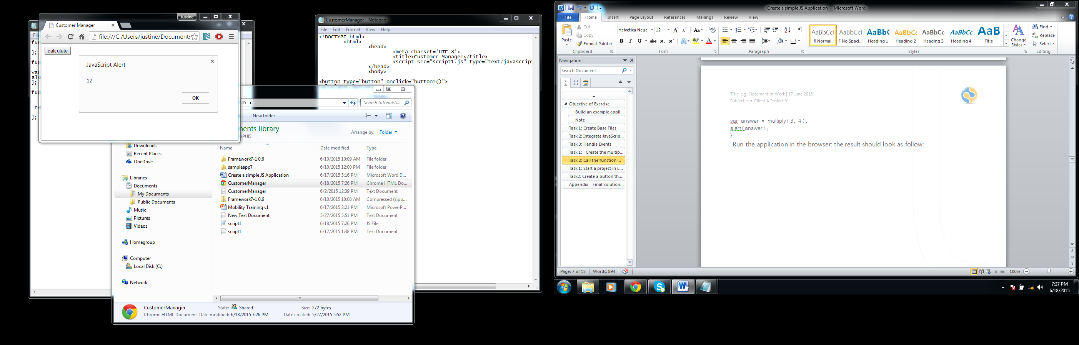

## Script1.js

function loaded(){

alert("page loaded");

}

function button1(){

var answer = multiply(3, 4);

alert(answer);

}

function multiply(a, b){

var answ = a * b;

return answ;

};

Tutorial 3

Control structures

# Task 1: Create a function that takes an array values

Write a function that takes an array, compare them to each other and return the highest value.

Function returnmax(arr){

}

# Task 2: Create the array, call the function.

Create the array within the button1() function, call the function and print its result as an alert:

Function button1(){

Var arrayO = new Array();

arrayO[0] = 1;

arrayO[1] = 5;

arrayO[2] = 4;

arrayO[3] = 3;

arrayO[4] = 6;

arrayO[5] = 2;

arrayO[6] = 7;

alert(returnmax(arrayO));

}

# Task 3: Compare the values

Create a for loop that runs through all the values in the array, compares them and return the highest value.

function returnmax(arr){

var hold = 0;

for(i=0;i<arr.length;i++){

if(hold>arr[i]){

hold = arr[i];

}

}

return hold;

}

Save and run the application.

## Script1.js

function loaded(){

alert("page loaded");

}

function button1(){

var answer = multiply(3, 4);

alert(answer);

}

function multiply(a, b){

var answ = a * b;

return answ;

};

function returnmax(arr){

var hold = 0;

for(i=0;i<arr.length;i++){

if(hold>arr[i]){

hold = arr[i];

}

}

return hold;

}

function button1(){

Var arrayO = new Array();

arrayO[0] = 1;

arrayO[1] = 5;

arrayO[2] = 4;

arrayO[3] = 3;

arrayO[4] = 6;

arrayO[5] = 2;

arrayO[6] = 7;

alert(returnmax(arrayO));

}