SAP Mobility 101

Tutorial 13 – Adding an entry

# Objective of Exercise

## Build an example application

The objective of this exercise is to create a new entry to the data table currently in use.

## Note

* The Mock server will be used for this tutorial.

# Task 1: Create function:

In ProductList.Controller, add a function that would be called when a request for a new entry is sent.

CreateEntry: **function**() {

},

# Task 2: Create a Dialog

We will now be exploring a new user interface element, the Dialog:

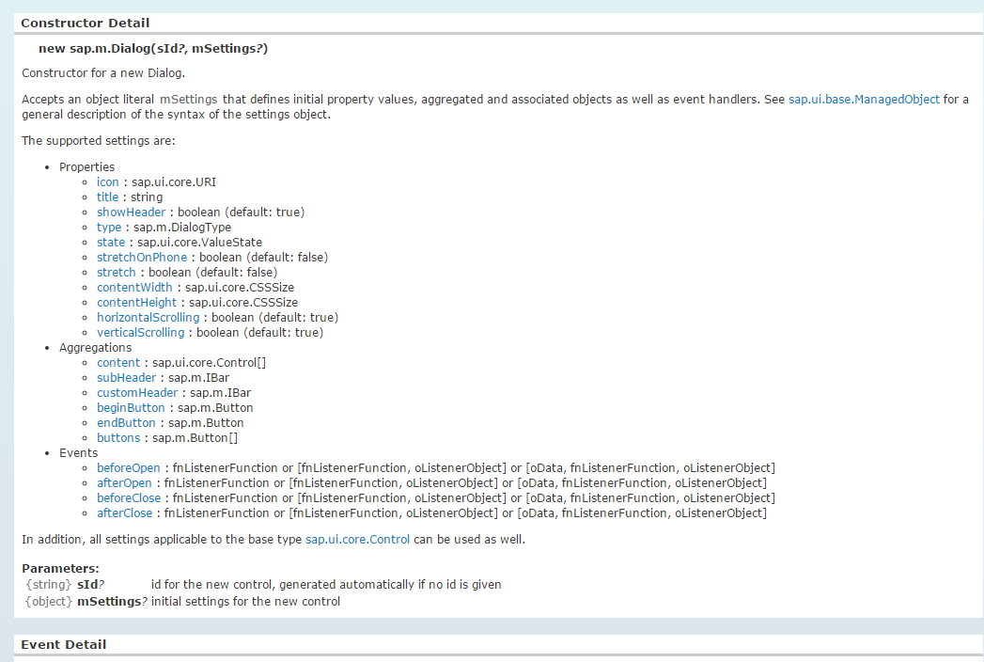

CreateEntry: **function**() {

**var** CreateDialog = **new** sap.m.Dialog('CreateE',{

title: "Create product Entry"

type: sap.m.DialogType.Message,

verticalScrolling: **true**,

});

},

Create a label and entry field for each of the labels in the Product table, also add the following buttons: save, clear and back.

When the dialog has been created, open the dialog using the .open function.

CreateEntry: **function**() {

**var** CreateDialog = **new** sap.m.Dialog('CreateE',{

title: "Create product Entry",

type: sap.m.DialogType.Message,

verticalScrolling: **true**,

content: [

**new** sap.m.Label({text: "Product name"}),

**new** sap.m.Input({

id: "Pname",

type: sap.m.InputType.Text

}),

**new** sap.m.Label({text: "Product ID"}),

**new** sap.m.Input({

id: "Prod_id",

type: sap.m.InputType.Text

}),

**new** sap.m.Label({text: "Category ID"}),

**new** sap.m.Input({

id: "Cat_id",

type: sap.m.InputType.Text

}),

**new** sap.m.Label({text: "Supplier ID"}),

**new** sap.m.Input({

id: "Sup_id",

type: sap.m.InputType.Text

}),

**new** sap.m.Label({text: "Quantity per Unit"}),

**new** sap.m.Input({

id: "QpU",

type: sap.m.InputType.Text

}),

**new** sap.m.Label({text: "Unit price"}),

**new** sap.m.Input({

id: "Unit_p",

type: sap.m.InputType.Text

}),

**new** sap.m.Label({text: "Units in stock"}),

**new** sap.m.Input({

id: "stock",

type: sap.m.InputType.Text

}),

**new** sap.m.Label({text: "Units on order"}),

**new** sap.m.Input({

id: "order",

type: sap.m.InputType.Text

}),

**new** sap.m.Label({text: "Reorder level"}),

**new** sap.m.Input({

id: "reorder",

type: sap.m.InputType.Text

}),

**new** sap.m.Label({text: "Discontinued"}),

**new** sap.m.CheckBox('dis')

], buttons:[

**new** sap.m.Button({

type: sap.m.ButtonType.Back

}),

**new** sap.m.Button({

text: "save"

}),

**new** sap.m.Button({

text: "clear"

})

]

});

CreateDialog.open();

}

Add a “create” button to your Productlist view, that would call this function.

**var** aButton = **new** sap.m.Button();

aButton.setText("create new product");

aButton.attachPress(oController.CreateEntry);

save and run your program.

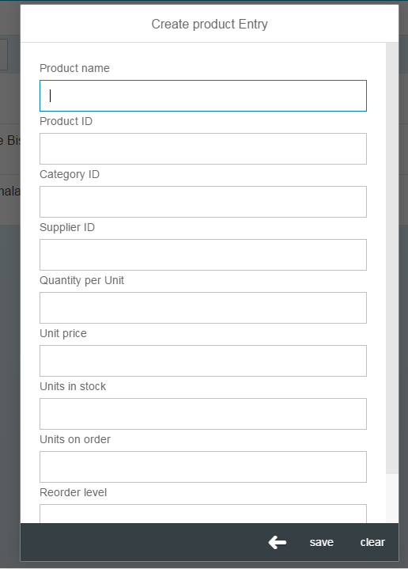

# Task 3: Submit changes

Create a function that would handle the submit new data event when the “save”

Button is clicked.

**new** sap.m.Button({

text: "save",

press: oController.submit

}),

**new** sap.m.Button({

text: "save",

press: **function**(e){

}

}),

Test the following code to see if you get the value of the entered value.

**new** sap.m.Button({

text: "save",

press: **function**(e){

**var** content = sap.ui.getCore().byId("Pname").getValue();

console.log(content);

}

Save all the elements of the product in an object.

press: **function**(e){

**var** newEntry = {};

newEntry.ProductName =sap.ui.getCore().byId("Pname").getValue();

newEntry.ProductID =sap.ui.getCore().byId("Prod_id").getValue();

newEntry.CategoryID =sap.ui.getCore().byId("Cat_id").getValue();

newEntry.SupplierID =sap.ui.getCore().byId("Sup_id").getValue();

newEntry.QuantityPerUnit =sap.ui.getCore().byId("QpU").getValue();

newEntry.UnitPrice =sap.ui.getCore().byId("Unit_p").getValue();

newEntry.UnitsInStock =sap.ui.getCore().byId("stock").getValue();

newEntry.UnitsOnOrder =sap.ui.getCore().byId("order").getValue();

newEntry.ReorderLevel =sap.ui.getCore().byId("reorder").getValue();

newEntry.Discontinued =sap.ui.getCore().byId("dis").getSelected();

console.log(newEntry);

}

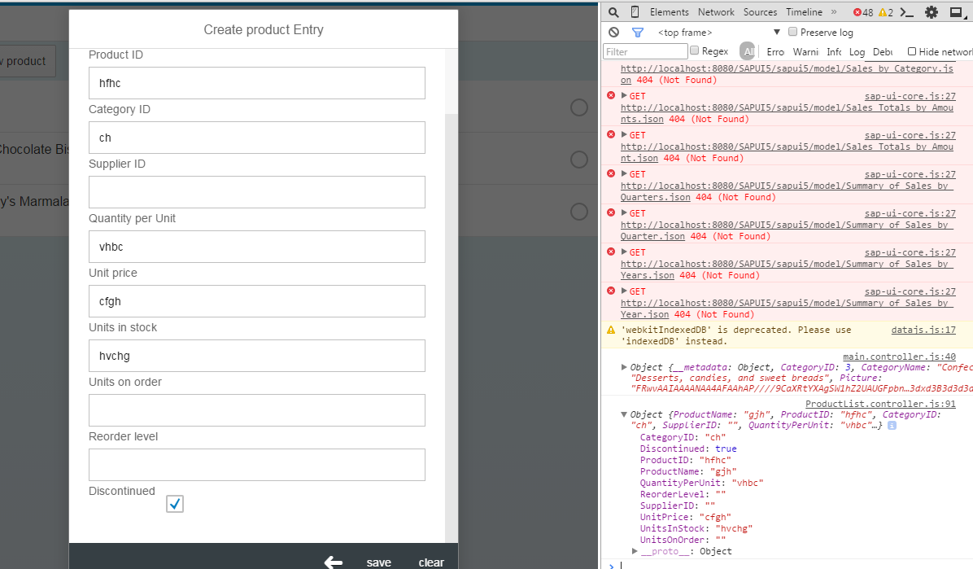

Create a new entry in the datamodel using the create function, Create Entry can also be used, for now we will work with the CRUD functions.

sap.ui.getCore().getModel('data1').create('/Products', newEntry);

# Task 4: Refresh Model

Close the dialog, see the changes in your list after you have refreshed the model.

sap.ui.getCore().getModel('data1').refresh();

CreateDialog.close();

# Task 5: Back Button

Close the dialog when the back button is pressed:

**new** sap.m.Button({

type: sap.m.ButtonType.Back,

press: **function**(){CreateDialog.close();}

}),

When closing the Dialog, we want the dialog element as well as all the input tables deleted so that when the dialog table is called again at a later stage we do not have to deal with duplicate ids. Thus destroy the dialog element.

**new** sap.m.Button({

type: sap.m.ButtonType.Back,

press: **function**(){

CreateDialog.close();

sap.ui.getCore().byId("CreateE").destroy();

}

}),

# Task 6: Clear button

Use the setvalue function to change all the values of the input fields to “”, and the checkbox to false.

**new** sap.m.Button({

text: "clear",

press: **function**(){

sap.ui.getCore().byId("Pname").setValue("");

sap.ui.getCore().byId("Prod_id").setValue("");

sap.ui.getCore().byId("Cat_id").setValue("");

sap.ui.getCore().byId("Sup_id").setValue("");

sap.ui.getCore().byId("QpU").setValue("");

sap.ui.getCore().byId("Unit_p").setValue("");

sap.ui.getCore().byId("stock").setValue("");

sap.ui.getCore().byId("order").setValue("");

sap.ui.getCore().byId("reorder").setValue("");

sap.ui.getCore().byId("dis").setSelected("false");

}

})

## Final Create entry code:

CreateEntry: **function**() {

**var** CreateDialog = **new** sap.m.Dialog('CreateE',{

title: "Create product Entry",

type: sap.m.DialogType.Message,

verticalScrolling: **true**,

content: [

**new** sap.m.Label({text: "Product name"}),

**new** sap.m.Input({

id: "Pname",

type: sap.m.InputType.Text

}),

**new** sap.m.Label({text: "Product ID"}),

**new** sap.m.Input({

id: "Prod_id",

type: sap.m.InputType.Text

}),

**new** sap.m.Label({text: "Category ID"}),

**new** sap.m.Input({

id: "Cat_id",

type: sap.m.InputType.Text

}),

**new** sap.m.Label({text: "Supplier ID"}),

**new** sap.m.Input({

id: "Sup_id",

type: sap.m.InputType.Text

}),

**new** sap.m.Label({text: "Quantity per Unit"}),

**new** sap.m.Input({

id: "QpU",

type: sap.m.InputType.Text

}),

**new** sap.m.Label({text: "Unit price"}),

**new** sap.m.Input({

id: "Unit_p",

type: sap.m.InputType.Text

}),

**new** sap.m.Label({text: "Units in stock"}),

**new** sap.m.Input({

id: "stock",

type: sap.m.InputType.Text

}),

**new** sap.m.Label({text: "Units on order"}),

**new** sap.m.Input({

id: "order",

type: sap.m.InputType.Text

}),

**new** sap.m.Label({text: "Reorder level"}),

**new** sap.m.Input({

id: "reorder",

type: sap.m.InputType.Text

}),

**new** sap.m.Label({text: "Discontinued"}),

**new** sap.m.CheckBox('dis')

],

buttons:[

**new** sap.m.Button({

type: sap.m.ButtonType.Back,

press: **function**(){

CreateDialog.close();

sap.ui.getCore().byId("CreateE").destroy();

}

}),

**new** sap.m.Button({

text: "save",

press: **function**(e){

**var** newEntry = {};

newEntry.ProductName =sap.uigetCore().byId("Pname").getValue();

newEntry.ProductID =sap.ui.getCore().byId("Prod_id").getValue();

newEntry.CategoryID =sap.ui.getCore().byId("Cat_id").getValue();

newEntry.SupplierID =sap.ui.getCore().byId("Sup_id").getValue();

newEntry.QuantityPerUnit =sap.ui.getCore().byId("QpU").getValue();

newEntry.UnitPrice =sap.ui.getCore().byId("Unit_p").getValue();

newEntry.UnitsInStock =sap.ui.getCore().byId("stock").getValue();

newEntry.UnitsOnOrder =sap.ui.getCore().byId("order").getValue();

newEntry.ReorderLevel =sap.ui.getCore().byId("reorder").getValue();

newEntry.Discontinued =sap.ui.getCore().byId("dis").getSelected();

sap.ui.getCore().getModel('data1').create('/Products', newEntry);

sap.ui.getCore().getModel('data1').refresh();

CreateDialog.close();

sap.ui.getCore().byId("CreateE").destroy();

}

}),

**new** sap.m.Button({

text: "clear",

press: **function**(){

sap.ui.getCore().byId("Pname").setValue("");

sap.ui.getCore().byId("Prod_id").setValue("");

sap.ui.getCore().byId("Cat_id").setValue("");

sap.ui.getCore().byId("Sup_id").setValue("");

sap.ui.getCore().byId("QpU").setValue("");

sap.ui.getCore().byId("Unit_p").setValue("");

sap.ui.getCore().byId("stock").setValue("");

sap.ui.getCore().byId("order").setValue("");

sap.ui.getCore().byId("reorder").setValue("");

sap.ui.getCore().byId("dis").setSelected("false");

}

})

]

);

CreateDialog.open();

},