SAP Mobility 101

Tutorial 15 – Updating entries

# Objective of Exercise

## Build an example application

The objective of this exercise is to update the data entries in the mock data.

## Note

* For this tutorial we will use the Mock data.

# Task 1: Create the Update handler

In the productList.controller file, add a function that would handle the updating of entries, also create a button in the productlist view that would call this function.

UpdateEntry: **function**(){

}

Button in the view;

**var** Ubutton = **new** sap.m.Button({

text: "Edit",

press: oController.UpdateEntry

});

# Task 2: Create Dialog

Create a Dialog similar to the dialog used in the Create entry tutorial.

**var** updateDialog = **new** sap.m.Dialog('UpdateE',{

title: "Edit Product Entry",

type: sap.m.DialogType.Message,

verticalScrolling: **true**,

content:[],

buttons: []

});

updateDialog.open();

copy the contents of the create dialog into the content of the Dialog.

content:[

**new** sap.m.Label({text: "Product name"}),

**new** sap.m.Input({

id: "Pname",

type: sap.m.InputType.Text

}),

**new** sap.m.Label({text: "Product ID"}),

**new** sap.m.Input({

id: "Prod_id",

type: sap.m.InputType.Text

}),

**new** sap.m.Label({text: "Category ID"}),

**new** sap.m.Input({

id: "Cat_id",

type: sap.m.InputType.Text

}),

**new** sap.m.Label({text: "Supplier ID"}),

**new** sap.m.Input({

id: "Sup_id",

type: sap.m.InputType.Text

}),

**new** sap.m.Label({text: "Quantity per Unit"}),

**new** sap.m.Input({

id: "QpU",

type: sap.m.InputType.Text

}),

**new** sap.m.Label({text: "Unit price"}),

**new** sap.m.Input({

id: "Unit_p",

type: sap.m.InputType.Text

}),

**new** sap.m.Label({text: "Units in stock"}),

**new** sap.m.Input({

id: "stock",

type: sap.m.InputType.Text

}),

**new** sap.m.Label({text: "Units on order"}),

**new** sap.m.Input({

id: "order",

type: sap.m.InputType.Text

}),

**new** sap.m.Label({text: "Reorder level"}),

**new** sap.m.Input({

id: "reorder",

type: sap.m.InputType.Text

}),

**new** sap.m.Label({text: "Discontinued"}),

**new** sap.m.CheckBox('dis')

],

Add the value of the selected item to each input field.

First get the selected item, use the code created in tutorial 13.

**var** name = sap.ui.getCore().byId("Productslist").getSelectedItem();

**var** path1 = name.oBindingContexts.data1.sPath;

**var** item = sap.ui.getCore().getModel('data1').getProperty(path1);

console.log(item);

to get the specific element use item.<element>. Make sure you use the correct name.

ex

value: item.ProductName

**new** sap.m.Input({

id: "Pname",

type: sap.m.InputType.Text,

value: item.ProductName

}),

if you get any errors, double check the spelling of all the items, inspect the item in the console to double check.

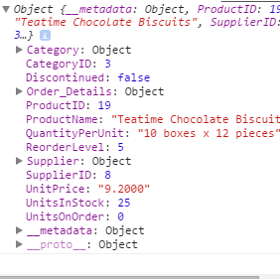 

content:[

**new** sap.m.Label({text: "Product name"}),

**new** sap.m.Input({

id: "Pname",

type: sap.m.InputType.Text,

value: item.ProductName

}),

**new** sap.m.Label({text: "Product ID"}),

**new** sap.m.Input({

id: "Prod_id",

type: sap.m.InputType.Text,

value: item.ProductID

}),

**new** sap.m.Label({text: "Category ID"}),

**new** sap.m.Input({

id: "Cat_id",

type: sap.m.InputType.Text,

value: item.CategoryID

}),

**new** sap.m.Label({text: "Supplier ID"}),

**new** sap.m.Input({

id: "Sup_id",

type: sap.m.InputType.Text,

value: item.SupplierID

}),

**new** sap.m.Label({text: "Quantity per Unit"}),

**new** sap.m.Input({

id: "QpU",

type: sap.m.InputType.Text,

value: item.QuantityPerUnit

}),

**new** sap.m.Label({text: "Unit price"}),

**new** sap.m.Input({

id: "Unit_p",

type: sap.m.InputType.Text,

value: item.UnitPrice

}),

**new** sap.m.Label({text: "Units in stock"}),

**new** sap.m.Input({

id: "stock",

type: sap.m.InputType.Text,

value: item.UnitsInStock

}),

**new** sap.m.Label({text: "Units on order"}),

**new** sap.m.Input({

id: "order",

type: sap.m.InputType.Text,

value: item.UnitsOnOrder

}),

**new** sap.m.Label({text: "Reorder level"}),

**new** sap.m.Input({

id: "reorder",

type: sap.m.InputType.Text,

value: item.ReorderLevel

}),

**new** sap.m.Label({text: "Discontinued"}),

**new** sap.m.CheckBox('dis',{

selected:item.Discontinued

})

],

# Task 3: Cancel button

The cancel button can be copied from the Create function. Just change the id and dialog name.

buttons: [

**new** sap.m.Button({

type: sap.m.ButtonType.Back,

press: **function**(){

updateDialog.close();

sap.ui.getCore().byId("UpdateE").destroy();

}

})

]

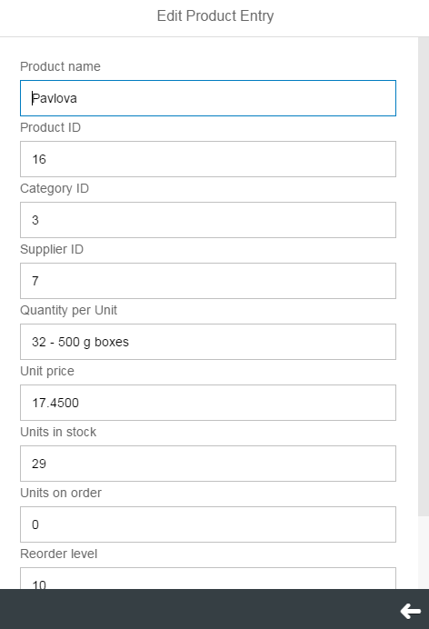

# Task 4: Save changes button

Add a button that would call a function that saves the changes when pressed.

**new** sap.m.Button({

text: "save changes",

press: **function**(){

}

})

# Task 5: Updating Datamodel

Copy the function used to create a new entry.

**var** newEntry = {};

newEntry.ProductName =sap.ui.getCore().byId("Pname").getValue();

newEntry.ProductID =sap.ui.getCore().byId("Prod_id").getValue();

newEntry.CategoryID =sap.ui.getCore().byId("Cat_id").getValue();

newEntry.SupplierID =sap.ui.getCore().byId("Sup_id").getValue();

newEntry.QuantityPerUnit =sap.ui.getCore().byId("QpU").getValue();

newEntry.UnitPrice =sap.ui.getCore().byId("Unit_p").getValue();

newEntry.UnitsInStock =sap.ui.getCore().byId("stock").getValue();

newEntry.UnitsOnOrder =sap.ui.getCore().byId("order").getValue();

newEntry.ReorderLevel =sap.ui.getCore().byId("reorder").getValue();

newEntry.Discontinued =sap.ui.getCore().byId("dis").getSelected();

sap.ui.getCore().getModel('data1').create('/Products', newEntry);

sap.ui.getCore().getModel('data1').refresh();

CreateDialog.close();

sap.ui.getCore().byId("CreateE").destroy();

Make the following changes;

Change the create method to an update method.

Point the method to the path of the selected row, eg use path1.

Change the dialog name to updateDialog and the id to UpdateE.

sap.ui.getCore().getModel('data1').update(path1, newEntry);

sap.ui.getCore().getModel('data1').refresh();

updateDialog.close();

sap.ui.getCore().byId("UpdateE").destroy();

Save and run your application.

## The final Update function

UpdateEntry: **function**(){

**var** name = sap.ui.getCore().byId("Productslist").getSelectedItem();

**var** path1 = name.oBindingContexts.data1.sPath;

**var** item = sap.ui.getCore().getModel('data1').getProperty(path1);

console.log(item);

**var** updateDialog = **new** sap.m.Dialog('UpdateE',{

title: "Edit Product Entry",

type: sap.m.DialogType.Message,

verticalScrolling: **true**,

content:[

**new** sap.m.Label({text: "Product name"}),

**new** sap.m.Input({

id: "Pname",

type: sap.m.InputType.Text,

value: item.ProductName

}),

**new** sap.m.Label({text: "Product ID"}),

**new** sap.m.Input({

id: "Prod_id",

type: sap.m.InputType.Text,

value: item.ProductID

}),

**new** sap.m.Label({text: "Category ID"}),

**new** sap.m.Input({

id: "Cat_id",

type: sap.m.InputType.Text,

value: item.CategoryID

}),

**new** sap.m.Label({text: "Supplier ID"}),

**new** sap.m.Input({

id: "Sup_id",

type: sap.m.InputType.Text,

value: item.SupplierID

}),

**new** sap.m.Label({text: "Quantity per Unit"}),

**new** sap.m.Input({

id: "QpU",

type: sap.m.InputType.Text,

value: item.QuantityPerUnit

}),

**new** sap.m.Label({text: "Unit price"}),

**new** sap.m.Input({

id: "Unit_p",

type: sap.m.InputType.Text,

value: item.UnitPrice

}),

**new** sap.m.Label({text: "Units in stock"}),

**new** sap.m.Input({

id: "stock",

type: sap.m.InputType.Text,

value: item.UnitsInStock

}),

**new** sap.m.Label({text: "Units on order"}),

**new** sap.m.Input({

id: "order",

type: sap.m.InputType.Text,

value: item.UnitsOnOrder

}),

**new** sap.m.Label({text: "Reorder level"}),

**new** sap.m.Input({

id: "reorder",

type: sap.m.InputType.Text,

value: item.ReorderLevel

}),

**new** sap.m.Label({text: "Discontinued"}),

**new** sap.m.CheckBox('dis',{

selected:item.Discontinued

})

],

buttons: [

**new** sap.m.Button({

type: sap.m.ButtonType.Back,

press: **function**(){

updateDialog.close();

sap.ui.getCore().byId("UpdateE").destroy();

}

}),

**new** sap.m.Button({

text: "save changes",

press: **function**(){

**var** newEntry = {};

newEntry.ProductName =sap.ui.getCore().byId("Pname").getValue();

newEntry.ProductID =sap.ui.getCore().byId("Prod_id").getValue();

newEntry.CategoryID =sap.ui.getCore().byId("Cat_id").getValue();

newEntry.SupplierID =sap.ui.getCore().byId("Sup_id").getValue();

newEntry.QuantityPerUnit =sap.ui.getCore().byId("QpU").getValue();

newEntry.UnitPrice =sap.ui.getCore().byId("Unit_p").getValue();

newEntry.UnitsInStock =sap.ui.getCore().byId("stock").getValue();

newEntry.UnitsOnOrder =sap.ui.getCore().byId("order").getValue();

newEntry.ReorderLevel =sap.ui.getCore().byId("reorder").getValue();

newEntry.Discontinued =sap.ui.getCore().byId("dis").getSelected();

sap.ui.getCore().getModel('data1').update(path1, newEntry);

sap.ui.getCore().getModel('data1').refresh();

updateDialog.close();

sap.ui.getCore().byId("UpdateE").destroy();

}

})

]

});

updateDialog.open();

}