SAP Mobility 101

Tutorial1 – create a Simple HTML file containing JavaScript

# Objective of Exercise

## Build an example application

The objective of this exercise is to build an HTML page that uses JavaScript.

## Note

* We recommend that you use a chrome browser for testing
* Any text editor will work for this example such as notepad or notepad++

# Task 1: Create Base Files

Create a text file containing the following code:

<!DOCTYPE html>

<html>

<head>

<meta charset=”UTF-8”>

<title>Customer Manager</title>

</head>

<body>

<p>Customer Manager</p>

</body>

</html>

Save this file as an html file, eg. Customer_Manager.html

Open the file in the browser, the following screen should appear in your browser:

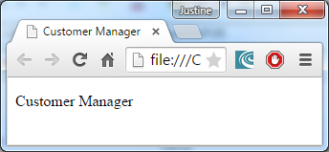

New browsers are already integrated with developer tools; these tools include a console for displaying errors and serve as a debugger. To access the development tools, the following key combinations can be pressed in the relevant browser:

|  |  |
| --- | --- |
| Browser | Keyboard |
| Firefox | F12 |
| Microsoft IE | F12 |
| Chrome | F12 |
| Safari | Ctrl + Alt + i |
| Opera | Ctrl + Alt + i |

Another debugging tool is the command console.log(), this is used to write immediate results to the console.

Add the following line to your code after <p>Customer Manager</p>:

<script type =”text/javascript”>

console.log(“this line is executed”);

</script>

Note that the console line is within an element called script with type = text/javascript: this is also a way of including javascript into your code in the header of your HTML file. Note that normal javascript syntax is applied to the code in the script element.

Save and run the HTML file, be sure the debugging console is opened, the following will appear:

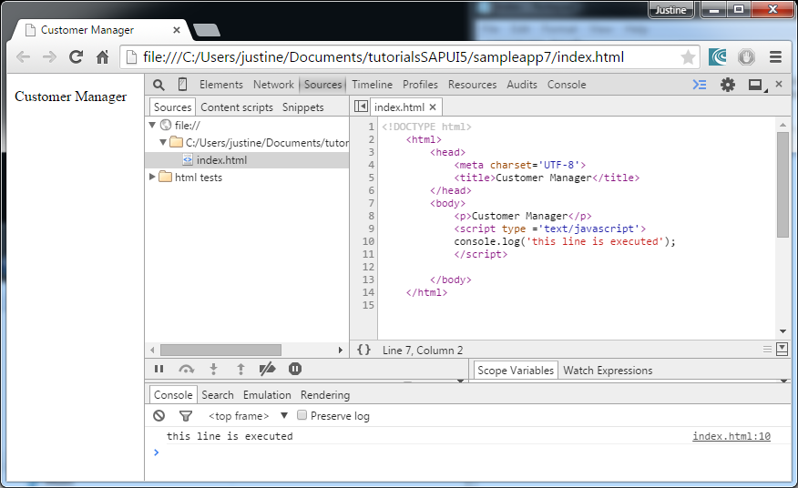

# Task 2: Integrate JavaScript as a separate file:

Create a text document with the following code:

function loaded(){

alert("page loaded");

}

Save the file as script1.js in the same directory as your CustomerManager.html file.

Edit your CustomerManager file as follow:

<!DOCTYPE html>

<html>

<head>

<meta charset=”UTF-8”>

<title>Customer Manager</title>

**<script src="script1.js" type="text/javascript"></script>**

</head>

<body **onload="loaded()">**

</body>

</html>

Save the file as CustomerManager.html and open it with your web browser, the result will look as follow:

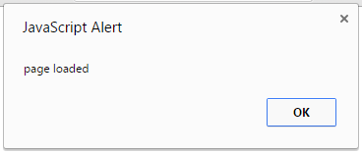

Explanation of code:

The java script are included as an external file into the HTML page. When the body is loaded, the onload() function is called and executed from the script.

# Task 3: Handle Events

Add a button to the body of your HTML page. In the event of your Button being pressed, the function ‘button1’ should be called and display a message.

Add a button to the body of your HTML file:

When the button is pressed, the “button1()” function will be called.

<button type="button" onclick="button1()">

button1

</button>

In your javascript file add a function that handles the onclick event:

function button1(){

alert("button was pressed");

}

Your result:

