SAP Mobility 101

Tutorial 4 – Document Object Model

# Objective of Exercise

## Build an example application

The objective of this exercise is to build an HTML page that uses JavaScript and use the DOM library.

## Note

* We recommend that you use a chrome browser for testing
* Any text editor will work for this example such as notepad or notepad++

Tutorial 4

Document Object Model

# Task 1: Create a form

Create a form with an input id=”UserInput”, and a button. Also add a <div> with id = “content”.

<form>

User Input: <input type="text" name="UserInput" id="UserInput">

<button type="button" onclick="button1()">

Submit</button>

</form>

<div id="content"></div>

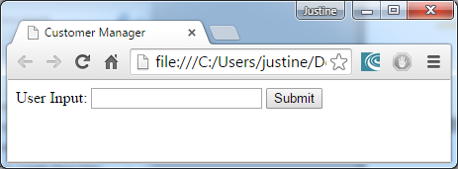

# Task 2: Get elements from the HTML page

In your js file under the button1() function, use the getElementById method to create a link to the user input and the output.

function button1(){

var Uinput = document.getElementById("UserInput");

var Output = document.getElementById("content");

};

# Task 3: Use User input and respond with text

Use the Uinput.value method to get the input from the user, compare it to another value and respond with two possible answers that can be printed to the screen.

function button1(){

var Uinput = document.getElementById("UserInput");

var Output = document.getElementById("content");

if(Uinput.value == "one"){

Output.innerHTML = "the word 'one' was entered";

}

else{

Output.innerHTML = "a word other than one was entered";

};

};

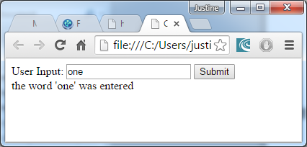

# Task 4: Change the style of the output

In the button1() function, change the background color of the output to red.

var Output = document.getElementById("content");

Output.style.backgroundColor ="red";

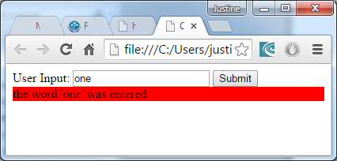

# Task 5: Load a picture to the screen

Save an image in the same directory as the other files.  
Position the image in the body under the form. Call a function init() as the body is loaded.

<body onLoad="init()">

<form>

User Input: <input type="text" name="UserInput" id="UserInput">

<button type="button" onclick="button1()">

Submit</button>

</form>

<div id="content"></div>

<div STYLE = "position:relative" ID="img">

<IMG SRC="demo_image.png">

</div>

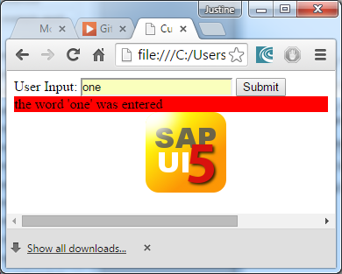

# Task 6: Animate the image

* Create a function that sets the picture ***n*** amount of pixels from the left:
  + function setL(n){

document.getElementById("img").style.left=n+"px";

}

* Create a function that gets the image’s position from the left.
  + function getL(){

return parseInt(document.getElementById("img").style.left);

}

* Create a function that tests the position of the image, if the image is <0 from the left, it means the image image should be moves a few px to the right, if the image is >0 from the left, move it to 0px from the left.
* Call the function again to repeat the process using the setTimeout method.
  + function animate(){

if(getL()>0){

setL(0);

}

if(getL()<1000){

setL(getL()+3);

setTimeout("animate()", 30);

};

};

* The init() function that is called when the body is initialized, should set the initial position of the image – 300px from the left, and start the animation.

# Task 7: Create an Event Listener

Create an event listener that displays an alert when clicked on the image.

Create an object with a link to the image, in a Eventhandle() function that is called in the init() function;

function init(){

setL(-300);

animate();

Eventhandle();

};

function Eventhandle(){

var Obj_img = document.getElementById("img");

};

Use the addEventListener method to create the event listener that calls a function imgHover();

function imgHover(){

alert("image Hovered");

};

function Eventhandle(){

var Obj_img = document.getElementById("img");

Obj_img.addEventListener(

'mouseover',

imgHover,

false

);

};

# Final code:

## HTML file:

<!DOCTYPE html>

<html>

<head>

<meta http-equiv="X-UA-Compatible" content="IE=edge">

<meta charset='UTF-8'>

<meta http-equiv='Content-Type' content='text/html;charset=UTF-8'/>

<script src="resources/sap-ui-core.js"

id="sap-ui-bootstrap"

data-sap-ui-libs="sap.m, sap.ui.table"

data-sap-ui-theme="sap_bluecrystal">

</script>

<meta charset='UTF-8'>

<title>Customer Manager</title>

<script src="script1.js" type="text/javascript"></script>

</head>

<body onLoad="init()">

<form>

User Input: <input type="text" name="UserInput" id="UserInput">

<button type="button" onclick="button1()">

Submit</button>

</form>

<div id="content"></div>

<div STYLE = "position:relative" ID="img">

<IMG SRC="demo_image.png">

</div>

</html>

## Script1.js file:

function init(){

setL(-300);

animate();

Eventhandle();

};

function button1(){

var Uinput = document.getElementById("UserInput");

var Output = document.getElementById("content");

Output.style.backgroundColor ="red";

if(Uinput.value == "one"){

Output.innerHTML = "the word 'one' was entered";

}

else{

Output.innerHTML = "a word other than one was entered";

};

};

function init(){

setL(-300);

animate();

Eventhandle();

};

function setL(n){

document.getElementById("img").style.left=n+"px";

};

function getL(){

return parseInt(document.getElementById("img").style.left);

};

function animate(){

if(getL()>0){

setL(0);

}

if(getL()<1000){

setL(getL()+3);

setTimeout("animate()", 30);

};

};

function Eventhandle(){

var Obj_img = document.getElementById("img");

Obj_img.addEventListener(

'mouseover',

imgHover,

false

);

};

function imgHover(){

alert("image Hovered");

};