SAP Mobility 101

Tutorial 5 – Your First SAPUI5 Page

# Objective of Exercise

## Build an example application

The objective of this exercise is to build an HTML page that uses JavaScript.

## Note

* We recommend that you use a chrome browser for testing
* Eclipse Luna will be needed for this tutorial

Tutorial 5

Create your first SAPUI5 Application

# Task 1: Start a project in Eclipse:

For this project we will not use the MVC pattern. To start a new project, choose the menu path: **File>New>Project**, the following screen will appear:

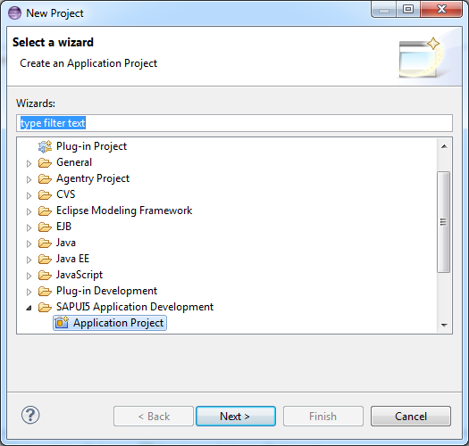

Select Application Project under SAPUI5 Application Development, click next.

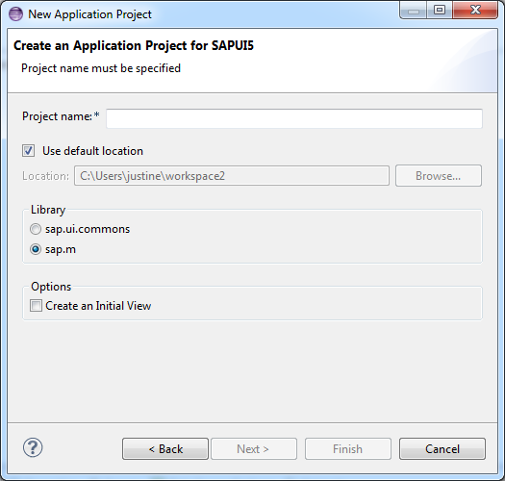

Enter an appropriate Project name, for this example use: SUI5_demo1, ensure that sap.m are selected. For the project to be created without the MVC pattern, deselect the ‘Create an Initial View’ option. Click Finish.

A project will be created with the following structure:

* Libraries
* Content
* Bootstrap
* Application
* UI area

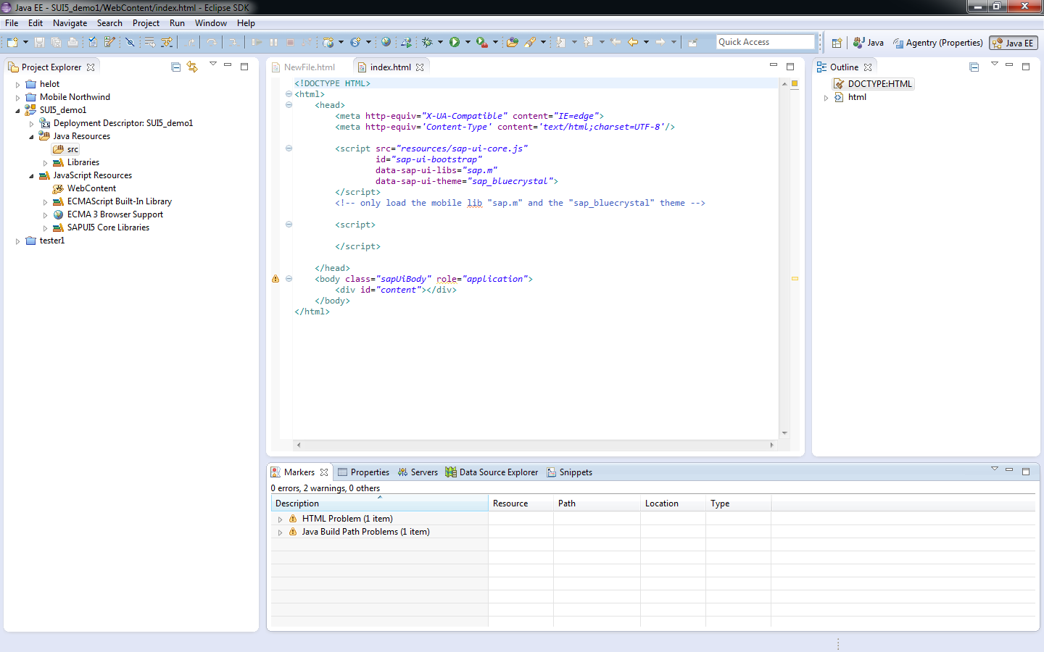

UI area

Application

Bootstrap

Libraries

Content

Console

# Task2: Create a button that displays an alert:

In your Project explorer go to the following folder:

JavaScript Resources>SAPUI5 Core Libraries>sap.m>Button this file contains the methods for the Button class that can be used, the following class will be used: Button(sId, mSettings).

In the <script></script> area start typing your JavaScript code:

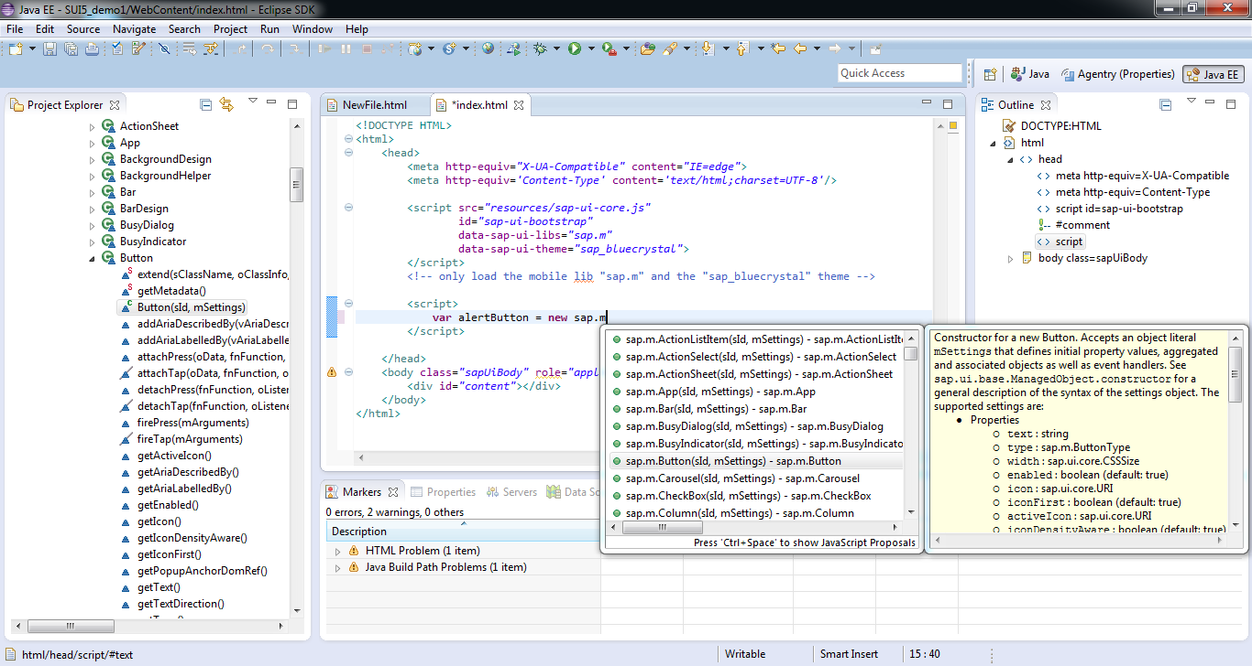

Eclipse has the ability to show all available classes in the library that you can use. Create a new button labeled ‘click’ from the sap.m library that calls a function that displays an alert saying ‘alert!’.

<script>

**var** alertButton = **new** sap.m.Button({

text: "click",

press: alertButtonHandler });

**function** alertButtonHandler(){

alert("alert!");

};

</script>

Note: The notation used in the sap.m.Button method is called JSON notation. To set these properties, the GET and SET methods can also be used.

Your application must be transferred to the UI area so the user can see it.

This can be achieved by the placeAt function from the sap.ui.core.control class:

alertButton.placeAt("content");

The button will be placed in the division with id=”content”.

Save the project.

In eclipse go to the menu option: **Run>Run as> Web app preview**

The following screen will appear as a result:

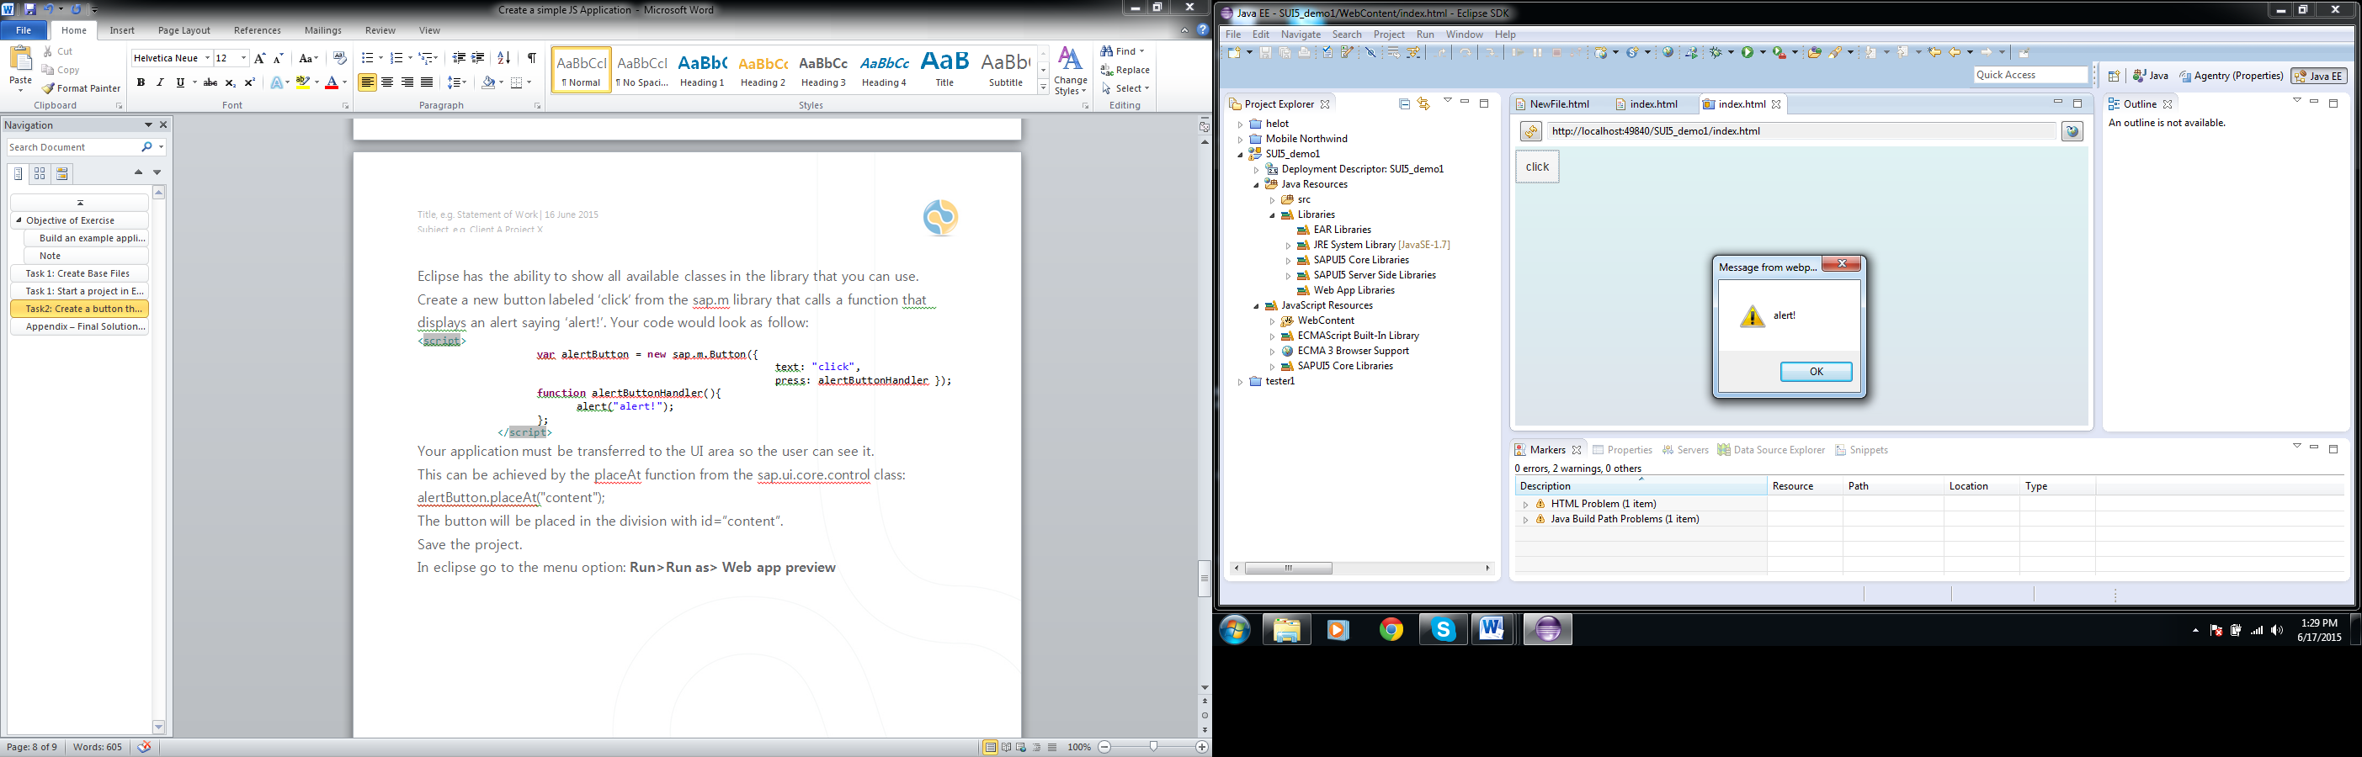

This was you first basic SAP application