**Laboratory Activity**

**Web Systems and Technology**

**Midterm**

Procedure:

* Open your individual unit and check your current PHP version using the command prompt see sample image below : Write the command in the black provided

_____________________________________________

* Then open the XAMPP control panel (see image)

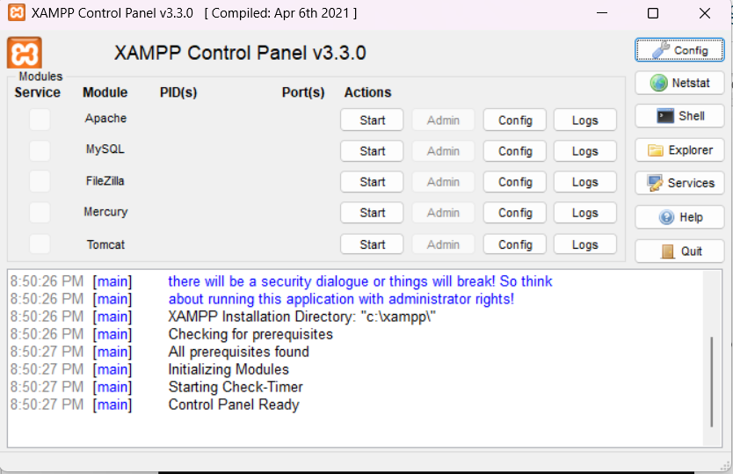

Make sure to click the Start button to open the Apache and MySQL

* Once it green your server is now running

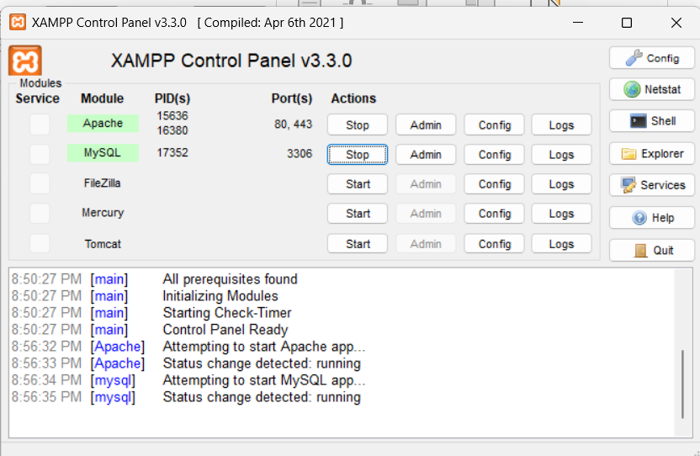

* Make sure to check the ports of Apache and MySQL as follows

* Your now ready to test your server
* Access the XAMPP dashboard in a browser
  + Open your preferred web browser and type http://localhost into the address bar and press **Enter**.
  + If XAMPP is working correctly, you will see the XAMPP welcome page, which confirms the Apache web server is running.

* + Alternatively, you can type http://127.0.0.1 to get the same result.
* Next, open your VS code app if the following Extension are available and properly installed
  + PHP server
  + Live server
  + PHP intelephense

* Once installed start your first PHP code

**First thing first create a folder inside your XAMPP**

* **Locate your root folder**. Open the XAMPP Control Panel and click the **Explorer** button to navigate to your installation directory, typically **C:\xampp\ on Windows**.

* **Find htdocs**. Open the htdocs folder. This is the root directory for all your web projects.

* **Create a project folder**. Create a new folder inside htdocs for your project (e.g., C:\xampp\htdocs\MyWebsite(any name you set)).
* **After creating the Filename inside htdocs, open your VS CODE app then**
* **Then locate this folder as show in the image below**

* **Save your projects**
  + you need to save your files in the correct directory.
* Create at least one sample code using the following.
  + Concatenate String

* + Math Functions

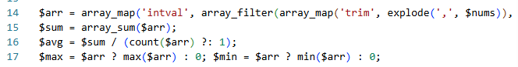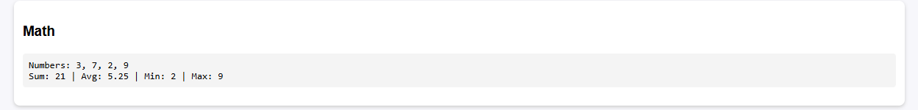

* + Loops
  + Constants
  + PHP Superglobals
  + Sample Form Handling

Note: Don’t forget to save your sample with PHP extension (e.g index.php)

* Display an output for each sample
  + **Access your project**. To view your website, go to your browser then type  <http://localhost/MyWebsite> (or the name you set)  . If you created a specific file, such as index.php, you would visit <http://localhost/MyWebsite/index.php> (or the filename you saved)

Activity 2 – Laboratory Activity

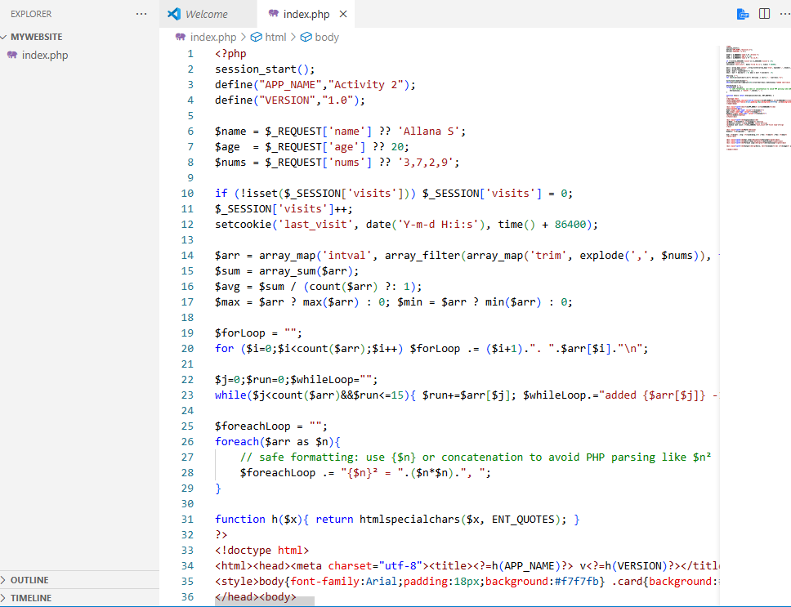

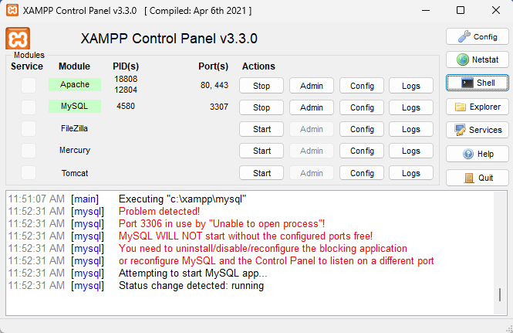

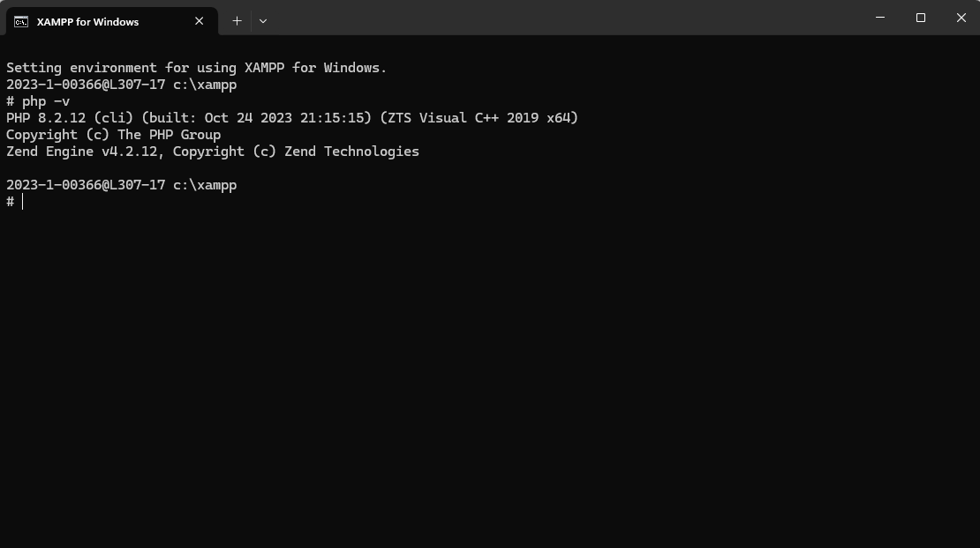

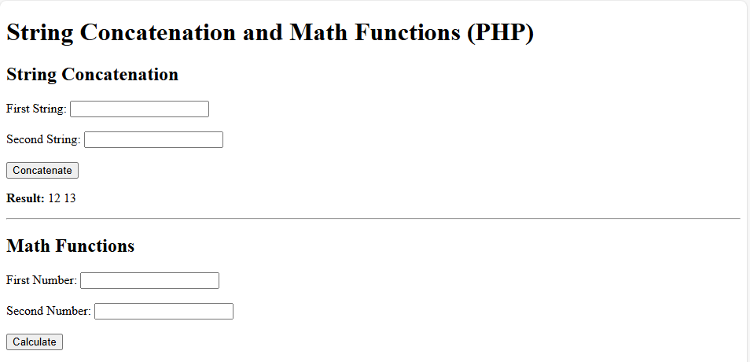

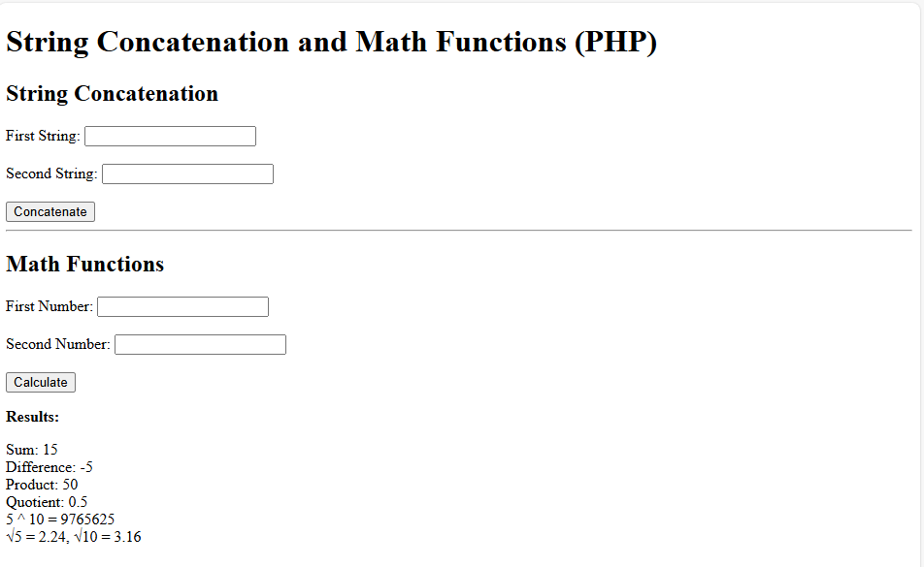

<!DOCTYPE html>

<html>

<head>

  <title>String Concatenation and Math Functions (PHP)</title>

</head>

<body>

  <h1>String Concatenation and Math Functions (PHP)</h1>

  <!-- Form for string concatenation -->

  <h2>String Concatenation</h2>

  <form method="post">

    <label>First String:</label>

    <input type="text" name="str1"><br><br>

    <label>Second String:</label>

    <input type="text" name="str2"><br><br>

    <input type="submit" name="concat" value="Concatenate">

  </form>

  <?php

    if (isset($_POST['concat'])) {

      $str1 = $_POST['str1'];

      $str2 = $_POST['str2'];

      $result = $str1 . " " . $str2;

      echo "<p><strong>Result:</strong> $result</p>";

    }

  ?>

  <hr>

  <!-- Form for math functions -->

  <h2>Math Functions</h2>

  <form method="post">

    <label>First Number:</label>

    <input type="number" name="num1" step="any"><br><br>

    <label>Second Number:</label>

    <input type="number" name="num2" step="any"><br><br>

    <input type="submit" name="calculate" value="Calculate">

  </form>

  <?php

    if (isset($_POST['calculate'])) {

      $num1 = $_POST['num1'];

      $num2 = $_POST['num2'];

      if ($num1 === "" || $num2 === "") {

        echo "<p>Please enter valid numbers.</p>";

      } else {

        $sum = $num1 + $num2;

        $difference = $num1 - $num2;

        $product = $num1 * $num2;

        $quotient = ($num2 != 0) ? round($num1 / $num2, 2) : "undefined";

        $power = pow($num1, $num2);

        $sqrt1 = round(sqrt($num1), 2);

        $sqrt2 = round(sqrt($num2), 2);

        echo "<p><strong>Results:</strong></p>";

        echo "Sum: $sum <br>";

        echo "Difference: $difference <br>";

        echo "Product: $product <br>";

        echo "Quotient: $quotient <br>";

        echo "$num1 ^ $num2 = $power <br>";

        echo "√$num1 = $sqrt1, √$num2 = $sqrt2";

      }

    }

  ?>

</body>

</html>