**BSPO Account**

**Sidebar-Dashboard**

**Sidebar**-**Household**

Add Household Head

Household Heads

|  |  |  |  |  |  |  |  |  |  |  |  |  |  |  |  |  |  |
| --- | --- | --- | --- | --- | --- | --- | --- | --- | --- | --- | --- | --- | --- | --- | --- | --- | --- |
| Household Number | Family Number | Name | sex | Civil Status | Date of birth  (mm/dd/yy) | Age | Relationship | Highest Educational Attainment | Occupation | FP Method | PWD | Senior Citizen | Out of School Youth | How long you staying in the Brgy | Previous Address | Remarks | Actions |
|  |  |  |  |  |  |  |  |  |  |  |  |  |  |  |  |  | Add Family Members |

Pag i-click ya an button na “Add Household Head” may magawas na modal tas it mga field amo ito na aada ha table

Ha FP method ya (Family planning Method) dropdown hya tas adi it choices

-Vasectomy

-Tubal Ligation

-Implant

-Condom

-IUD

-Pills

-Injectable

-NFP

Tas ha relationship ya dropdown ghap tas adit choices (Father, Mother, Son, Daughter, Other- pag other ya ma input la hra)

Ha Highest Education Attainement adi it choices

(Day care,

Nursery,

Kinder,

Elementary Level,

Elementary Grad,

ALS High School,

High School Level,

High School Grad,

Senior High,

Vocational,

College Level,

College Grad,

Post Graduate)

OCCUPATION choices:

GOVERNMENT EMPLOYEE

PRIVATE EMPLOYEE

BARANGAY EMPLOYEE

BARANGAY VOLUNTEERS

OFW

BUSINESS

CARPENTER

LABORER/CONSTRUCTION

DRIVER

SARI-SARI STORE

HELPER

VENDOR

SELF-EMPLOYED (MANICURIST, PEDICURIST, BARBER, LAUNDRY AND ETC.)

OTHERS: Pwde hya makag input ya kun others it iya pillion may label na “Please Specify”

Tas an PWD, Senior Citizen ngan out of School youth yes /no la hya. Ikaw nala bahala ya mag design para hne na modal

Pag ig click lwt ya an “Add family Members” ha actions, same la ghap na modal an magawas pero waray na an field na “Household Number”

**Sidebar-Family Information Records**

Same la ghap ya an table ha household, pero tanan na gn add (Household Head and Family Members) aanhi makikita ha table tas an action ya balyuan la hn edit

Tas pwde hya ya ma export ha excel

**Sidebar- Business Establishments**

Add Establishment

|  |  |  |  |
| --- | --- | --- | --- |
| Name of Business Establishment | Type of Business | Name of Owner | Action |
|  |  |  | Edit |

List of Business Establishments

Amo la ito na field ya it kailangan inputan.

Pwde Ma export ha excel

**Sidebard-Reports (**Upload Documents)

**BNS Account**

**Sidebar- OPT plus**

**Preschooler Nutritional Status**

Add Child or Preschooler

|  |  |  |  |  |  |  |  |  |  |  |  |  |  |  |
| --- | --- | --- | --- | --- | --- | --- | --- | --- | --- | --- | --- | --- | --- | --- |
| Purok | Household Number | Name of Household head/Mother/Caregiver | Name of Preschooler | Sex | Birthday  (Yr-Mo-day | Weight | Length/  Height | Age in  Months | Weight (kg) | Length/  Height  (cm) | Weight  for age | Length/  Height  for Age | Weight  for  Length/height | Action |
|  |  |  |  |  |  |  |  |  |  |  |  |  |  | Edit |

Codes for Nutritional Status:

Pag click hadto na “Add child or Preschooler” may magawas na modal ya para pag fill up tas it mga fields amo ito na ada ha table ya. Ikaw nala bahala mag design ghap ya.

An **weight for age** dropdown hya ya adi it choices (Normal, Underweight, Severely Underweight, Overweight)

An **length/Height for age** dropdown ghap (Normal, Stunting, Severely Stunting, Tall)

An **weight for length/height** dropdown ghap (Normal, Wasted, Severely Waisted, Overweight, Obese)

-Pwde ma export ha excel

**Sidebar- Reports**

**Upload Documents**

**Secretary account**

**Sidebar additional- Summon Letter**

**Add Summon Letter**

|  |  |  |  |  |
| --- | --- | --- | --- | --- |
| **Complainant** | **Respondent** | **Barangay Case Number** | **Date and Time** | **Actions** |
|  |  |  |  | **Print, Edit** |

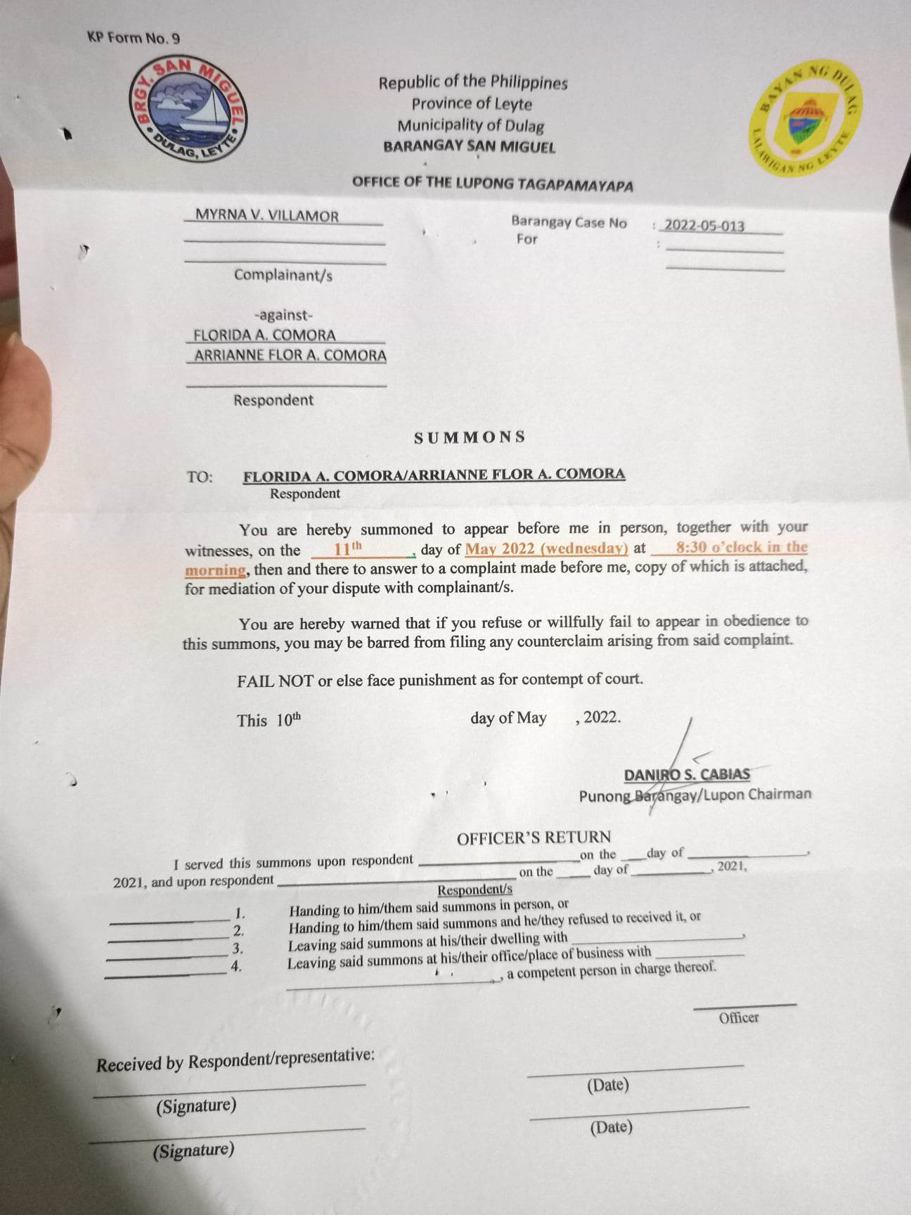

Adi it format ya han letter, pag click han print may magawas anay an pareho ha certificate pag print ma input anay kun pera an bayad, tas ma rerecord ghap ito hya ya ha revenue.

**Dashboard (Basta amo ine tanan ya it ada ha dashboard)**

Pinaka title ha dashboard “ General Information of Barangay 6-A”

-Descriptive Analytics (Title: Population Count by Year)

2019- 1,511

2020 – 1654

2021 – 1610

2022 – 1570

-COVID Chart

-Population Chart (male, female, pwd, Out of school youth, 4ps and mcct, Senior Citizen)

-Age Structure (Young dependent 0-14, Working Population 15-64, Old dependents 65 above)

-Educational Attainment ( graph ine hya ya, macocount for example kun pera an mga high school grad)

-Occupation (same ha educational attainment)

-Revenue chart

|  |  |
| --- | --- |
| Land Area | 3.04 ha |
| Population Density | 477.96 pers |

Default lat na table ya