Bugs

* Ha health services waray po an mother na choices. Dapat 3 it hra dida

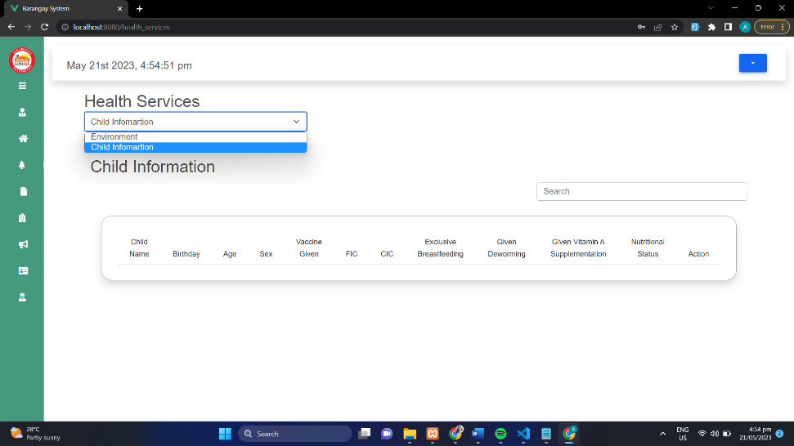

* Search bar BSPO, BHW and BNS not working.
* Eye button in reports not working
* Paki tanggal po an delete button ha barangay officials na sidebar ha tanan na accounts.
* Pag mag add po hn household or family members authomatic po dapat na magkakamayda ghap account ito na resident same po han amon dati na system an ira UI.
* Ha family information record na sidebar dapat po mayda button for request certification same po han amon dati na resident information na sidebar. Pero ha captain ngan secretary account lat mayda.
* Tas dapat po pag mag-add hn household or family members same ghap nam dati na system na ma rerecord an ira name ha covid 19 na sidebar tas for edit nalang an ira vaccination status