

**LODGE**

**USER MANUAL**

**TechWave 2023**

Carlloyd Viray

Justine Leung Furuganan

**REGISTERING NEW ACCOUNT**

1. Navigate to register new account button.

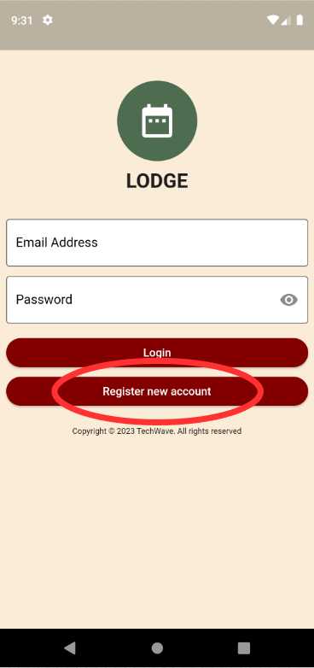

1. Input Credentials
   1. Staff
      1. Input Credentials

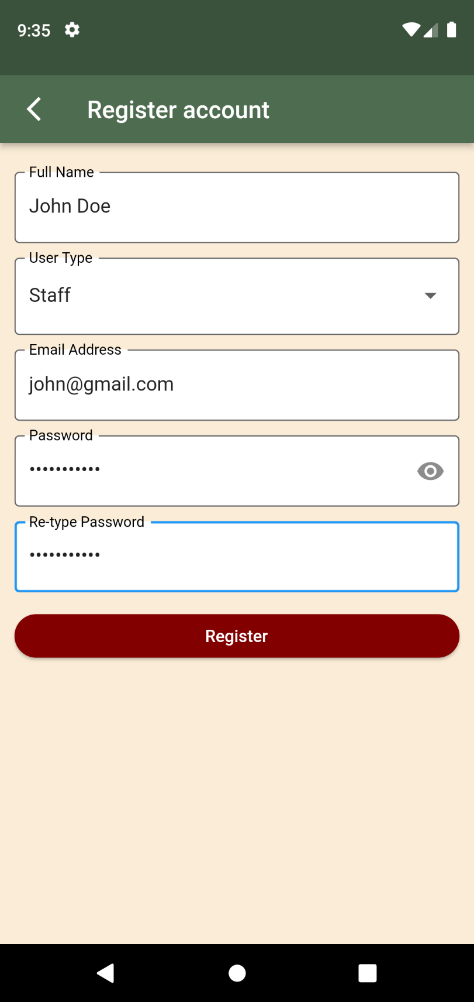

* + 1. After Signing up, app will redirect to staff home screen.

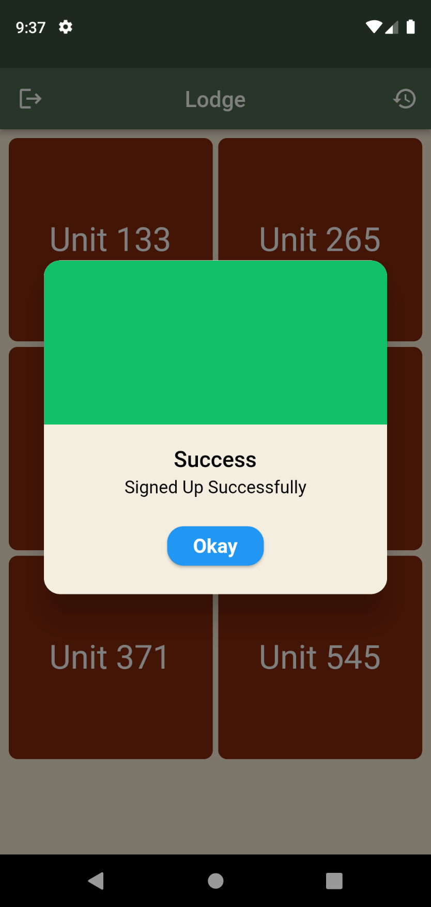

* 1. Admin
     1. Input Credentials

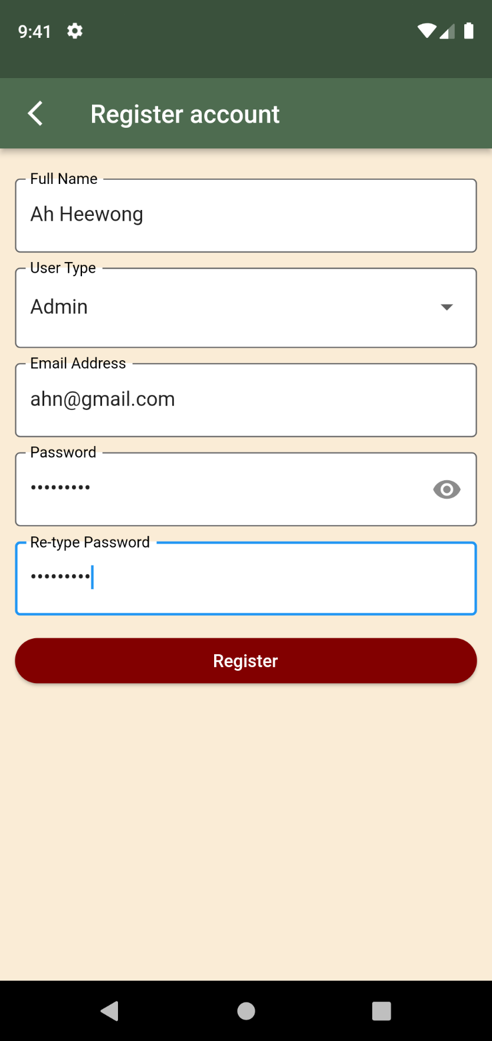

* + 1. Input PIN: 1216 (PIN can be change in database)

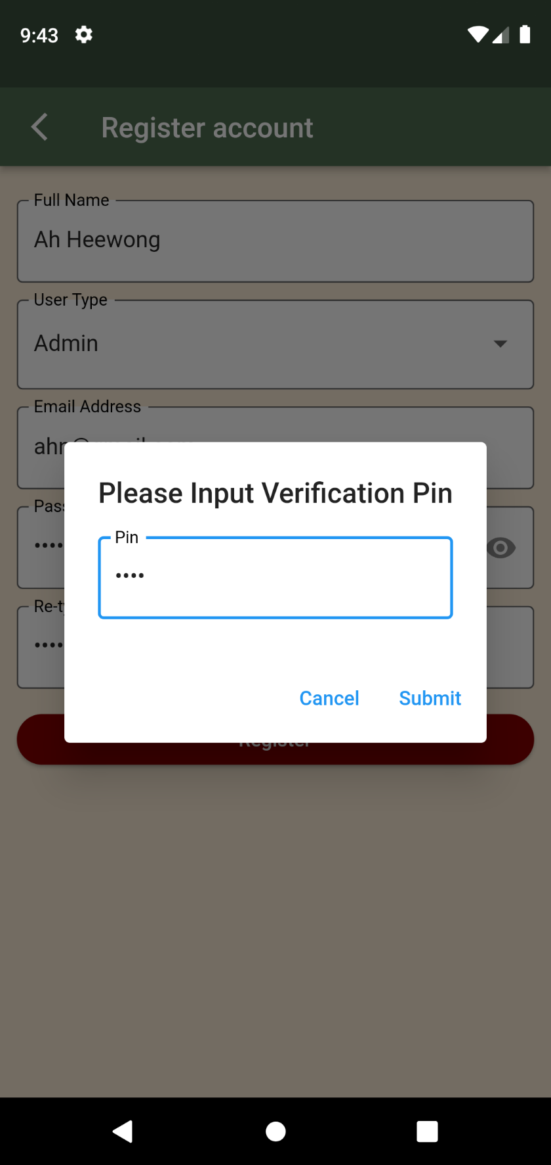

* + 1. After Signing up, app will redirect to admin home screen.

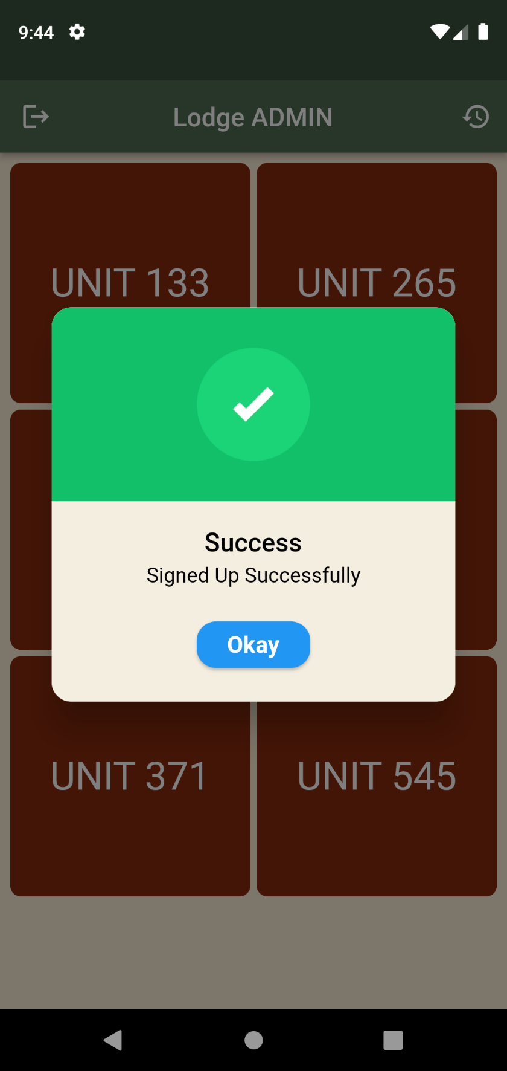

**VIEWING AND EDITING OF SCHEDULES FOR STAFF USERS**

1. Navigate to a Unit

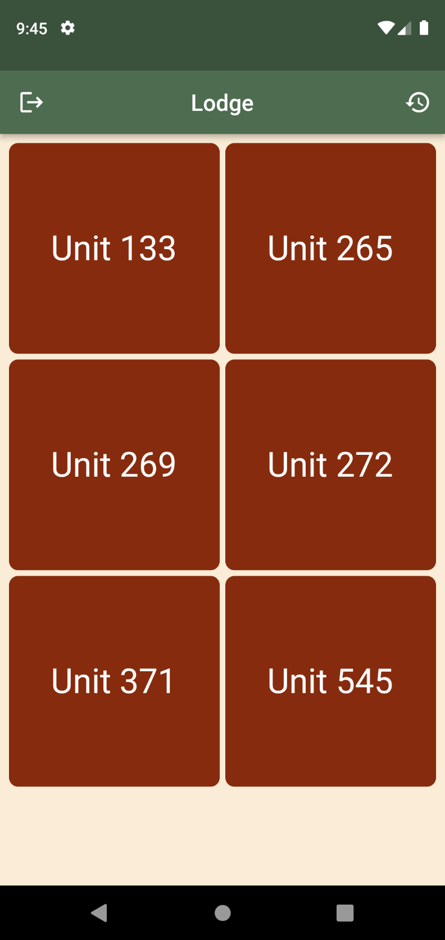

1. Overall Calendar viewing

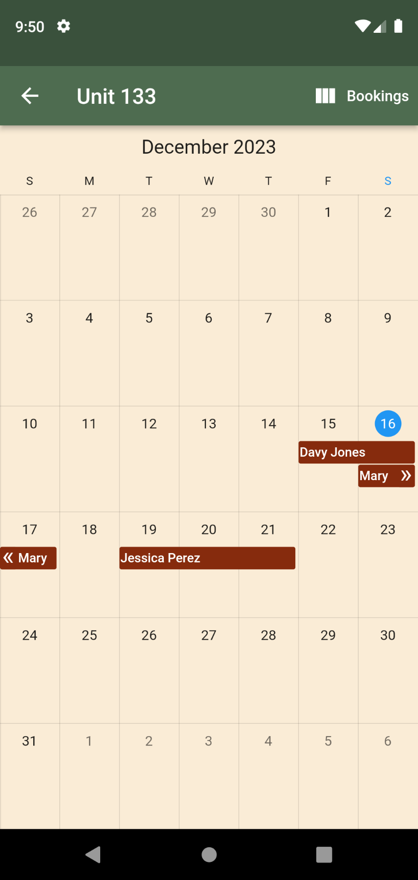

1. Navigate to Bookings tab

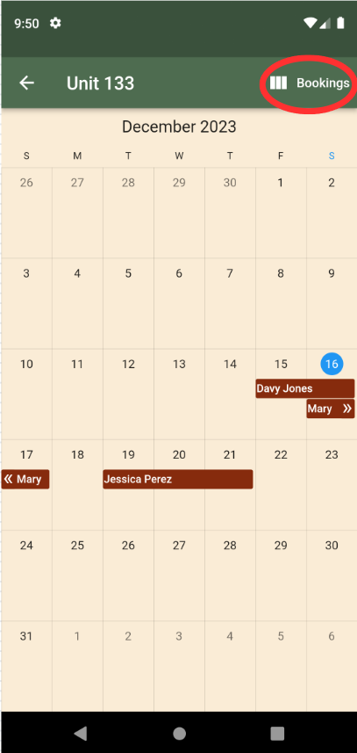

1. View all bookings with check mark indication whether the booking date has already passed.

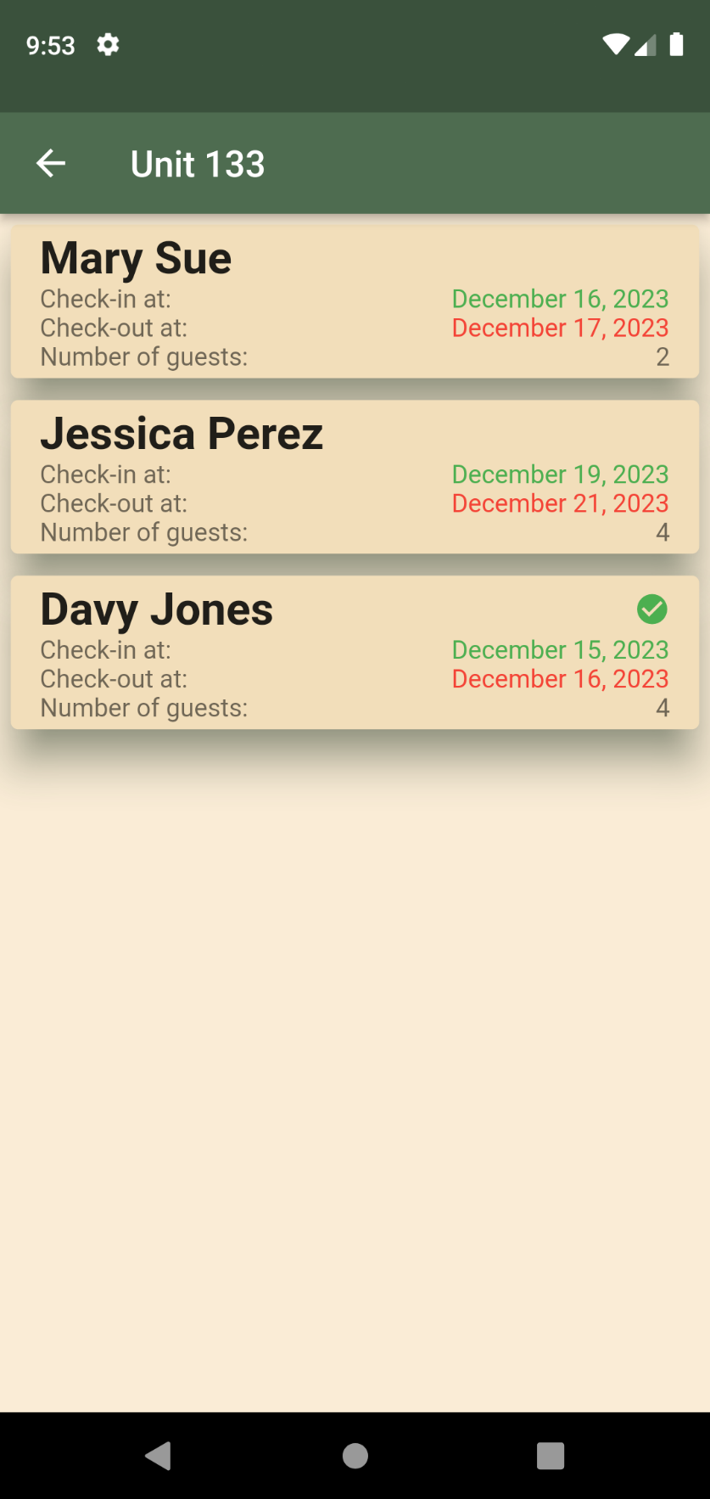

1. Clicking any booking will direct to full booking details.

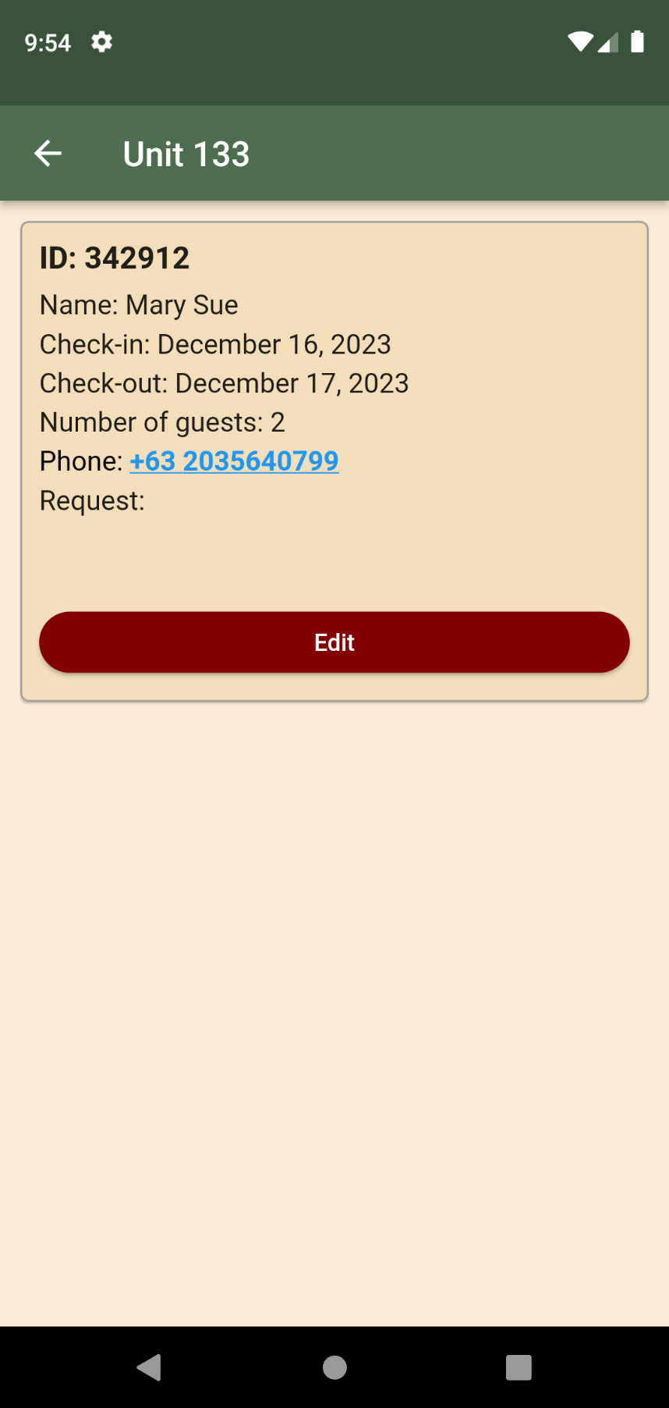

1. Staff can only edit number of guests and requests inputs.

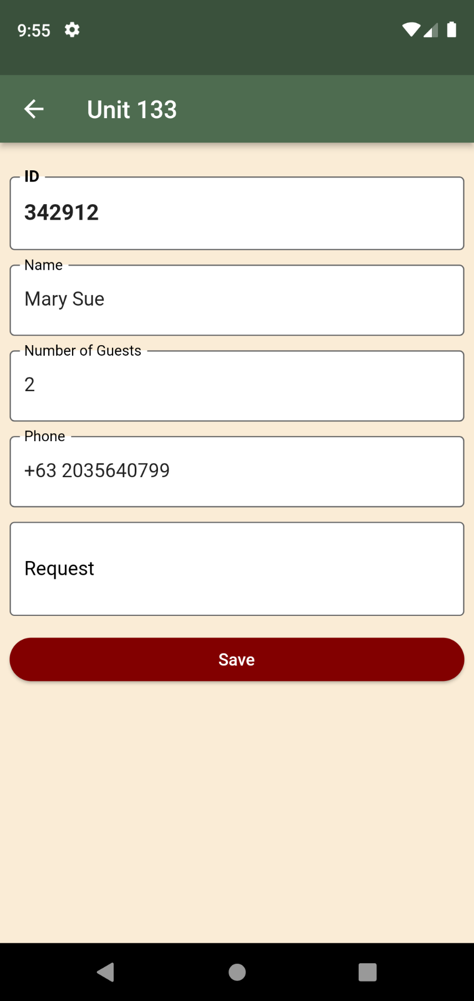

**VIEWING, ADDING, EDITING, AND DELETING SCHEDULES FOR ADMIN**

1. Navigate to any Units

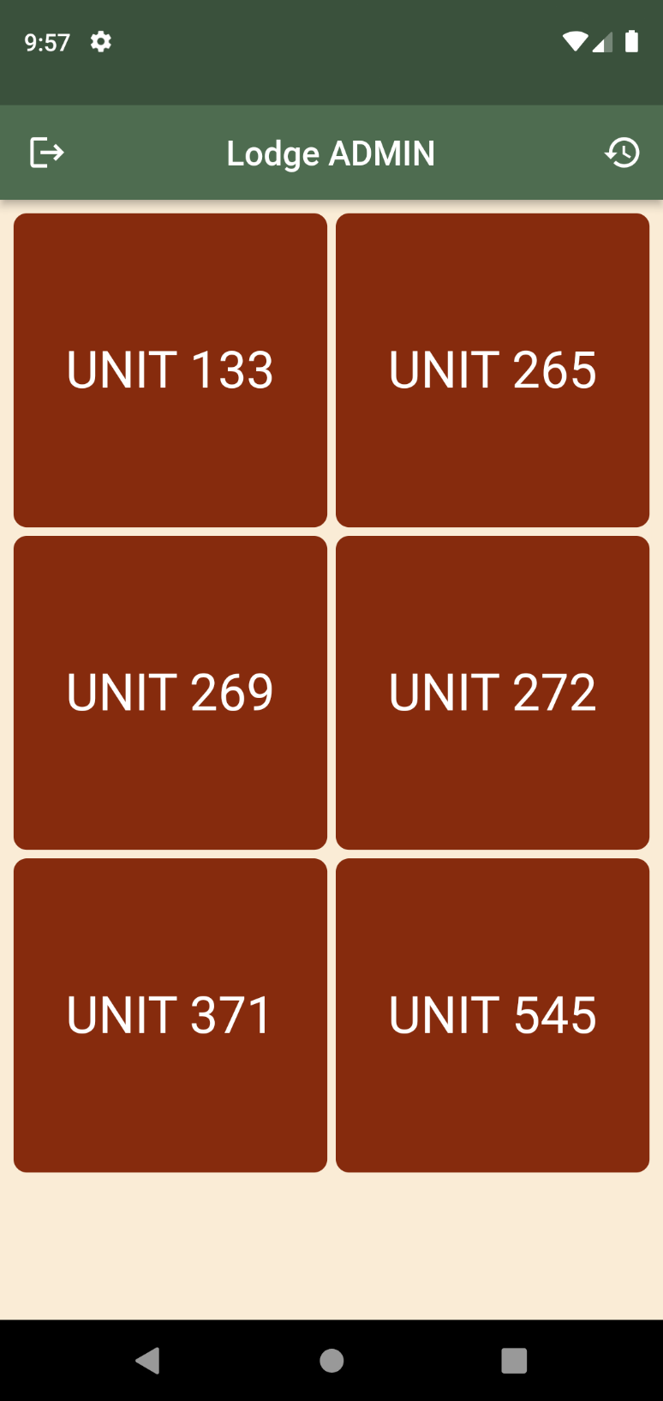

1. Overall Calendar viewing

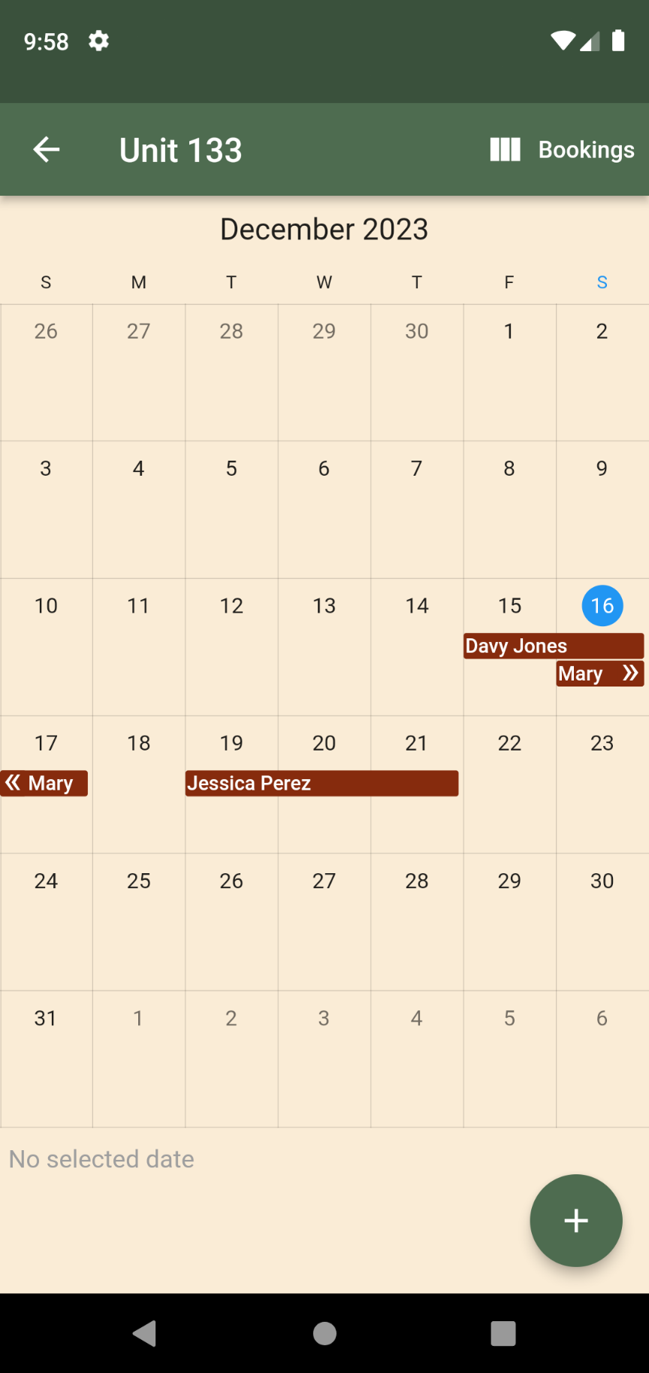

1. Click add button to add booking.

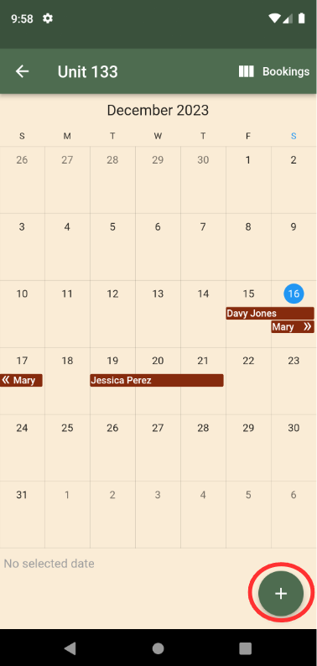

1. Add booking details

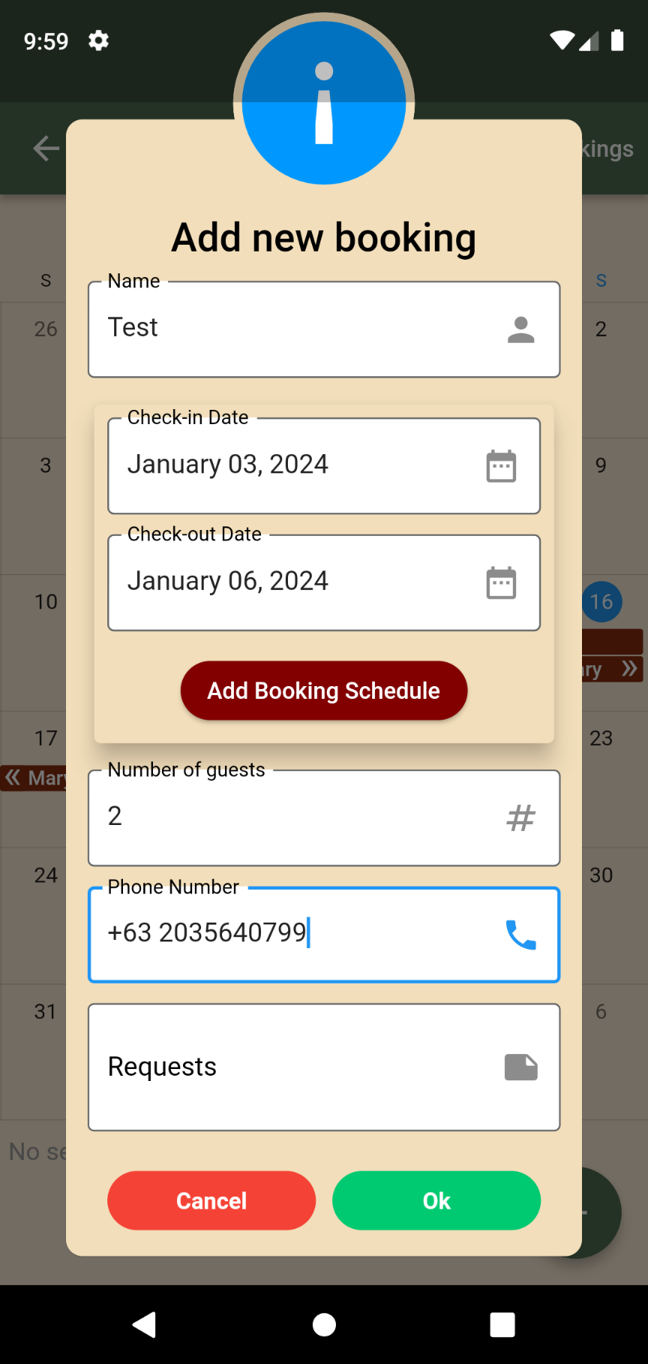

1. Booking added successfully

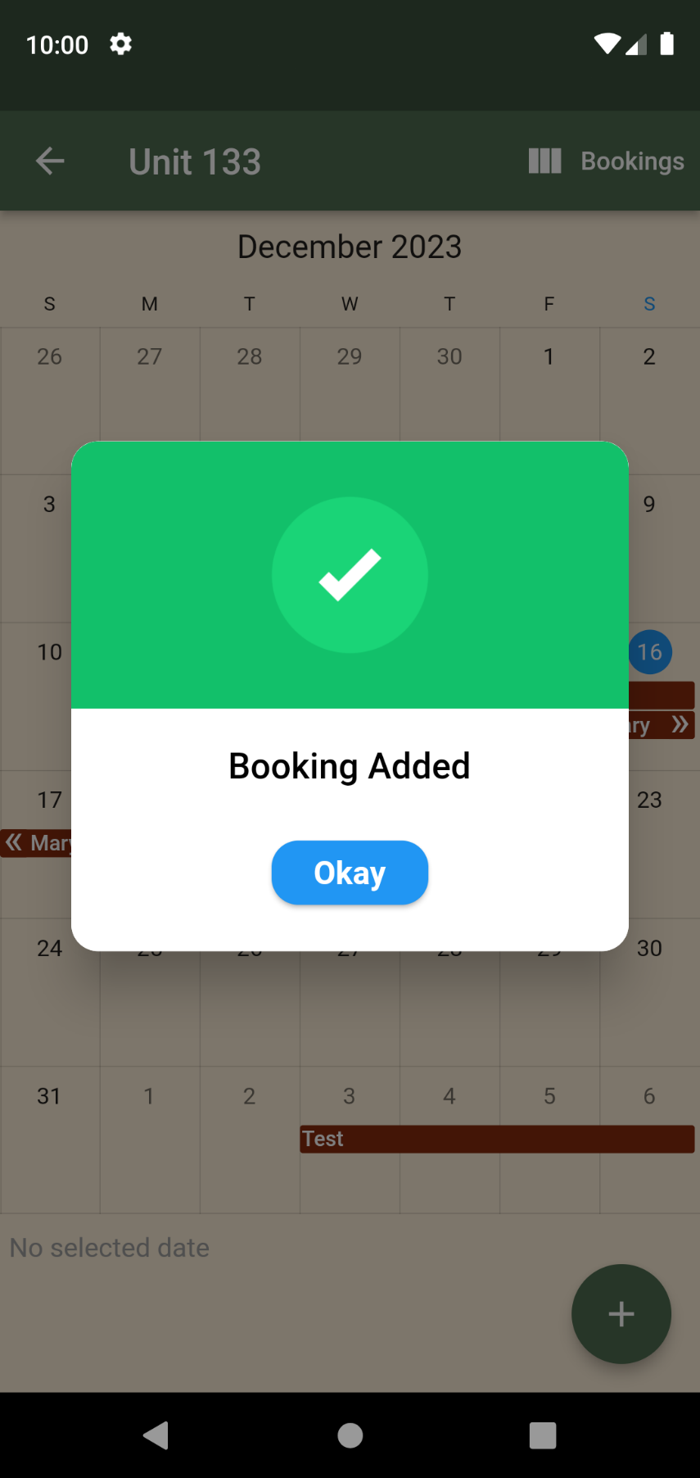

1. Go to bookings tab

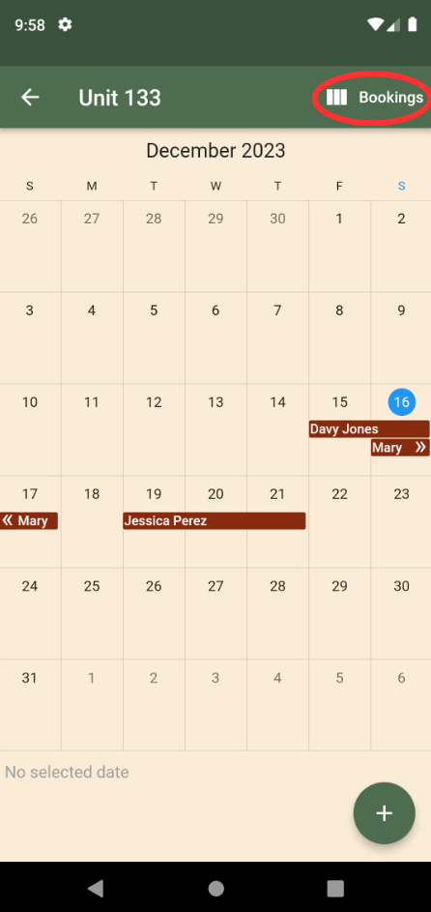

1. View all bookings with check mark indication whether the booking date has already passed.

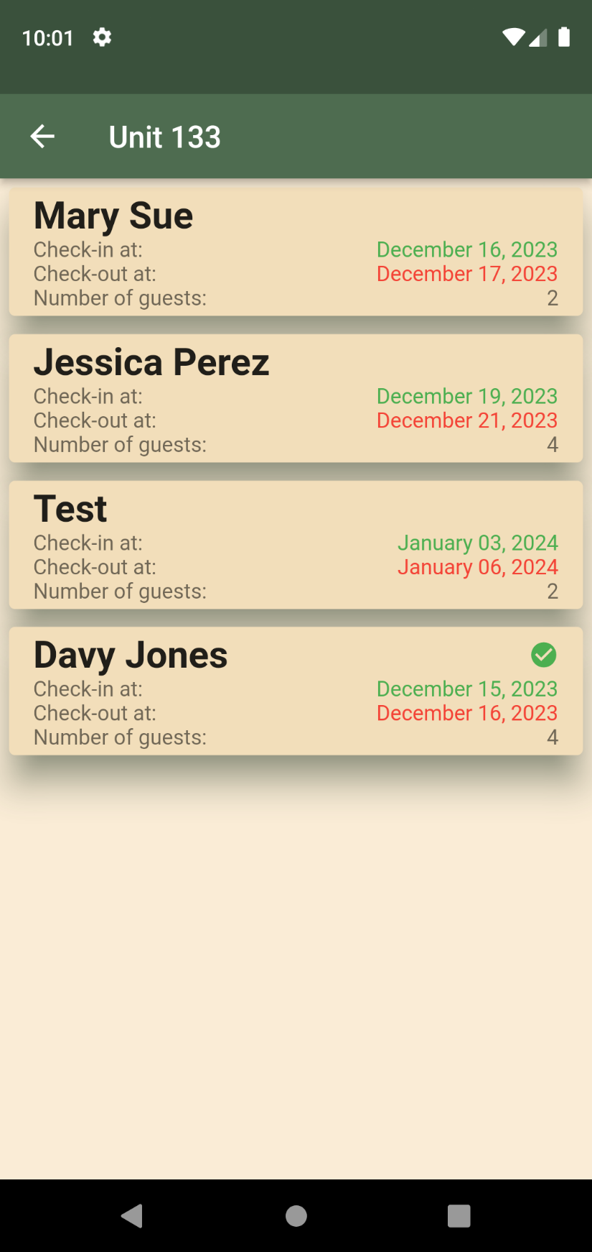

1. Clicking any booking will direct to full booking details.

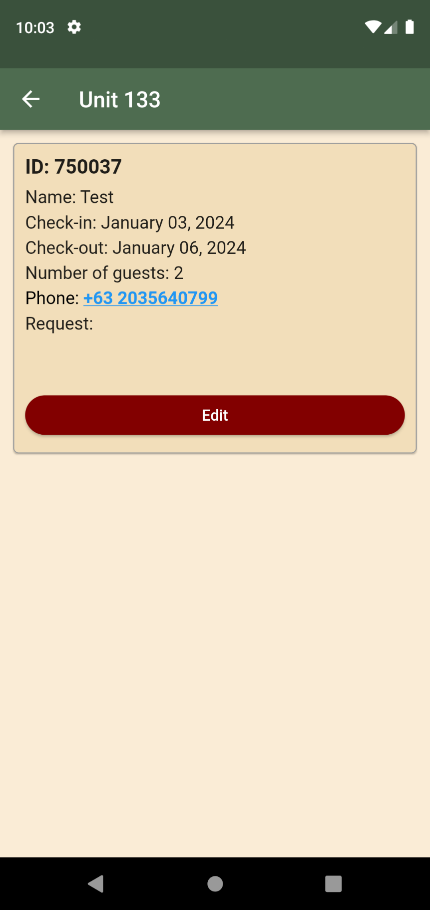

1. Admin Users can edit all booking input details.

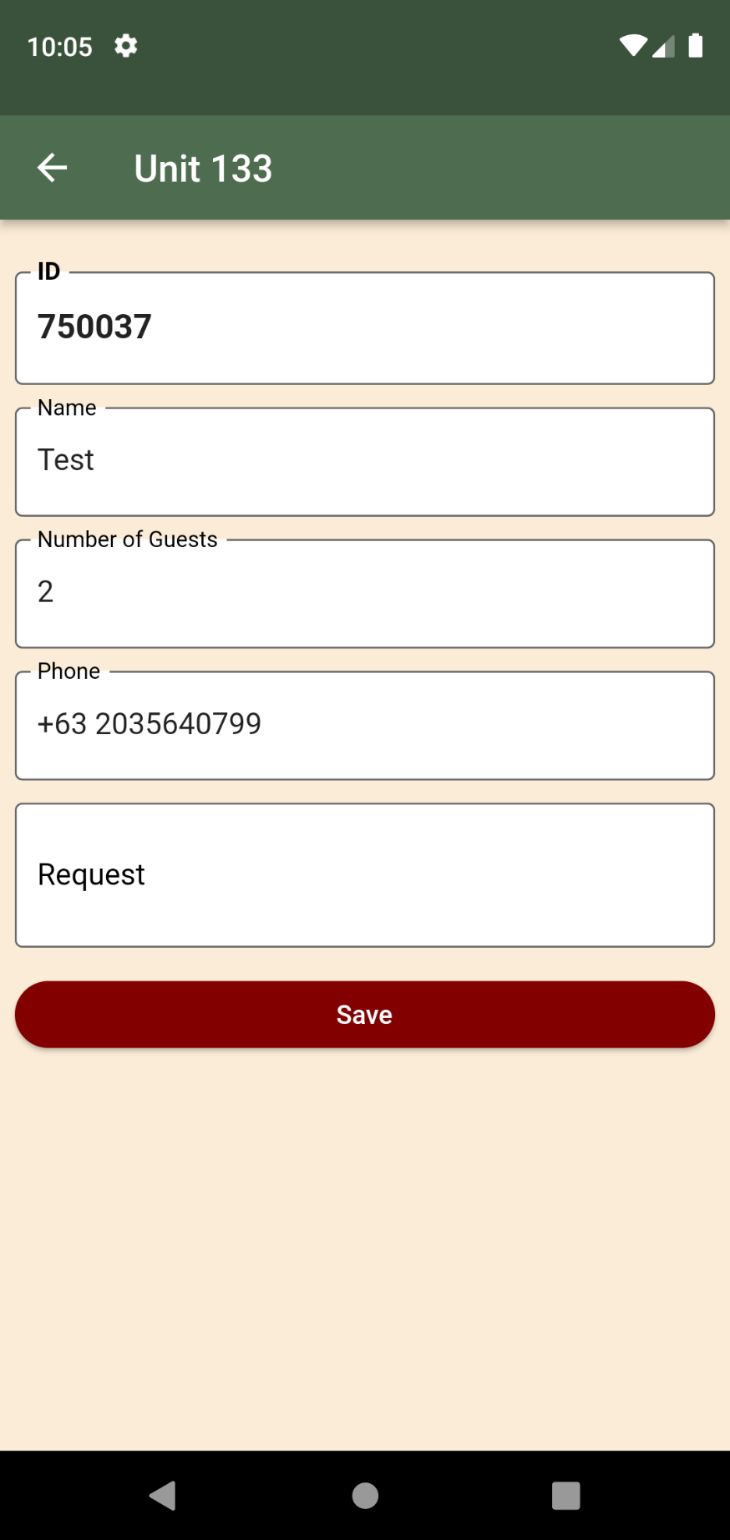

1. Press and hold booking to delete/cancel booking.

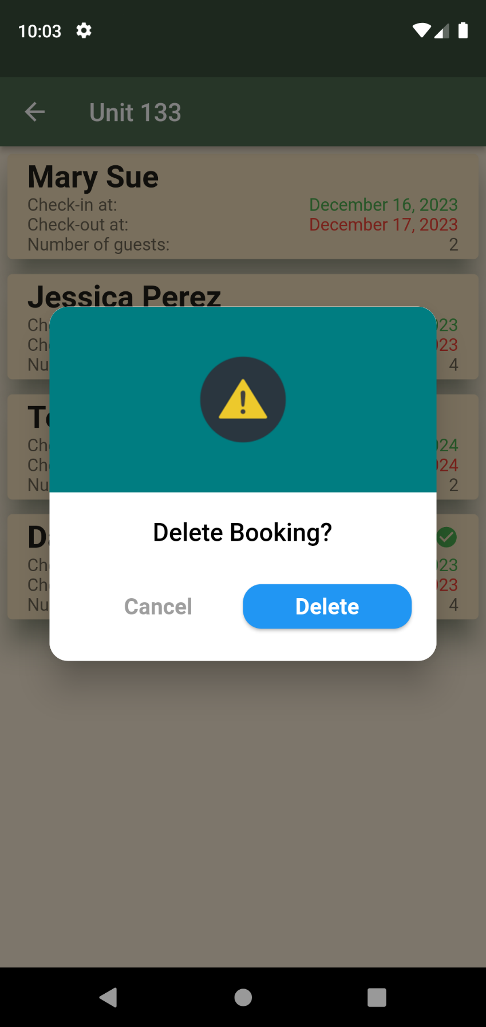

**CHECKING HISTORIES TAB**

1. Navigate to Histories tab.

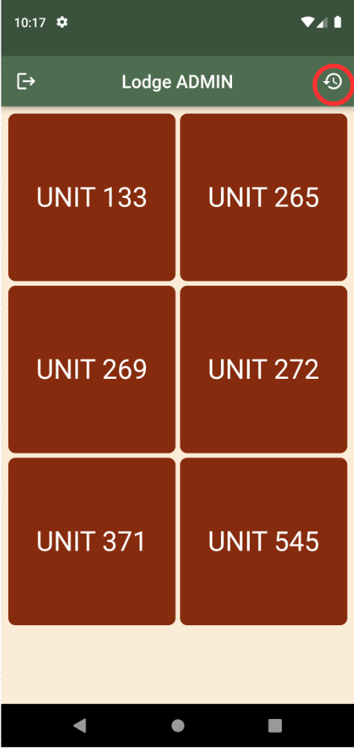

--- OR ---

1. Click Notifications.

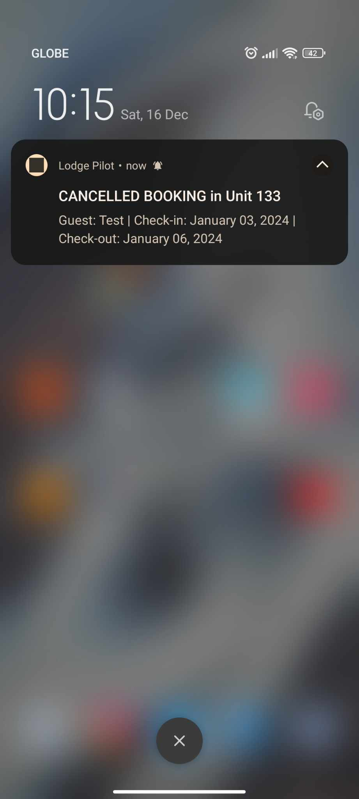

1. Viewing of histories of bookings.

