

**ORDONEZ_VET**

**USER MANUAL**

**TechWave 2023**

Carlloyd Viray

Justine Leung Furuganan

**REGISTERING NEW ACCOUNT**

1. Navigate to register new account button.

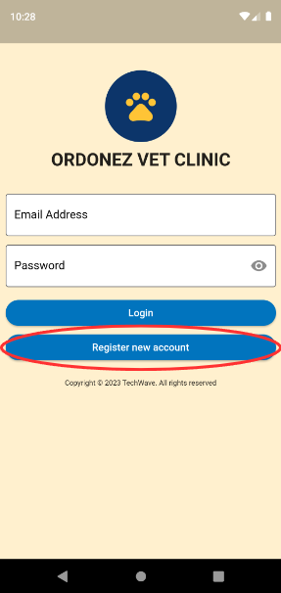

1. Input Credentials.
   1. Client
      1. Input Credentials

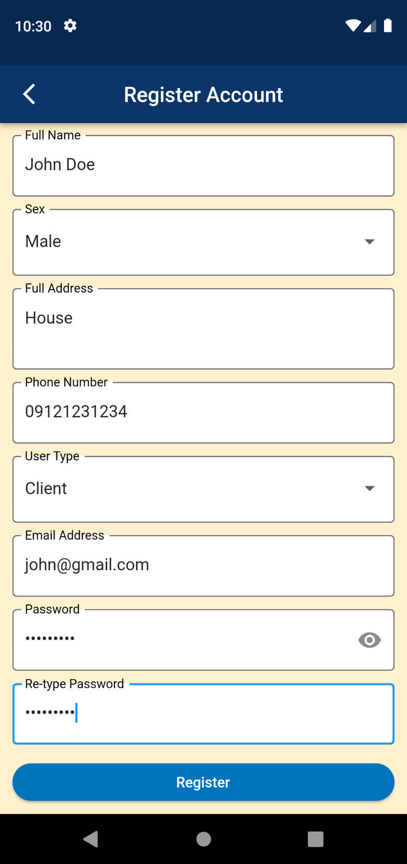

* + 1. After Signing up, app will redirect to client home screen.

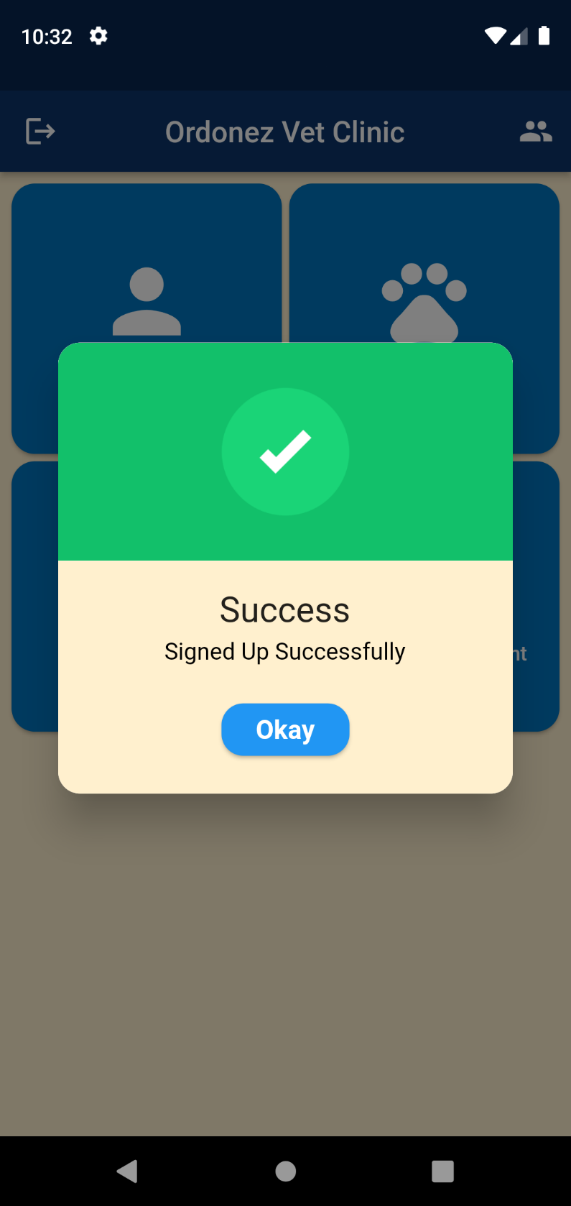

* 1. Admin
     1. Input Credentials

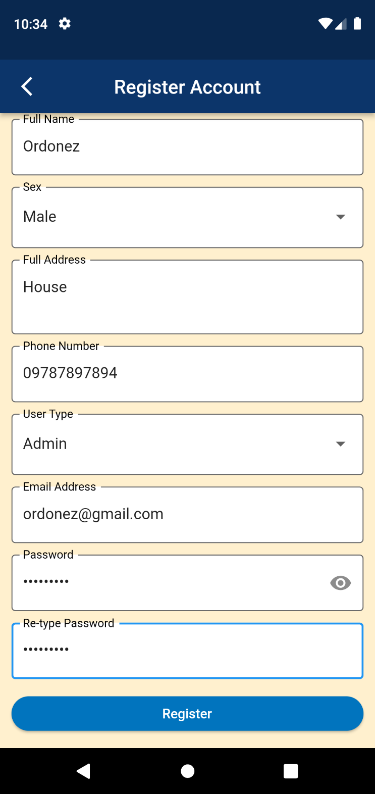

* + 1. Input PIN: 11182023 (PIN can be change in database)

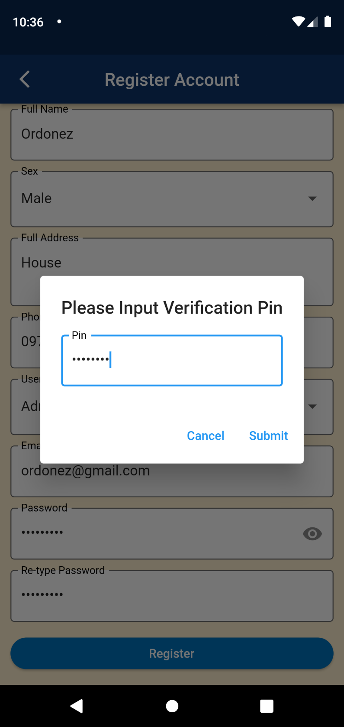

* + 1. After Signing up, app will redirect to admin home screen.

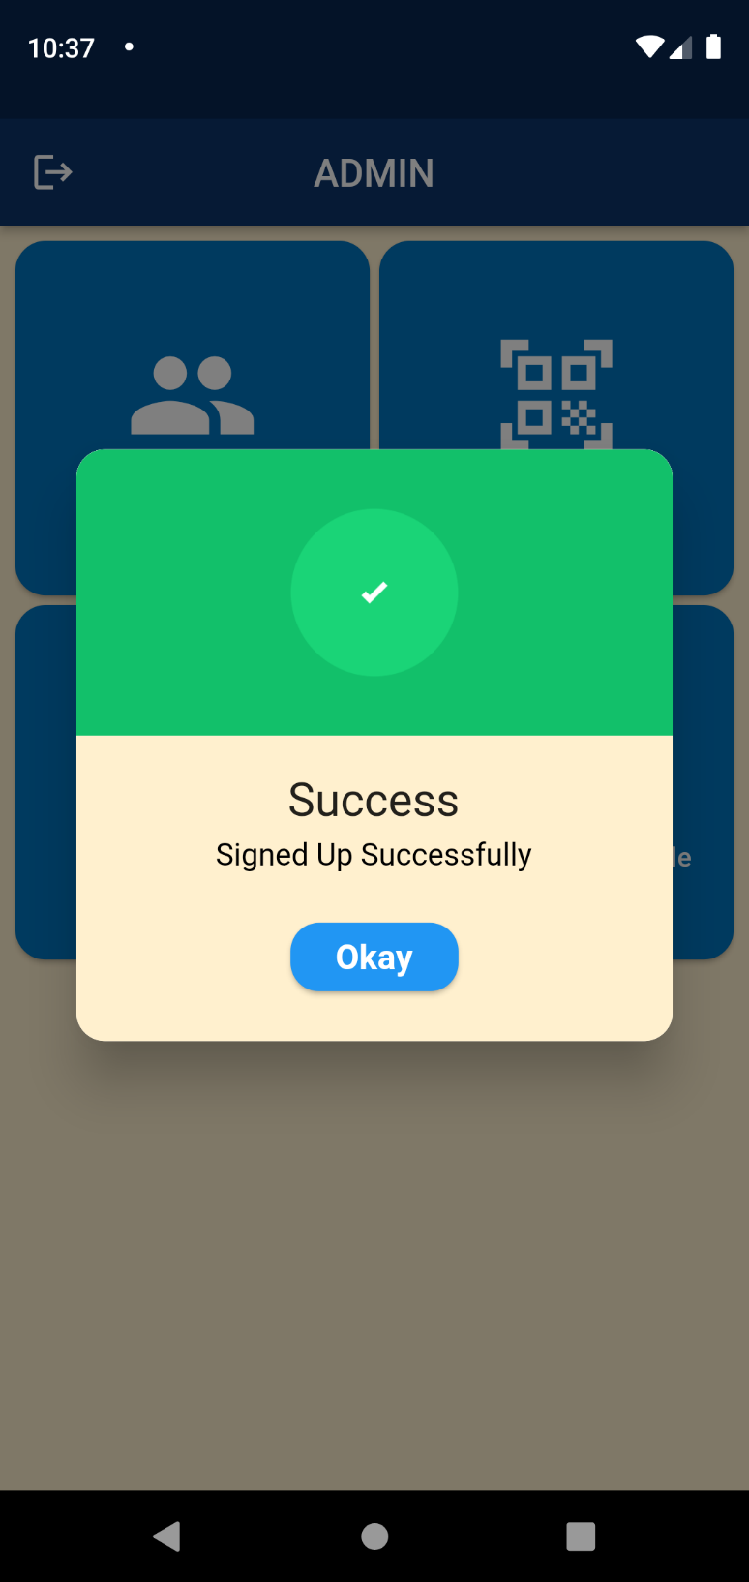

**VIEW AND EDIT PROFILE FOR CLIENT**

1. Navigate to my profile page.

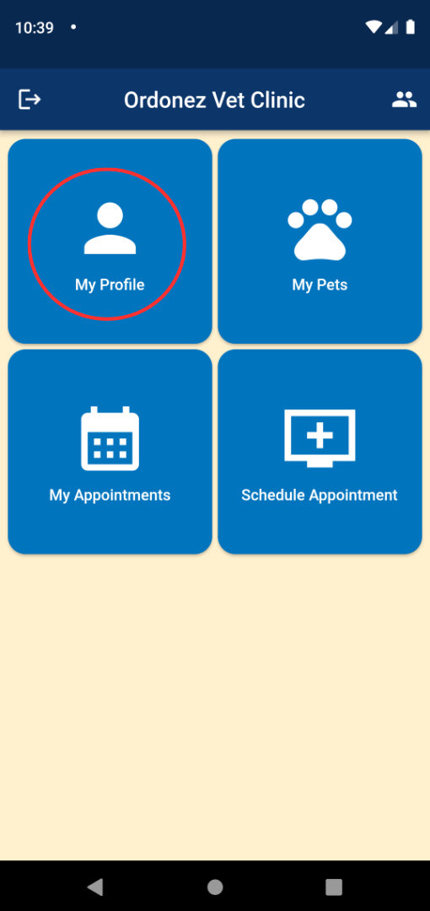

1. View client profile.

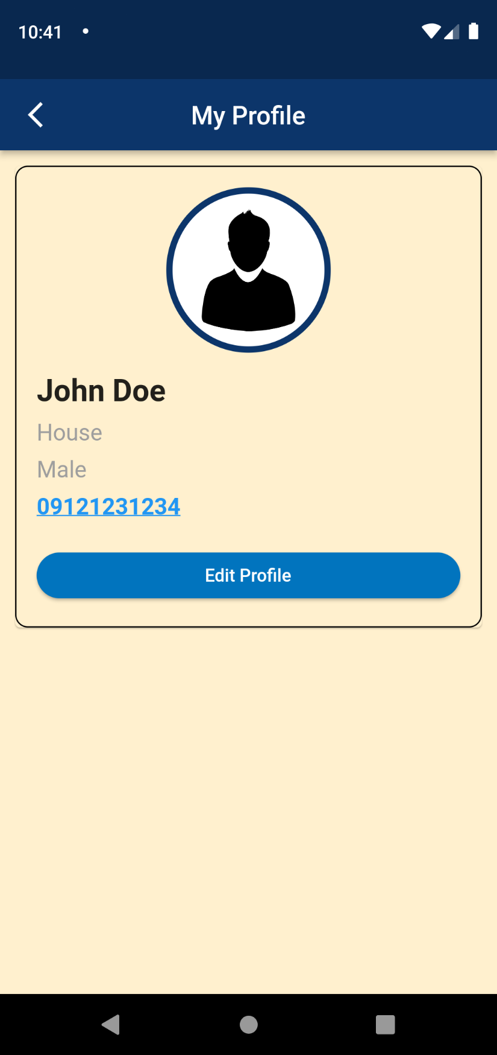

1. Click Edit Profile button to navigate to edit page.

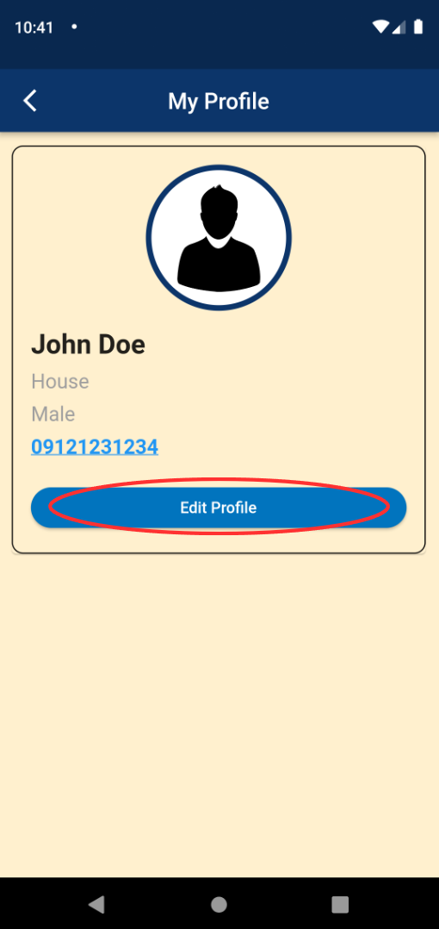

1. Edit profile.

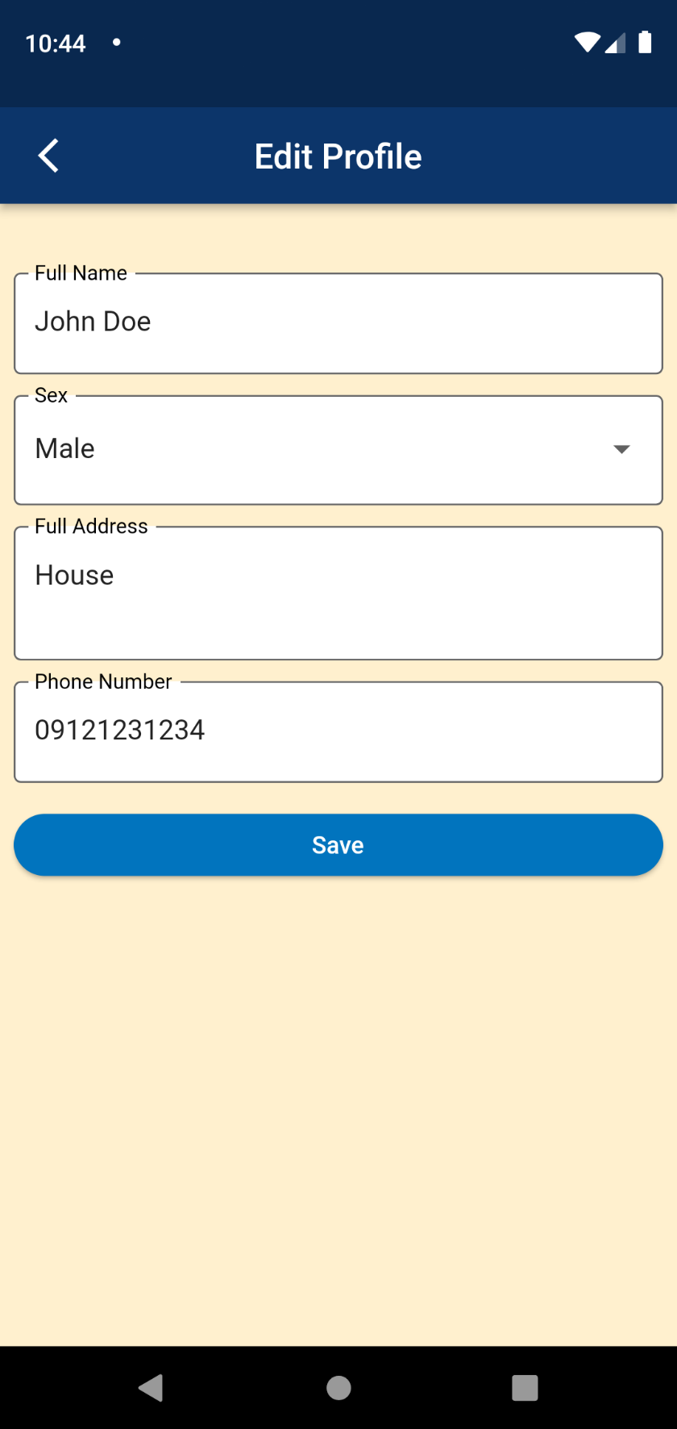

**VIEW, ADD, EDIT, AND DELETE PETS FOR CLIENTS**

1. Navigate to My Pets page

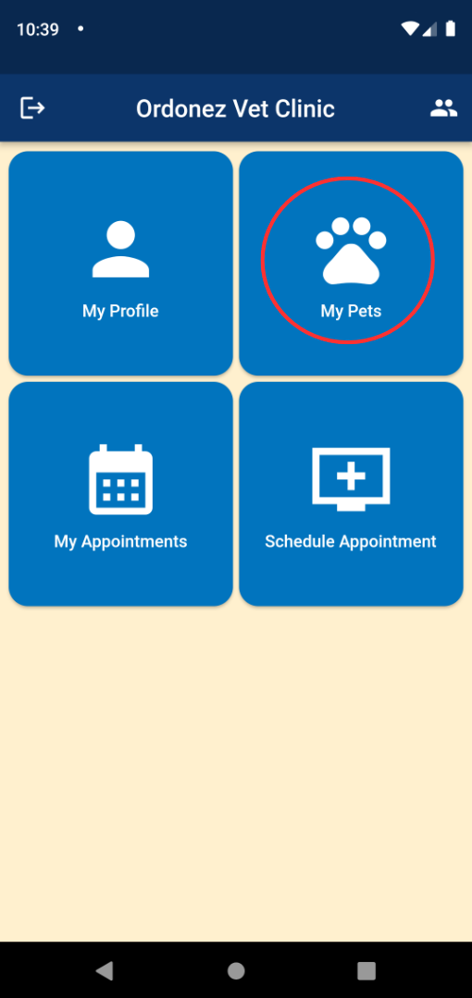

1. Viewing client’s pets.

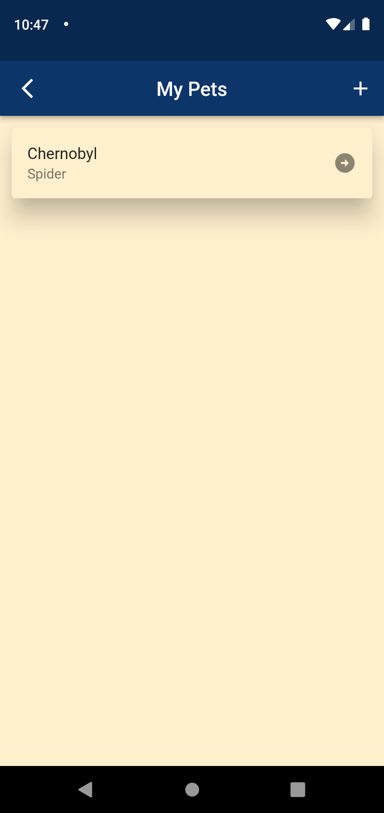

1. Click add button to add pet.

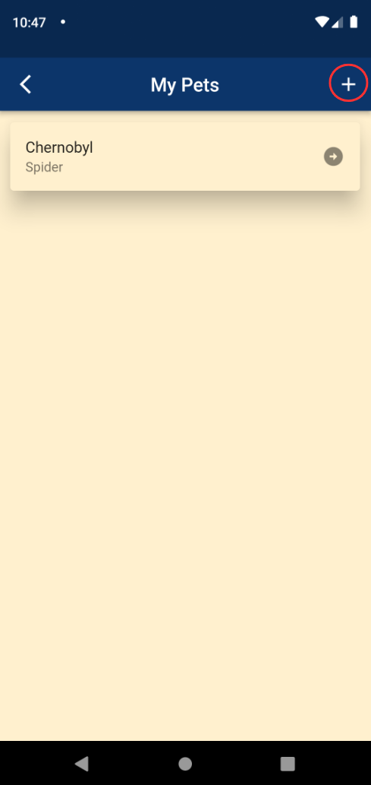

1. Input pet details.

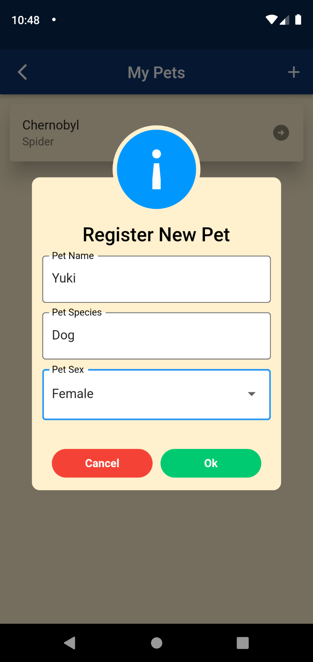

1. Pet added successfully.

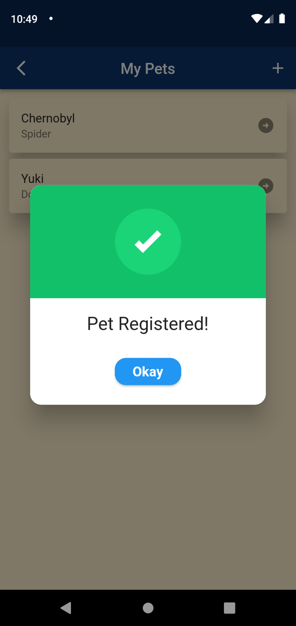

1. Click a pet to view pet details

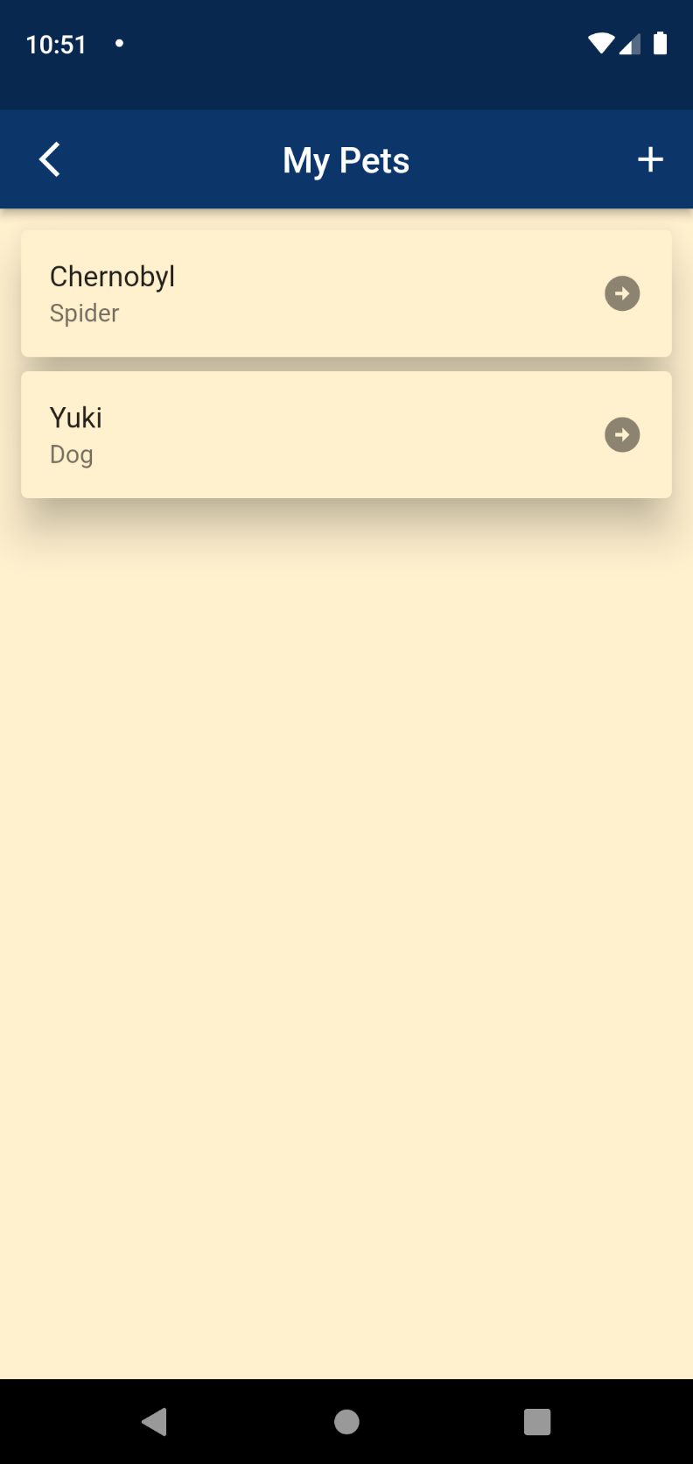

1. Viewing of pet details.

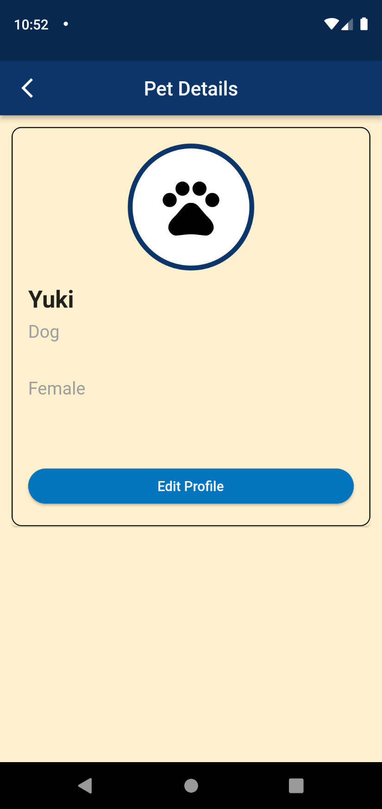

1. Click edit profile to navigate to edit page, edit pet details and save.

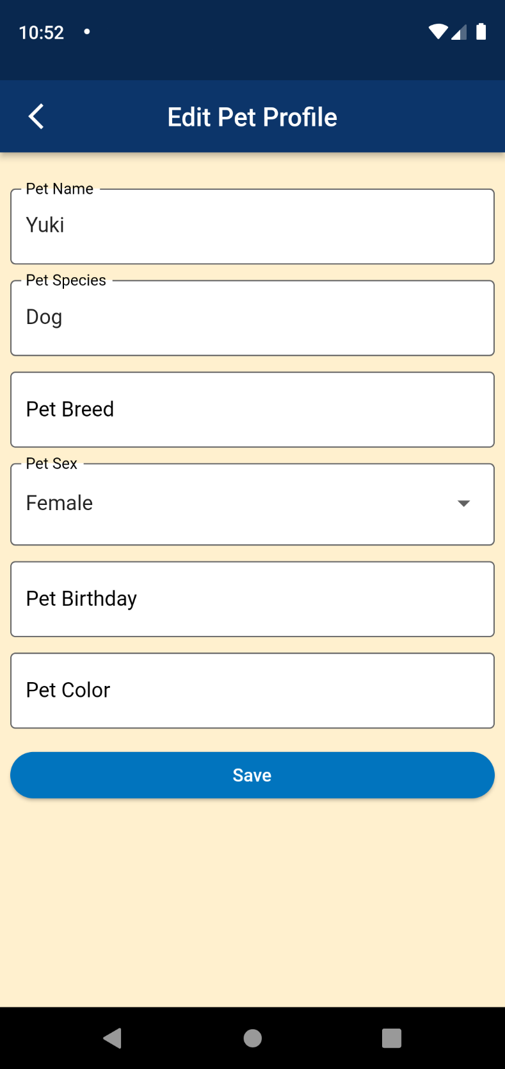

1. Press and Hold pet to delete.

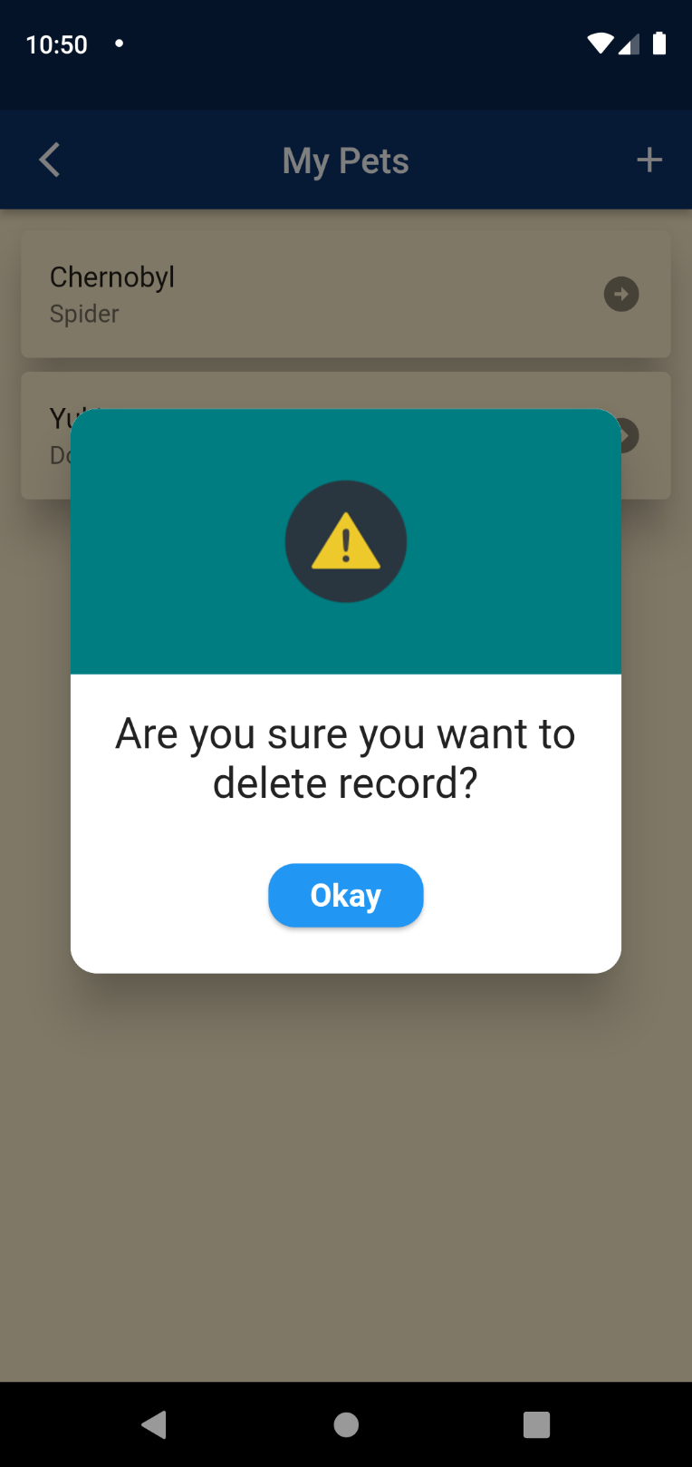

**SCHEDULING NEW APPOINTMENT FOR CLIENTS**

1. Navigate to schedule appointment page.

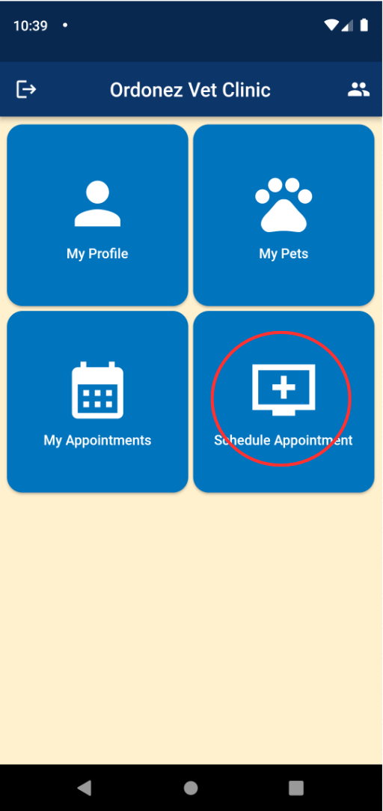

1. View overall appointments calendar.

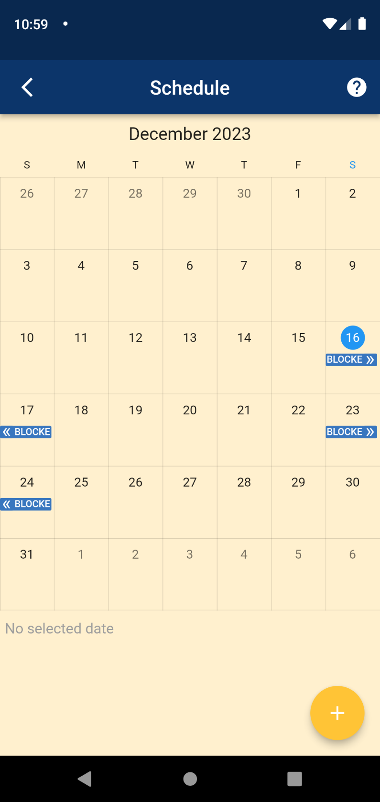

1. Click add button to schedule an appointment.

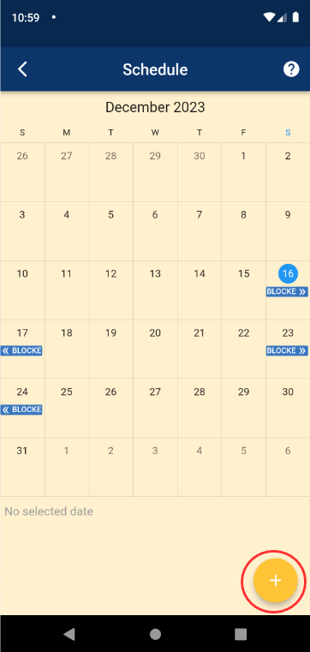

1. Input details and schedule appointment.

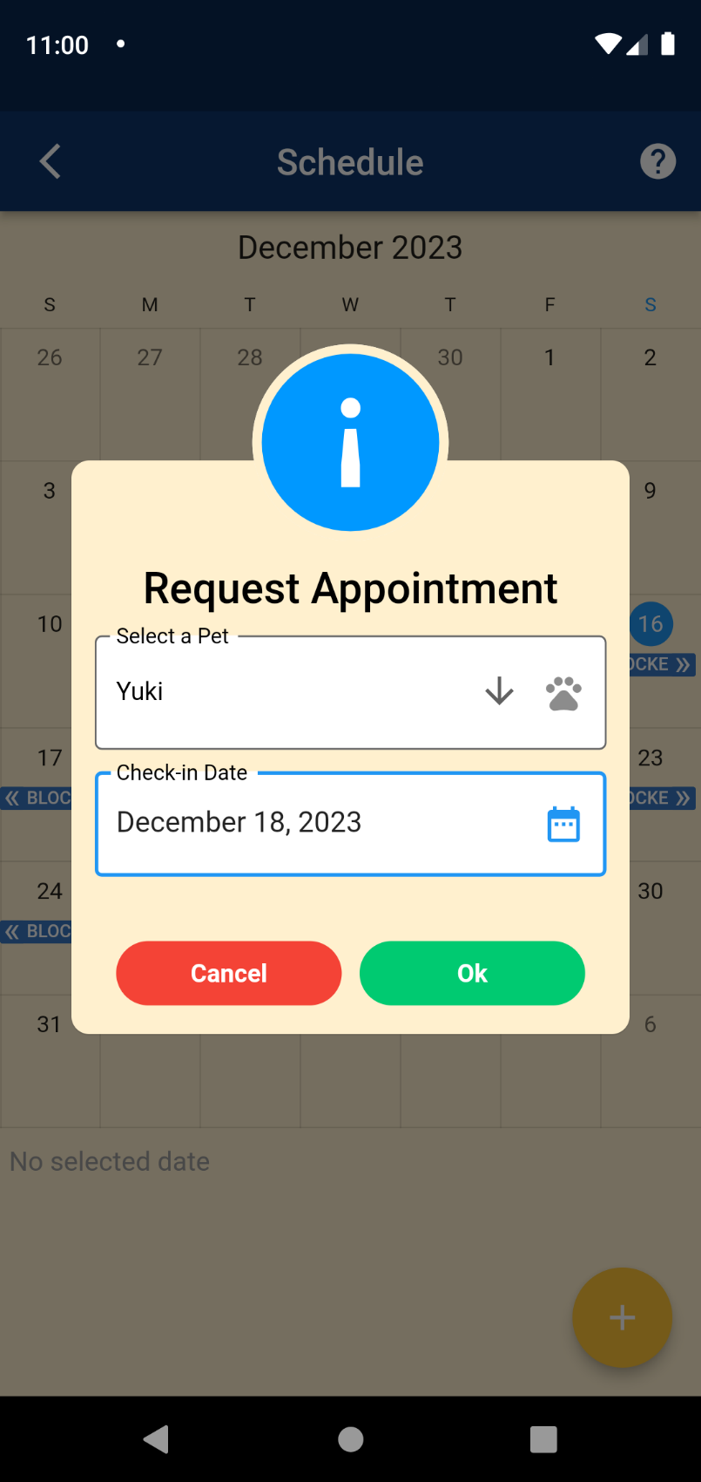

**VIEW, CANCEL APPOINTMENT FOR CLIENTS**

1. Navigate to my appointments page.

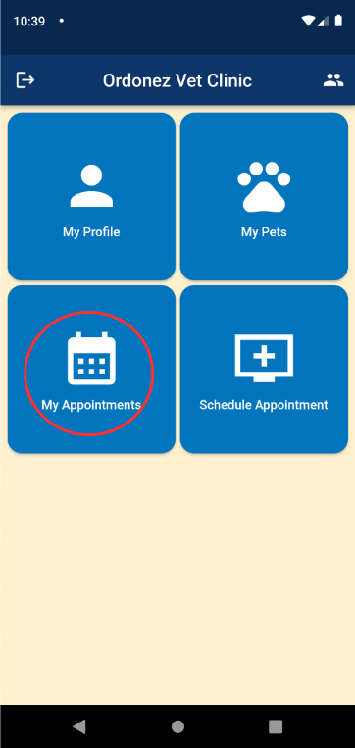

1. Viewing of all appointments.

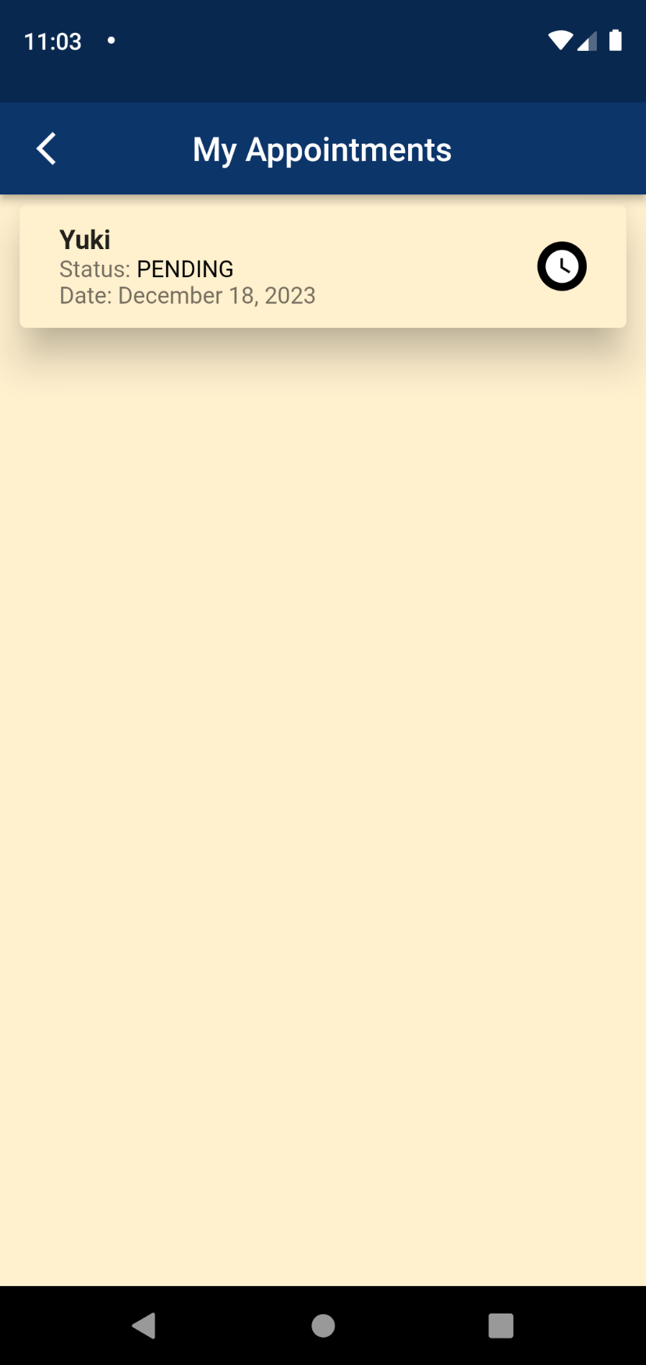

1. Press and Hold appointment to cancel appointment.

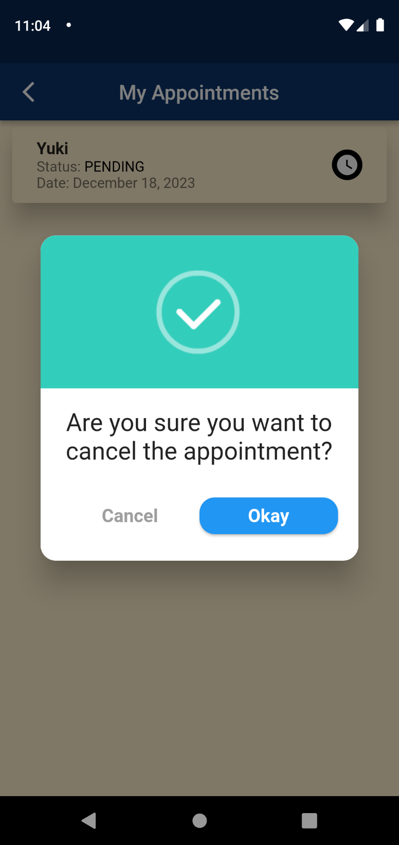

**VIEW ORDONEZ VET STAFF**

1. Navigate to our staff page

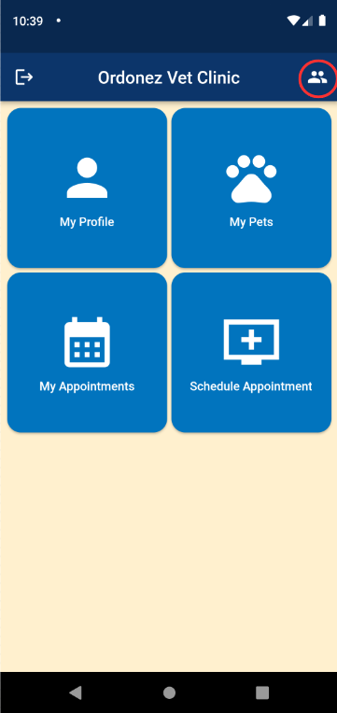

1. Click a staff to view details.

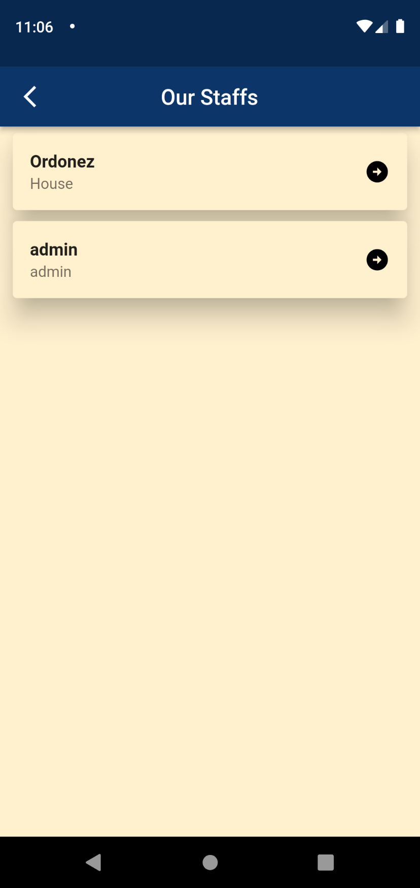

1. Viewing of staff details.

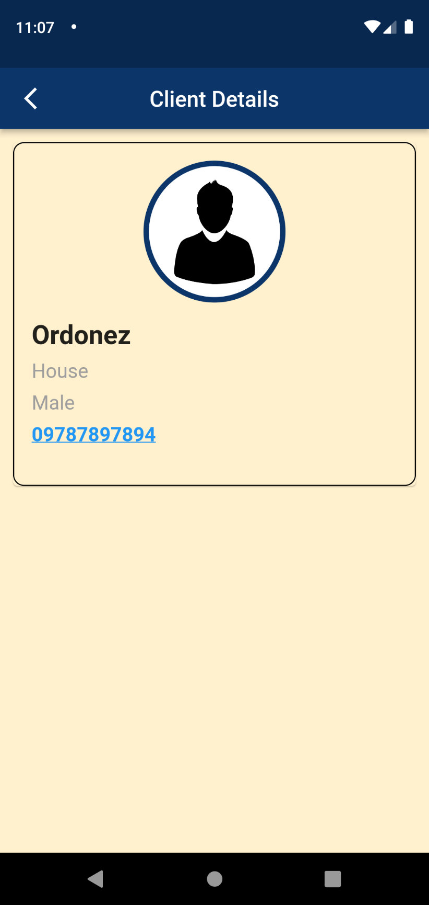

**VIEWING OF CLIENTS AND PETS FOR ADMIN**

1. Navigate to Clients page

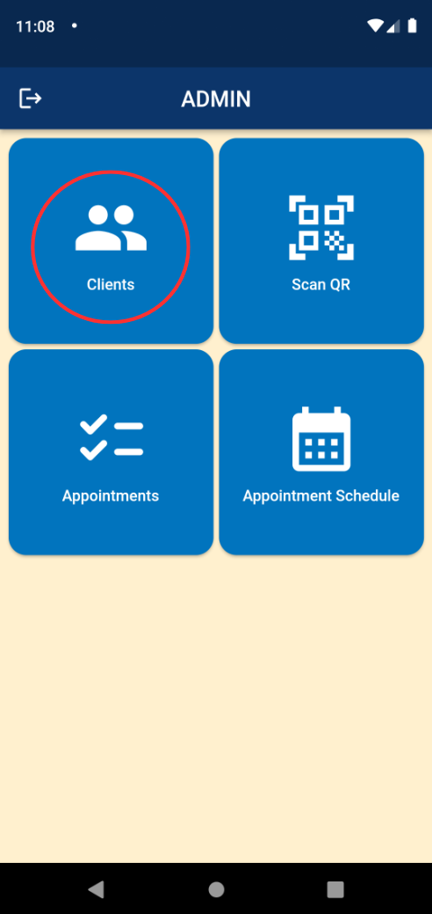

1. Viewing of all registered clients.

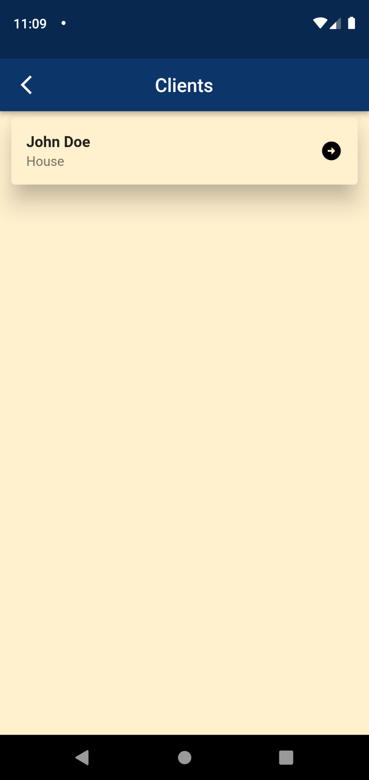

1. Click a client to view details.

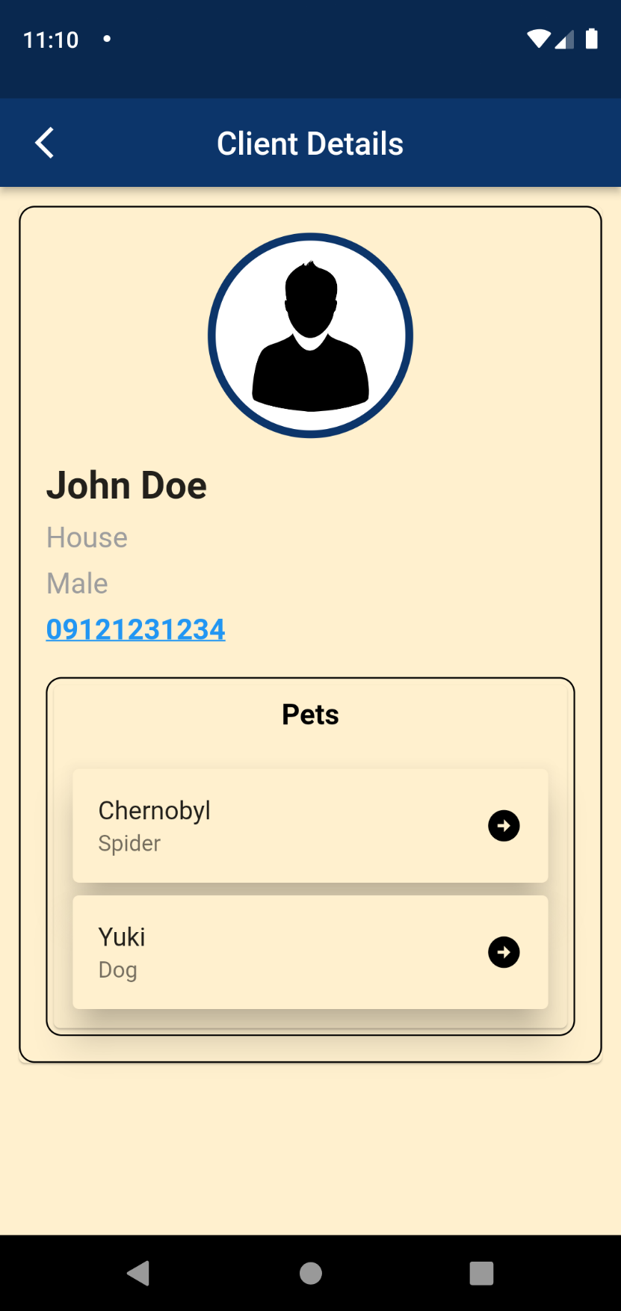

1. Click a client’s pet to view details.

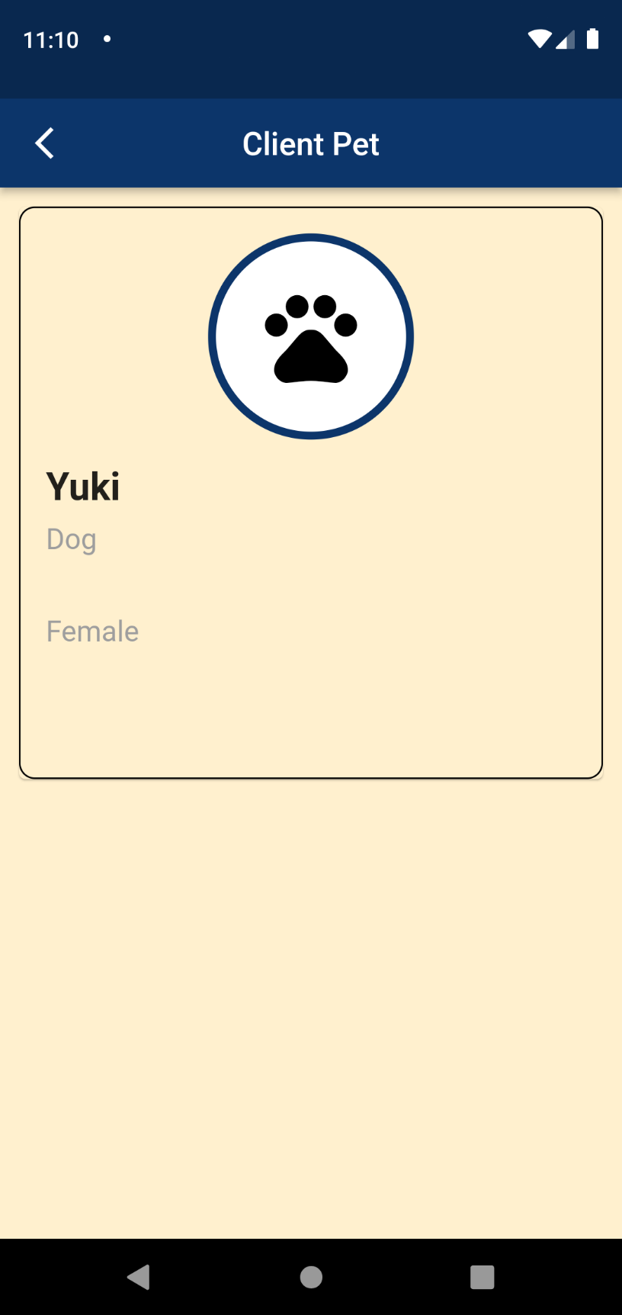

**VIEW APPOINTMENTS FOR ADMIN**

1. Navigate to appointments page.

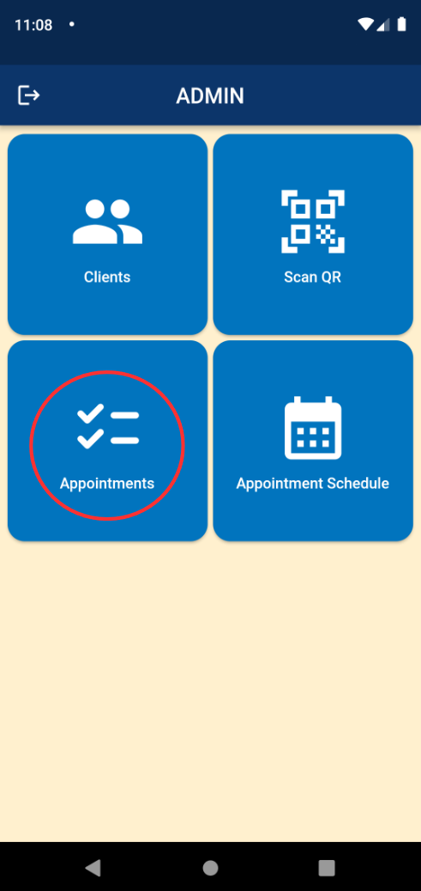

1. Viewing of all appointments.

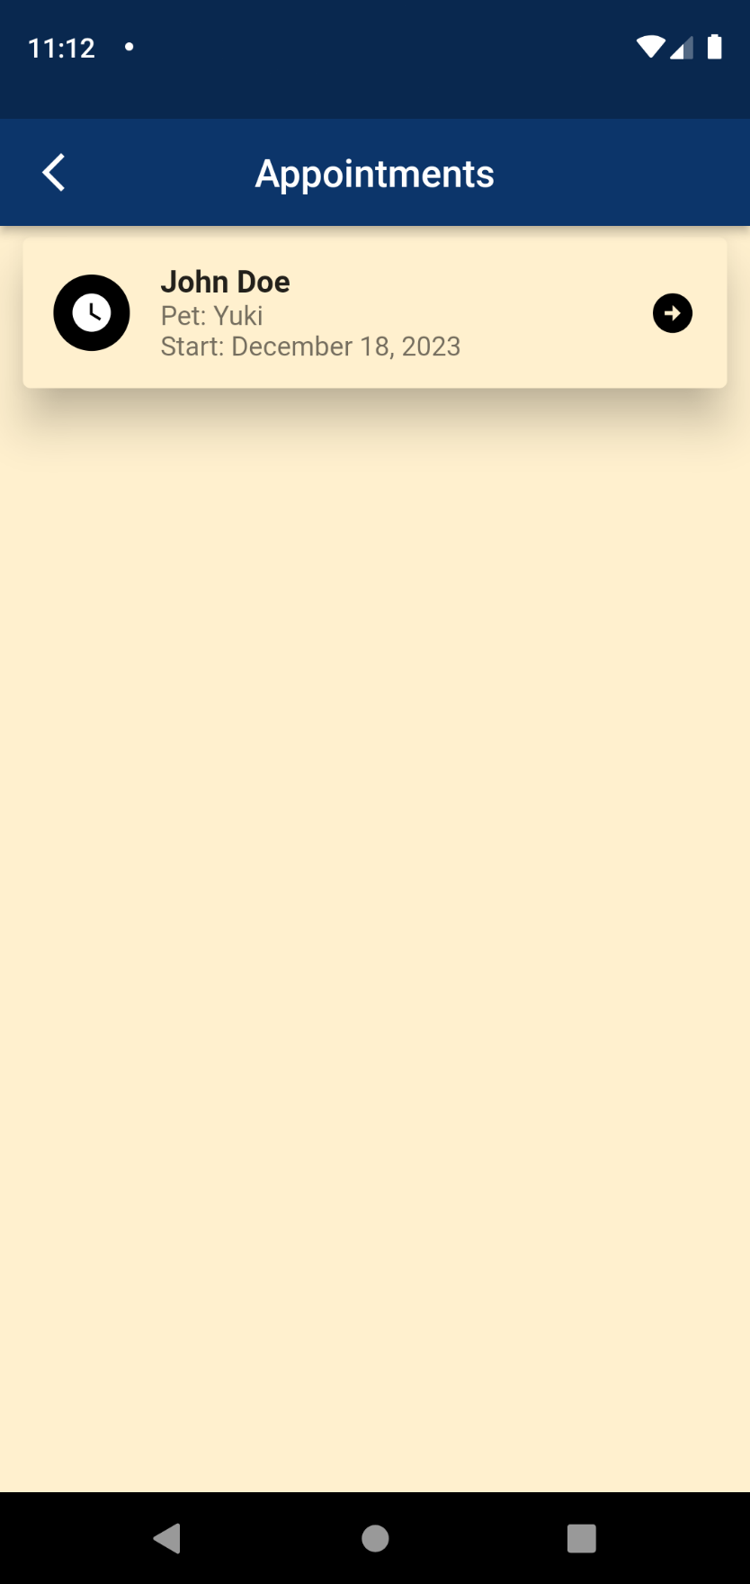

1. Click an appointment to view details and decide to deny, pending, approve, and done.

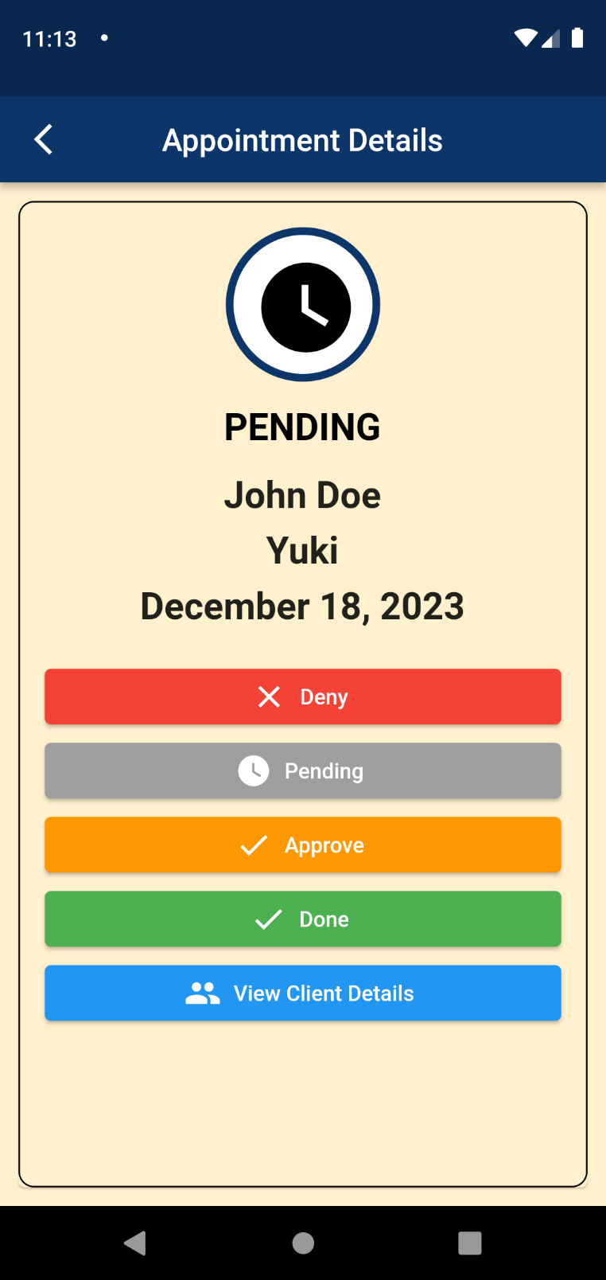

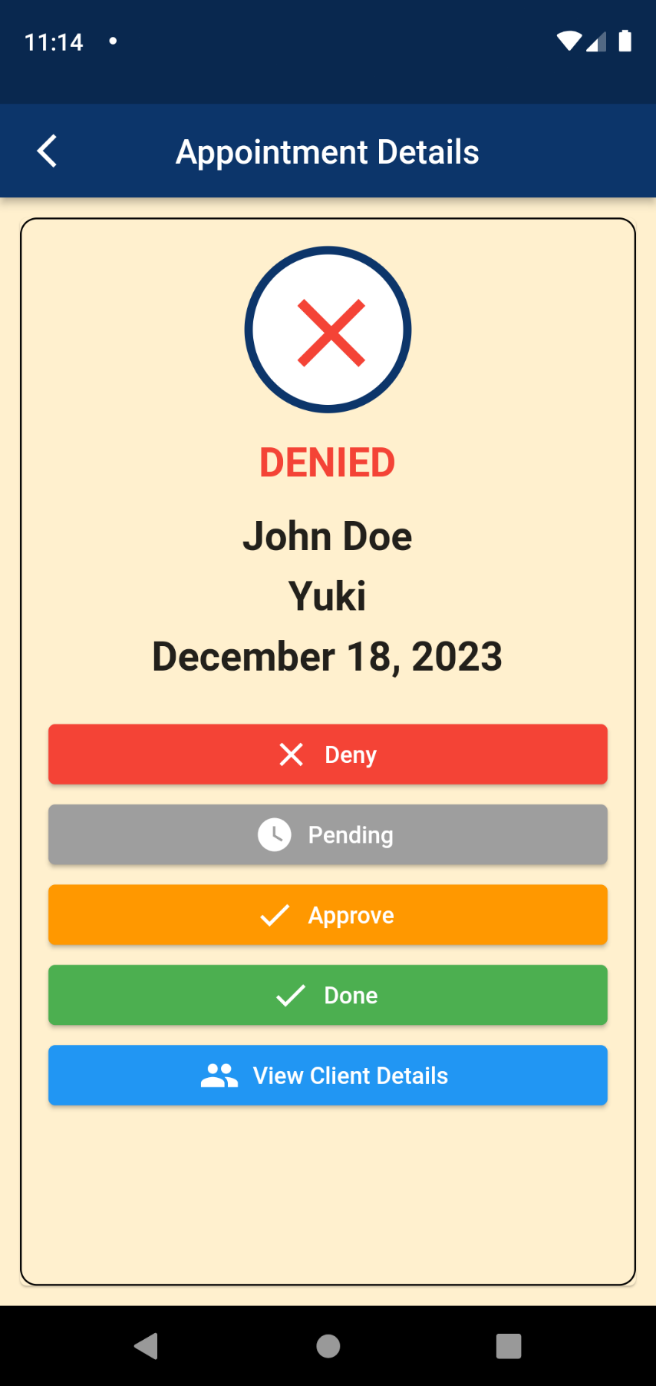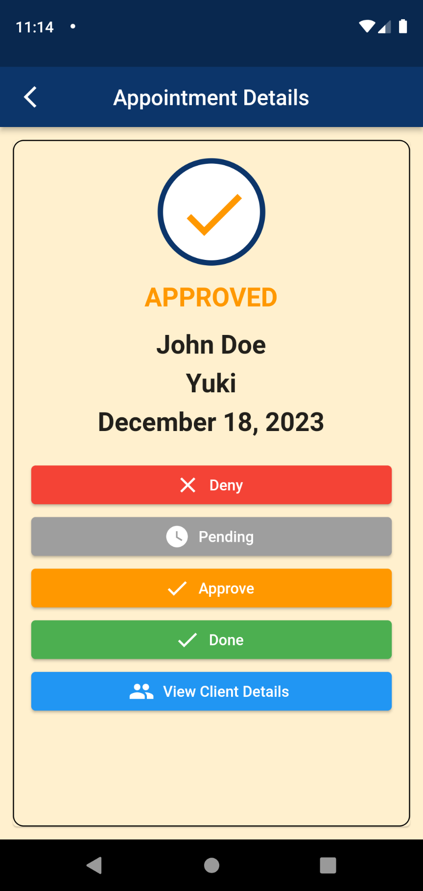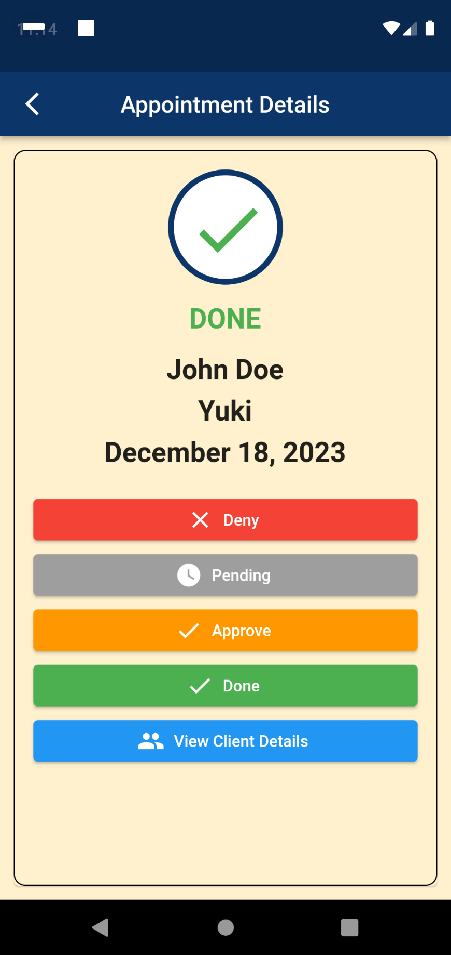

1. Click view client details to navigate to client details page.



VIEW AND BLOCK DATES FOR ADMIN

1. Navigate to appointments Schedule.

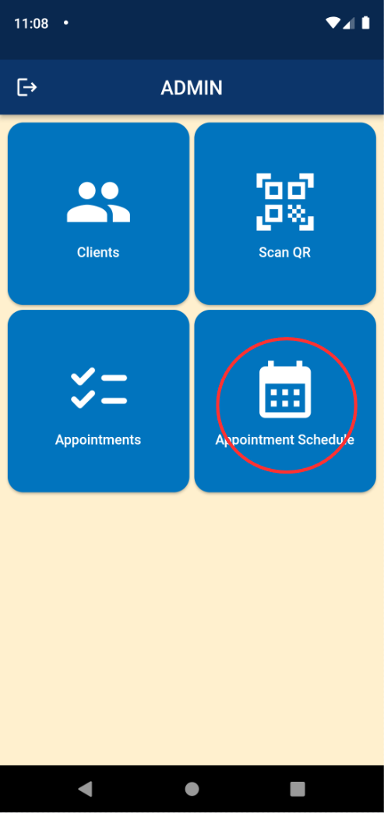

1. Viewing of all approved appointments and blocked dates.

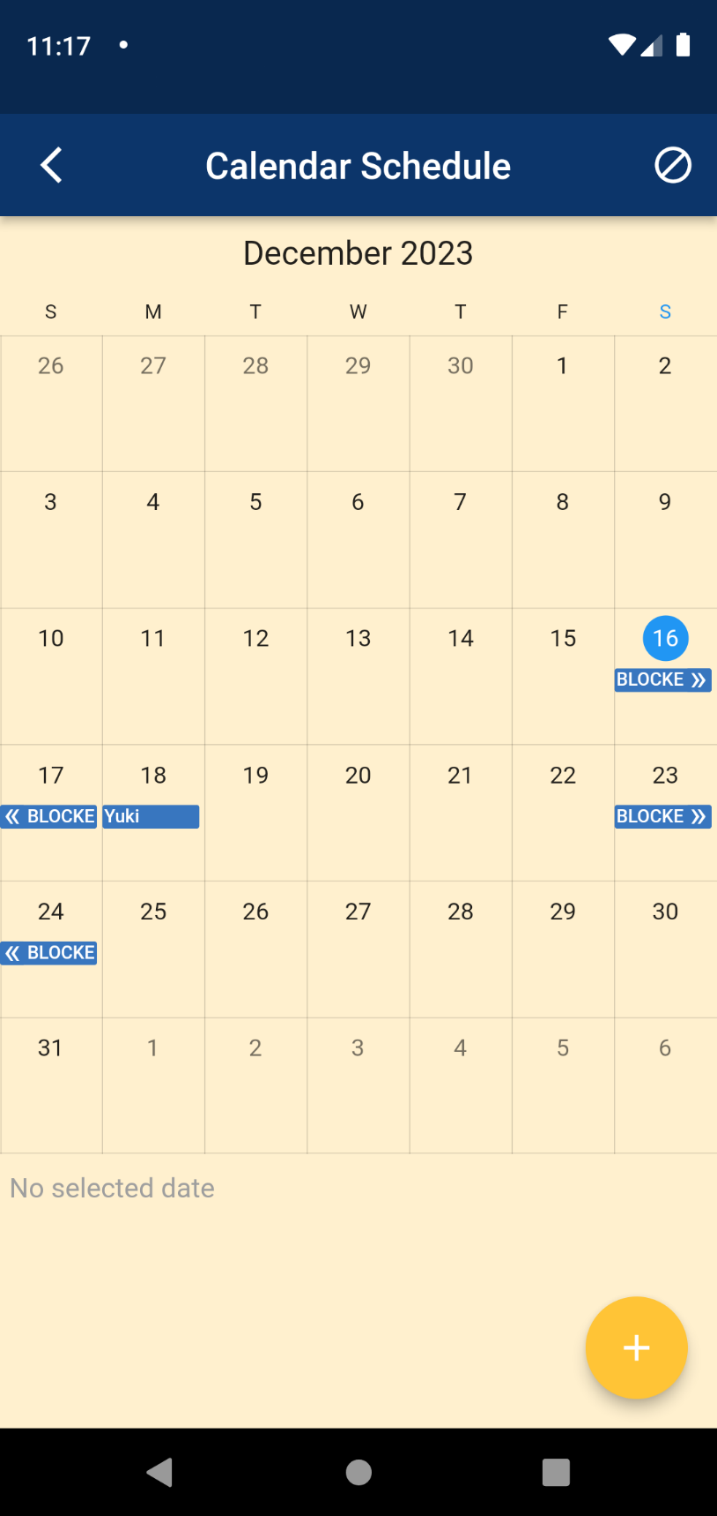

1. Press add button to add blocked dates.

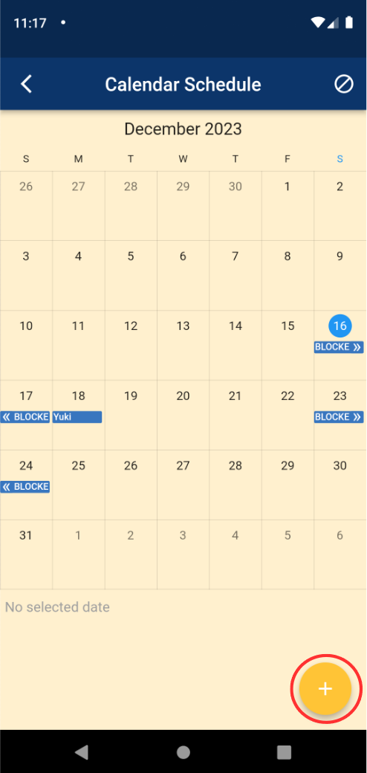

1. Input dates to block.

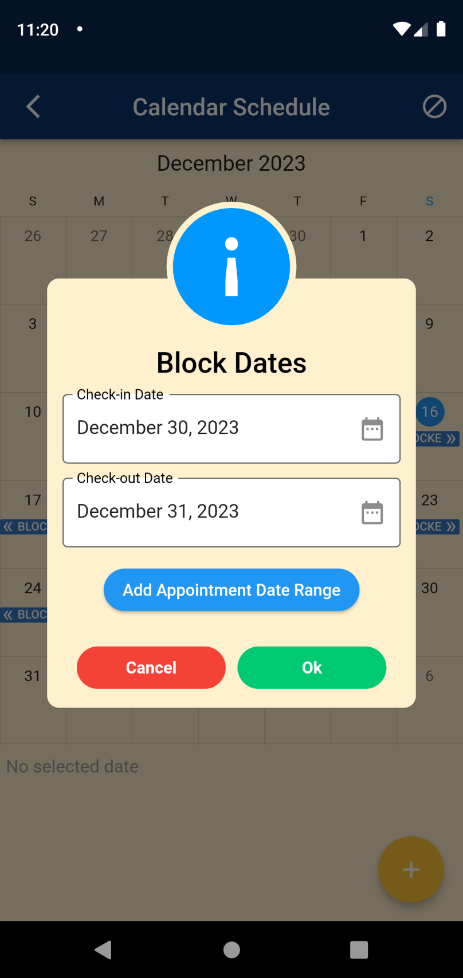

1. View all blocked dates.

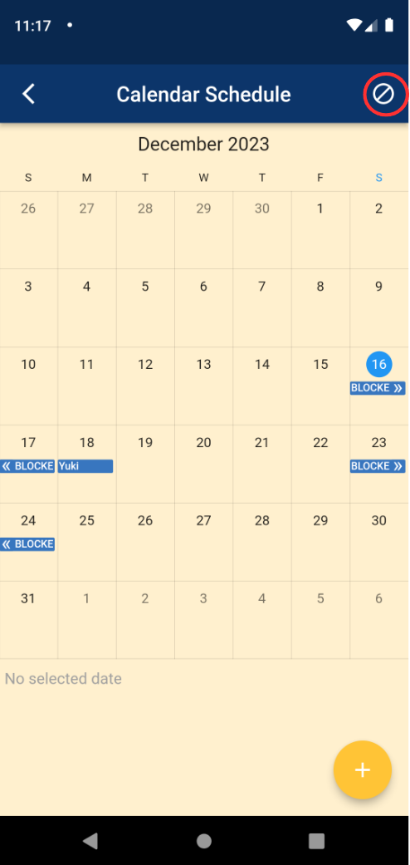

1. Viewing of all blocked dates.

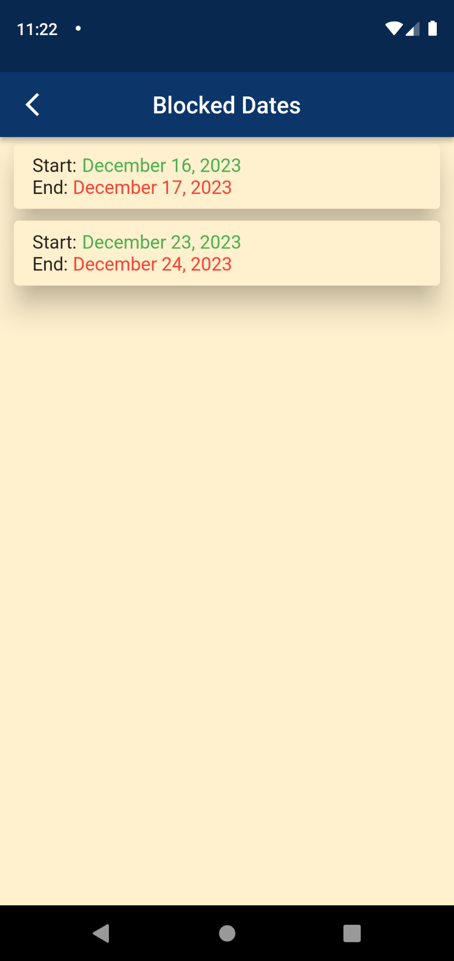

1. Press and hold blocked dates to delete.

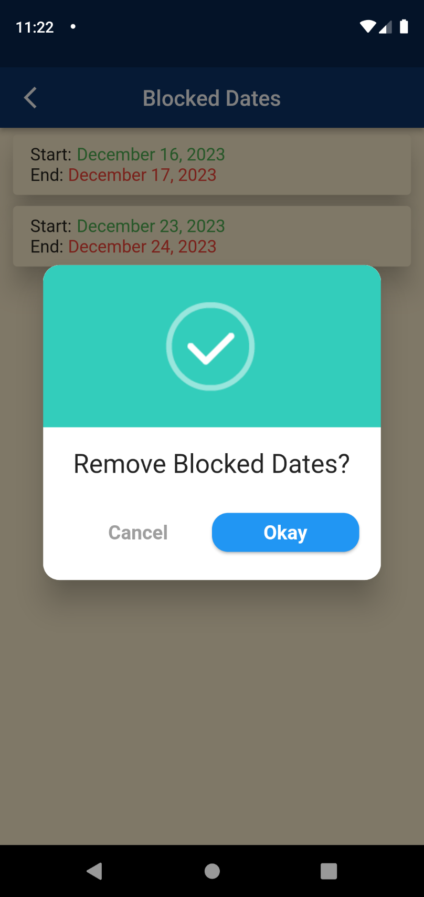

USE QR CODE FOR CLIENT

1. Navigate to my appointments page.



1. Click QR icon.

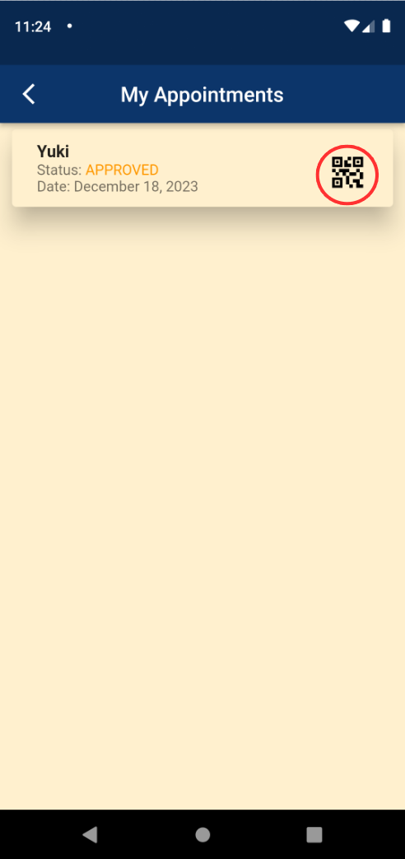

1. Viewing of Appointment QR Code.

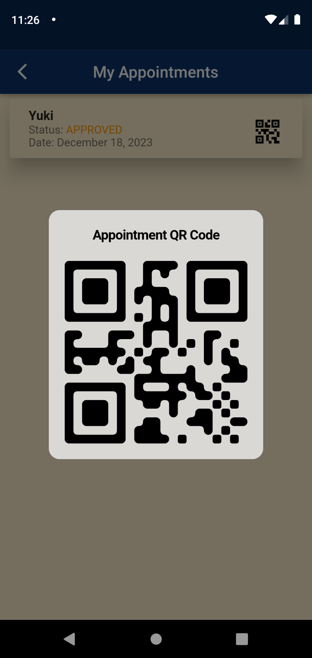

1. Appointment will be marked as done after scanning of QR code.

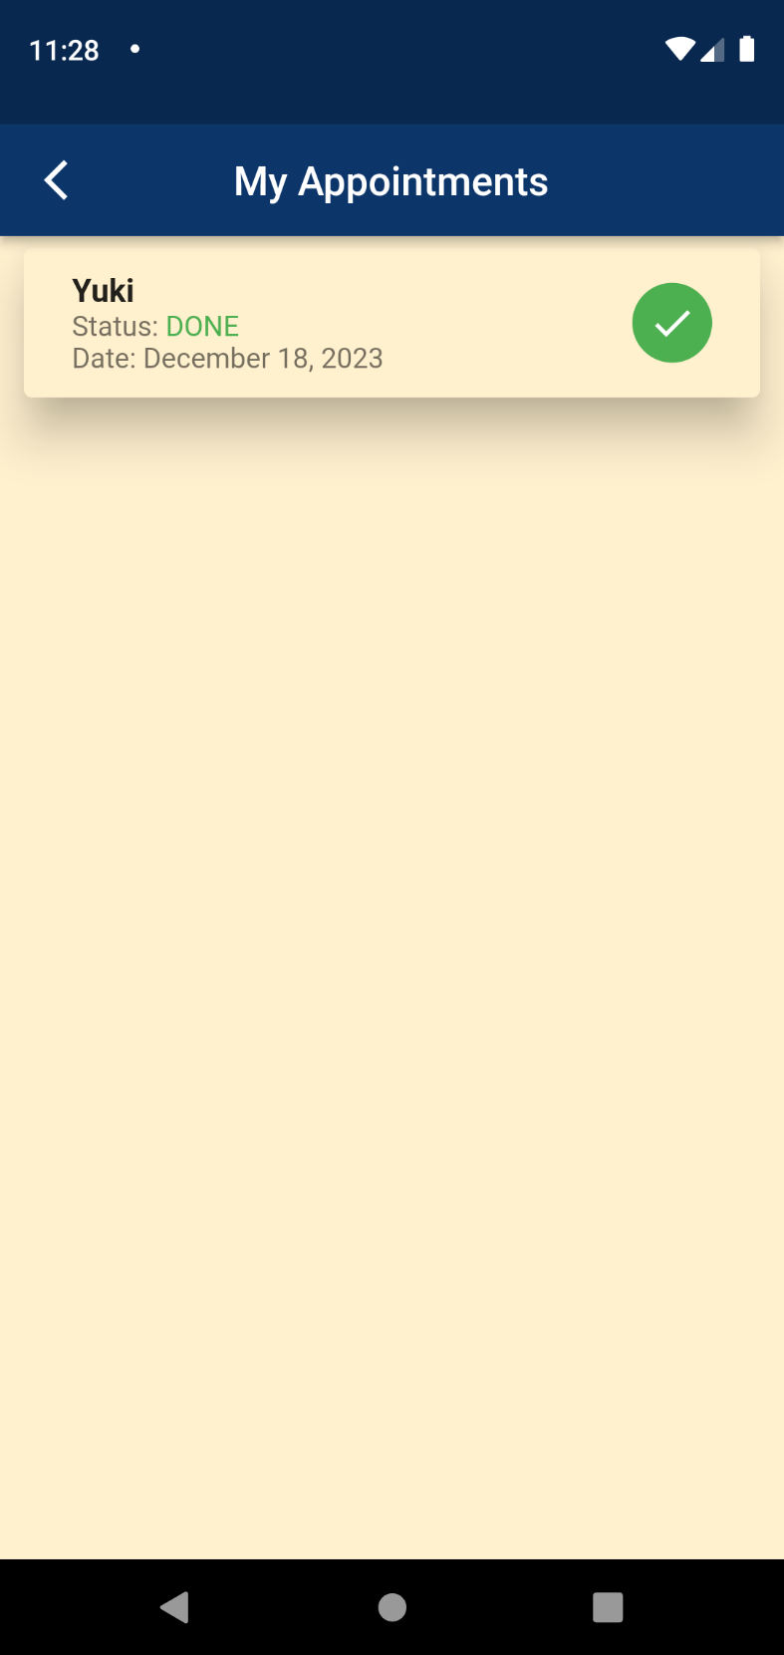

SCANNING OF QR CODE FOR ADMIN

1. Navigate to Scan QR popup.

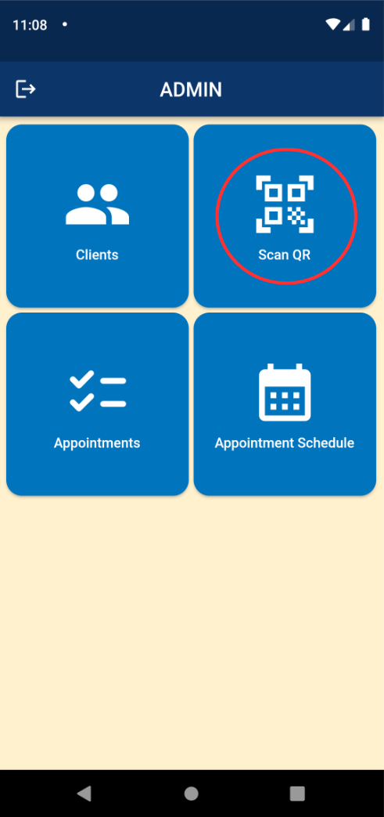

1. Scan client’s appointment QR code.

