Justin Schumann

4/19/2025

CS-330 final Project Reflection

Going through each milestone, through research and error, I learned a great many things about codding, 3D modeling, and the creative process. My original image includes a book, a shoebox, a pen, a container, a crystal ball, a shoe, and a rubber band.

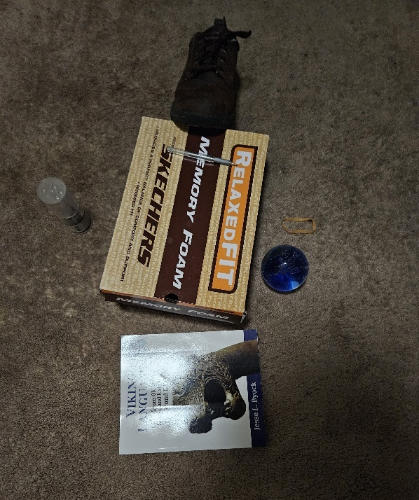

As you can see, all of the items in the original pitch didn’t make it into the 3D image. For one, the shoe was too complicated to render. There wasn’t a perfect shape or combination of shapes that I could make. The book took up too much space, since the shoe box was already a box shape, didn’t add to the diversity of the shapes displayed. What remains is the sphere, shoe box, pen, container and rubber band.

The easiest item to make was the shoe box. All that was needed was a large box. The crystal ball was the second easiest to make, representing a simple sphere (sphere being any ball object). Though positioning it within the image was rather complicated. The container was obliviously represented by a narrow cylinder (since its rounded on the sides, and flat top and bottom), and the rubber band by a small torus (a torus being a round object with a hole). The pen, despite being the second smallest item, was the most complicated and time consuming to make. I use a cylinder (being rounded on sides, flat bottom and top) to represent the body, and a cone (since best to represent a pointed surface) to represent the head. Getting it to positioned as both tilted and laying on the box was more difficult than rendering it.

I try to find textures that best fit the item. For the pen, I used a purple surface to depict the body, and a glass surface to depict the head. I used a cardboard surface to texture the box. A bright crystal surface to depict the crystal ball. I used the surfaces of plastic to textured the container and rubber band. The plane on which all these items were positioned was textured with a brownish carpet surface. I used shedder materials to better capture the item’s characteristics. A “crystal” shedder for the container, ball, and pen’s body. A “plastic” shedder for the rubber band, a “ground” shedder for the plane, and a “shiny” shedder for the pen’s head

As required and to get the full details of the scene, I added navigation features to the viewManager. W: to zoom in. S: to zoom out. A: to pan towards left. D: to pan towards right. Q: to move the camera upwards. E: to move the camera downwards. O: to get an orthographic view. P: to get a perspective view.

There were a number of features that had to be added to the program. First was adding mouse and keyboard control features. Features such as lighting, textures and shedder materials were later added. All of these features are perfectly reuseable when working on future projects that include 3D rendering.