**Individual Project Report**

Last name: Sherrell

Fist name: Justin

**Your report sections.**

1. **Summary**: Write a summary of your program design.

My program is a simulation of an archery tournament, where you can change stats of players and weather to manipulate the game. And it also keeps track of all the stats of the players throughout the game.

1. **Output**: Attach screenshot images of your entire C++ program running output (not the source code) with a short description.

A picture of a user accessing the show team’s stats menu.

A picture of a user changing the stats of a player.

A picture of one of the contestants shooting and hitting a perfect shot.

A picture of the results from a tournament.

1. Text

   Description automatically generatedLogo

   Description automatically generated with medium confidence**Code**: Explain a few highlights of your algorithm design in detail including conditional statements (e.g., *if, else),* loop *(while or/and for),* randomization*, and* function definition. You must add images of screen capture or actual code block along with your design approach.  
     
   Text

   Description automatically generated

One big hurtle I had to over come was making the teams fight in a random order every time the game was played. So, I figured out that I can create pointers to structures and randomize the where the pointers pointed.

This is the key feature that makes all the players stats random at the beginning of the game and when you hit random stats. It works by putting in the team’s structure and there corresponding array with there names in it.   
Then it set’s all the players names and randoms all the stats of the players.

This is the auto play function it’s what let’s users not have to manually input to make the game move forward. It also let’s users determine the speed of the game and if they want to skip to the end.

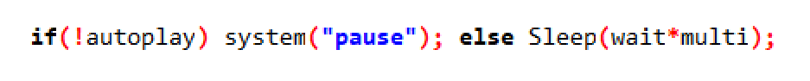

Where the game would do a system pause it now just does a sleep based off the user selection of play speed.

If user selected the skip to end option, the program will bypass the weather input.

1. APA:

Hangg, R. (n.d.) Ascii Art Archive.  [https://www.asciiart.eu](%20https://www.asciiart.eu%20)  (Accessed on Nov 28th, 2022).  
  
<https://www.asciiart.eu/weapons/bows-and-arrows> <--- Ascii art of guy shooting a bow and arrow   
Name: jah/SSt

