Text Summarization using Sentiment Analysis

In this project we are summarizing user reviews by identifying sentiments and if user is happy then his reviews may contains more generous words and if neutral then they may use few generous words and if not happy then his words will have more negativity and based on this we can identify sentiments and can summarize user reviews.

We will input user reviews to Transformer summary model which will analyse sentiments from user reviews and then predict summary

To implement this project we have designed following modules

1. Generate & Load Summary Sentiment Model: using this module we will load sentiment and transformer summary model
2. Preprocess Text: this module will read user review and then remove stop words and special symbols and make review clean
3. Generate Summary using Sentiment: Cleaned review will be input transformer algorithm model to analyse sentiments and based on sentiment will predict summary.

To run project double click on ‘run.bat’ file to get below screen

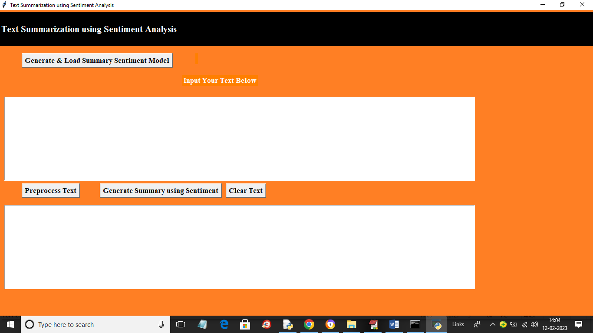

In above screen click on ‘Generate & Load Summary Sentiment Model’ button to load sentiment summary model and get below output

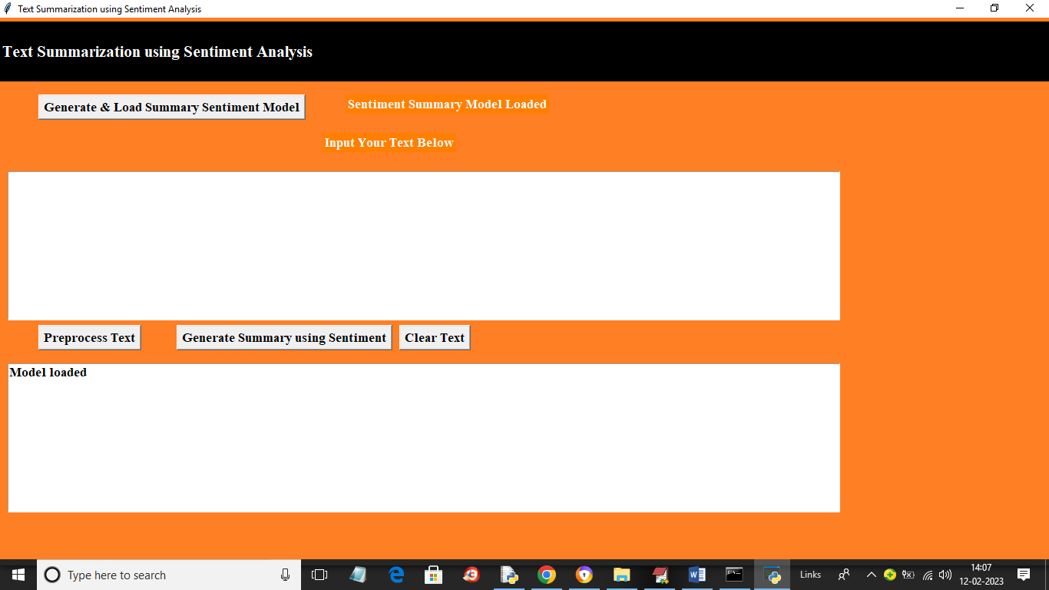

In above screen in white colour text we can see summary sentiment model loaded and now entered some review in first text box like below screen

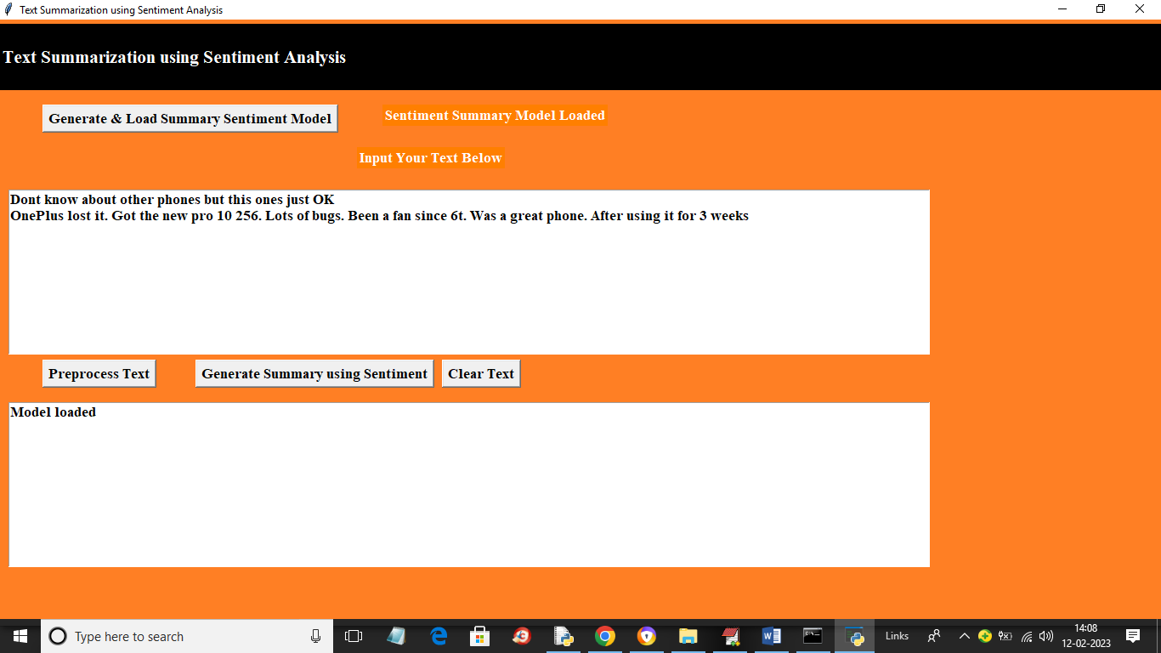

In above screen in first text box I entered some review and then click on ‘Preprocess Text’ button to remove stop words and special symbols to clean review and get below output

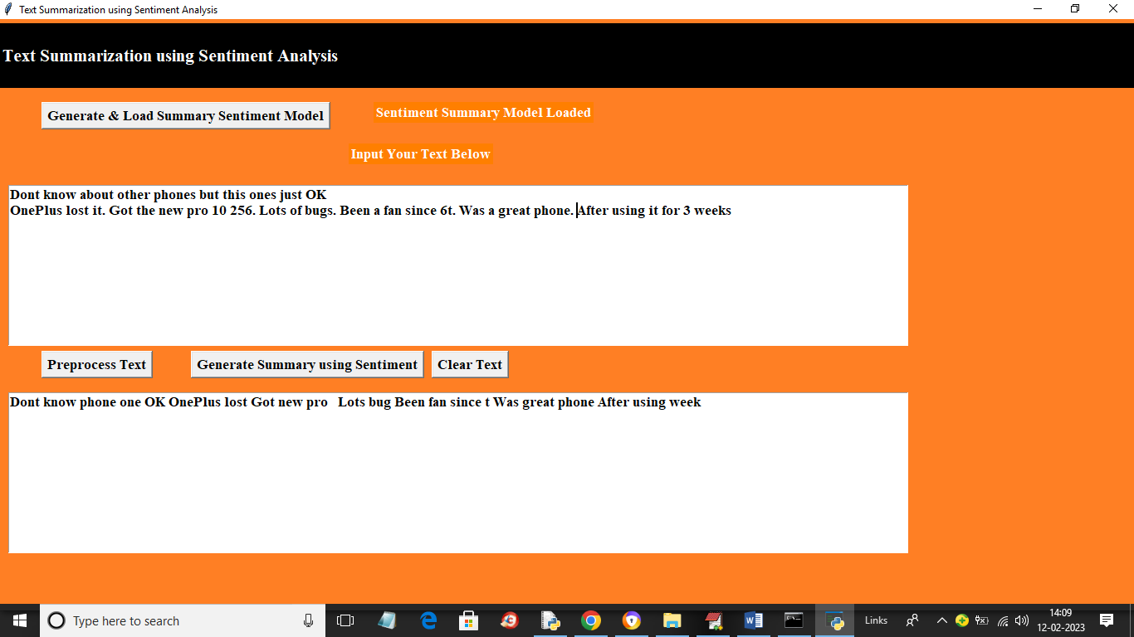

In above screen in second text area we got clean review after removing stop words and now click on ‘Generate Summary using Sentiment’ button to summarize user reviews based on sentiment and get below output

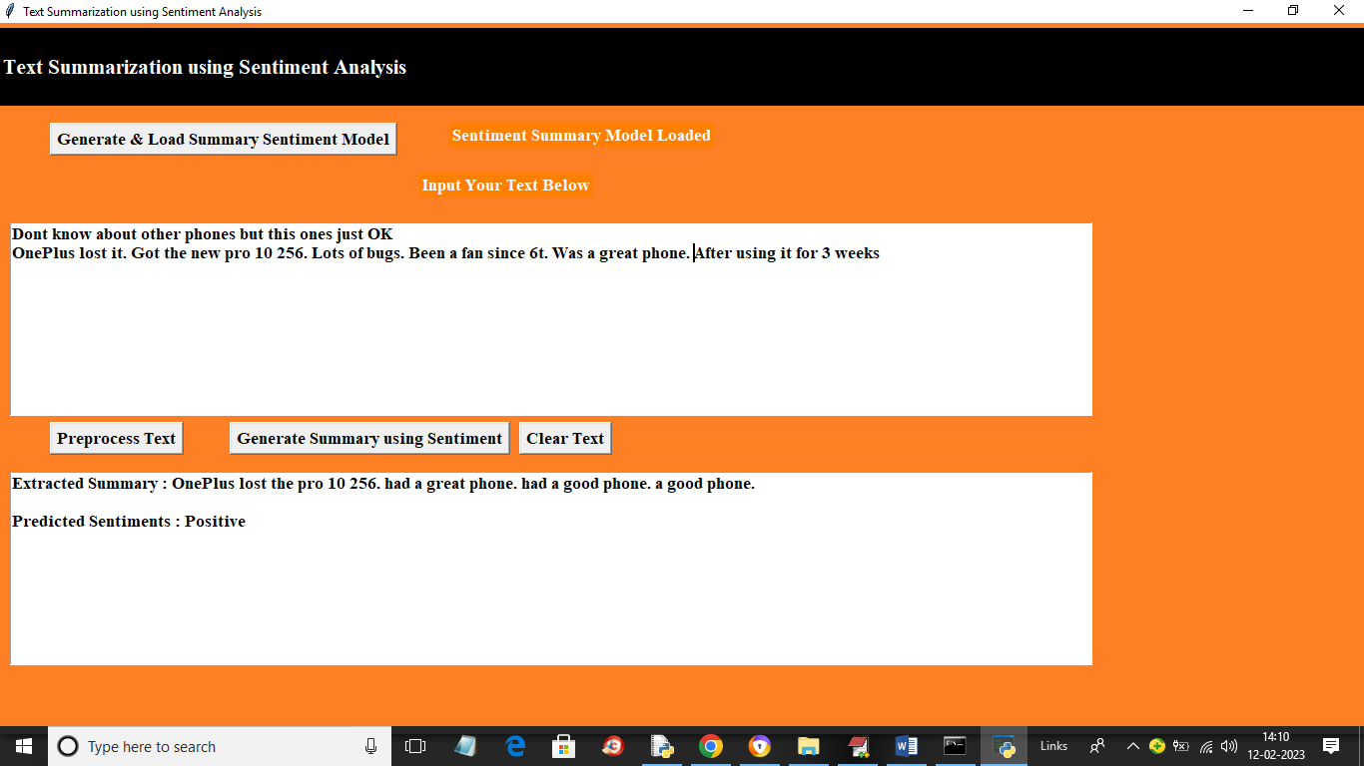

In above screen in first area we can see user review and in second text area we can see summary of review with detected sentiment as ‘Positive’. Similarly you can upload and test other reviews. Below is another example

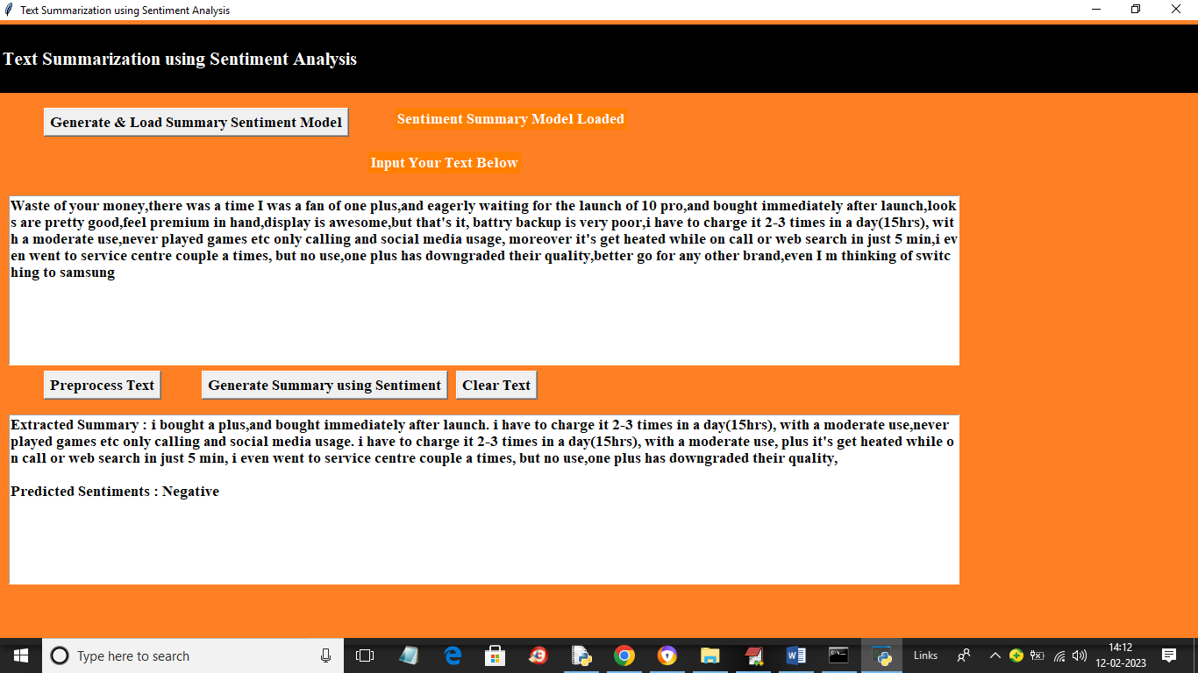

In above screen in first text box you can see another review and in second text box you can see SUMMARY and predicted sentiment as negative

Below is another review

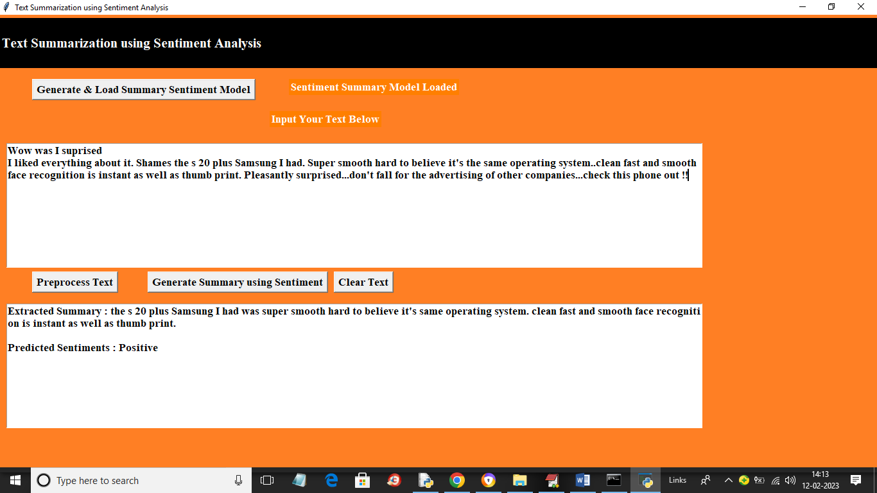

Similarly like above output you can test for any review