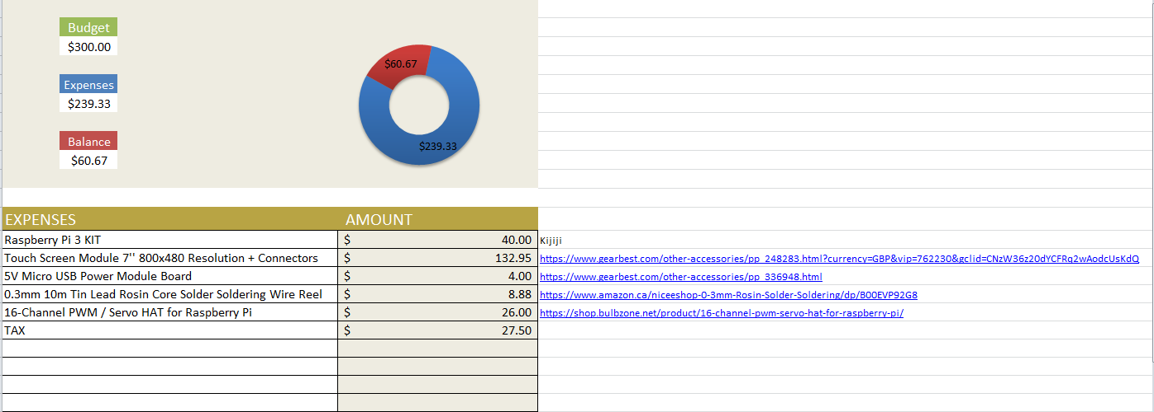

**Project Budget**

**NOTE:**

All items above will be bought in quantity of one.

The prices mentioned above are an estimate and may change with time

The data above was collected and compiled on 10/02/2017