Vaelis Moonshadow, High Elf
Diviner/Cleric, Warcaster

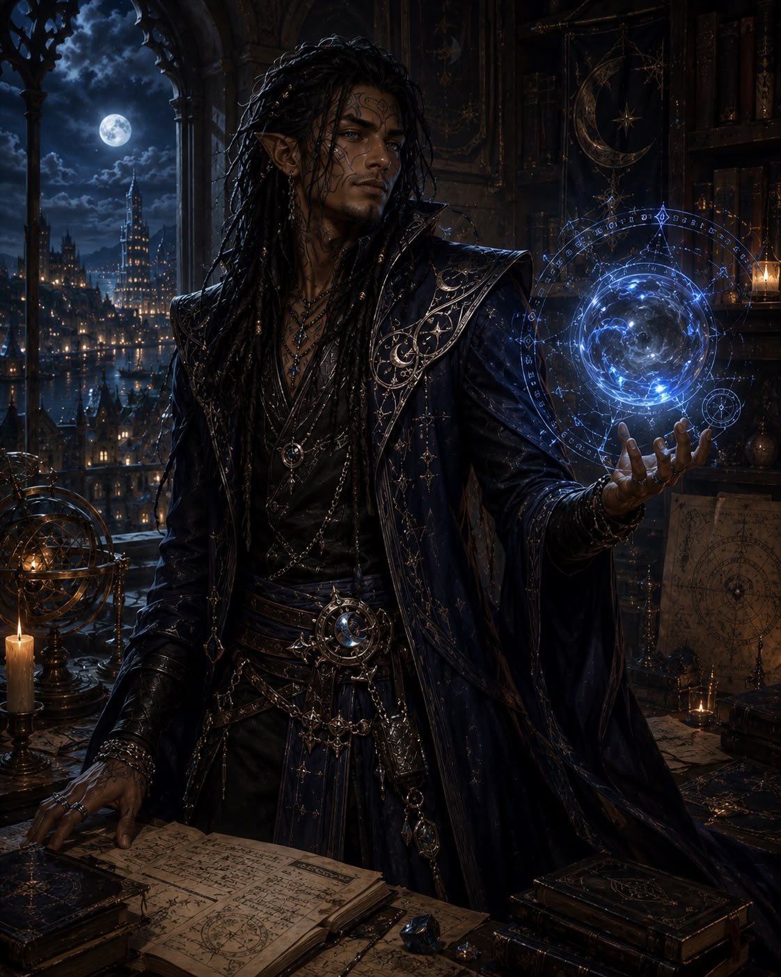

Voss Angmar: Half Elf,
Moon Druid, Fey Touched
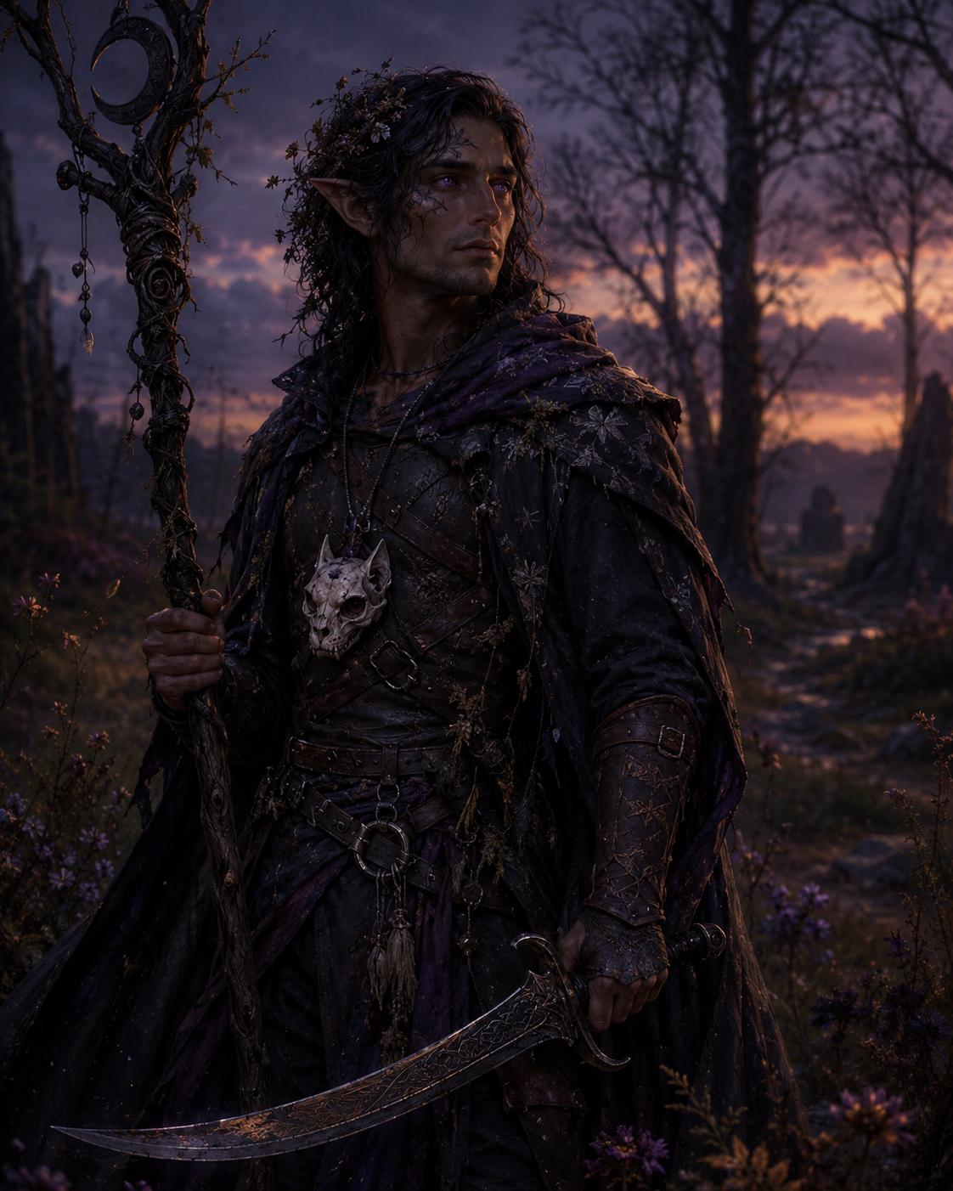

Roscoe Tealeaf, Hafling
Sorlock, magic initiate, shadow touched
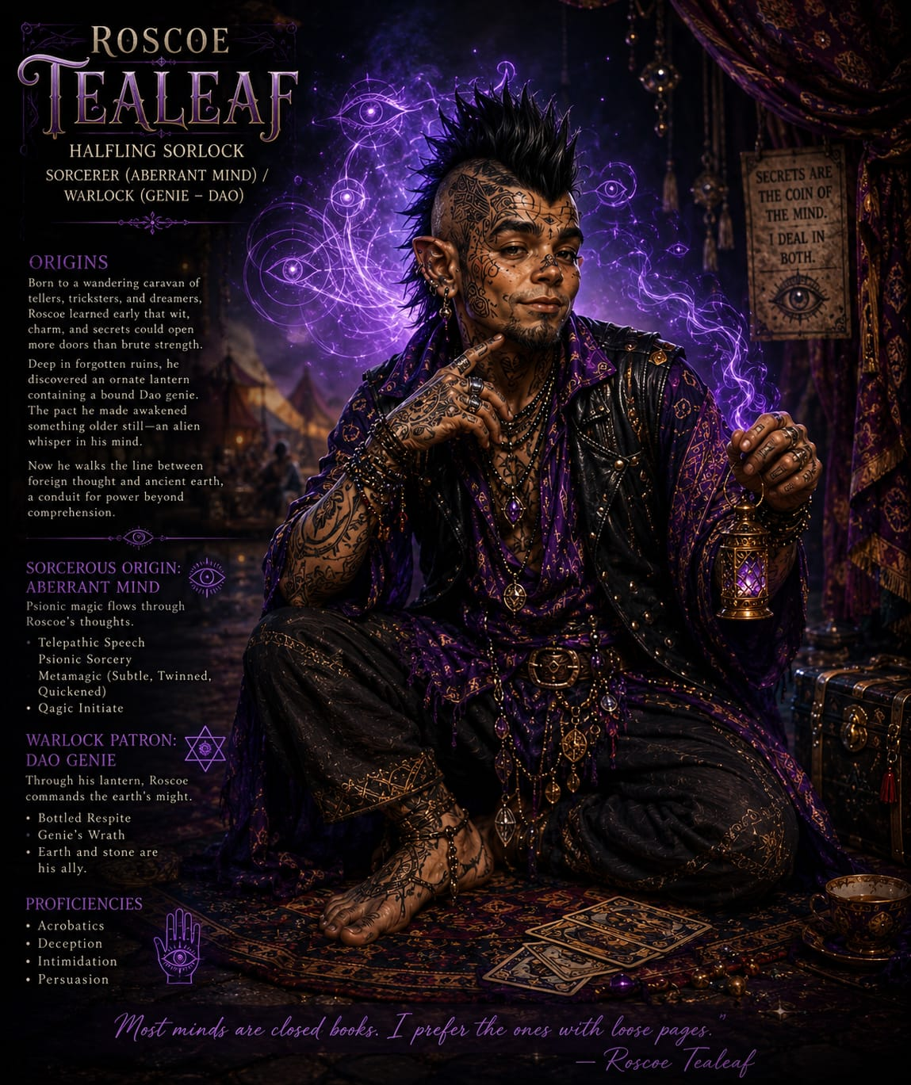

Lucian, Leonin
Echo Knight, Barbarian/Fighter
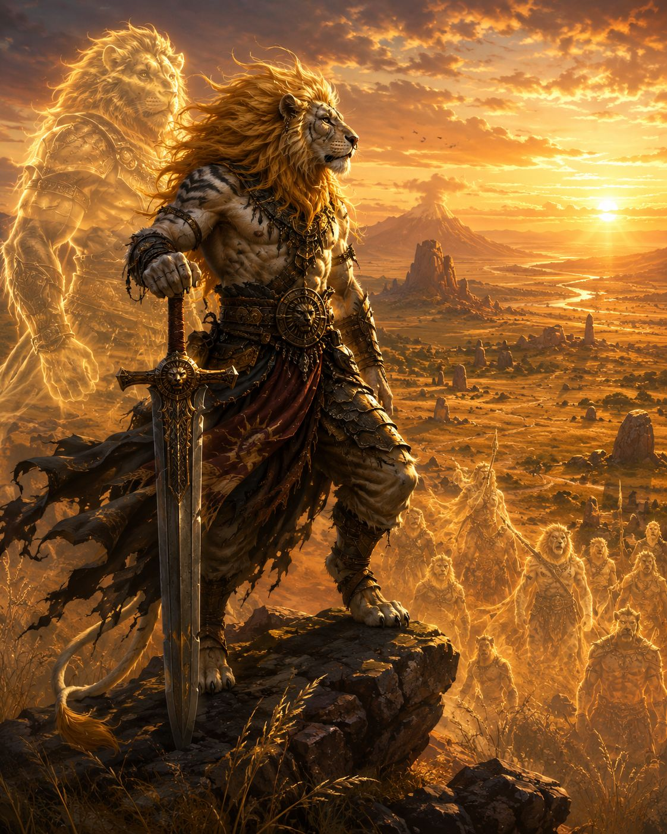

Drogath Ironbound: Orc, Fighter
Polearm Master
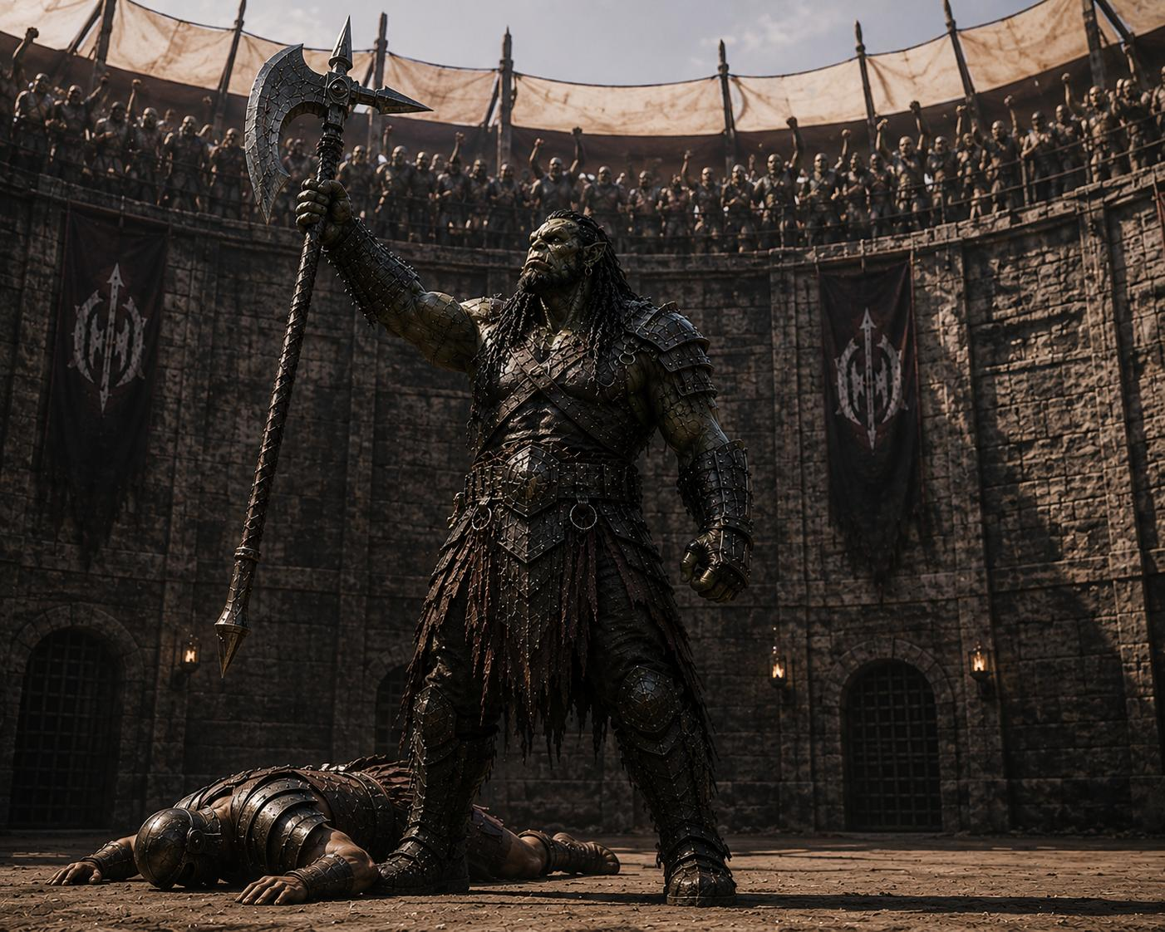

Lucia Devaux, Aasimar
Rogue
