**INTRODUCTION:**

a GUI-based Website Blocker application for Windows is built which will also have an option to unblock the blocked websites using Python.

**About Website Blocker:**

Website blockers are software programs that are used to block any websites on the internet and prevent us from accessing them. They are most widely used as browser extensions that “Blacklist” websites for users so that users cannot see the results from those websites. Here a program is created that blocks websites and the user cannot access those blocked websites.

Instead of using third-party applications to blocks certain website, a custom application is developed which will block websites of user choice.

### Knowledge Prerequisites:

#### Computer Networking:

* localhost – It is a set of hostnames that refer to the local computer to access the network services being used by the computer. These hostnames usually start with ‘127’.
* hostname – It is an IP address (not specifically on each computer) that is used to identify your computer during electronic communications.
* localhost 127.0.0.1 – It is a localhost address called the “Internet Loopback Protocol”. This address is used to establish an IP connection to the same machine or computer being used by the end-user.
* hosts file – It is an operating system file that is used to map a connection between an IP address (localhost ) and a domain name, before actually going to the domain name servers. It is a .txt file that contains a mapping of the IP addresses and domain names. It no longer has an extension but can still only be edited as a .txt file. It has different locations on different OSs, i.e., it has a different location on Windows and Linux, but the same location on MAC and Linux

#### Web Applications:

* Every domain name has its own IP address and when user type that domain name on the browser, it takes the user to its IP address, and vice versa.
* For example, If 142.250.77.110 is typed on the URL bar, it will take to google.com page , because that is Google.com’s IP address

**WORKING:**

The hosts file, maps addresses to domains; and when 127.0.0.1 is typed on the URL bar on the browser, it always refuses to connect (as on local machine usually ). So, to block websites, the program will map the desired websites to the localhost address 127.0.0.1 and add that to the hosts file. Similarly, to unblock the website, the program will remove that line from the hosts file.

**Project File Structure:**

1. **blocked_websites.txt –** A text file we will create that contains a list of all the blocked websites, something that will be used while unblocking blocked websites. [This file must never be edited manually, else it might not be able to unblock a certain website]
2. **hosts (OS file) –** An operating system file that maps IP addresses to domain names, before letting the computer go to the domain name servers.
3. **main.py –** The source code Python file.s

**OUTPUT OF A WEBSITE USING WEBSITE BLOCKER APPLICATION:**

When a website is blocked using this application in a system (PC) the following output is displayed when the user tries to access that particular website from that particular website

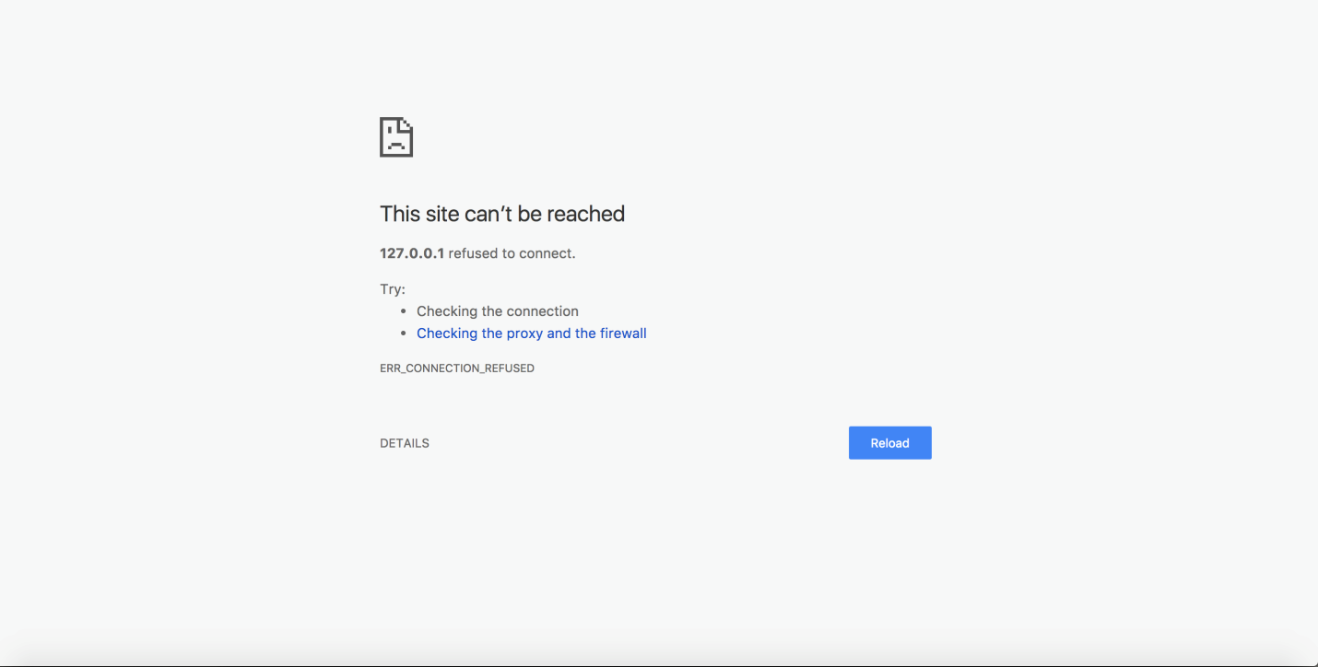

**NOTE:**

When this file is made to run on a standalone machine(as localhost), an error is encountered called as:

“PermissionError: [Errno 13] Permission denied: ’C:\\Windows\\System32\\drivers\\etc\\hosts'”

To resolve this error, required privileges to hosts file is provided , navigate to:  
C:\\Windows\\System32\\drivers\\etc\\

Now right click on hosts file >> Properties >> Security >> Edit >> Provide Full control to user >> click apply and ok

**Summary:**

A python website blocker application for windows is successfully created where the user can also unblock websites. This python project is going to be really applicable, since there are many irritating websites the user might want to block. This application is also used to block unwanted or misleading websites, so the user can focus during your classes, or for dopamine detoxification as well.