
Resto
ver. 1.0.0

The name
„Resto” is a Spanish first person singular form of a verb „restar”, which can be translated as „to remain”. There is also an obvious phonetic connection to an English verb „to rest”.
The name is explaining two main purposes of the application: to count the remaining time of your work and to take care of your regular rests.

Reason
Resto is useful for every one working with a computer. To keep you in a good health and let you remain focused whole day it is important to do regular breaks. You should stand up for a while, take a short walk and try not to think about your work issues.
Additionally Resto is especially useful for anyone working at home. It is counting your working time, so you are free to mix your personal and professional tasks and you are always aware of how many hours you have already worked.
You can customize Resto to fit to your own need. It is up to you to decide how often you want to take breaks, how long they should last and more. You can event choose your favorite color!
Of course you are not always able to take a break at certain time. That is why Resto just reminds you gently about a need of rest and let you to decide what you want to do. You can take your break right away, postpone it by some time or even skip it if you are really busy.

Functions

Main window (idle)
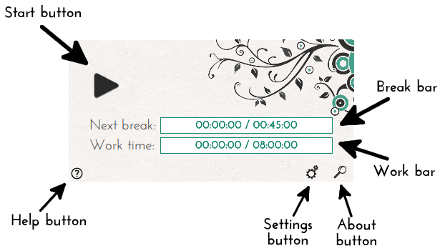
- Start button: Use this to start counting your working time.
Navigates to working window.
- Help button: Use this to find the document you are reading now.
- Settings button: Use this to change application settings.
Navigates to settings dialog.
- About button: Use this to find about dialog with information about the version, the author and resources.
Navigates to about dialog.
- Break bar: Displays a time last from the previous break, comparing to defined break interval.
- Work bar: Displays a time that have already been worked, comparing to defined work time.

Main window (working)
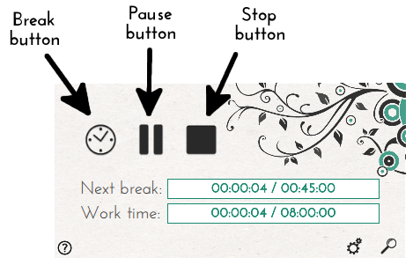
- Break button: Use this to manually take your break, without any reminders.
Navigates to break dialog.
- Pause button: Use this to pause your work for a longer time, without displaying break dialog.
Navigates to idle window.
- Stop button: Use this to stop your work – all times will be restarted.
Navigates to idle window.

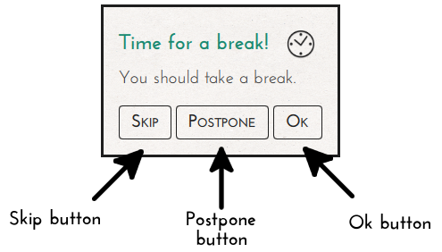
Break request dialog
- Skip button: Use this to skip a break. The break is treated as taken, there will be no further reminders until next break.
- Postpone button: Use this to postpone a break. Next reminder occurs after a defined time.
- Ok button: Use this to take a break right away.
Navigates to break dialog.

Break dialog
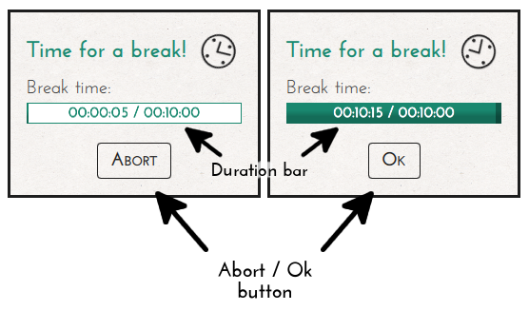
- Duration bar: Displays a break time last comparing to the defines break duration time.
- Abort / Ok button: Use this to finish a break.

Work finish request dialog
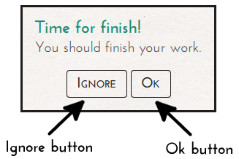
- Ignore button: Use this to ignore finish request dialog. Your work will be continued normally.
- Ok button: Use this to finish your work – all times will be restarted. This is the same as click Ignore and then Stop.

Settings dialog
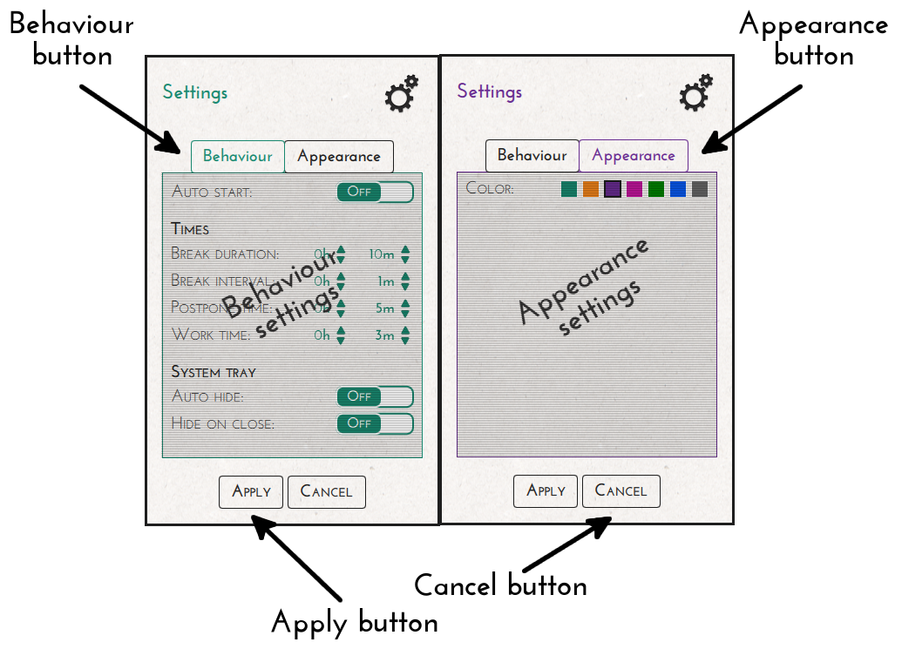
- Behaviour button: Use this to show behaviour settings.
- Appearance button: Use this to show appearance settings.
- Apply button: Use this to apply all your changes.
- Cancel button: Use this to discard all your changes.

Behaviour settings:
- Auto start (ON/ OFF)
If this option is set (ON) the application starts counting your work time immediately after run.

Times:
- Break duration (TIME)
This option defines how long you would like your break to be. It is displayed on Duration bar in Break dialog.
- Break interval (TIME)
This option defines how often you would like to take your breaks. It is displayed on Break bar in Main window.
- Postpone time (TIME)
This option defines how much you would like to postpone your break. It mean how long after using Postpone button, your break request shall reappear.
- Work time (TIME)
This option defines how many hours you would like to work a day. It is displayed on Work bar in Main window.

System tray: (not supported on all systems)
- Auto hide (ON/ OFF)
If this option is set (ON) the applications is hidden automatically after run.
- Hide on close (ON/ OFF)
If this option is set (ON) a close button only hides the application.

Appearance settings:
- Color (COLOR)
This option allows you to change a color theme of the application. You can click on a color box to see a preview of your change.

About dialog
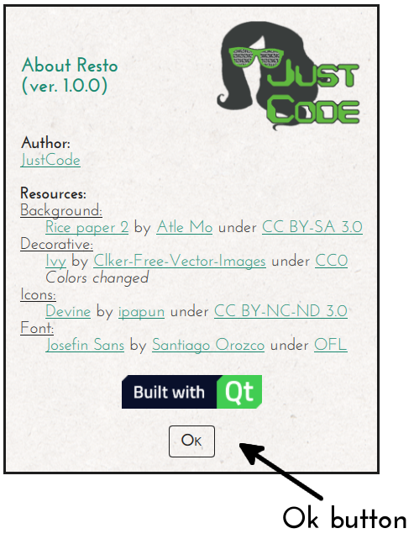
In this dialog you can find some links and information about the author of the application, used libraries and resources.
- Ok button: Use this to close this window.

Tray icon/ menu (not supported on all systems)
You can go into settings to see if tray features are supported on your system. If you see tray related settings it is supported.
For your convenience the application can be hidden into the tray using minimize button (and close button if you used the settings). All break related dialogs will continue to be displayed normally. You can use tray icon to show and hide the main window of the application (left mouse click) and to display tray menu (right mouse click).

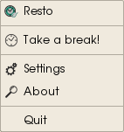
Tray menu:
- Resto Can be used to show the application,
- Take a break! Can be used to take a break on demand.
- Settings Opens the settings window.
- About Opens the about window.
- Quit Quit the application.

Epilogue
If you have any additional questions, notes or comments. You're welcomed to share them. Please take a look on authors page, which you can find in the About dialog.

