User Guide – Frühwarnsystem

Early-Warning Dashboard

Autor: Justyna Kmiecik

Content

Introduction 1

Solution Design 1

System Requirements 4

1. Installation of OCMT – Oracle Client for Microsoft Tools 4

2. Installation of Oracle ODAC – Oracle Data Access Components 4

3. Setting Up Oracle Database Access in your Excel 5

4. Open USO Ticket to be added to [DWH_TABLE_READER] 7

Functionalities of this Dashboard 7

1. User Interface 8

2. Refresh Data 8

Contact for Support 9

# Introduction

The project focuses on market data and index data, with quality checks performed on the index data. Specific tasks include completeness checks to ensure all required data has been received, identifying delayed delivery files, and visualizing missing data if it doesn't arrive. Quality control measures are implemented, and cases where indices remain unchanged or display incorrect values, such as in the case of standard deviation, are handled. Data control and receipt are monitored, and collaboration with relevant contacts for subject-specific requirements is ensured. Exceptions, such as the exclusion of certain index families, are managed, and constituent files (index files) are maintained. It is checked whether excluded indices are excluded, and the presence of indices is verified.

The goals include:

* Completeness checks for index prices
* Verifying the presence of constituents
* Defining a threshold for the prices fluctuations day by day (absolute 5% differences)

# Solution Design

After analyzing the business and technical requirements, we have decided to build the Dashboard using Power Query in Excel as the main transformation tool, connected directly to DWH (Datawarehouse – REPO.UI.NET). We are also using several calculated fields in Excel fields at a later stage to showcase KPIs like the amount of delayed Index (per today) or the Holiday name on one of 4 markets (Germany, Great Britain, Japan and United States).

See Page 3.

Ein Bild, das Text, Screenshot, Schrift, Diagramm enthält.

Graph 1 – Solution Design – Early Warning Dashboard

# System Requirements

To use this Dashboard, it is important to prepare your Local Environment and install necessary Tools.

## Installation of OCMT – Oracle Client for Microsoft Tools

Please refer to Documentation [here](https://docs.oracle.com/en/database/oracle/oracle-data-access-components/19.3.2/ocfmt/using-oracle-client-microsoft-tools.pdf).

It is required to install OCMT before using this Dashboard. Please open USO Ticket ([here](https://serviceportal.universal-investment.com/vmweb/vmweb)). After IT Administrator installs it for you, go to Software center and install on your local machine.

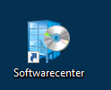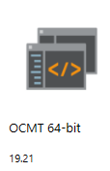

## Installation of Oracle ODAC – Oracle Data Access Components

Please refer to Documentation [here](https://www.oracle.com/database/technologies/odac-downloads.html).

It is required to install OCMT before using this Dashboard. Please open USO Ticket ([here](https://serviceportal.universal-investment.com/vmweb/vmweb)). After IT Administrator installs it for you, go to Software center and install on your local machine.

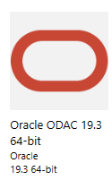

## Setting Up Oracle Database Access in your Excel

Before your first use, please insert Password for REPO.UI.NET in the Database Settings:

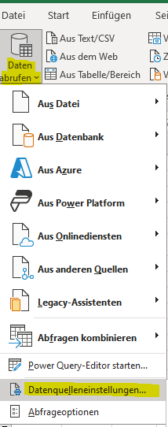

Ein Bild, das Text, Screenshot, Software, Computersymbol enthält.

Ein Bild, das Text, Screenshot, Display, Software enthält.

Click on Settings Modify and insert DWH_TABLE_READER as a User and Password: DWH_OWN

Ein Bild, das Text, Screenshot, Software, Display enthält.

## Open USO Ticket to be added to [DWH_TABLE_READER]

Please note, that you must open a [USO Ticket](https://serviceportal.universal-investment.com/vmweb/vmweb) to be added to [DWH_TABLE_READER]:

# Functionalities of this Dashboard

## User Interface

Go to the DASHBOARD TAB and see it’s functionalities:

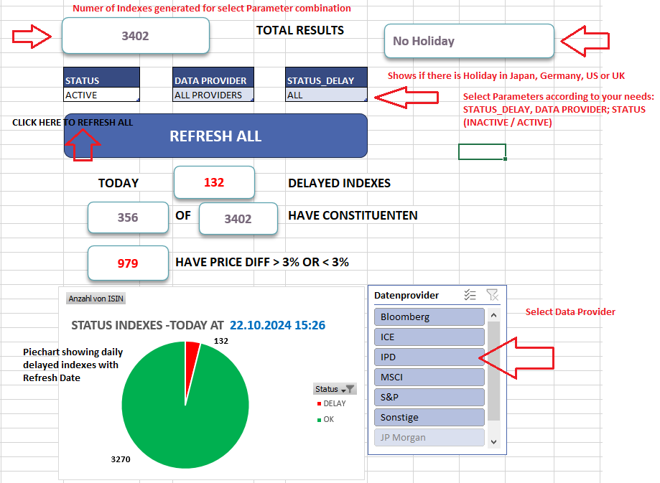

Entire Dashboard Overview

Ein Bild, das Text, Screenshot, Diagramm, Zahl enthält.

## Refresh Data

If you want to refresh all data click on “REFRESH ALL”.

You can see the refresh progress on the right side:

Ein Bild, das Text, Screenshot, Software, Zahl enthält.

See when the Query was refreshed last time

Ein Bild, das Text, Screenshot, Display, Software enthält.
