APPROVAL SHEET
This Capstone Project hereto entitled:
WEB-BASED IRRIGATION MANAGEMENT SYSTEM WITH SMS NOTIFICATION FOR NATIONAL IRRIGATION ADMINISTRATION
developed and submitted by Christian Jay Alcanzarin, Jonald Penpillo, Tzarina Paula Silva and Regine Valenzuela has been examined and is recommended for acceptance and approval for ORAL EXAMINATION.

JUAN B. DELA CRUZ SHERWIN C. FERRER, MSIT
Project Adviser Program Head – BSIT Program

APPROVED by the committee on Oral Examination with a Grade of PASSED on March 7, 2026.

MARY JOY M. VELASCO, LPT, DIT
Chairman

JULIUS P. MARCELINO, MPA CHRISTIAN MARK A. PATOSA, MIT
Examiner Examiner

ACCEPTED and APPROVED in partial fulfilment of the requirements for the degree of Bachelor of Science in Information Technology (BSIT).

FERDINAND G. ALCANTARA, Ed.D.
School Administrator

Date: ______________________________

DEDICATED

ACKNOWLEDGEMENT

TABLE OF CONTENTS
Page
Dedication i
Acknowledgement ii
Table of Contents iii
List of Tables iv
List of Figures v
Abstract vi

CHAPTER I - THE PROBLEM AND ITS SETTING
1.1 Introduction 1
1.2 Statement of the Problem 5
1.3 Objectives of the Project 10
1.4 Scope and Limitation
1.5 Significance of the Study
1.6 Definition of Terms

CHAPTER II - REVIEW OF RELATED LITERATURE AND SYSTEMS
2.1 Theoretical Background
2.2 Related Literature
2.3 Related Systems

CHAPTER III – TECHNICAL BACKGROUND
3.1 Technicality of the Project
3.3.1 The Current Process
3.3.2 The Proposed Project
3.2 Technologies Used in the Project
CHAPTER IV – METHODOLOGY
4.1 System Development
4.2 Requirements Specifications
4.2.1 Schedule Feasibility
4.2.2 Requirements Modeling
4.2.1.1 Context Flow Diagram
4.2.1.2 Data Flow Diagram
4.2.3 Design of Software, System and Product
Output and User Interface Design
4.2.4 Data Design
4.2.4.1 Entity Relationship Diagram
4.2.4.2 Data Dictionary
4.2.5 System Architecture and Security
4.2.5.1 Network Model
4.2.5.2 Security
4.2.6 Software and Hardware Specifications
4.2.7 Deployment Diagram
4.2.7.1 Mobile Application
4.2.7.2 Web Application
4.2.8 Verification, Validation and Testing
4.2.8.1 Unit Testing
4.2.8.2 Integration Testing
4.2.8.3 System Testing
CHAPTER V - CONCLUSIONS, RECOMMENDATIONS AND IMPLEMENTATION PLAN
5.1 Conclusions
5.2 Recommendations
5.3 Implementation Plan
Implementation Checklist and Diagram
5.4 References

APPENDICES
Appendix A – Authorization Letter
Appendix B – Grammarian’s Certificate
Appendix C – Project Team Assignment Form
Appendix D – Project Working Title Form
Appendix E – Relevant Source Code
Appendix F – System’s User Guide
Appendix G – Other Relevant Documents
Appendix H – Proponents’ Background

LIST OF TABLES
Table Page
- Frequency and percentage distribution
of respondents according to Age 16
- Frequency and percentage distribution
of respondents according to Gender 17
- Frequency and percentage distribution
of respondents according to Civil Status 18

LIST OF FIGURES
Figure Page
- Conceptual Framework 7
- Research Design 13

ABSTRACT

CHAPTER I
THE PROBLEM AND ITS SETTING

  - Introduction
On March 11, 2020, the World Health Organization declared the Covid-19 pandemic. It affected businesses and institutions all over the world, leading to the normalization of online services. Goldenstate College of Koronadal is one of those affected.
Goldenstate College of Koronadal, Inc. (GSCK) is a private educational institution that caters to senior high school and college students in Koronadal City. It has six college departments with a wide variety of undergraduate programs.
Before the pandemic, GSCK did not have a formal appointment procedure and announcements were disseminated verbally, through print, or GSCK’s social media account. For appointments, students simply checked the school staff members’ schedules and directly approached them based on the schedules. Based on the long physical queues outside the Registrar and Accounting Office that went on for days and even extended after business hours during pre-enrollment, permit signing, and UniFAST transactions, the school’s growing population made it hard for school staff to manage students that had the same agenda on the same day. For announcements, school staff would either make announcements during class or events, ask a student to disseminate to their classmates or post a print on the bulletin board. There were instances when verbally disseminated information became inaccurate as important details were often left out or forgotten.
On May 21, 2021, during his presentation at the "Educating our Children in the New Normal" webinar, Commission on Higher Education chair Prospero de Vera III stated that flexible learning will be the "new norm" and that there will be no turning back to traditional face-to-face classes. He went on to say that because schools have spent much in training and infrastructure to meet this new norm, CHED has embraced these policies and would continue to do so even after the pandemic is over. As a CHED-accredited institution, GSCK adheres to its policies.
During the pandemic, GSCK adopted flexible learning practices that allowed student-teacher interaction through printed modules and online means, and teachers became work-from-home employees and were not required to work from the school premises. Koronadal
  - Statement of the Problem
Since the Covid-19 pandemic started and GSCK was forced to implement flexible learning, its students have had a hard time with both getting to school and submitting requirements at school. It was hard for the students to make appointments with the school staff they needed or find announcements by school staff. Students did not know if it was safe or possible to go to school. There was no certainty if the school was closed or would let the student in without an appointment. The current appointment process of GSCK required students to consult their teachers or the guard first and then the teacher would relay the information to whoever was involved in the inquiry. Simple inquiries involved different school staff. The request for documents involved the Registrar’s office. Meetings involved different school staff. It was hard for students to find the contact information of school staff. It was also hard to make appointments with teachers just through messenger or text as there were chances that the teachers were not able to see the messages. There was a need for school staff to arrange and monitor the schedules of different types of appointments. The school’s growing population made it hard for school staff to manage students that had the same agenda on the same day. Queueing outside the school should have been discouraged as there was a pandemic. Not all students were up-to-date with school announcements. The school staff could not monitor the appointments they made on that particular day causing overcrowding in the school.
  - General Objectives of the Project
The proponents aimed to create a Web-Based Appointment and Information Management with SMS Notification and Queuing System for Goldenstate College of Koronadal.
1.3.1 Objectives of the Project
Specifically, the project aimed:
- To create a module that would allow users to reach the school staff they need to request an appointment.
- To create a module that would allow the school staff to arrange appointment schedules at their convenience.
- To create a module that would assign a priority number for students every appointment.
- To create a module that would allow the school staff to post announcements that could be viewed by all users.
- To create a module that would inform students of their appointment schedules and important school announcements by SMS.
- To create a module that would generate the following reports:
  - For Teachers, the Accounting Staff/Scholarship Coordinator, and the Registrar:
    - List of active appointments for GSCK for a given day
    - List of pending appointment requests for a given day, first-in, first-out order
  - For the Accounting Staff/Scholarship Coordinator:
    - For UniFAST transactions: List of appointments, ordered alphabetically by surnames
  - For the Registrar:
    - List of students enrolled in GSCK
    - List of students registered in the system
    - List of employees of GSCK
    - List of employees registered in the system

  - Scope and Limitation
1.4.1 Scope
The project focused on the development of the Web-Based Appointment and Information Management with SMS Notification and Queuing System for Goldenstate College of Koronadal. The project was web-based. It was developed using Hypertext Markup Language (HTML5), Cascading Style Shee.

1.4.2 Limitation
Only enrolled students and employees, validated by the Registrar’s Office, will be able to do appointment transactions. Alumni of GSCK will not be covered by the project but can access the general information and announcements. It will not cover appointments requested by school staff from the students.

  - Significance of the Study
This project “Web-Based Appointment and Information Management with SMS Notification and Queuing System for Goldenstate College of Koronadal.” will be implemented for the benefit of the following:
The Students of Goldenstate College of Koronadal - The project will make it more convenient to make appointments with their teachers and other school staff. They will be up-to-date with school announcements. They will be notified of their appointments through SMS notification.

The Parents of Future and Current Students of Goldenstate College of Koronadal - The project will reduce their difficulty finding school information and announcements.
The Teachers of Goldenstate College of Koronadal - The project will make it more convenient to manage and organize appointments requested by students. They can accept appointments for meetings, project submission, consultations, etc. The queuing system will help them manage the usual queue of students outside the school whenever there are scheduled appointments.
The Registrar’s Office of Goldenstate College of Koronadal - The project will make it more convenient to manage and organize appointments requested by students. They can accept appointments for enrollment, grades inquiry, consultations, and requests for documents. The queuing system will help them manage the usual queue of students outside the school whenever there are scheduled appointments.
The Accounting Staff/Scholarship Coordinator of Goldenstate College of Koronadal - The project will make it more convenient to manage and organize appointments requested by students. They can accept appointments for UniFAST transactions, consultations, and payment transactions. The queuing system will help them manage the usual queue of students outside the school whenever there are scheduled appointments.
The Future Researcher- The project may serve as a guide or basis for the future researcher on creating a more advanced and high-technology-integrated system that is valuable to users.

  - Definition of Terms
For better clarification and understanding of the terms related to this study, the following terms were defined:
Accounting Staff - A person employed to handle accounting transactions by Goldenstate College of Koronadal.
GSCK - Acronym for Goldenstate College of Koronadal.
Registrar - A person employed to handle the student and employee registry at Goldenstate College of Koronadal.
Scholarship Coordinator - A person employed as Scholarship Coordinator by Goldenstate College of Koronadal.
School staff - The collective employees of Goldenstate College of Koronadal.
SMS - Acronym for Short Message Service.
Student - A person enrolled as a student in Goldenstate College of Koronadal.
Teacher - A person employed as an educator by Goldenstate College of
Koronadal.

CHAPTER II
REVIEW OF RELATED LITERATURE AND STUDIES/SYSTEM

  - Theoretical Background
Task-Technology Fit (TTF) theory
According to Goodhue, D. and Thompson R. (1995), the Task-Technology Fit theory’s central claim is that in order for information technology to have a positive influence on individual performance, it must: (1) likewise be utilized or effectively used; and (2) be a good fit for the tasks it supports.
Cumulative evidence of previous research showing the impact of usefulness, relative advantage, and importance on utilization suggests that under some circumstances a link between TTF and utilization exists.

Application of the Task-Technology Fit Theory
In the paper “A Scoping Review of the Application of the Task-Technology Fit Theory” by Spies, R. et al (2020), they stated that the TTF theory was a significant advancement in IS research, and it has been widely used in a variety of contexts and on a variety of technologies. The purpose of their study was to find and evaluate relevant literature that uses the specific components of TTF in order to answer three research questions about why, where, and on what TTF was applied on.
The first research question is addressed in the analysis and synthesis of the intents for using TTF, where several degrees of categorization for the intentions were defined. The categories were then utilized to identify particular patterns throughout time, demonstrating how the emphasis of studies changed from mostly theory-based to the use of TTF to analyze various phenomena.
As a result of addressing both the second and final research questions, the analysis and synthesis of the application environment, as well as the evaluated technology, revealed the vast range of environments and technologies connected with the application of TTF. These findings demonstrated the TTF theory's broad spectrum of applicability, as well as the possibility for both business and academics to use it in new contexts and with new technology. (Spies, R., et al., 2020).
  - Related Literature
Appointment System
Oluwaseun, B., et al. (2016) created a system for Student-Teacher Online Booking Appointment System in Academic Institutions. Students and instructors can obtain access to the system simply by connecting to the Internet. It also allows students to send any message, including the reason and time of the appointment. The system was built with Hypertext Markup Language (HTML5), Hypertext Pre-processor (PHP) as a scripting language, the Bootstrap framework, and My Structured Query Language (MySQL) as a database. This will allow the web application to be robust, inexpensive, and capable of running on a variety of platforms. The system is not only fully automated, and performs excellently well, but also user-friendly, time-effective, and efficient.
Reza, M., et al. (2018) investigated patient satisfaction with appointment scheduling systems in outpatient clinics. It indicated that the majority of patients (67.1 percent) supported the use of a web-based appointment scheduling system. Cao et al. revealed that utilizing a web-based appointment scheduling system might improve patient satisfaction while decreasing waiting time. As a result, using a web-based appointment scheduling system is advised.
Chaudhry, S., et al. (2021) conducted a study in Designing an Online Appointment System for Semiliterate Users. The study discussed how important it is in making easy to understand, easy-to-use, easy to remember, effective, and efficient user interfaces for the users. To achieve this, a prototype was designed to overcome issues in the existing appointment systems gathered through a field study. The effectiveness is measured through the number of errors and tasks accomplished in UI, efficiency by the time required to complete the task and satisfaction by the System Usability Scale (SUS). The SUS score improved from 50.8 to 77.6 for the prototype.

Queuing System
The amount of time and energy spent by people waiting in lines for public services is a major issue. Even more so if the people queuing are rushed or ill. Due to a person's hectic schedule, he or she may be required to accomplish several tasks in various locations in a short amount of time. As a result, we want a queuing system capable of integrating all queuing .

  - Related Systems
Student-Teacher Online Booking Appointment System in Academic Institutions
Oluwaseun B et al.(2016) developed a system Student-Teacher Online Booking Appointment System in Academic Institutions. This provides an appointment scheduler for the student and lecturer. The server/ client interaction occurs through Hypertext–transfer protocol (HTTP), a protocol on the Transmission Control Protocol/ Internet Protocol (IP/TCP) suite. The application is implemented on both mobile and Windows platforms. Thus, providing an interactive interface determined the increasing number of users with interest to use the system. The database is a file structured specifically for efficient storage and easy retrieval of data. My Structured Query Language (MySQL) server was used as the database. To gain access to the system, the students register with their personal information, thereby getting their username and password needed for logging into the system. The Staff is enabled to schedule the time to be booked by the student daily. The Staff can either accept or reject the appointment booked by the Student.

School Event Notification Through SMS
Lumauag, R. (2016) developed a system for School Event Notification Through SMS. It is beneficial to students, teachers, and parents in receiving first-hand information from the school right into their mobile phones. With the use of SMS Notification, students will be notified of the upcoming events of the school, changes in the schedule of events, and suspension of classes due to bad weather. Teachers will be notified of the schedule of meetings, emergency meetings, and deadlines of requirements. Parents will also be informed about the school activities and be aware of the activities of their children in school. The system was tested and evaluated using ISO 9126 standard questionnaire for software quality characteristics such as functionality, reliability, usability, efficiency, maintainability, and portability. The evaluators were five (5) IT Experts who are in line with database and mobile development. For the users, it was evaluated by ninety (90) parents, ninety (90) students, and twelve (12) faculty and staff who were chosen based on random selection using the random

CHAPTER III
TECHNICAL BACKGROUND

  - Technicality of the Project
This chapter includes the current processes used by the client as well as the processes used by the proposed system in addressing those problems stated in the study, as well as the representation of operations and transactions performed by the proposed system in solving the problem.

3.1.1 The Current Process
Before Pandemic, GSCK did not have a formal appointment procedure and announcements were disseminated verbally, through print, or GSCK’s social media account. For appointments, students simply checked the school staff members’ schedules and directly approached them based on the schedules. Based on the long queues that went on for days and even extended after business hours during pre-enrollment, permit signing, and UniFAST transactions, the school’s growing population made it hard for school staff to manage students that had the same agenda on the same day. For announcements, school staff would either make announcements during class or events, ask a student to disseminate to their classmates or post a print on the bulletin board. There were instances when verbally disseminated information became inaccurate as important details were often left out or forgotten.
During Pandemic, GSCK adjusted to the situation by implementing a few procedures. Some of these are for the Enrollment Process, the Announcement Process, the UniFAST transaction process, as well as a general appointment process.
The figure below shows the enrollment process which includes the pre-enrollment where students wait for the school to post the enrollment link on the school’s social media page or shared by staff to students on social media groups and group chats; students open the link, fill up the enrollment form, wait for a text message that has the time and date for enrollment, go to school on the appointed day, form a queue at the entrance to get the enrollment form, fill-up the form, queue again at the entrance to register.

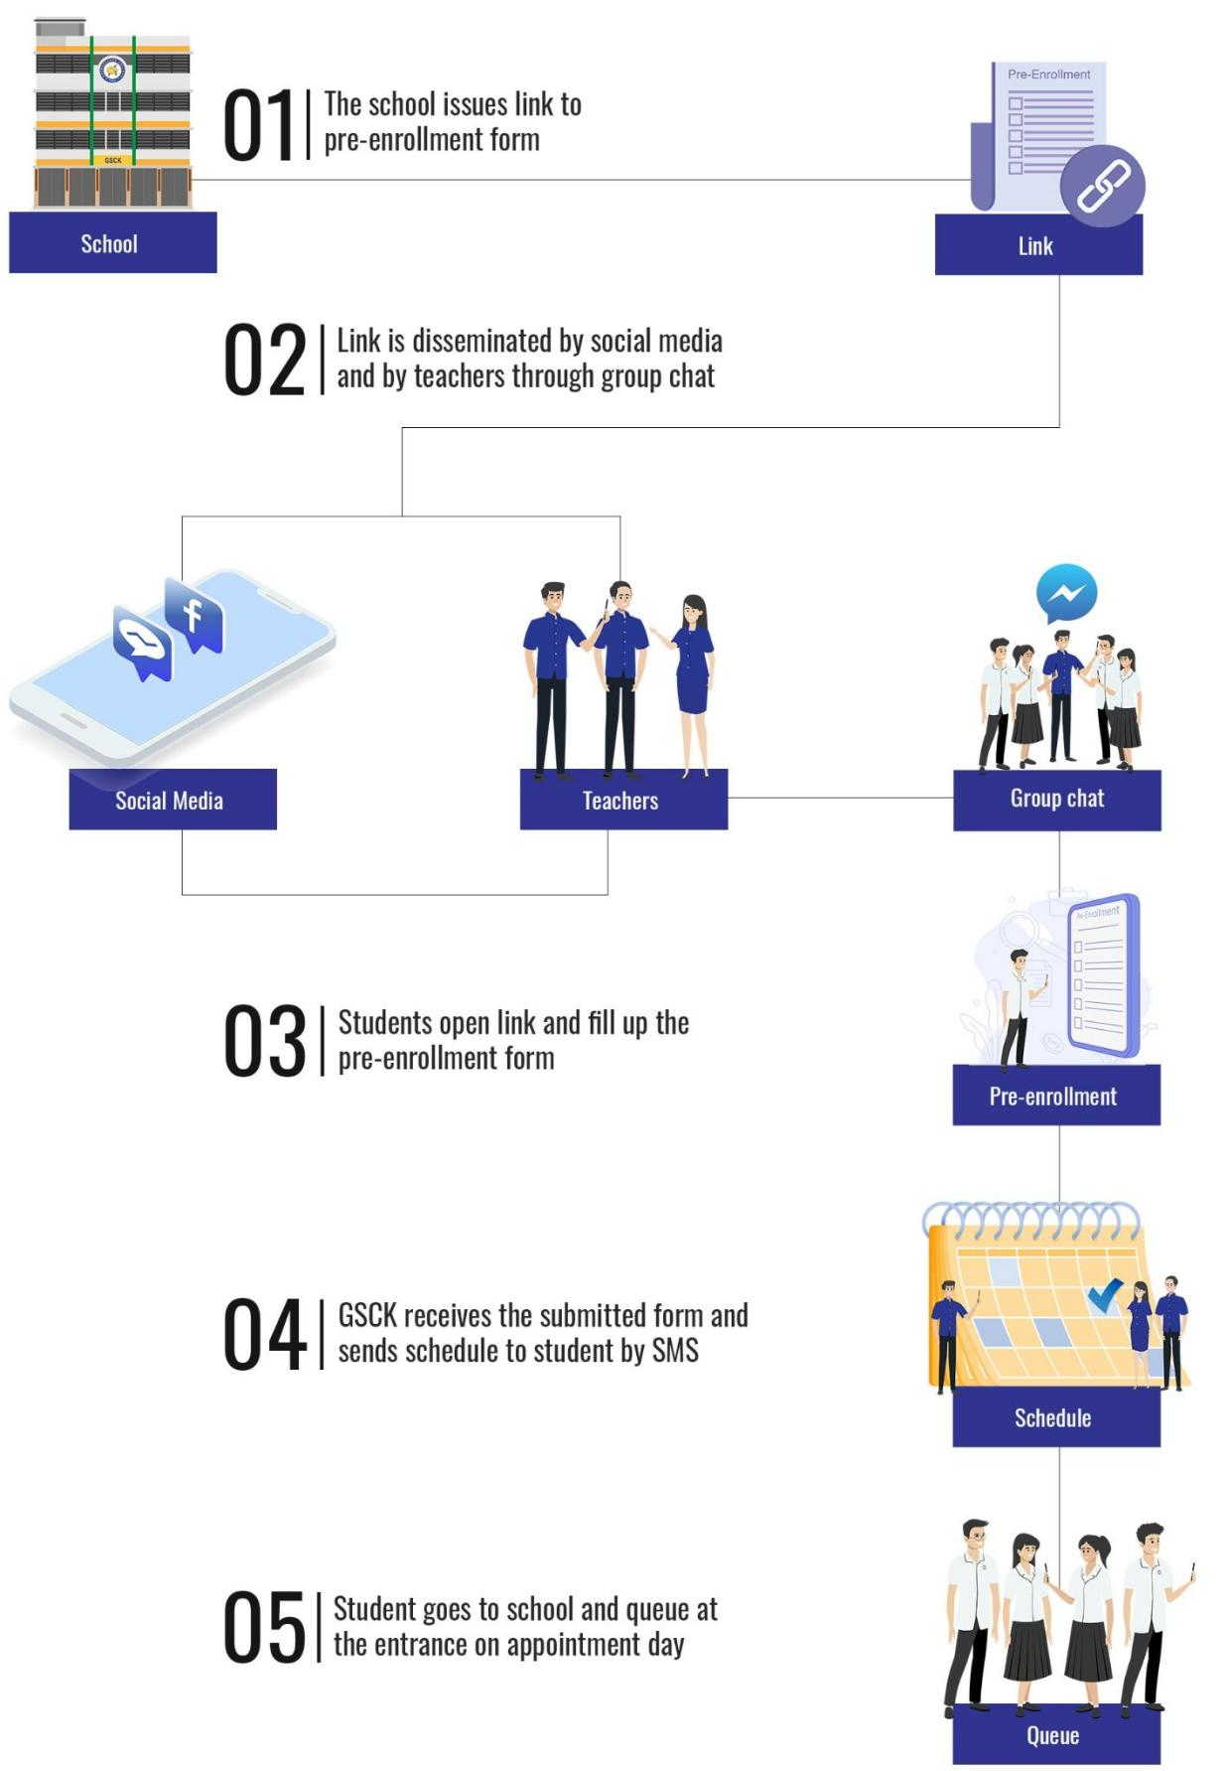

Figure 1: Plan, Do, Check and Act (PDCA) Process
3.1.2 The Proposed Project
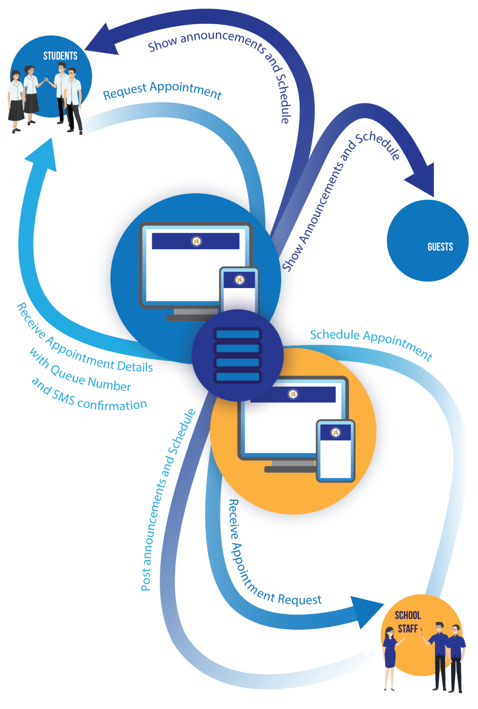
Figure 5: The Proposed Project
Most of the processes that were mentioned in the Current Process are features in the Proposed Project. The project allows Staff members to post, update, and delete an announcement. Examples of announcements are that for UniFAST and Enrollment. The announcements are shown to both Students and Guests. The project also has the appointment process where the student can request an appointment which the school staff would receive and schedule.

  - Technologies Used in the Project
MySQL - The proponents used MySQL to store the database. It is open-sourced, reliable, compatible with all major hosting providers, cost-effective, and easy to manage.
PHP - The system was made using PHP, because it is a widely-used, free, and efficient alternative to competitors such as Microsoft's ASP. A benefit of using PHP is that it can interact with many different database languages including MySQL.

CHAPTER IV
METHODOLOGY
Communication
cv
Planning

cv
Modeling

Construction
Deployment
Start
cv
estimation
scheduling
risk analysis
analysis
design
code
test
delivery
feedback
team meetings
interview with the client

  - System Development
Figure 6: The Spiral Methodology

The proponents used the Spiral Methodology because each component of the overall project was designed independently, and as such, each component could have its own lifecycle. Each component may be a middleware component, an object, or a reusable application.
The phases of the Spiral Methodology were the Communication, Planning, Modeling, Construction, and Deployment Phases.
The Communication Phase consisted of team meetings and client interviews. Team meetings covered the planning and scheduling of all activities needed to create the system. This was also the time when key stakeholders were identified, and roles and responsibilities were outlined. Interviews were arranged with the employees of GSCK. It was an effective fact-finding instrument. This phase was also when the proponents got the client’s approval to start the project.

  - Requirement Specifications
4.2.1 Schedule Feasibility
(Insert the Gantt chart and briefly discuss)

4.2.2 Requirements Modelling
4.2.2.1 Context Flow Diagram
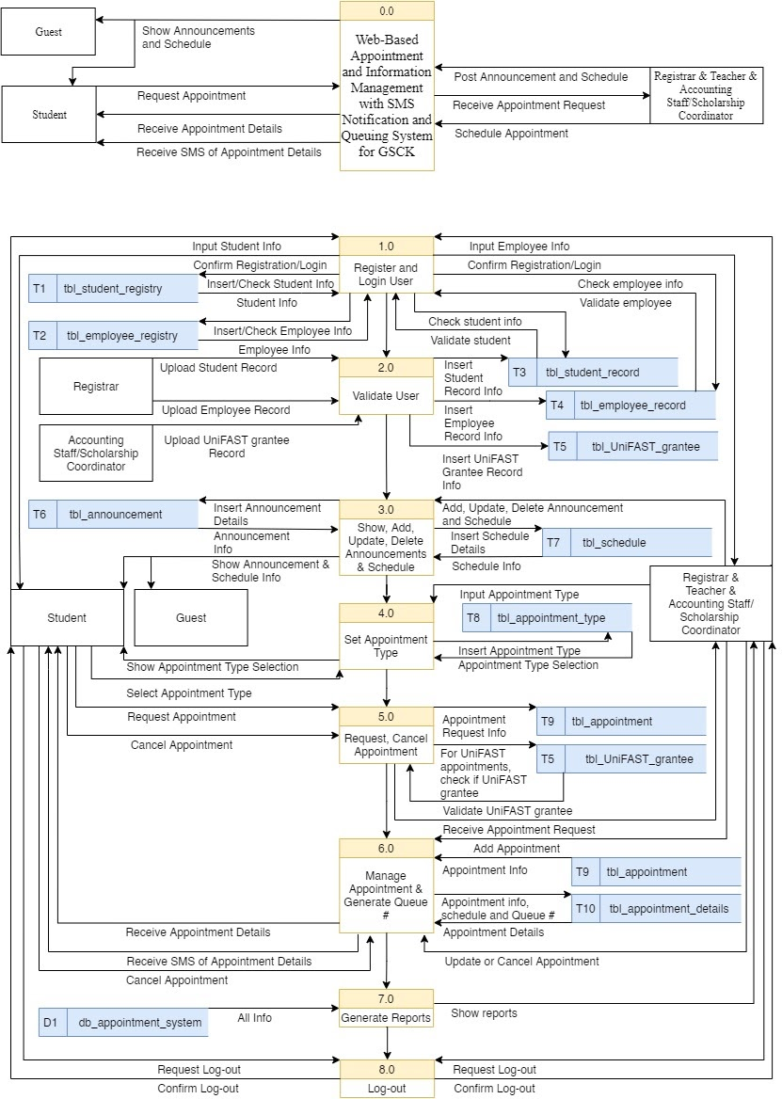 Figure 7: Context Flow Diagram

The context flow diagram of the Web-Based Appointment and Information Management with SMS Notification and Queuing System for GSCK, there were 5 involved entities: Guest, Student, Teacher, Accounting Staff/Scholarship Coordinator, and Registrar. The system showed announcements to both the Guest and Student. Only the Student can make appointment transactions. The Teacher, Accounting Staff/Scholarship Coordinator, and Registrar can post an announcement and do appointment transactions.
4.2.2.2 Data Flow Diagram

Figure 8: Level 0 Data Flow Diagram
4.2.3 Design of Software, System and Product
(Insert the screenshots of the interface of the system/app and provide descriptions)

4.2.4 Data Design
4.2.4.1 Entity Relationship Diagram
(Insert the figure of ERD of the system/app and provide descriptions)

4.2.4.2 Data Dictionary
(Insert the table of Data dictionary of the system/app and provide descriptions)

4.2.5 System Architecture and Security
4.2.5.1 Network Model
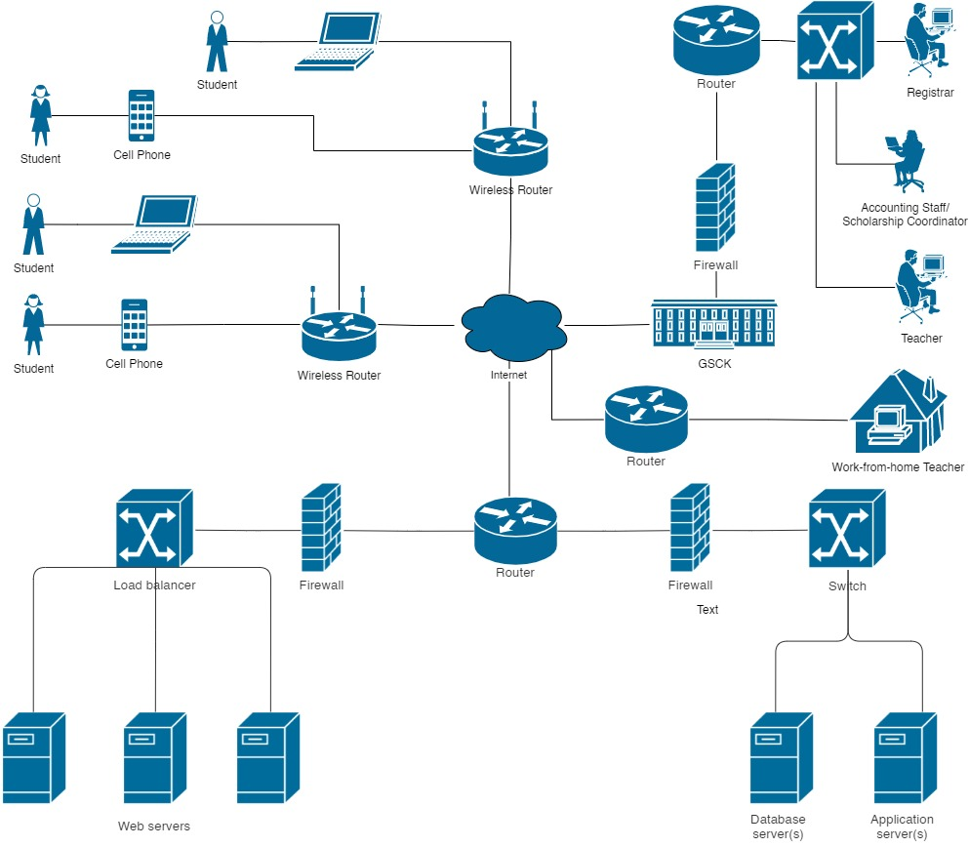
Figure 9: Network Diagram
(provide descriptions/discussions for the network diagram)

4.2.6 Software and Hardware Specifications
Software Specifications (Minimum Requirements)
OS
- Windows 7
- Android Lollipop 5.0
- iOS 7.0
- OS X 10.6
Web Browser App
- Google Chrome
- Firefox
- Safari
- Microsoft Edge
- Gener8
Hardware Specifications (Minimum Requirements)
Desktop/Laptop
- Windows 7
- Intel Pentium 4 processor or later that's SSE2 capable
- 2GB of RAM
- Web Browser App
- Computer Mouse
- Computer Keyboard
- Internet Connection
Android Phone
- Android Lollipop 5.0
- Any 1 Ghz single core processor or better (non-Intel)
- 512MB of RAM
- Web Browser App
- Internet Connection
iPhone/iPad
- iOS 7.0
- Any 1 Ghz single core processor or better (non-Intel)
- 512MB of Ram
- Web Browser App
- Internet Connection
MacBook
- OS X 10.6
- Intel X86 processor
- 1GB of RAM
- Web Browser App
- Internet Connection
And other devices that have a Web Browser App to access the system.

4.2.7 Deployment Diagram
4.2.7.1 Mobile Application
(Insert the deployment diagram of the mobile app and provide descriptions)

4.2.7.2 Web Application
(Insert the deployment diagram of the web system and provide descriptions)

4.2.8 Verification, Validation and Testing

4.2.8.1 Unit Testing
(Insert unit testing results)

4.2.8.2 Integration Testing
(Insert integration testing results)

4.2.8.3 System Testing
(Insert system testing results)

CHAPTER IV
CONCLUSION, RECOMMENDATIONS AND IMPLEMENTATION PLAN

  - Conclusion
The Bachelor of Science in Information Technology (BSIT) includes the study of the utilization of both hardware and software technologies involving planning, installing, customizing, operating, managing, and administering

  - Recommendations
(Provide recommendations)

  - Implementation Plan
The Bachelor of Science in Information Technology (BSIT) includes the study of the utilization of both hardware and software technologies involving planning, installing, customizing, operating, managing, and administering

5.3.1 Project Implementation Checklist

5.3.2 Implementation Contingency

  - Bibliography

Appendix A
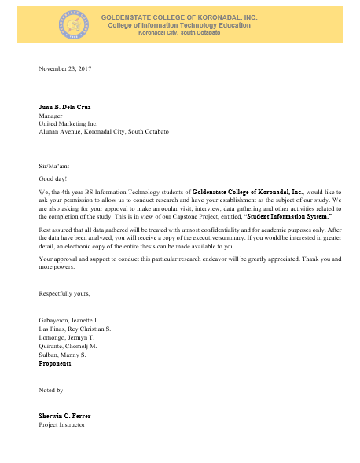
AUTHORIZATION LETTER

(Insert the scanned copy of Authorization Letter signed/received by the proponents, project instructor and client)\

Appendix B
GRAMMARIAN’S CERTIFICATE
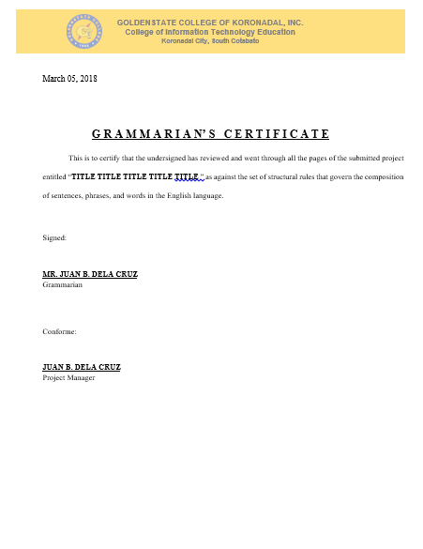

(Insert the scanned copy of Grammarian’s cerificate signed by the grammarian and project manager)

Appendix C
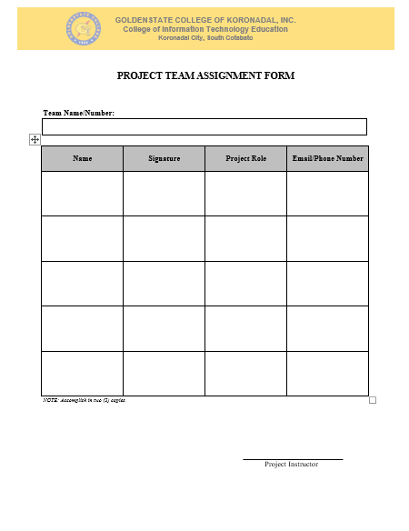
PROJECT TEAM ASSIGNMENT FORM

(Insert the scanned copy of Project team assignment form signed by the project instructor)

Appendix D
PROJECT WORKING TITLE FORM
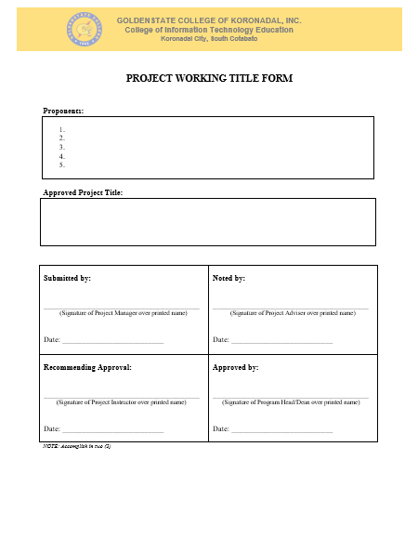

(Insert the scanned copy of Project working title form)

Appendix E
RELEVANT SOURCE CODE
(Insert the relevant source code of the system/app, use 8 as font size and Courier New as font style)

Appendix F
SYSTEM’S USERS GUIDE
(Insert figurative instructions and procedures in using the system/app)

Appendix G
OTHER RELEVANT DOCUMENTS
(Insert the scanned copy of relevant documents provided by the clients during interview etc.)

Appendix H
PROPONENTS’ BACKGROUND



JUAN B. DELACRUZ
Project Manager
Juanb@gmail.com
(083) 228-8593

Skills, Specializations and Academic Achievements:

Multimedia
Phyton Programming

Internship:

hjdkvlfl

