Activity 4: Designing a Secure Network
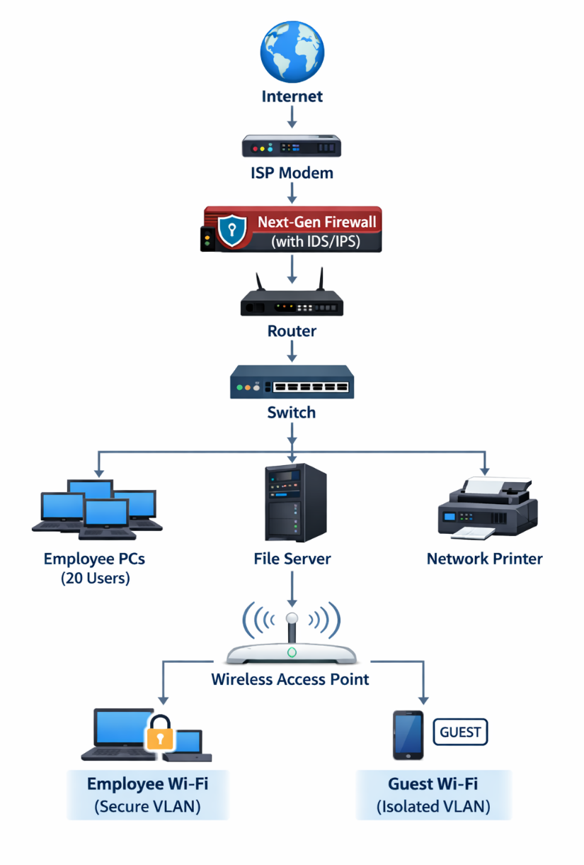

2. Security Design Suggestions
A. Type of Firewall / IDS
The network should use a Next-Generation Firewall (NGFW) with built-in Intrusion Detection System (IDS) and Intrusion Prevention System (IPS).
Examples:
- Hardware firewall such as Fortinet FortiGate 40F
- Small office firewall like Cisco Meraki MX64
Features that should be enabled:
- Packet filtering
- Intrusion detection and prevention
- Malware and phishing protection
- Application control
- VPN for remote employees
This firewall will monitor all traffic entering and leaving the office network.
B. Segmentation Strategy
Network segmentation should be implemented using VLANs to separate different types of devices.
Suggested VLAN structure:
VLAN | Purpose | Devices
VLAN 10 | Employee Network | 20 employee computers
VLAN 20 | Servers | File server and internal systems
VLAN 30 | Printers/IoT | Network printers
VLAN 40 | Guest Network | Visitor Wi-Fi
Benefits:
- Limits the spread of malware
- Prevents guests from accessing company files
- Improves network performance and monitoring
Access Control Lists (ACLs) should allow employees to access servers, but guest users should only access the internet.

C. Guest Wi-Fi Policy
The office should implement a separate guest wireless network.
Guest Wi-Fi security rules:
- Use a separate SSID (example: Office-Guest).
- Place guest users in a separate VLAN.
- Block access to internal resources (servers, printers, employee PCs).
- Limit bandwidth usage.
- Change the guest Wi-Fi password regularly or use temporary login access.
This ensures visitors can access the internet without risking the company's internal systems.

