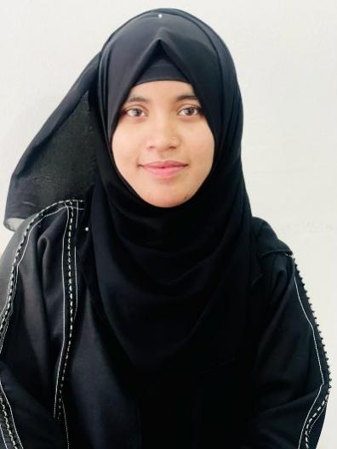

**JUTHY AKTHER**

I am deeply passionate about Web development and eager to immerse myself in real-time projects to enhance my skills. I thrive on learning from diverse projects and collaborating with teams to expand my knowledge and expertise.

* **Landing Page** (<juthy123.github.io/Landing-Page/>)
* Developed a landing page using pure HTML and CSS
* **Restaurant Website** (<juthy123.github.io/Restaurant-Website/>)
* Developed a responsive restaurant website
* Used HTML, CSS and for responsive design used media query technique
* **Portfolio** ([Portfolio](https://juthy123.github.io/Portfolio/))
* Creating a portfolio about myself using HTML, CSS and JavaScript
* Software Development
* System Analysis & Design
* Problem Solving

**SKILL**

* **BACHELOR OF COMPUTER SCIENCE & ENGINEERING**

**IUBAT**- International University of Business Agriculture and Technology

CGPA: 4.81 Year: 2020 – present

* **HIGHER SECONDARY CERTIFICATE (H.S.C)**

Akhaura Shahid Smrity Govt. College

GPA: 4.61 Year: 2017-2019

* **SECONDARY SCHOOL CERTIFICATE (S.S.C)**

Hirapur Shahid Nowab Memorial High School

GPA: 4.33 Year: 2014-2016

**EDUCATION**



+8801402146303

[juthyakther12345@gmail.com](mailto:juthyakther12345@gmail.com)

<https://github.com/Juthy123>

Sector-10, Raod-11, Uttara, Dhaka

**CONTACT**

* **Certificate of Book Reading competition**

British Council

* **Academic Mentor**

Department of CSE, IUBAT

**CERTIFICATE**

**PROJECT**

As a current student, I have gained valuable experience through numerous projects directly aligned with my field of study. These projects were undertaken as part of my departmental coursework, showcasing my dedication to practical learning and commitment to mastering the subject matter.

**WORK EXPERIENCE**

**ABOUT ME**

I am a hardworking individual who has a passion in programming. To find a challenging position to meet my competencies and capabilities. skills, education & experience.

I want to engage myself in a company where there is an opportunity to contribute to the growth of the organization as well as.

**PERSONAL ATTRIBUTES**

**PERSONAL INFORMATION**

* Good organization and interpersonal communication skills.
* Self-Confident and being positive.
* Ability to manage time and be flexible.
* Ability to work efficiently under pressure and fulfill deadlines.
* Open mined in adapting to new challenging situations.
* Ability to work collaboratively as part of a team.

Name : Juthy Akther

Father’s Name : Monir Hossain

Mother’s Name : Jarina Begum

Date of Birth : 25-01-1999

Present Address : Sector-10, Road- 11, Uttara, Dhaka

Permanent Address : Vill: college-Para, P.O: Akhaura

Thana: Akhaura, Dist: Brahmanbaria

Religion : Islam

Marital Status : Unmarried

Gender : Female

Nationality : Bangladeshi

Blood Group : A+

* Problem Solving
* Reading
* Travelling

**INTEREST**

Krishna Das

Assistant Professor

Department of Computer Science & Engineering, IUBAT, Dhaka - 1230

[krishna.das@iubat.edu](mailto:krishna.das@iubat.edu), +8801553543733

**REFERENCE**