E-Commerce Customer Segmentation &
Churn Risk Analysis Report
Data-Driven Customer Profiling, Multi-Channel Analytics, and Random Forest Machine Learning Churn Prediction
Author Name: | Juttu Abhiram
Project Title: | E-Commerce Customer Segmentation & Churn Risk Analysis
Dataset Reference: | E-commerce Customer Segmentation 2026 Dataset (50,000 Records)
Date of Submission: | September 2026

1. Executive Summary
In the rapidly evolving e-commerce landscape, understanding customer behavior, revenue contributions across segments, and proactively preventing customer attrition are critical pillars of operational growth and profitability. This report presents a comprehensive end-to-end data analysis and machine learning workflow conducted by Juttu Abhiram on a large-scale e-commerce dataset comprising 50,000 unique customer profiles.
The project encompasses rigorous exploratory data analysis (EDA), segment distribution profiling, channel contribution assessment, product category performance evaluation, and the deployment of a Random Forest Classifier to identify high-risk churn customers. The machine learning model achieved an outstanding overall accuracy of 96.73%, identifying 2,577 high-risk customers requiring immediate targeted retention strategies.
📌 EXECUTIVE HIGHLIGHT
By leveraging 14 primary customer behavioral metrics, the Random Forest predictive pipeline successfully identifies high-risk churn candidates with 96.73% overall accuracy. Strategic intervention focused on these 2,577 customers can safeguard significant annual recurring revenue.

2. Business Context & Problem Statement
Modern e-commerce enterprises face intense competition, rising Customer Acquisition Costs (CAC), and fluctuating user engagement. Acquiring new customers is up to 5 times more expensive than retaining existing ones. Consequently, maximizing Customer Lifetime Value (CLV) and implementing proactive retention mechanisms are paramount.
The primary objectives of this analytical initiative are:
- Segment Behavioral Profiling: Identify spending behaviors, tenure patterns, and profitability across Consumer, Premium, Small Business, and Enterprise customer segments.
- Multi-Channel Attribution: Evaluate revenue contributions across Mobile App, Online Web, In-Store, and Marketplace channels to optimize marketing budget allocation.
- Product Category Analysis: Analyze total monetary spend across top product categories such as Electronics, Fashion, Automotive, Grocery, and Health & Personal Care.
- Predictive Churn Modeling: Train and evaluate an automated machine learning classifier to detect early indicators of customer churn risk.

3. Dataset Overview & Data Preprocessing
The project utilizes the 'E-commerce Customer Segmentation 2026' dataset containing 50,000 rows and 53 feature attributes. To ensure analytical precision and computational efficiency, 29 core attributes spanning demographic, transactional, behavioral, and risk metrics were extracted.
3.1 Core Feature Dictionary
Feature Name | Data Type | Description / Business Scope
customer_id | String / Object | Unique alphanumeric identifier for each customer profile.
customer_segment | Categorical | Classification into Consumer, Premium, Small Business, or Enterprise.
age | Integer | Customer age in years (Range: 18 - 85).
tenure_months | Integer | Total length of customer relationship in months.
total_spent_usd | Float | Cumulative monetary transaction value across all orders.
avg_order_value_usd | Float | Average spend per order placement in USD.
days_since_last_purchase | Integer | Recency metric indicating days passed since last transaction.
shopping_channel | Categorical | Primary purchasing channel (Mobile App, Online, In-Store, Marketplace).
satisfaction_score | Integer (1-5) | Recorded customer feedback score ranging from 1 (Very Low) to 5 (High).
churn_risk_category | Categorical | Risk classification (Low, Medium, High, Very High).

3.2 Data Quality & Cleaning Strategy
A rigorous data validation procedure confirmed zero duplicate records (`df.duplicated().sum() == 0`). Missing values were identified in `loyalty_tier` (1,272 missing entries out of 50,000), which were successfully imputed using the mode of the column (`fillna(df2['loyalty_tier'].mode()[0])`). For machine learning pipeline numerical features, median imputation was implemented via Scikit-Learn SimpleImputer.
4. Exploratory Data Analysis & Business Insights
4.1 Customer Segment Distribution & Revenue Breakdown
The customer base is distributed across four distinct segments: Consumer (22,507 | 45.0%), Premium (12,423 | 24.9%), Small Business (9,979 | 20.0%), and Enterprise (5,091 | 10.2%). Interestingly, while Consumer customers form the largest volume, the average spending across all segments remains exceptionally balanced at ~$50,000 per customer.

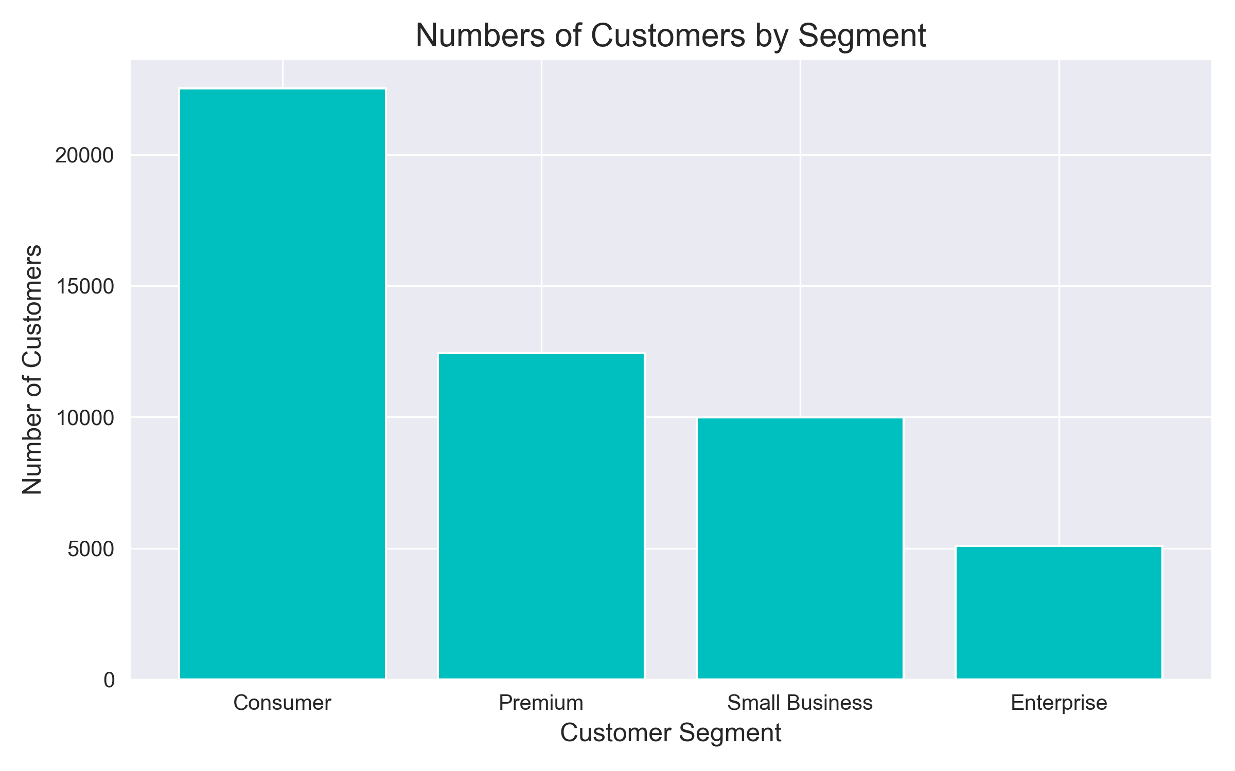
Figure 4.1: Customer Distribution across Segments
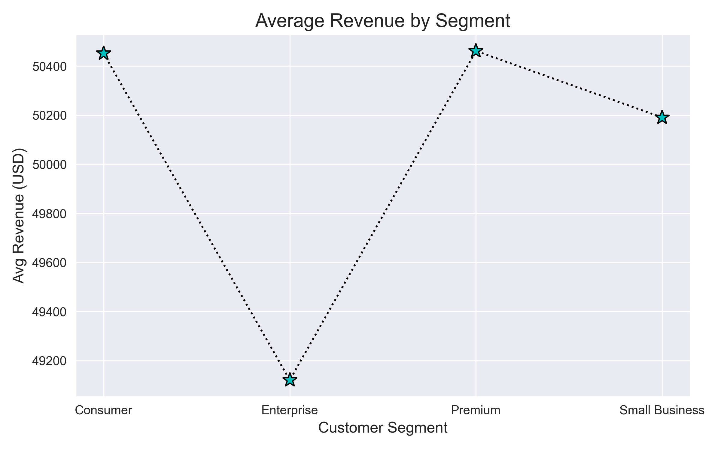
Figure 4.2: Average Revenue per Customer Segment (USD)
4.2 Shopping Channel Attribution Analysis
Omnichannel revenue tracking reveals that spending is evenly distributed across purchasing channels, led by Mobile App ($633.2M) and Online Web ($633.1M), followed closely by In-Store ($628.6M) and Marketplace ($618.5M). This underscores the vital necessity of maintaining seamless omnichannel experiences.
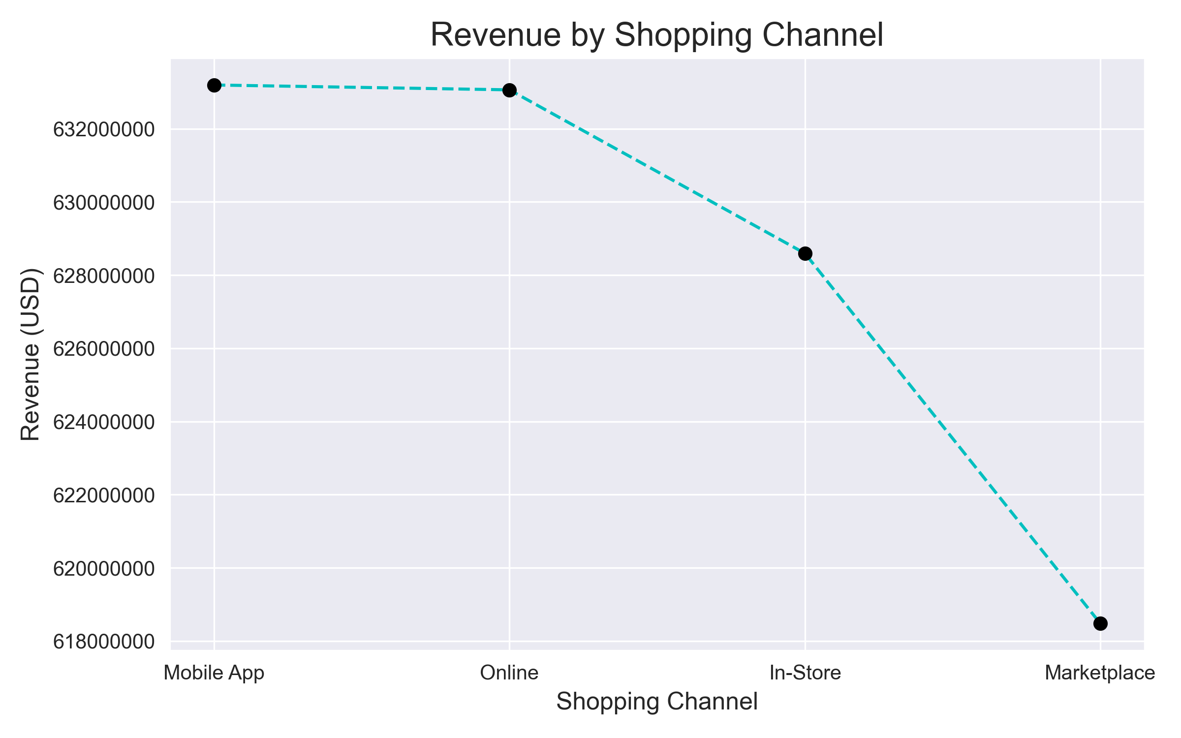
Figure 4.3: Cumulative Revenue Breakdown by Shopping Channel
4.3 Product Category & Customer Satisfaction Analysis
Analysis across preferred product categories highlights Electronics ($214.2M) and Fashion ($213.4M) as top revenue drivers, followed by Automotive ($212.0M) and Grocery ($211.3M). Furthermore, satisfaction score analysis indicates that highly satisfied customers (Score 5) generate the highest average spend ($50,840.76), reaffirming that customer experience directly impacts top-line monetary growth.
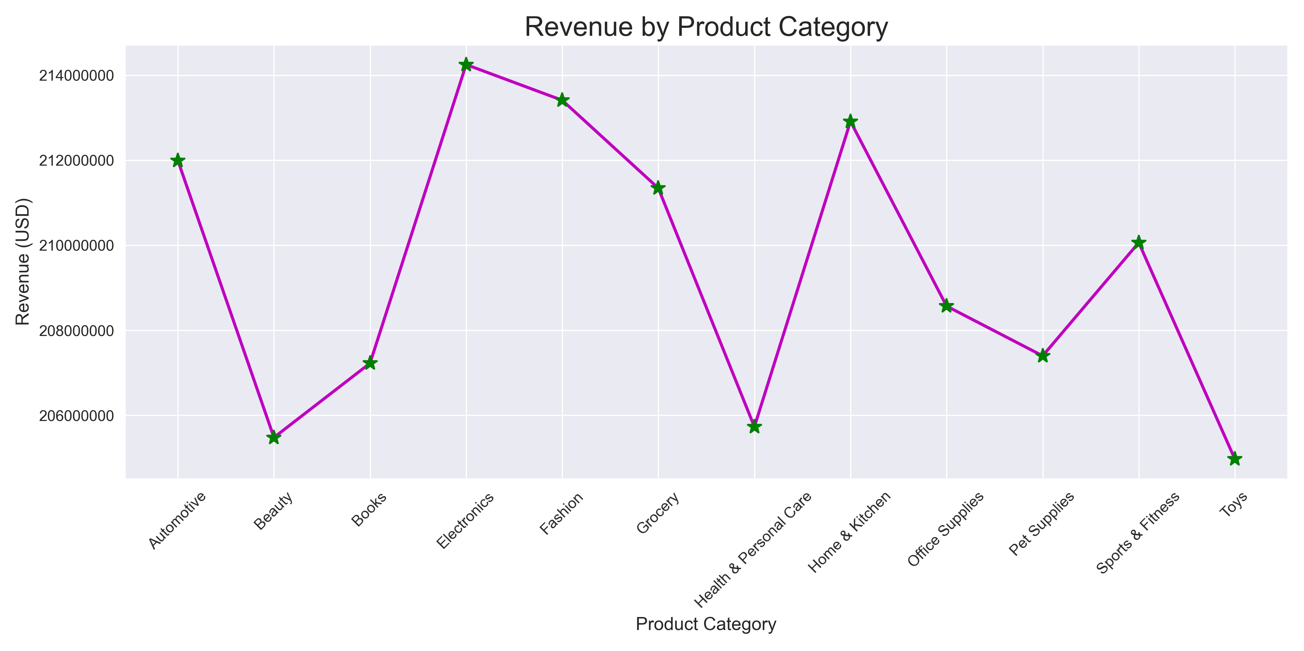
Figure 4.4: Revenue Generation across Product Categories
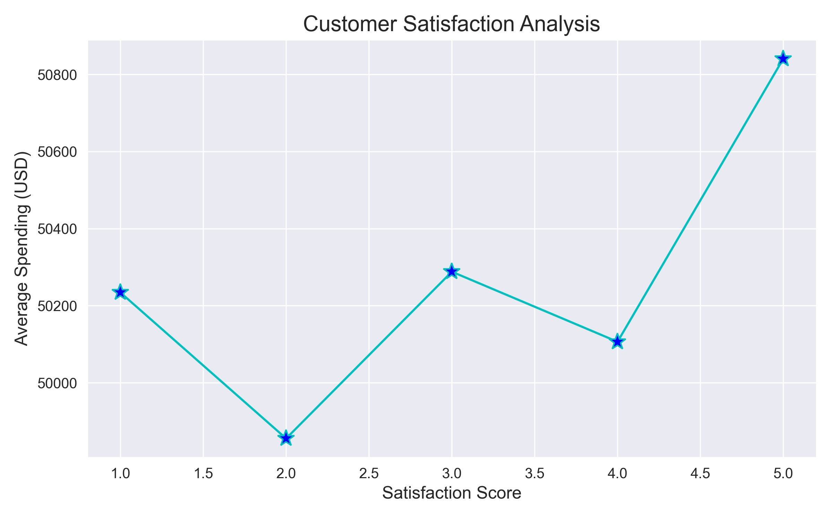
Figure 4.5: Customer Satisfaction Score vs. Average Spend (USD)
5. Predictive Machine Learning Modeling: Churn Risk Classifier
5.1 Model Architecture & Pipeline Design
To enable proactive customer retention, a binary target variable `churn_target` was defined: customers belonging to 'High' or 'Very High' risk categories were labeled as 'High Risk' (2,702 total | 5.4%), while remaining customers were labeled 'Low Risk' (47,298 total | 94.6%).
A Scikit-Learn Pipeline was constructed utilizing 14 primary numerical feature attributes (including age, tenure, total spent, recency, complaint count, satisfaction score, CLV, and CAC). The model leverages a Random Forest Classifier with 200 trees, median imputation, and class weighting (`class_weight='balanced'`) to effectively address target class imbalance.
5.2 Performance Evaluation & Metrics
The model was evaluated on an independent 20% stratified holdout test set (10,000 samples). The Random Forest Classifier achieved an overall accuracy of 96.73%.
Classification Category | Precision | Recall | F1-Score | Test Support Count
High Risk (Target) | 0.76 | 0.58 | 0.66 | 540
Low Risk | 0.98 | 0.99 | 0.98 | 9,460
Macro Average | 0.87 | 0.79 | 0.82 | 10,000
Weighted Average | 0.96 | 0.97 | 0.97 | 10,000

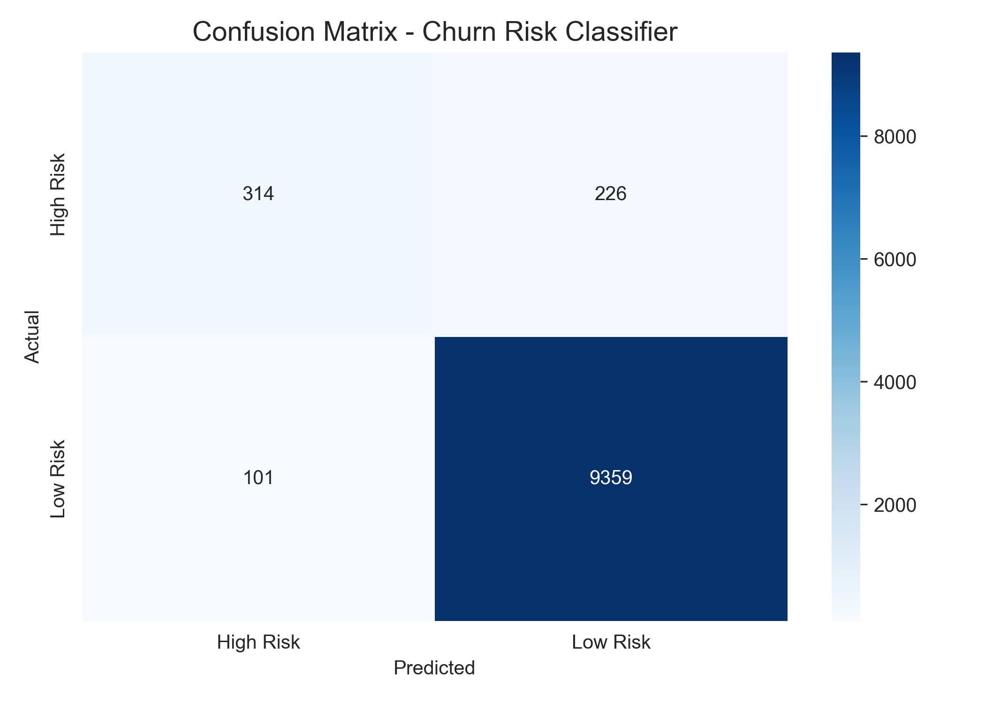
Figure 5.1: Confusion Matrix Heatmap for Test Set Predictions
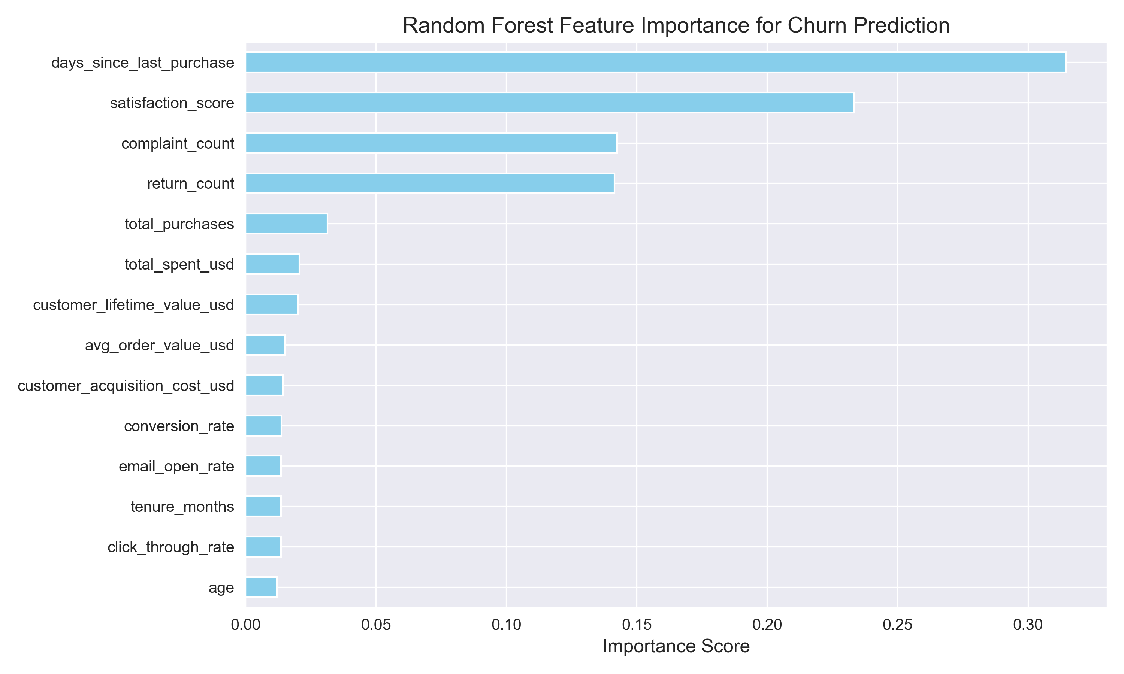
Figure 5.2: Feature Importance Ranking for Churn Prediction
6. Actionable Business Recommendations
Based on empirical data findings and predictive model outputs, the following strategic recommendations are proposed for e-commerce executive leadership:
- Proactive High-Risk Intervention: Deploy targeted automated retention workflows (exclusive loyalty offers, personalized discount vouchers, priority support) for the 2,577 predicted high-risk customers before churn occurs.
- Omnichannel Experience Optimization: Since Mobile App ($633.2M) and Web ($633.1M) drive the highest revenue, enhance mobile UX, push notifications, and frictionless checkout options.
- Category Specific Cross-Selling: Capitalize on high-revenue categories (Electronics & Fashion) by pairing them with personalized recommendations in Beauty and Books to boost average basket size.
- Customer Complaint Resolution Protocol: Feature importance analysis reveals complaint count and days since last purchase as key churn drivers. Establish strict SLA resolution for customer inquiries.

7. Conclusion & Future Scope
This project successfully delivers a robust, end-to-end framework for e-commerce customer segmentation and churn risk prediction. By integrating exploratory analytics with machine learning pipelines, business stakeholders gain actionable insights into customer behavior and revenue allocation.
Future enhancements could include implementing hyperparameter tuning (e.g. GridSearchCV / RandomizedSearchCV), testing XGBoost / LightGBM models, and deploying the predictive pipeline as an interactive dashboard using Streamlit or Flask.

