**RasPiCar**

**Raspberry pi and Android app controller lego car.**

Juuso Ohra-aho

IoT Course

April 2016

Contents

1 Introduction 1

2 Parts 1

2.1 Brains 1

2.2 Power 1

2.3 Driving 1

3 System 2

4 Source 2

# Introduction

In this course i made remote controller Lego car with Raspberry pi.

Car is made, suprise suprise, with legos. Non lego parts are servo for steering, motors, h-bridge and alot of batteries. And of course raspberry pi.

# Parts

## Brains

Cars brains are raspberry pi model 2b computer. There is no intelligence on android app, it sends just 2 or 3 different statuses. Raspberry handles that information and does what it should.

Handling http request send by android app are handled by apache2 server and PHP. PHP reads what the car should do and writes data to file. Actual actions are caused by Python script that is runned on machine start. Python reads the file that PHP writes and does actions based on it.

## Power

Car is powered by 3 different power sources:  
- For motors 4 1,5V AA batteries, connected through h-bridge.  
- For servo and Raspberry there is 6 1,5V AA batteries with voltage regulator to 5V  
- For Raspberry there is 5V mobile powerbank to keep it alive during steering.

## Driving

Steering is done with servo that runs with 5V voltage and PWM signal.

Motors are controlled by h-bridge.

# System

This is how system works:

First you must connect your phone to WiFi network generated by rasp. Then you can open the app and press some button. Phone sends http request to rasp that is hadled by apache2 server and php. Depending on request, php saves action to be done to file. Meanwhile python script, that is started with rasp and run on background, is reading that file. When it finds some action to be done it takes action: for drive forward/backward it starts up or shuts down GPIO pin #X. For steering it send PWM signal to dedicated GPIO pin.

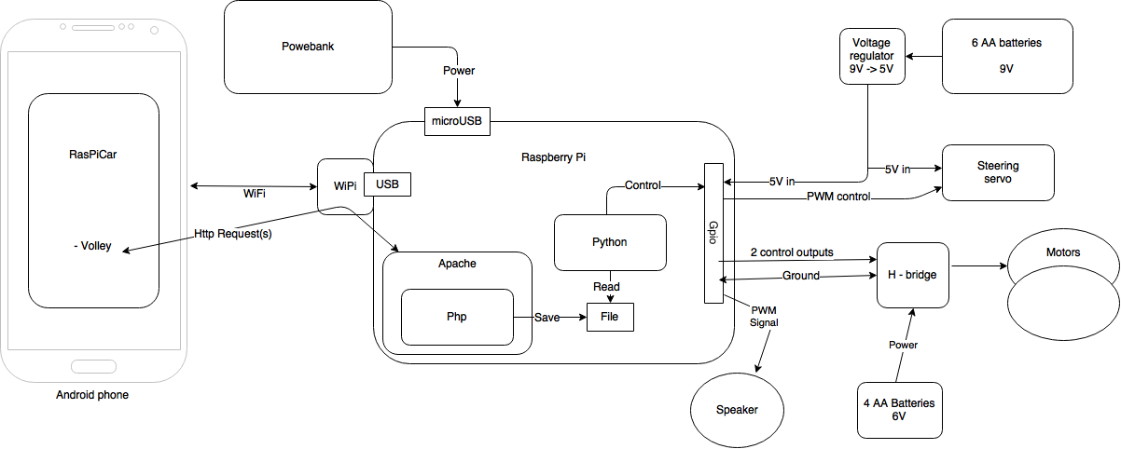

Image 1 System

# Source

All sources for can be found from [GitHub](https://github.com/Juuso-O/RasPiCar).

The repo is android studio project but, python and php files used are in ”Python ja php” folder.