­­­

**UK Linguistics Olympiad**

``````````````````````````````````````````````````````````````````````````````````````````````````````````````````````

This is to certify that

Yuv Saxena

of

Aylesbury Grammar School

was awarded

**Merit**

in the Second Round of the

Fourteenth UK Linguistics Olympiad

March 2023

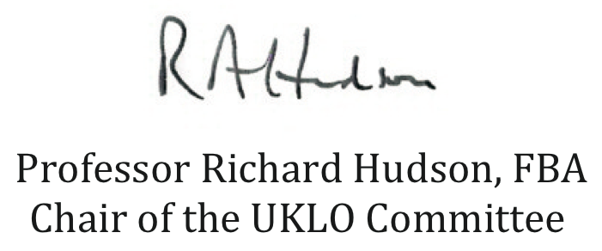

Professor Richard Hudson, FBA  
Chair of the UKLO Committee