Baseline Assessment of Satellite-Derived MODIS AOD as a Proxy for Ground-Measured Air Pollution in Bangladesh (2014–2021)

1. Introduction
Air pollution is becoming a concern for Bangladesh and going to a threat to the public health [1]. For the effective management and evidence-based policy relevant solution data driven air pollution planning is needed. But, due to technical limitations and human error, data wasn't captured consistently in the ground stations of the Bangladesh. That's why, we have to use satellite derived proxy air pollution parameter/s. But, how much it co-related with ground database? This short-report will explore on this issue.

1.1 Objective
To quantify the baseline correlation between satellite derived daily MODIS AOD and DOE-CAMS measured particulate matter (PM2.5) concentrations.

2. Methodology & Data Integration

2.1 Data Sources
Ground measured air quality parameters are $PM_{2.5},PM_{10},NO_{2},SO_{2},CO,O_{3}$ and meteorological parameters are temperature, relative humidity, rainfall, wind speed, wind direction, solar radiation, and barometric pressure. These are hourly measured data covered the period from November 2012 to December 2021.
Whereas, satellite derived AOD is available on daily basis from Jan 2014 to December 2021.

2.2 Data Pre-processing
To compare and corelated ground-measured PM₂.₅ with satellite-derived AOD, the hourly DoE-CAMS observations were aggregated into daily averages. Ground measured database has several temporal gaps and potential inaccurate data. So, for the proper analysis we eliminate the blank and inaccurate data by using python code in Jupyter notebook.
A minimum of 18 valid hourly observations per station per day was required to generate a daily value. Along with, satellite derived stations and ground stations are not equal, so for merging data we prioritize the satellite derived database’s stations.

2.3 Correlation Between Satellite AOD and Ground-Measured PM2.5
To quantify the baseline relationship between satellite-derived daily MODIS Aerosol Optical Depth (AOD) and DoE-CAMS ground-measured PM2.5, three nested Ordinary Least Squares (OLS) regression models were estimated.
$$\text{Model 1 (AOD only):} PM2.5=β_{0}+β_{1}⋅AOD+ε$$
Variable | Coef. | Std. Err. | t | P>|t| | 95% CI
const | 182.2666 | 27.078 | 6.731 | 0.000 | 127.237, 237.296
AOD | -17.6827 | 32.574 | -0.543 | 0.591 | -83.882, 48.516
(R² = 0.009, Adj. R² = -0.021, n = 36)
The baseline model (Model 1) indicates that satellite AOD alone explains a negligible proportion of variance in ground-measured PM2.5 (R² = 0.009). The estimated coefficient (β1 = -17.68, p = 0.591) is not statistically distinguishable from zero, and its negative sign runs counter to the expected positive association between AOD and surface particulate concentration. This corresponds to no reliable linear association between the two variables at the baseline level in this sample.

Model 2 (Meteorology Only): $PM2.5=β_{0}+β_{1}T+β_{2}RH+β_{3}WS+β_{4}R+β_{5}BP+β_{6}SR+β_{7}VWS+ε$
Variable | Coef. | Std. Err. | t | P>|t| | 95% CI
const | -73.4164 | 1603.989 | -0.046 | 0.964 | -3359.039, 3212.206
Temperature | 9.1457 | 7.117 | 1.285 | 0.209 | -5.434, 23.725
Relative Humidity | -0.4150 | 2.263 | -0.183 | 0.856 | -5.051, 4.221
Wind Speed | -36.1013 | 19.566 | -1.845 | 0.076 | -76.179, 3.977
Daily Rainfall | -37.3499 | 54.426 | -0.686 | 0.498 | -148.836, 74.136
Barometric Pressure | 0.1897 | 1.729 | 0.110 | 0.913 | -3.353, 3.732
Solar Radiation | -0.0034 | 0.371 | -0.009 | 0.993 | -0.764, 0.757
Vertical Wind Speed | -299.8818 | 305.618 | -0.981 | 0.335 | -925.912, 326.149
(R² = 0.582, Adj. R² = 0.477, n = 36)
Meteorological conditions account for a substantially larger share of PM2.5 variability (R² = 0.582). However, no individual meteorological predictor reaches conventional significance thresholds (all p > 0.05) despite the model's overall significance (F = 5.57, p < 0.001), a pattern consistent with multicollinearity among the meteorological covariates rather than a single dominant driver.
$\text{Model 3 (AOD + Meteorology):} PM2.5=β_{0}+β_{1}AOD+β_{2}T+β_{3}RH+β_{4}WS+β_{5}R+β_{6}BP+β_{7}SR+β_{8}VWS+$ε
Variable | Coef. | Std. Err. | t | P>|t| | 95% CI
const | 38.8045 | 1774.556 | 0.022 | 0.983 | -3602.284, 3679.893
AOD | -4.9966 | 30.961 | -0.161 | 0.873 | -68.524, 58.531
Temperature (T) | 9.3688 | 7.375 | 1.270 | 0.215 | -5.764, 24.502
Relative Humidity (RH) | -0.2145 | 2.617 | -0.082 | 0.935 | -5.585, 5.156
Wind Speed (WS) | -36.8314 | 20.422 | -1.803 | 0.082 | -78.735, 5.072
Daily Rainfall (R ) | -36.6179 | 55.583 | -0.659 | 0.516 | -150.665, 77.429
Barometric Pressure (BP) | 0.0842 | 1.878 | 0.045 | 0.965 | -3.769, 3.937
Solar Radiation (SR) | -0.0315 | 0.416 | -0.076 | 0.940 | -0.886, 0.822
Vertical Wind Speed (VWS) | -297.7486 | 311.357 | -0.956 | 0.347 | -936.600, 341.103
(R² = 0.582, Adj. R² = 0.458, n = 36)
In model 3, AOD alongside meteorology does not improve model performance: R² is unchanged (0.582), Adjusted R² decreases (0.477 → 0.458, these results indicate that AOD contributes no meaningful explanatory power beyond what meteorology already captures, and its inclusion is penalized for added model complexity without a compensating gain in fit.

3.1 Bivariate Correlation Analysis
The following spearman correlation matrix in Figure-1 shows that, co-emission patterns among ground-level pollutants (${\text{PM}}_{2.5}$ and ${\text{PM}}_{10}$, $r_{s}=0.82$) are significantly strong, while meteorological factors like temperature ($r_{s}=-0.42$) and relative humidity exert significant negative effects by promoting atmospheric dispersion and scavenging.
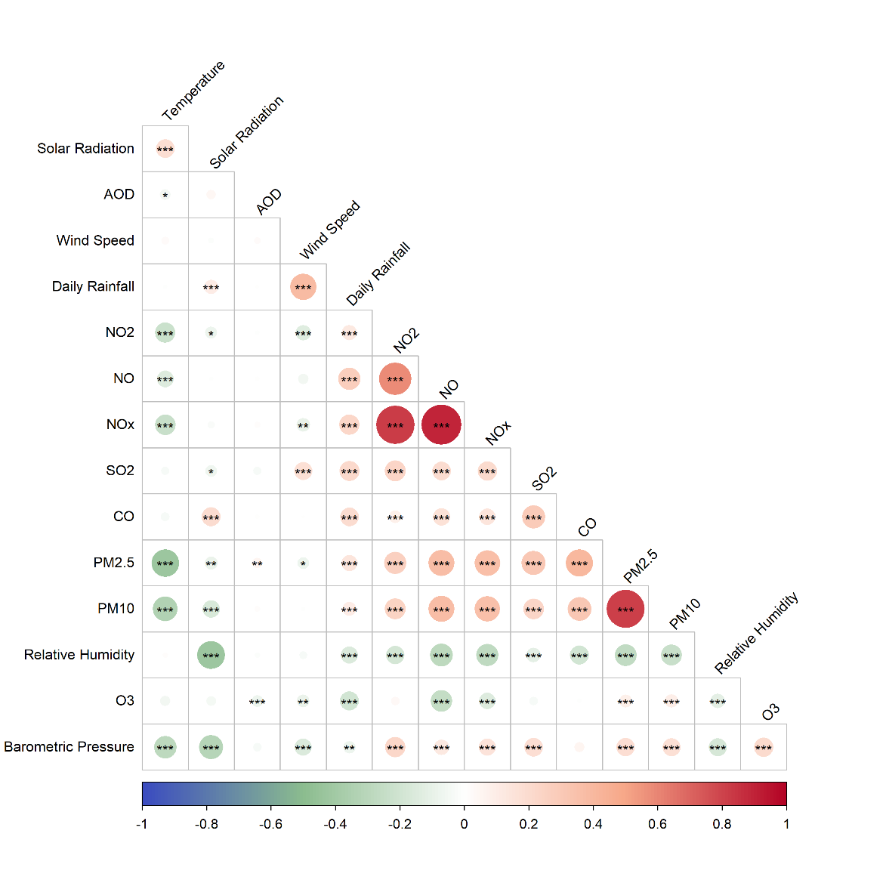
In contrast, AOD shows near-zero correlation ($r_{s}=0.05$) with ground monitored ${\text{PM}}_{2.5}$, highlighting that satellite observations require vertical boundary layer and meteorological adjustments to accurately reflect ground air quality.
Figure 1: Spearman Correlation Matrix of Atmospheric & Meteorological Variables & AOD

4. Conclusion
The study found a very weak relationship between MODIS AOD and ground-measured PM₂.₅ (Spearman rₛ = 0.05; OLS R² = 0.009). Meteorological variables explained substantially more PM₂.₅ variability (R² = 0.582), while adding AOD did not improve model performance (R² = 0.582; adjusted R² decreased from 0.477 to 0.458). Overall, AOD alone is not a reliable proxy for surface PM₂.₅ in this dataset. The findings highlight the need for meteorological adjustment, improved spatial and temporal matching, and larger high-quality datasets for satellite-based PM₂.₅ estimation.

5. Declaration of AI Tools
Claude (Anthropic) and ChatGPT (GPT-5.6 Luna) was used to process DOE-CAMS Air pollution data and converted hourly to daily and merged with AOD data by python code development. Gemini (3.6 Flash) was used to prepare the r programming code for correlation matrix and data analysis. All analytical decisions (research framing, season definitions, the choice to exclude corrupted rows, and interpretation of results) were made by the author.

