from Juvan Thavalingam, Tim Müller, Christian Graber

Task 4:
1. start Burp
2. open website Schoggi
3. log in as alice with password alice.123
4. under Bulk Order download sample file.
5. view the sample file.
6. take the slide XML External Entity Injection (3) on page 57 as an example.
7. copy the example file and customise it.

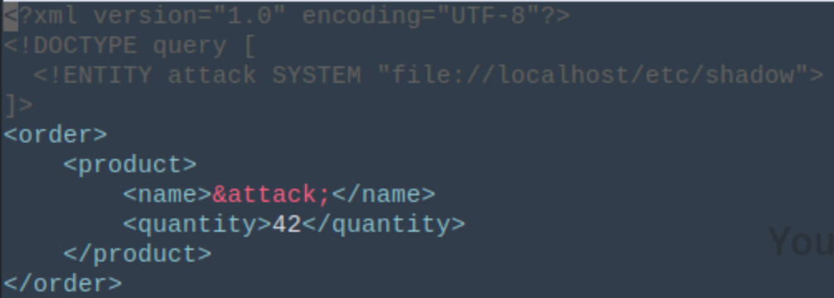
8 . upload this file to Bulk Order.
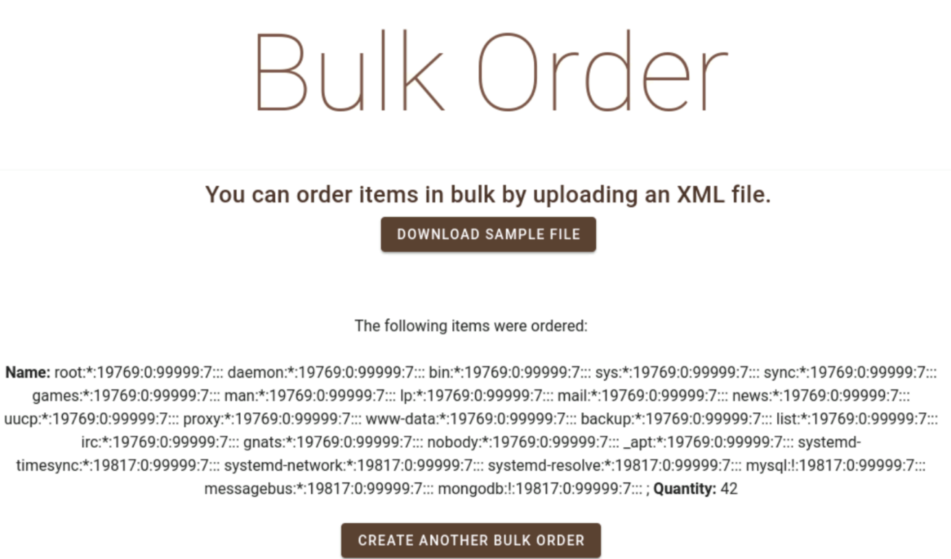
9. We now see the shadow file.

