from Juvan Thavalingam, Tim Müller, Christian Graber

Task 5:
1. to use gobuster with this command you have to go back so far with the console that you can see the usr folder.
2. gobuster dir -e -u https://80394981-a127-4f02-82f6-68798813fa44.i.vuln.land/ -w /usr/share/wordlists/dirb/common.txt

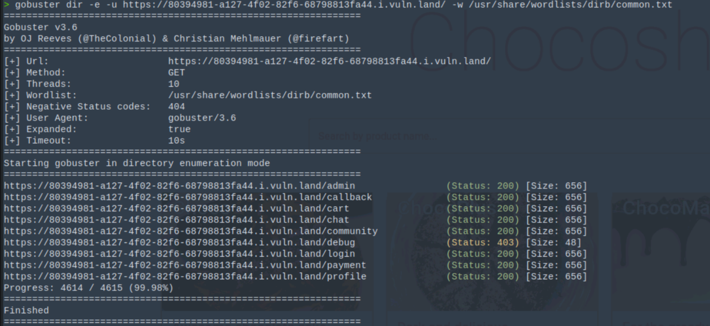
3 . /debug has status 403, so can only be opened from the inside.
4. log in again as alice with password alice.123.
5. go to the Bulk Order page:
6. copy the example from the last task again.
7. use the example from the lecture on page 55.
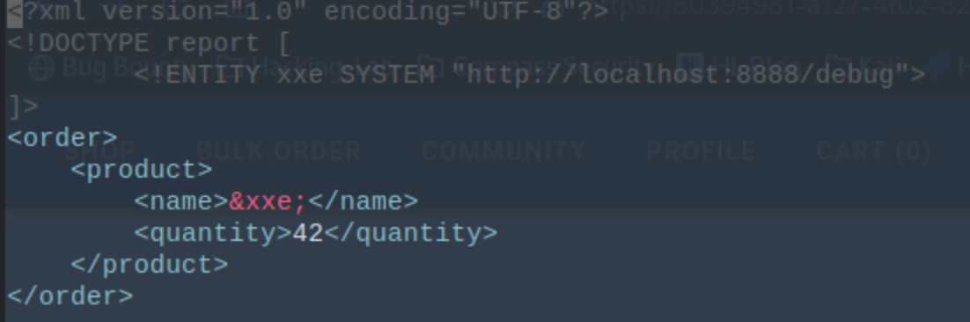
8. upload this bulk order.
9. output:
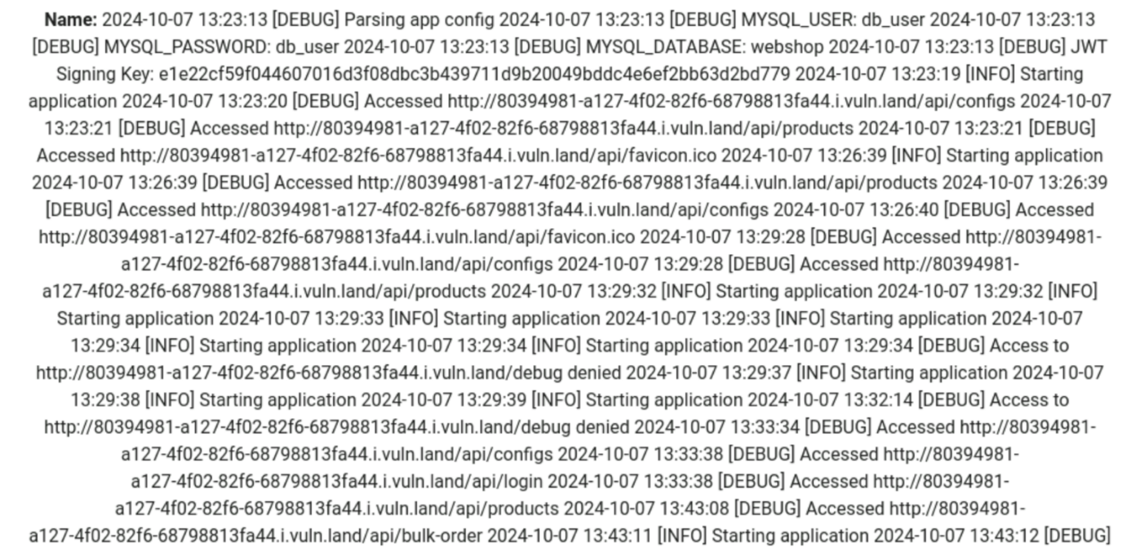

10.

MySQL password: db_user
JWT signing key: e1e22cf59f044607016d3f08dbc3b439711d9b20049bddc4e6ef2bb63d2bd779

