Task1:

- Log in as customer0 and go to credit card and click on edit
- You will get this url: https://084008af-8153-460e-8ac0-7c95f7401566.i.vuln.land/#!/creditcard/5404000000000001
- 5404000000000001 is the creditcard number of customer0
- Increase the number by 1: https://084008af-8153-460e-8ac0-7c95f7401566.i.vuln.land/#!/creditcard/5404000000000002 and you will get this:
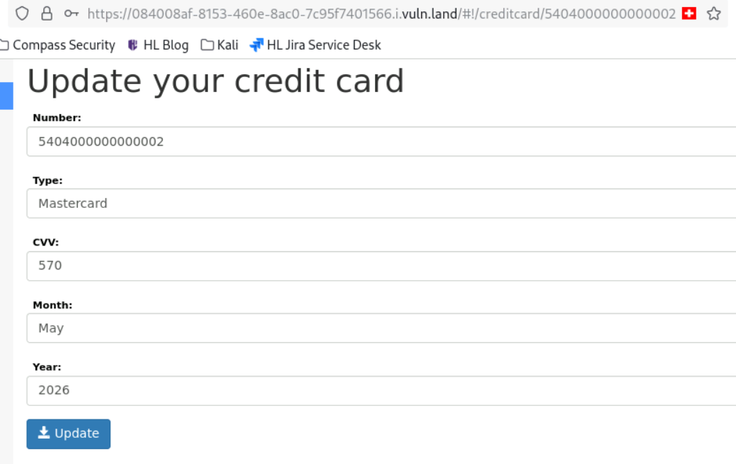
The vulnerability is in the url. This is an Object Level Access Problem. User has right to something which he shouldn’t have. He can get all the credit card informations of all customers by just manipulating the url.

Task 3:
- Log in as customer 0 and go to orders. Start Burp!
- In Burp, you can see this:
“GET /api/order/account/…”
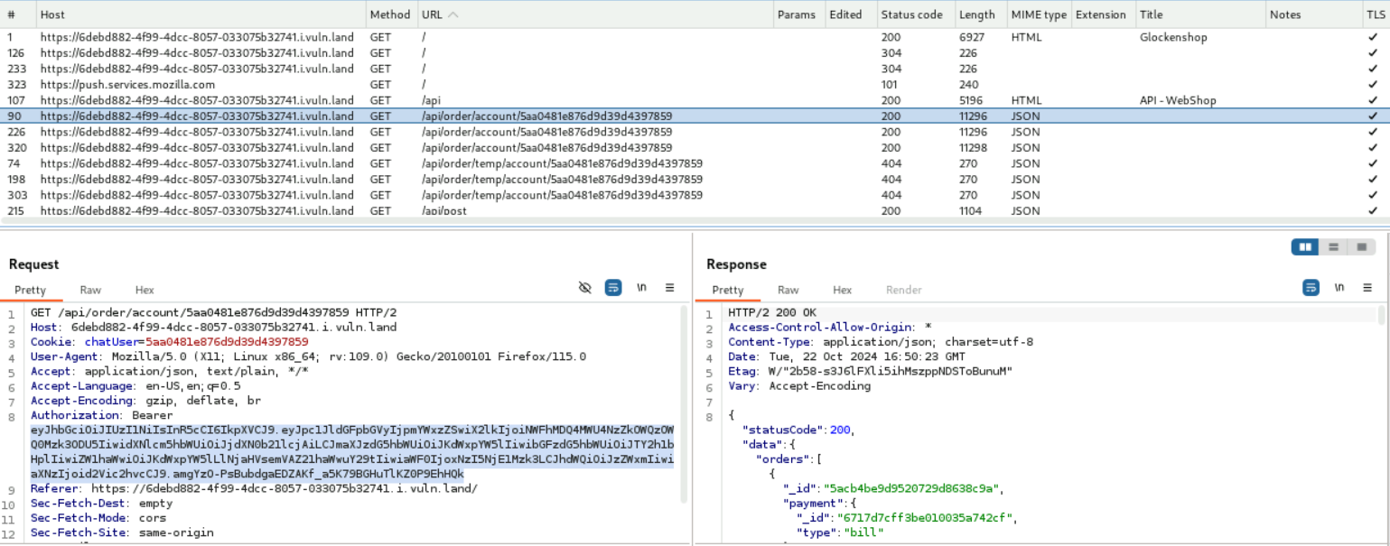
- Send this Json to Repeater!
- Go to a browser and type in: https://6debd882-4f99-4dcc-8057-033075b32741.i.vuln.land/api
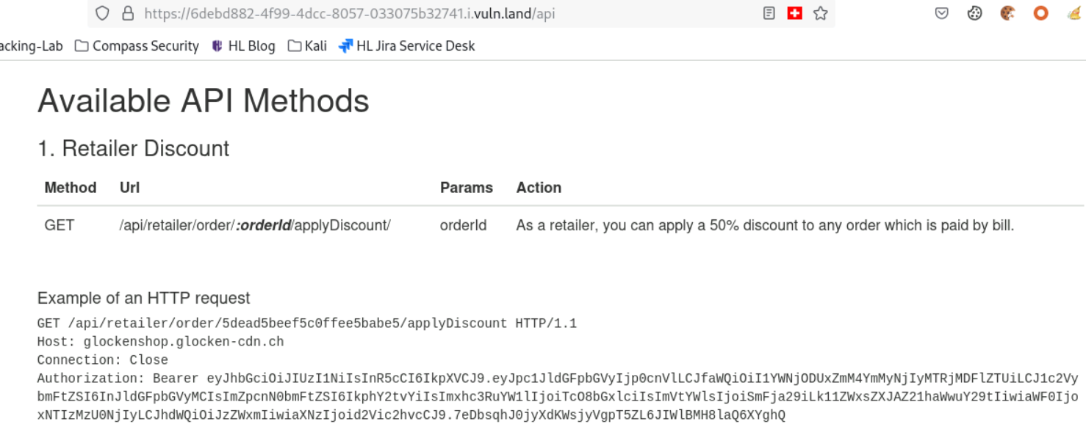
Copy GET /api/retailer/order/:orderID/applyDiscount/ and Authorization: Bearer…
- 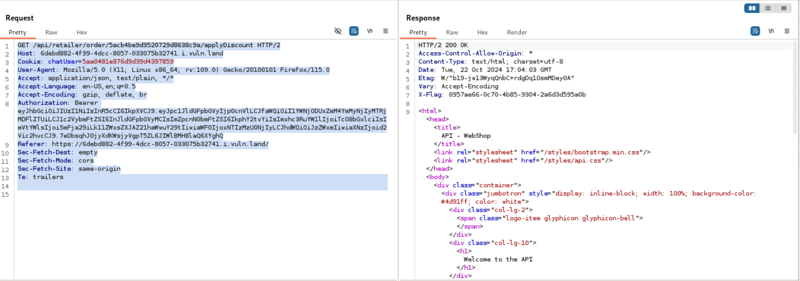
Replace the first line with the Retailer API Call and the line 8 with the Authorization!
Important! Replace in the Retailer API Call the orderID with the correct OrderId from customer0. This can be found on the webpage:
0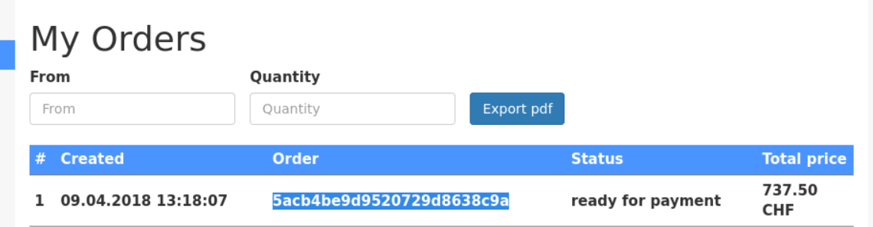

Task 4:

