UNIVERSITY OF GHANA
COLLEGE OF BASIC AND APPLIED SCIENCES

[ Insert the University of Ghana crest here ]

CAMPUS COMPANION: AN INTEGRATED MOBILE APPLICATION FOR ACADEMIC SCHEDULING, GRADE ANALYTICS AND CAMPUS-LIFE MANAGEMENT FOR GHANAIAN TERTIARY STUDENTS

BY
[ YOUR FULL NAME ]
( INDEX NUMBER )

A PROJECT WORK SUBMITTED TO THE DEPARTMENT OF COMPUTER SCIENCE, UNIVERSITY OF GHANA, LEGON, IN PARTIAL FULFILMENT OF THE REQUIREMENTS FOR THE AWARD OF BACHELOR OF SCIENCE (BSc) DEGREE IN COMPUTER SCIENCE

DEPARTMENT OF COMPUTER SCIENCE
OCTOBER, 2026
DECLARATION

I hereby declare that this project, “Campus Companion: An Integrated Mobile Application for Academic Scheduling, Grade Analytics and Campus-Life Management for Ghanaian Tertiary Students”, is the result of my own work, carried out under the supervision of [ supervisor's name ] in the Department of Computer Science, University of Ghana.
Except where other people's work has been duly acknowledged by reference, this work is my own, and it has not been submitted, in whole or in part, for the award of any other degree, diploma or qualification in this or any other institution.
STUDENT
Name: [ YOUR FULL NAME ]
Signature: ....................................
Date: ........................
SUPERVISOR
Name: [ SUPERVISOR'S FULL NAME ]
Signature: ....................................
Date: ........................

ABSTRACT

Context
Ghanaian university students manage timetables, grades, campus announcements, events and revision material using a patchwork of paper diaries, generic calendar apps, and social-media groups, none of which is built around the specific academic conventions of their institutions — such as the University of Ghana's letter-grade and GPA scale, under which a mark of 45–49 does not count as a pass. No evaluated application in the literature surveyed combines personal academic organisation and campus-wide services behind one institution-aware, authenticated account.

Aim
This study aimed to design, implement and evaluate Campus Companion, an integrated mobile-first application that consolidates academic scheduling, grade analytics and campus-life services for Ghanaian tertiary students within a single secure platform reflecting their institutions' actual academic conventions.

Method
Campus Companion was built as a Flutter mobile client backed by a Node.js/Express REST API on PostgreSQL, developed iteratively and feature by feature, with each feature's backend implemented and tested before its mobile client code. Correctness was verified through three automated test tiers — offline unit tests, database-backed integration tests, and end-to-end smoke tests — reinforced by deliberate mutation testing of key business rules, and cross-checked against a live Firebase credential for Google Sign-In.

Result
Re-running every test tier on 30 October 2026 produced 371/371 mobile tests, 50/50 backend unit tests, 14/14 database tests and 182/182 end-to-end smoke-test checks; running the application end to end also exposed three user-interface defects that the automated tests had missed, all of which were fixed and are now covered by regression tests. Five of the study's seven specific objectives were supported by evidence that included a live external check rather than only internal fakes; two — the AI assistant's behaviour against a live large-language-model key and on a device, and production delivery of push notifications and Google Sign-In — are code-complete and tested against fakes but not yet observable end-to-end, pending configuration steps outside the application's own code.

Conclusion
The fragmentation of academic and campus-life tools available to Ghanaian tertiary students can be addressed with a single institution-aware application whose correctness is demonstrated through repeatable automated testing rather than asserted; the remaining gaps identified in this study are deployment and configuration work, not unresolved design problems.

Keywords
mobile application; academic scheduling; grade point average; AI assistant; Ghana; Flutter

DEDICATION

[ A short, personal dedication — one or two sentences. Only you can write this one. ]

ACKNOWLEDGEMENT

[ Thank your supervisor, department, family/friends, and anyone who supported the project. Only you can write this one. ]

TABLE OF CONTENTS

DECLARATION i
ABSTRACT ii
DEDICATION iv
ACKNOWLEDGEMENT v
TABLE OF CONTENTS vi
LIST OF FIGURES viii
LIST OF TABLES ix
LIST OF ABBREVIATIONS x

CHAPTER ONE: INTRODUCTION 1
1.1 Background and Motivation 1
1.2 Statement of Problem 1
1.3 Scope of the Study 2
1.4 Research Objectives 3
1.4.1 Global Objective 3
1.4.2 Specific Objectives 3
1.5 Research Contribution 4
1.6 Organization of the Study 4

CHAPTER TWO: LITERATURE REVIEW 6
2.1 Introduction 6
2.2 Mobile Applications for Academic Scheduling and Student Life Management 6
2.3 Mobile Learning and Smartphone Use Among Ghanaian University Students 7
2.4 Authentication and Security in Mobile Applications 8
2.5 Push Notification Architectures in Mobile Systems 9
2.6 AI-Assisted Virtual Assistants and Chatbots in Education 9
2.7 Review of Existing Systems 10
2.8 Summary and Research Gap 11

CHAPTER THREE: RESEARCH METHODOLOGY 12
3.1 Requirement Gathering 12
3.2 Requirement Analysis 12
3.2.1 Functional Requirements 12
3.2.2 Non-Functional Requirements 13
3.3 System Design 14
3.3.1 System Architecture 14
3.3.2 Use Case Design 15
3.3.3 Database Design 16
3.3.4 Sign-in Design 18
3.4 Feature Selection 18
3.5 Experimental Setup 19
3.5.1 Development Tools and Environment 19
3.5.2 Development Methodology 19
3.5.3 Testing Strategy 20
3.5.4 Evaluation Criteria 20
3.5.5 Statistical Analysis 21

CHAPTER FOUR: EXPERIMENTAL RESULT AND DISCUSSION 22
4.1 Introduction 22
4.2 Test Results by Tier 22
4.3 Discussion Against the Specific Objectives 23
4.4 Discussion of Limitations Observed 23
4.5 The Implemented Application 25
4.6 Summary 28

CHAPTER FIVE: CONCLUDING REMARKS 29
5.1 Summary of the Study 29
5.2 Contribution of the Study 29
5.3 Limitations 30
5.4 Recommendations for Future Work 30
5.5 Conclusion 31

REFERENCES 33

LIST OF FIGURES

Figure 3.1: System architecture of Campus Companion 15
Figure 3.2: Use case diagram 16
Figure 3.3: Entity-relationship diagram of the Campus Companion database 17
Figure 3.4: Google Sign-In sequence 18
Figure 4.1: Onboarding and sign-in 26
Figure 4.2: Academic features 27
Figure 4.3: Campus-life features 28

LIST OF TABLES

Table 2.1: Summary of existing systems and related works 10
Table 3.1: Functional requirements 13
Table 3.2: Non-functional requirements 13
Table 3.3: System architecture layers 14
Table 3.4: Database tables in the Campus Companion schema 16
Table 3.5: Development tools and environment 19
Table 4.1: Automated test results, re-verified 30 October 2026 22
Table 4.2: Specific objectives and their supporting evidence 23

LIST OF ABBREVIATIONS

API | Application Programming Interface
APK | Android Package (Kit)
CRUD | Create, Read, Update, Delete
FCM | Firebase Cloud Messaging
GPA | Grade Point Average
ICS | iCalendar file format (.ics)
JSON | JavaScript Object Notation
JWT | JSON Web Token
LLM | Large Language Model
REST | Representational State Transfer
SQL | Structured Query Language
UG | University of Ghana
UI/UX | User Interface / User Experience

CHAPTER ONE
INTRODUCTION

1.1 Background and Motivation
University students in Ghana manage a wide range of day-to-day academic and campus-life tasks: tracking lecture and examination timetables, monitoring grades and cumulative grade point average (GPA), keeping up with departmental and institutional announcements, finding their way around campus, registering for events and student organisations, and revising for quizzes and tests. In practice, these tasks are typically spread across several disconnected tools — paper diaries, generic calendar applications, printed noticeboards, WhatsApp or other social-media groups, spreadsheets for grade tracking, and informal word-of-mouth for locating buildings or offices. None of these tools is designed specifically for the structure of a Ghanaian tertiary institution, and none of them is aware of institution-specific conventions such as the University of Ghana's letter-grade and GPA scale.
At the same time, smartphone ownership among Ghanaian university students is now near-universal, and cross-platform mobile frameworks such as Flutter make it possible to build a single application that behaves consistently across Android and web targets without maintaining separate native codebases. This convergence of a clear, everyday student need and mature, accessible mobile-development tooling motivated the present project: an attempt to bring the scattered academic and campus-life tools students already improvise with into one coherent, purpose-built mobile application.
The motivation is reinforced by the observation that most existing “student app” examples available internationally assume grading scales, semester structures, and campus services that do not match the Ghanaian tertiary context. A Ghanaian student's GPA, for instance, is computed on a scale where a mark of 45-49 is graded E and does not count as a pass, which differs from scales used elsewhere. An application that hard-codes a different scale, or that treats campus services generically, is of limited practical use to the students it is meant to serve.

1.2 Statement of Problem
Ghanaian university students currently have no single, verified application that brings together the routine academic and campus-life tasks described above in a way that reflects the specific conventions of their institutions. The consequences of this fragmentation are threefold. First, information is duplicated or lost: a class timetable kept on paper is not synchronised with a reminder app, and an announcement posted on a noticeboard may never reach a student who does not pass that location. Second, grade and GPA tracking is error-prone when done manually or with generic tools that do not encode the correct local grading bands, which can lead a student to misjudge their standing — for example, treating a borderline mark as a pass when, on the University of Ghana scale, it is not. Third, there is no single place where a student can get a quick, campus-aware answer to an everyday question (“when is my next class?”, “what is on this week?”, “where is this building?”) without separately consulting several different sources.
This project addresses that gap by designing and building Campus Companion, an integrated mobile application and supporting backend service that unifies timetabling, examinations, grade/GPA analytics on the correct local scale, campus announcements and events, campus-location lookup, clubs and societies, quizzes, a digital student identity card, and an AI-assisted virtual assistant, behind a single authenticated account.

1.3 Scope of the Study
The study covers the design, implementation and testing of both halves of the Campus Companion system: a Flutter-based mobile client and a Node.js/Express REST API backed by a PostgreSQL database. The following areas fall within the scope of the study:
- Account registration, authentication (including Google Sign-In) and role-based access for three roles — student, lecturer and administrator.
- A local-first timetable and examination module with reminders and calendar (.ics) import/export, independent of server connectivity.
- A grade-entry and GPA/CWA analytics module that implements the University of Ghana grading scale, including honours-class and target-grade prediction.
- Campus announcements, events (creation, registration, cancellation and deletion with ownership rules) and a clubs/societies directory with join/leave functionality.
- A campus-location directory with a custom map view.
- A quiz module, including automated question extraction from past-paper PDFs using a large language model (LLM).
- An AI assistant/tutor that answers academic and campus questions, backed by a cloud LLM (Gemini) where configured and a local rule-based engine otherwise, designed to keep answering even when parts of the backend are unreachable.
- A digital student identification card with a scannable QR code.
- An administrator panel for provisioning lecturer and administrator accounts.
- Push-notification delivery (Firebase Cloud Messaging) for announcements, built and tested but intentionally left disabled until a production Firebase project is fully provisioned.
The following are explicitly out of scope: a real payment gateway for hall/students'-association dues (the “Student Hub” dues and shuttle features are demonstrated with static, device-local data only); native iOS support (the mobile client targets Android and web); and full production deployment of push notifications and Google Sign-In, both of which are implemented and tested end-to-end against development credentials but are pending a small number of remaining console/configuration steps outside the application code itself. These limitations are revisited in Chapter Five.

1.4 Research Objectives

1.4.1 Global Objective
The global objective of this study is to design, implement and evaluate an integrated, mobile-first application that consolidates academic scheduling, grade analytics and campus-life services for Ghanaian tertiary students within a single secure platform, reflecting the specific academic conventions of their institutions.

1.4.2 Specific Objectives
- To design and implement a cross-platform mobile client (Flutter) and a RESTful backend service (Node.js/Express with PostgreSQL) providing unified, role-based authentication for student, lecturer and administrator accounts, including secure third-party sign-in via Google.
- To implement a local-first academic timetable, examinations and alerts module supporting calendar (.ics) import/export and reminder notifications without depending on constant server connectivity.
- To implement a grade and GPA/CWA analytics module that correctly applies the University of Ghana grading scale, keeping the mobile client and backend in agreement through a single shared source of truth.
- To implement campus-life features — events, clubs and societies, campus-location lookup, quizzes and a digital student identification card — behind the same authenticated platform.
- To design and implement an AI-assisted virtual assistant that answers academic and campus questions using a cloud large language model where available, falls back to a local rule engine otherwise, and remains useful when individual backend data sources are unreachable.
- To integrate push-notification delivery via Firebase Cloud Messaging for campus announcements.
- To verify the correctness of the resulting system through a layered automated-testing strategy — offline unit tests, database/integration tests, and end-to-end smoke tests — and through deliberate mutation testing of key business logic.

1.5 Research Contribution
This study contributes an integrated application architecture that brings academic-scheduling and campus-life functionality together under the grading and institutional conventions specific to Ghanaian tertiary education — a combination not offered by generic, internationally-oriented student-planner applications. It further contributes a concrete design pattern for building an AI assistant that degrades gracefully: rather than failing an entire query when one backend data source is unavailable, the assistant answers from whichever sources it can reach and reports, source by source, which ones it could not. Finally, the study contributes a demonstrated test-driven development discipline for a full-stack student application — offline unit tests, database-backed integration tests, end-to-end smoke tests, and deliberate mutation testing to confirm that the test suite actually detects regressions — together with a shared, machine-readable fixture (the grading-scale definition) used to keep the mobile client and the backend service from silently drifting apart on a rule as consequential as how a GPA is computed.

1.6 Organization of the Study
The remainder of this study is organised as follows. Chapter Two reviews literature relevant to mobile academic-management and campus-life applications, authentication and push-notification patterns in mobile systems, and AI-assisted educational assistants. Chapter Three describes the research methodology: how the requirements were gathered and analysed, the system's design (architecture, use cases, database and sign-in flow), the features selected, and the development and testing approach used to build and validate it. Chapter Four presents and discusses the results of that validation, including test outcomes and an assessment of the implemented features against the objectives in Section 1.4. Chapter Five concludes the study, summarising its contributions, acknowledging its limitations, and recommending directions for future work.

CHAPTER TWO
LITERATURE REVIEW

2.1 Introduction
This chapter reviews literature relevant to the design of Campus Companion. It is organised around the system's main technical and functional concerns: mobile applications built to support students' academic and campus life (Section 2.2); mobile and smartphone use among Ghanaian university students, which motivates and contextualises this study (Section 2.3); authentication and security practices for mobile applications and the standards behind them, relevant to the system's sign-in design (Section 2.4); push-notification architectures, relevant to announcement delivery (Section 2.5); and AI assistants and chatbots in education, relevant to the system's AI assistant and tutor (Section 2.6). Section 2.7 compares existing systems with the one built in this study, and Section 2.8 summarises the chapter and identifies the gap this study addresses.

2.2 Mobile Applications for Academic Scheduling and Student Life Management
A recurring theme in the literature on student-facing mobile applications is the attempt to bring separate parts of a student's life — tasks and deadlines, wellbeing, and campus services — into a single tool. Zhao and Pardo (2017) describe the user-centred design of myUniMate, an application that lets first-year students track and reflect on several aspects of their university life. Its components include a to-do list with reminders, a calendar view of those tasks, mood tracking, user-defined measures, and simple charts of the tracked information. In a four-week field trial with 11 first-year engineering students, the students' perceived competence and relatedness support and their learning motivation increased, while the autonomy support they attributed to the application decreased. myUniMate is a personal organiser: it does not hold a class timetable or grades, and it offers no campus-wide services.
Baras et al. (2018) describe an application that keeps a student's schedules and deadlines in one place and adds virtual-tutor features, with a particular focus on supporting students' mental health alongside their academic success. Like myUniMate, it centres on the individual student's organisation rather than on campus-wide information.
Wang and Yan (2018) take the other direction: they describe the design and implementation of an Android “mobile smart campus” system that delivers a campus's internet services through one mobile application. This is closer in spirit to the campus-life half of Campus Companion — events, clubs, campus locations and announcements — than to its academic half. The two strands of literature, personal academic organisers on one hand and campus-wide service systems on the other, are rarely combined into one evaluated system in the papers surveyed here; that combination, a single authenticated application spanning both a student's own academic data and campus-wide services, is one gap this study positions itself against (Section 2.8).
A methodological point carries across this literature: the systems reviewed are typically evaluated with small, single-institution samples over short periods (myUniMate's trial involved 11 students for four weeks), and none reports a long-running production deployment. This is consistent with the practical reality that student-facing academic tools are frequently built and evaluated as single-institution or final-year projects rather than at commercial scale, which is also the context of the present study.

2.3 Mobile Learning and Smartphone Use Among Ghanaian University Students
Ghana-specific studies show that mobile devices are already part of Ghanaian university students' academic lives, but largely outside formal academic systems. Afful and Boateng (2023) studied distance-education students at the University of Ghana and the University of Education, Winneba, using a decomposed Theory of Planned Behaviour and an explanatory sequential mixed-methods design to examine how students' attitudinal, social and control beliefs affect their mobile learning. They found that students mostly used their phones for calls and text messages, and recommended training in retrieving information on mobile devices. Adzifome and Agyei (2022), studying students at a Ghanaian university, reported that the facilities needed for mobile learning were largely available and students' experiences of it were positive, but that much of this mobile learning took place outside the institution's learning management system.
These findings are directly relevant to the problem motivating the present study (Section 1.2): Ghanaian students have mobile devices and use them for study, but the tools they use are general-purpose ones that are not built around their institution's academic structure (grading scale, semester calendar, courses and clubs). Neither study evaluates a purpose-built, institution-aware application; their findings describe the gap such an application would need to fill. Campus Companion's institution-aware design — in particular, its implementation of the University of Ghana grading scale rather than a generic one (Sections 1.2 and 3.3.3) — responds directly to this gap.

2.4 Authentication and Security in Mobile Applications
Because Campus Companion authenticates three distinct roles (student, lecturer, administrator) and supports both a password-based flow and third-party sign-in through Google, the security of its authentication design draws on the mobile-OAuth literature. Chen et al. (2014), in a widely cited empirical study, examined how 149 mobile applications implemented OAuth and found that 89 of them (59.7%) were implemented incorrectly and were therefore vulnerable — commonly by trusting client-side information as if it had been verified by the server. Their central lesson, that the application's own backend, not the mobile client, must verify any identity token before trusting it, is the pattern Campus Companion's backend follows: the Google ID token obtained on the mobile client is exchanged for a Firebase ID token, which the backend independently verifies through the Firebase Admin SDK before issuing its own session token, rather than trusting any claim the mobile client makes about who the user is (Figure 3.4).
Several standards underpin this design. Google Sign-In builds on OAuth 2.0, the authorisation framework whose misuse Chen et al. (2014) document (Hardt, 2012). After sign-in, the backend issues its own session token as a JSON Web Token: a compact, digitally signed set of claims that the server can check on every request without keeping session state (Jones et al., 2015). That suits the REST architectural style described by Fielding (2000), in which each request carries everything the server needs to process it. Passwords are never stored; the backend keeps only a bcrypt hash, a salted and deliberately slow hash whose cost can be raised as computers become faster (Provos & Mazières, 1999). These choices respond to the OWASP Top 10, which ranks broken access control as the most serious web application security risk and lists identification and authentication failures among the others (OWASP Foundation, 2021).
This body of work underlines a general principle followed throughout Campus Companion's design: role and identity claims are only trusted when they come from a server-side verification step, never from client-supplied data. For instance, the backend enforces that a self-registering user can only ever be created with the student role, regardless of any role value the client might send — precisely the class of client-trust vulnerability this literature warns against.

2.5 Push Notification Architectures in Mobile Systems
Campus Companion's announcement-delivery design uses Firebase Cloud Messaging (FCM), the push-delivery service most commonly used in the Android ecosystem. Samarin et al. (2024) provide the most directly relevant recent study of FCM in practice: examining 21 popular Android secure-messaging applications that use FCM, they found that 11 leaked some form of user-identifying metadata through push notifications and 4 leaked actual message content, and that none of the affected applications disclosed this in its privacy policy.
This finding shaped a design decision in Campus Companion: the FCM payload used for announcement notifications carries no announcement content, only a signal that new content is available, which the client then fetches from the authenticated announcements endpoint. Keeping content out of the payload avoids the class of leak Samarin et al. (2024) document, at the cost of one extra request when the notification is opened.

2.6 AI-Assisted Virtual Assistants and Chatbots in Education
Two systematic reviews give a broad picture of chatbot use in education. Okonkwo and Ade-Ibijola (2021), reviewing 53 articles, identify educational chatbots used for teaching, administration, assessment, advisory work and research; the benefits reported include immediate help for students, and the challenges include ethical, programming and maintenance issues. Wollny et al. (2021), reviewing 74 publications drawn from an initial pool of 2,678, frame the field's open research challenges around chatbot evaluation, mentoring and adaptation to the learner.
A study set directly in the Ghanaian context, and therefore the most relevant single source for this project's AI assistant, is Essel et al. (2022). The authors built KNUSTbot, a chatbot deployed in a multimedia-programming course at Kwame Nkrumah University of Science and Technology, motivated by the high instructor-to-student ratio common in Ghanaian higher education: a chatbot can give large cohorts immediate answers to routine questions that would otherwise wait for an instructor. In a pretest–posttest study with 68 undergraduates allocated across a 2×2 experimental design, students who interacted with the chatbot performed better academically than those who interacted with the instructor.
Essel et al. (2022)'s result is encouraging for the inclusion of an AI assistant in Campus Companion, but its sample (68 students, one course, one institution) is small, so the result should be read as a promising single data point rather than settled evidence that any chatbot improves outcomes. The studies reviewed here also focus on whether chatbots help learning, not on how a chatbot should behave when a service it depends on is unavailable. Campus Companion's AI assistant draws on several independent backend data sources (grades, events, alerts, campus locations) plus device-local data (today's classes and exams), and was designed to treat the failure of any single source as something to report to the student rather than a reason to fail every answer.

2.7 Review of Existing Systems
Table 2.1 compares Campus Companion with existing systems a Ghanaian student might use and with the related systems reviewed in this chapter.
Table 2.1: Summary of existing systems and related works
System / work | Description | Strengths | Limitations for this context
University of Ghana Sakai LMS (University of Ghana, n.d.) | The University's learning management system for course materials, assignments and notices. | Official; used across the University's courses. | Centred on course delivery; no GPA analytics on the UG scale, events, clubs or campus map.
MyStudyLife (MyStudyLife, n.d.) | Commercial student planner for timetables (weekly or rotating), exams, tasks and reminders, with grade tracking; syncs across devices and works offline. | Mature, multi-platform, usable offline. | Not tied to any institution, so it has no institution-specific grading rules or campus services; some features need a paid subscription.
myUniMate (Zhao & Pardo, 2017) | Research prototype for first-year students: to-do list with reminders, mood tracking and user-defined measures. | Designed and evaluated with students. | Personal organiser only; no timetable, grades or campus services; 11-student trial.
Mobile smart campus (Wang & Yan, 2018) | Android system delivering a campus's internet services through one application. | Brings campus services into one app. | Campus services only; no personal academic data.
KNUSTbot (Essel et al., 2022) | Chatbot teaching assistant for one course at a Ghanaian university. | Ghanaian context; students using it performed better. | A single-course chatbot, not an integrated campus application.
Campus Companion (this study) | Mobile application combining timetable, exams, UG-scale GPA analytics, announcements, events, clubs, campus map, quizzes, an AI assistant and a digital ID. | Personal academic data and campus services behind one account; institution-aware grading. | Push notifications and Google Sign-In await configuration; not yet evaluated with users (Section 5.3).

No single system in Table 2.1 combines a student's own academic data, institution-specific grading, campus-wide services and an AI assistant in one application, which is the combination this study builds.

2.8 Summary and Research Gap
Taken together, the literature reviewed in this chapter establishes three things relevant to this study. First, mobile applications that organise a student's personal academic life are a well-studied pattern (Zhao & Pardo, 2017; Baras et al., 2018), as are applications that bring campus-wide services together (Wang & Yan, 2018) — but the two are rarely combined and evaluated as one system behind a single authenticated account, which is the combination Campus Companion attempts (Table 2.1). Second, Ghanaian students already use mobile devices for study, largely outside formal academic systems (Afful & Boateng, 2023; Adzifome & Agyei, 2022), but no purpose-built, institution-aware application — one that, for instance, implements the correct local grading scale — is evaluated in this literature; this is the specific gap Section 1.2 identifies and this study addresses. Third, while mobile authentication security (Chen et al., 2014) and push-notification privacy (Samarin et al., 2024) are each well studied, and AI chatbots in education show early promise in a Ghanaian setting (Essel et al., 2022), none of the systems reviewed combines these concerns within a single academic-and-campus-life application. Chapter Three describes how Campus Companion was designed and built to close this gap.

CHAPTER THREE
RESEARCH METHODOLOGY

This chapter describes how Campus Companion was specified, designed, built and evaluated. Because this is a software development project rather than a data-modelling study, the template's methodology headings (dataset description, preprocessing, oversampling, feature selection, model training and statistical tests) have been adapted to the corresponding stages of building and evaluating a software system: gathering and analysing requirements, designing the system, selecting its features, and setting up its development and testing.

3.1 Requirement Gathering
The requirements for Campus Companion were drawn from four sources. The first was the project proposal, which defined the original data entities and screen mock-ups; the implemented database schema still records, table by table, where and why it departs from that proposal (backend/db/schema.sql). The second was the literature and existing systems reviewed in Chapter Two, which showed what comparable student applications provide and where they fall short. The third was the author's own experience as a student at the University of Ghana, which supplied the local conventions that a generic application misses, most importantly the University of Ghana grading scale, under which a mark of 45–49 does not count as a pass. The fourth was iterative refinement during development: each feature was used and tested as it was built, and the requirements were adjusted when that exposed a problem, as with the decision to keep the timetable on the device (Section 3.5.2) and the three user-interface defects found while running the finished application (Section 4.4).
[ If you also ran interviews or a questionnaire with students or staff, tell me what you did and I will add it here. If you did not, leave this section as it is: it must not claim data collection that did not happen. ]

3.2 Requirement Analysis
The gathered requirements were organised into functional requirements, which state what the system must do, and non-functional requirements, which state the qualities it must have (Sommerville, 2016). Tables 3.1 and 3.2 list them; Chapter Four checks the implemented system against them.

3.2.1 Functional Requirements
Table 3.1: Functional requirements
ID | Requirement | Users
FR1 | The system shall let a student register with a name, email address and password; self-registration always creates a student account. | Student
FR2 | The system shall authenticate users by email and password, and by Google Sign-In once that provider is enabled. | All users
FR3 | The system shall let an administrator create lecturer and administrator accounts. | Administrator
FR4 | The system shall let a user choose their institution, which sets the grading scale and branding the app uses. | All users
FR5 | The system shall let a student add, edit, delete, import (.ics or CSV) and export (.ics) timetable classes, stored on the device, with class reminders. | Student
FR6 | The system shall let a student record exams, see countdowns and receive exam reminders. | Student
FR7 | The system shall compute GPA or CWA from the student's grades on the institution's scale, with honours class and target-class prediction. | Student
FR8 | The system shall show campus announcements and let an administrator post them, with push notifications once push delivery is enabled. | All users, Administrator
FR9 | The system shall let users browse and RSVP to events; lecturers and administrators create events; a lecturer deletes only their own events, an administrator any event. | All users, Lecturer, Administrator
FR10 | The system shall let users search clubs and join or leave them. | Student
FR11 | The system shall list campus locations by category, show them on a map, and open them in a maps app. | All users
FR12 | The system shall let lecturers and administrators create quizzes, including from a past-paper PDF, and let students take them and see their scores. | Lecturer, Administrator, Student
FR13 | The system shall answer academic and campus questions through an AI assistant and tutor, and keep answering when some backend data sources are unreachable. | Student
FR14 | The system shall display a digital student ID card with a QR code. | Student

3.2.2 Non-Functional Requirements
Table 3.2: Non-functional requirements
Requirement | Description
Security | Passwords are hashed with bcrypt before storage; every protected request needs a valid JSON Web Token; roles are enforced on the server, not only hidden in the interface; request bodies are validated before use.
Privacy | Push notifications carry no announcement content (Section 2.5); the optional profile details for the ID card stay on the device.
Resilience | The timetable and exams work without the server; the AI assistant reports which data sources it could not reach instead of failing outright.
Correctness | The grading scale is defined once and shared by the server and the app, so the two cannot disagree on a grade.
Usability | Core features are reachable from the dashboard through labelled shortcuts, and forms show their errors in place.
Portability | One Flutter codebase runs on Android and the web, against one REST API.
Maintainability | The code is layered (screens, state, repositories; routes, controllers, services) and covered by automated tests at three levels (Section 3.5.3).

3.3 System Design

3.3.1 System Architecture
Campus Companion follows a layered client–server architecture, summarised in Table 3.3 and shown in Figure 3.1.
Table 3.3: System architecture layers
Layer | Technology | Responsibility
Mobile client | Flutter, Riverpod (state management), Dio (HTTP) | Renders the UI; holds local-first data (timetable, exams) on-device; calls the REST API for server-backed features.
Backend API | Node.js, Express, Zod (validation) | Stateless REST API; authentication/authorisation, business rules (grading scale, event-deletion ownership), request validation.
Database | PostgreSQL | Durable relational storage for the entities in Table 3.4.
Identity provider | Firebase Authentication | Issues and verifies Google Sign-In identity tokens, shared with the push-notification Firebase app.
Push delivery | Firebase Cloud Messaging | Delivers announcement notifications to registered device tokens; payload carries no announcement content (Section 2.5).
AI assistant backend | Google Gemini API (optional), local rule engine (fallback) | Answers assistant/tutor queries; falls back to an offline rule engine when no API key is configured or the call fails.

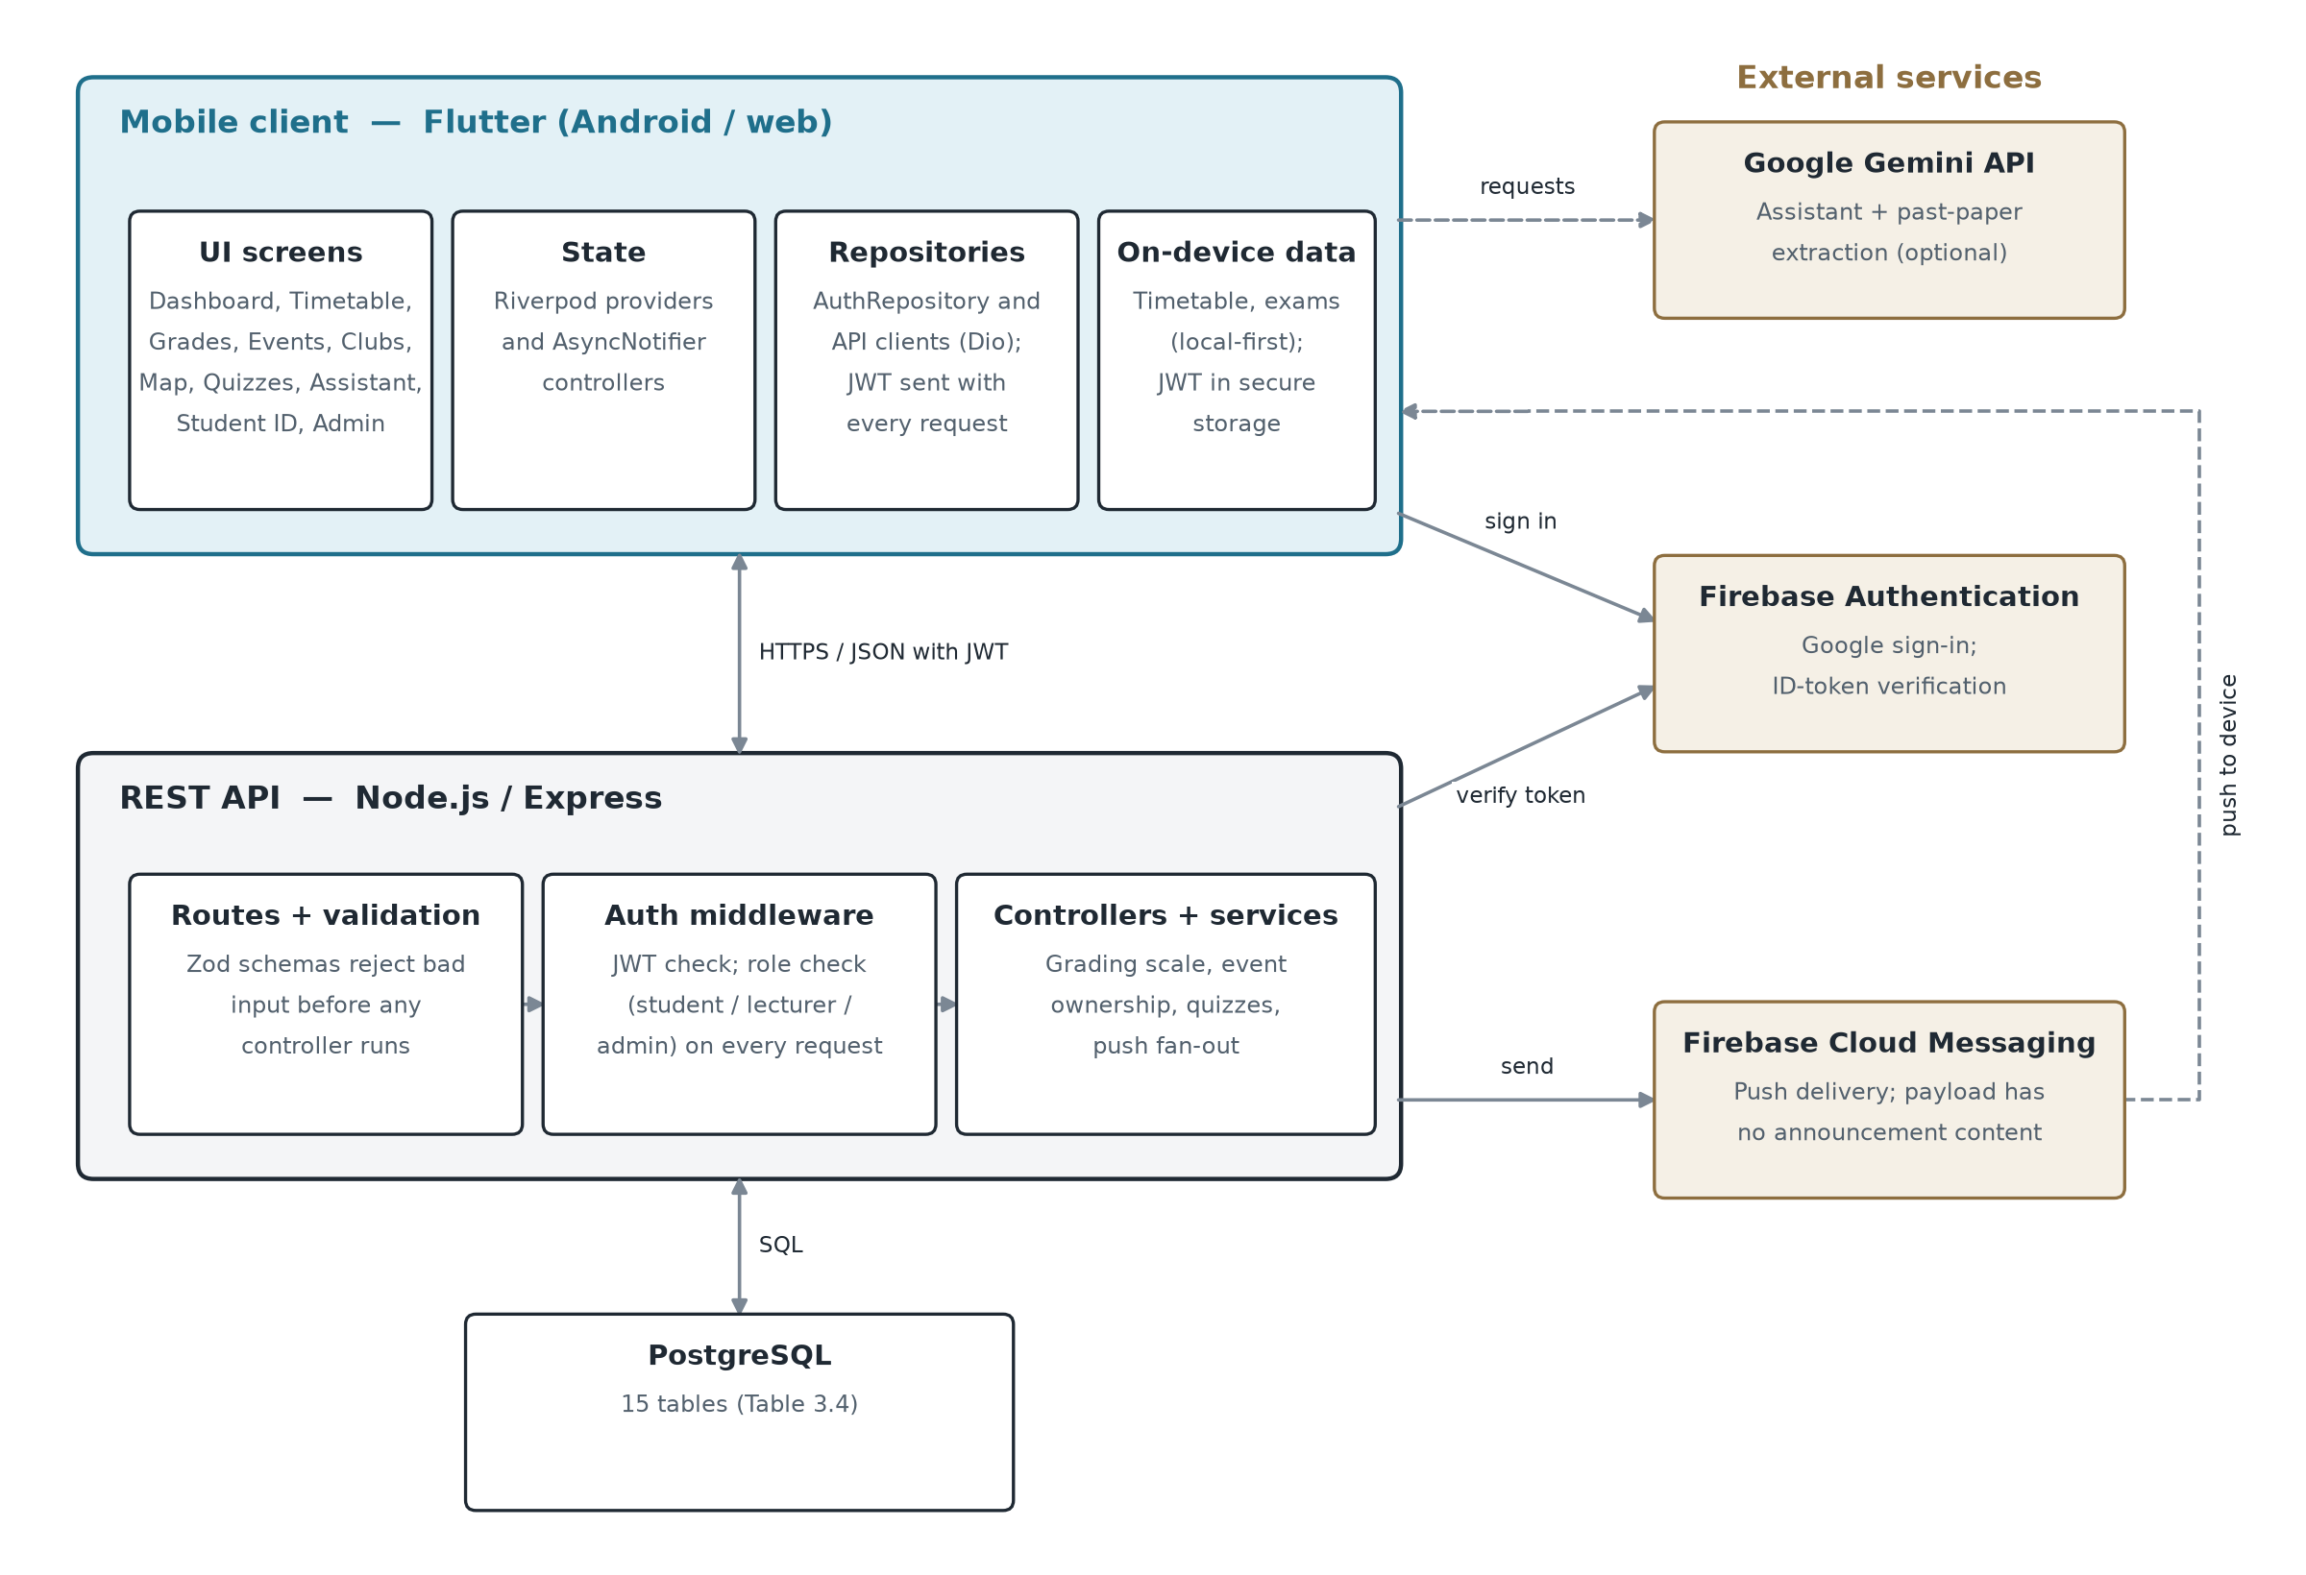
Figure 3.1: System architecture of Campus Companion
Each layer communicates over well-defined interfaces: the mobile client never queries the database directly, and the backend never assumes a specific client — the same REST API serves the Flutter app regardless of whether it runs on Android or as a web build. Role-based access control (student, lecturer, administrator) is enforced in the backend on every request that needs it, not merely hidden in the mobile UI, so that a client cannot grant itself privilege by skipping a UI check (Section 2.4).

3.3.2 Use Case Design
Figure 3.2 shows the system's three actors and what each can do. Students register themselves and use the academic and campus-life features. Lecturer and administrator accounts cannot be self-registered: an administrator creates them (FR3). Lecturers create events and quizzes and may delete only the events they created; administrators can also delete any event or quiz, post announcements, record grades and create staff accounts. These rules are enforced by the backend's role checks, and the diagram was drawn from those checks rather than from the interface.
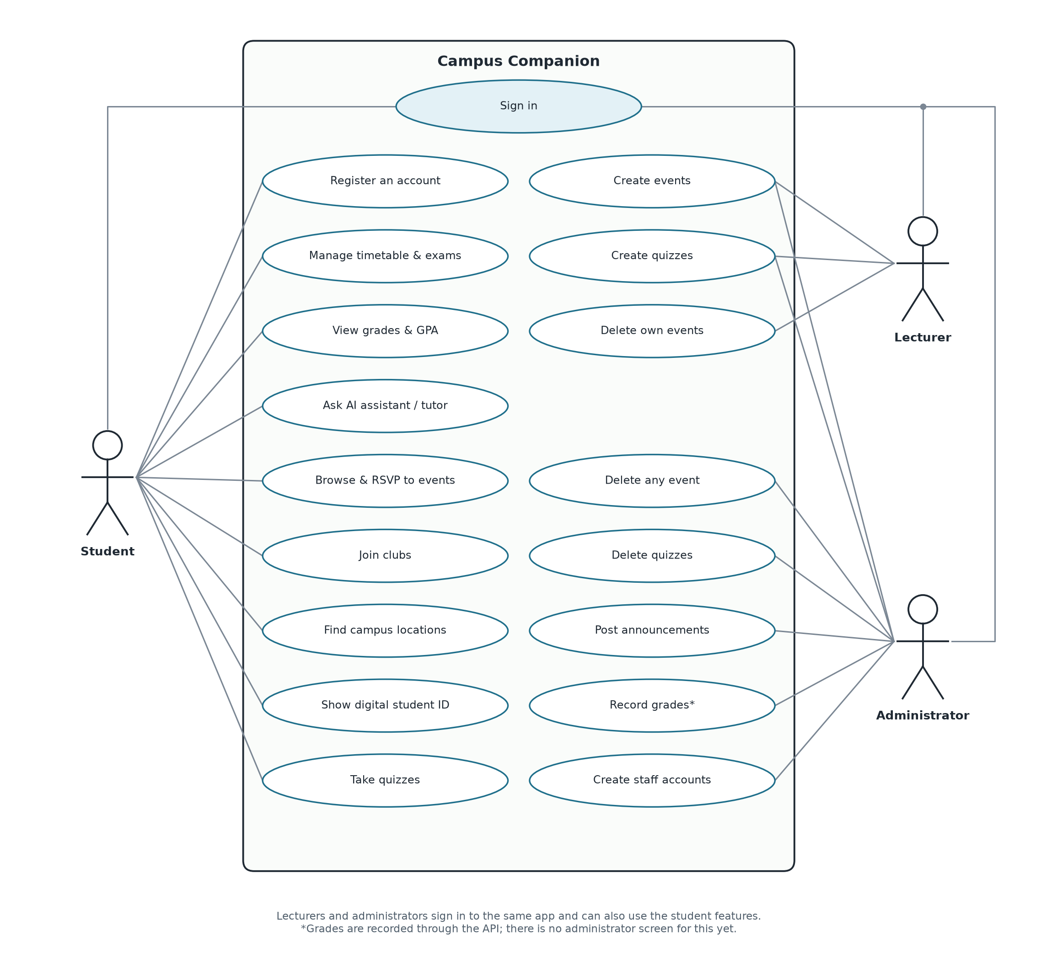
Figure 3.2: Use case diagram

3.3.3 Database Design
The system's data is held in a PostgreSQL database of fifteen tables (backend/db/schema.sql), listed in Table 3.4; Figure 3.3 shows how they relate.
Table 3.4: Database tables in the Campus Companion schema
Table | Purpose
users | One row per account (student, lecturer or admin), holding the password hash and/or a linked Google UID, role, and push preferences.
courses | Canonical course records (code, title, lecturer, credit hours), referenced by schedules, grades and quizzes to avoid free-text duplication.
schedules | A user's timetabled class slots (day, start/end time, room), used server-side only as an optional cloud-backup layer — the app itself is local-first (Section 1.3).
grades | A score per user per course per semester; the letter grade is a database-generated column derived from the score using the University of Ghana scale, so it cannot drift from the score it is derived from.
clubs / club_memberships | Club records and the many-to-many membership junction between users and clubs.
events / event_registrations | Campus events (optionally linked to a club and to the user who created them) and the many-to-many registration junction between users and events.
announcements | Broadcast messages posted by staff, categorised (general, academic, emergency) and timestamped for sync.
quizzes / quiz_questions / quiz_attempts / quiz_attempt_answers | A course-anchored quiz, its questions (multiple-choice or open-ended), and each student's attempt and per-question answers.
device_tokens | One row per installed app instance registered for push notifications, keyed by a unique FCM token.
locations | Named campus points of interest with a category and coordinates, used by the campus-map feature.

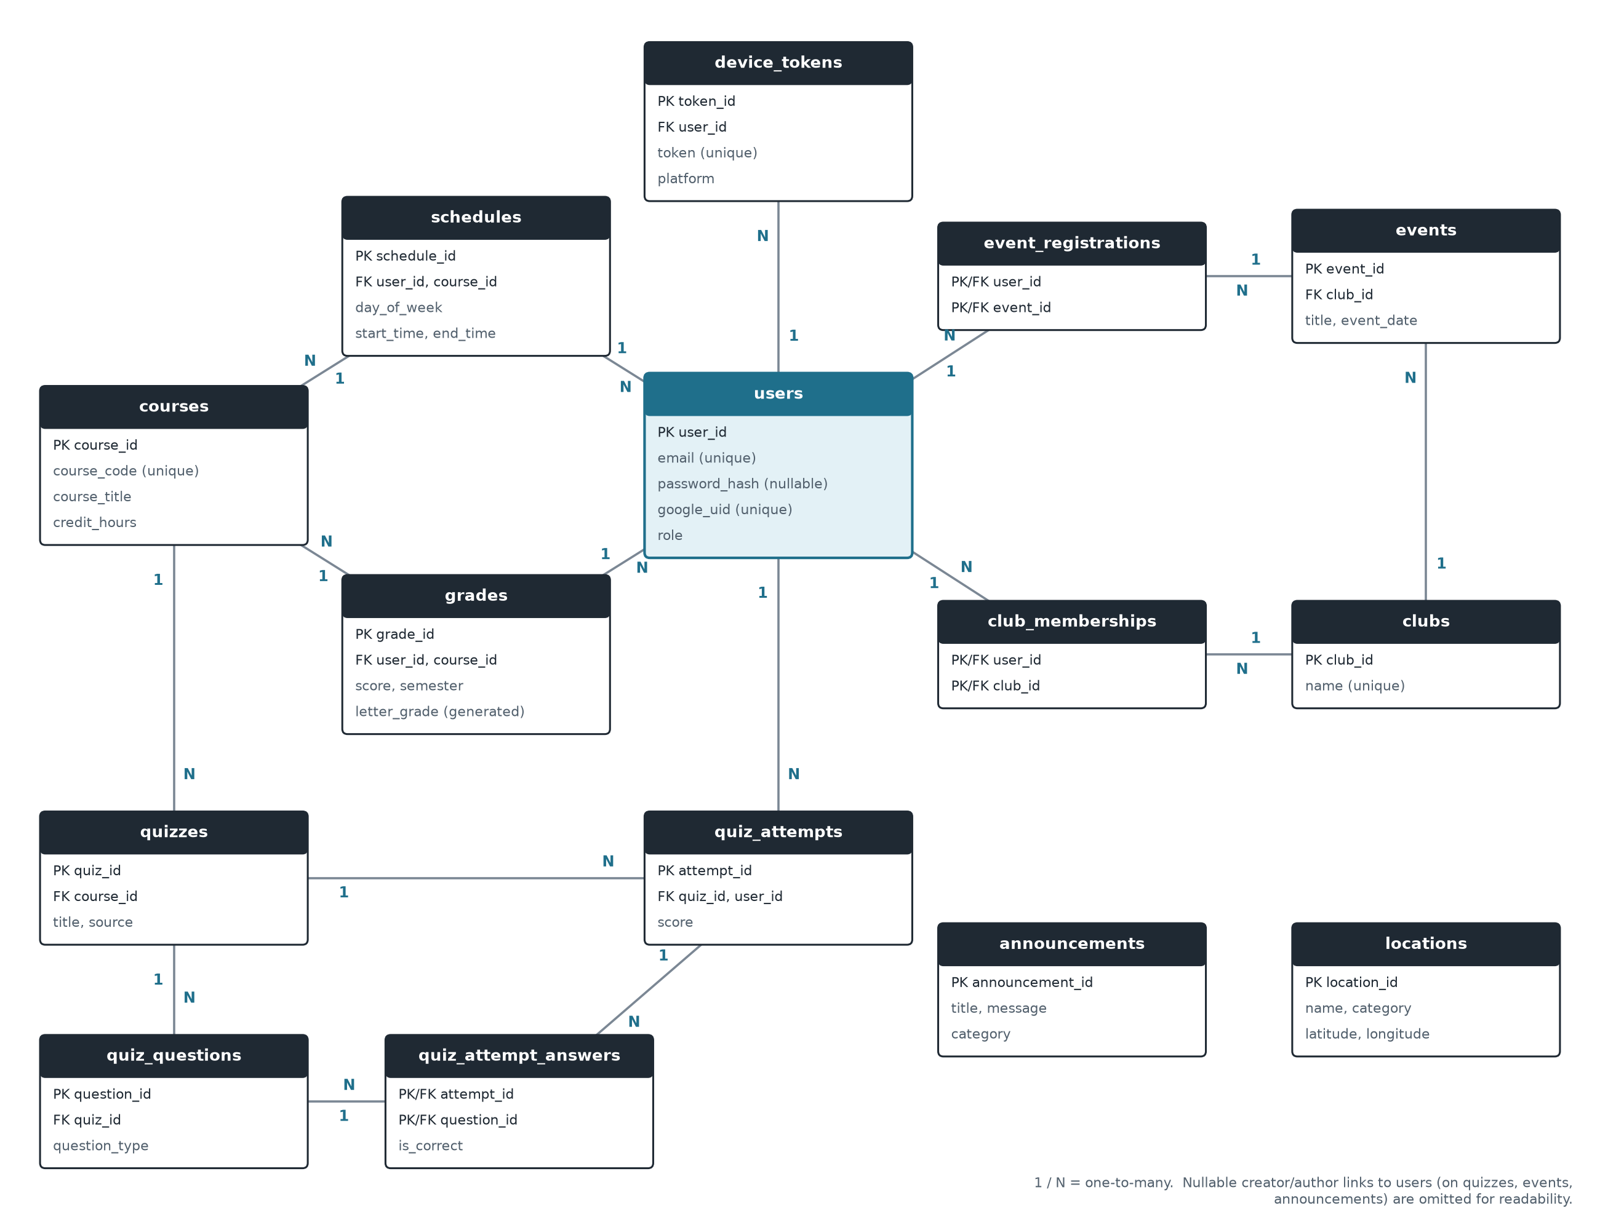
Figure 3.3: Entity-relationship diagram of the Campus Companion database
Data integrity is enforced before and at the database. Incoming API request bodies are validated and coerced against a schema (the zod library) before any controller logic runs — for example, registerSchema trims and lower-cases an email address and enforces a minimum password length before a new user row is ever written (backend/src/controllers/authController.js). A unique index on LOWER(email) guarantees case-insensitive matching regardless of how a client submits an address. The letter grade is derived from the numeric score inside the database itself (a GENERATED ALWAYS AS column), rather than accepted as separate client input that could disagree with its score. Externally authored calendar data (.ics/CSV files a student imports into their local timetable) is parsed and normalised into the app's internal schedule model by a dedicated, tested parser before any other feature uses it.

3.3.4 Sign-in Design
Figure 3.4 traces one request path through the layers in detail: Google Sign-In. The mobile app never tells the backend who the user is. It forwards a Firebase ID token, the backend verifies that token with Firebase itself, and only then looks up, links, or creates the account and issues the app's own session token (JWT). This is the server-side verification pattern recommended by Chen et al. (2014), discussed in Section 2.4.
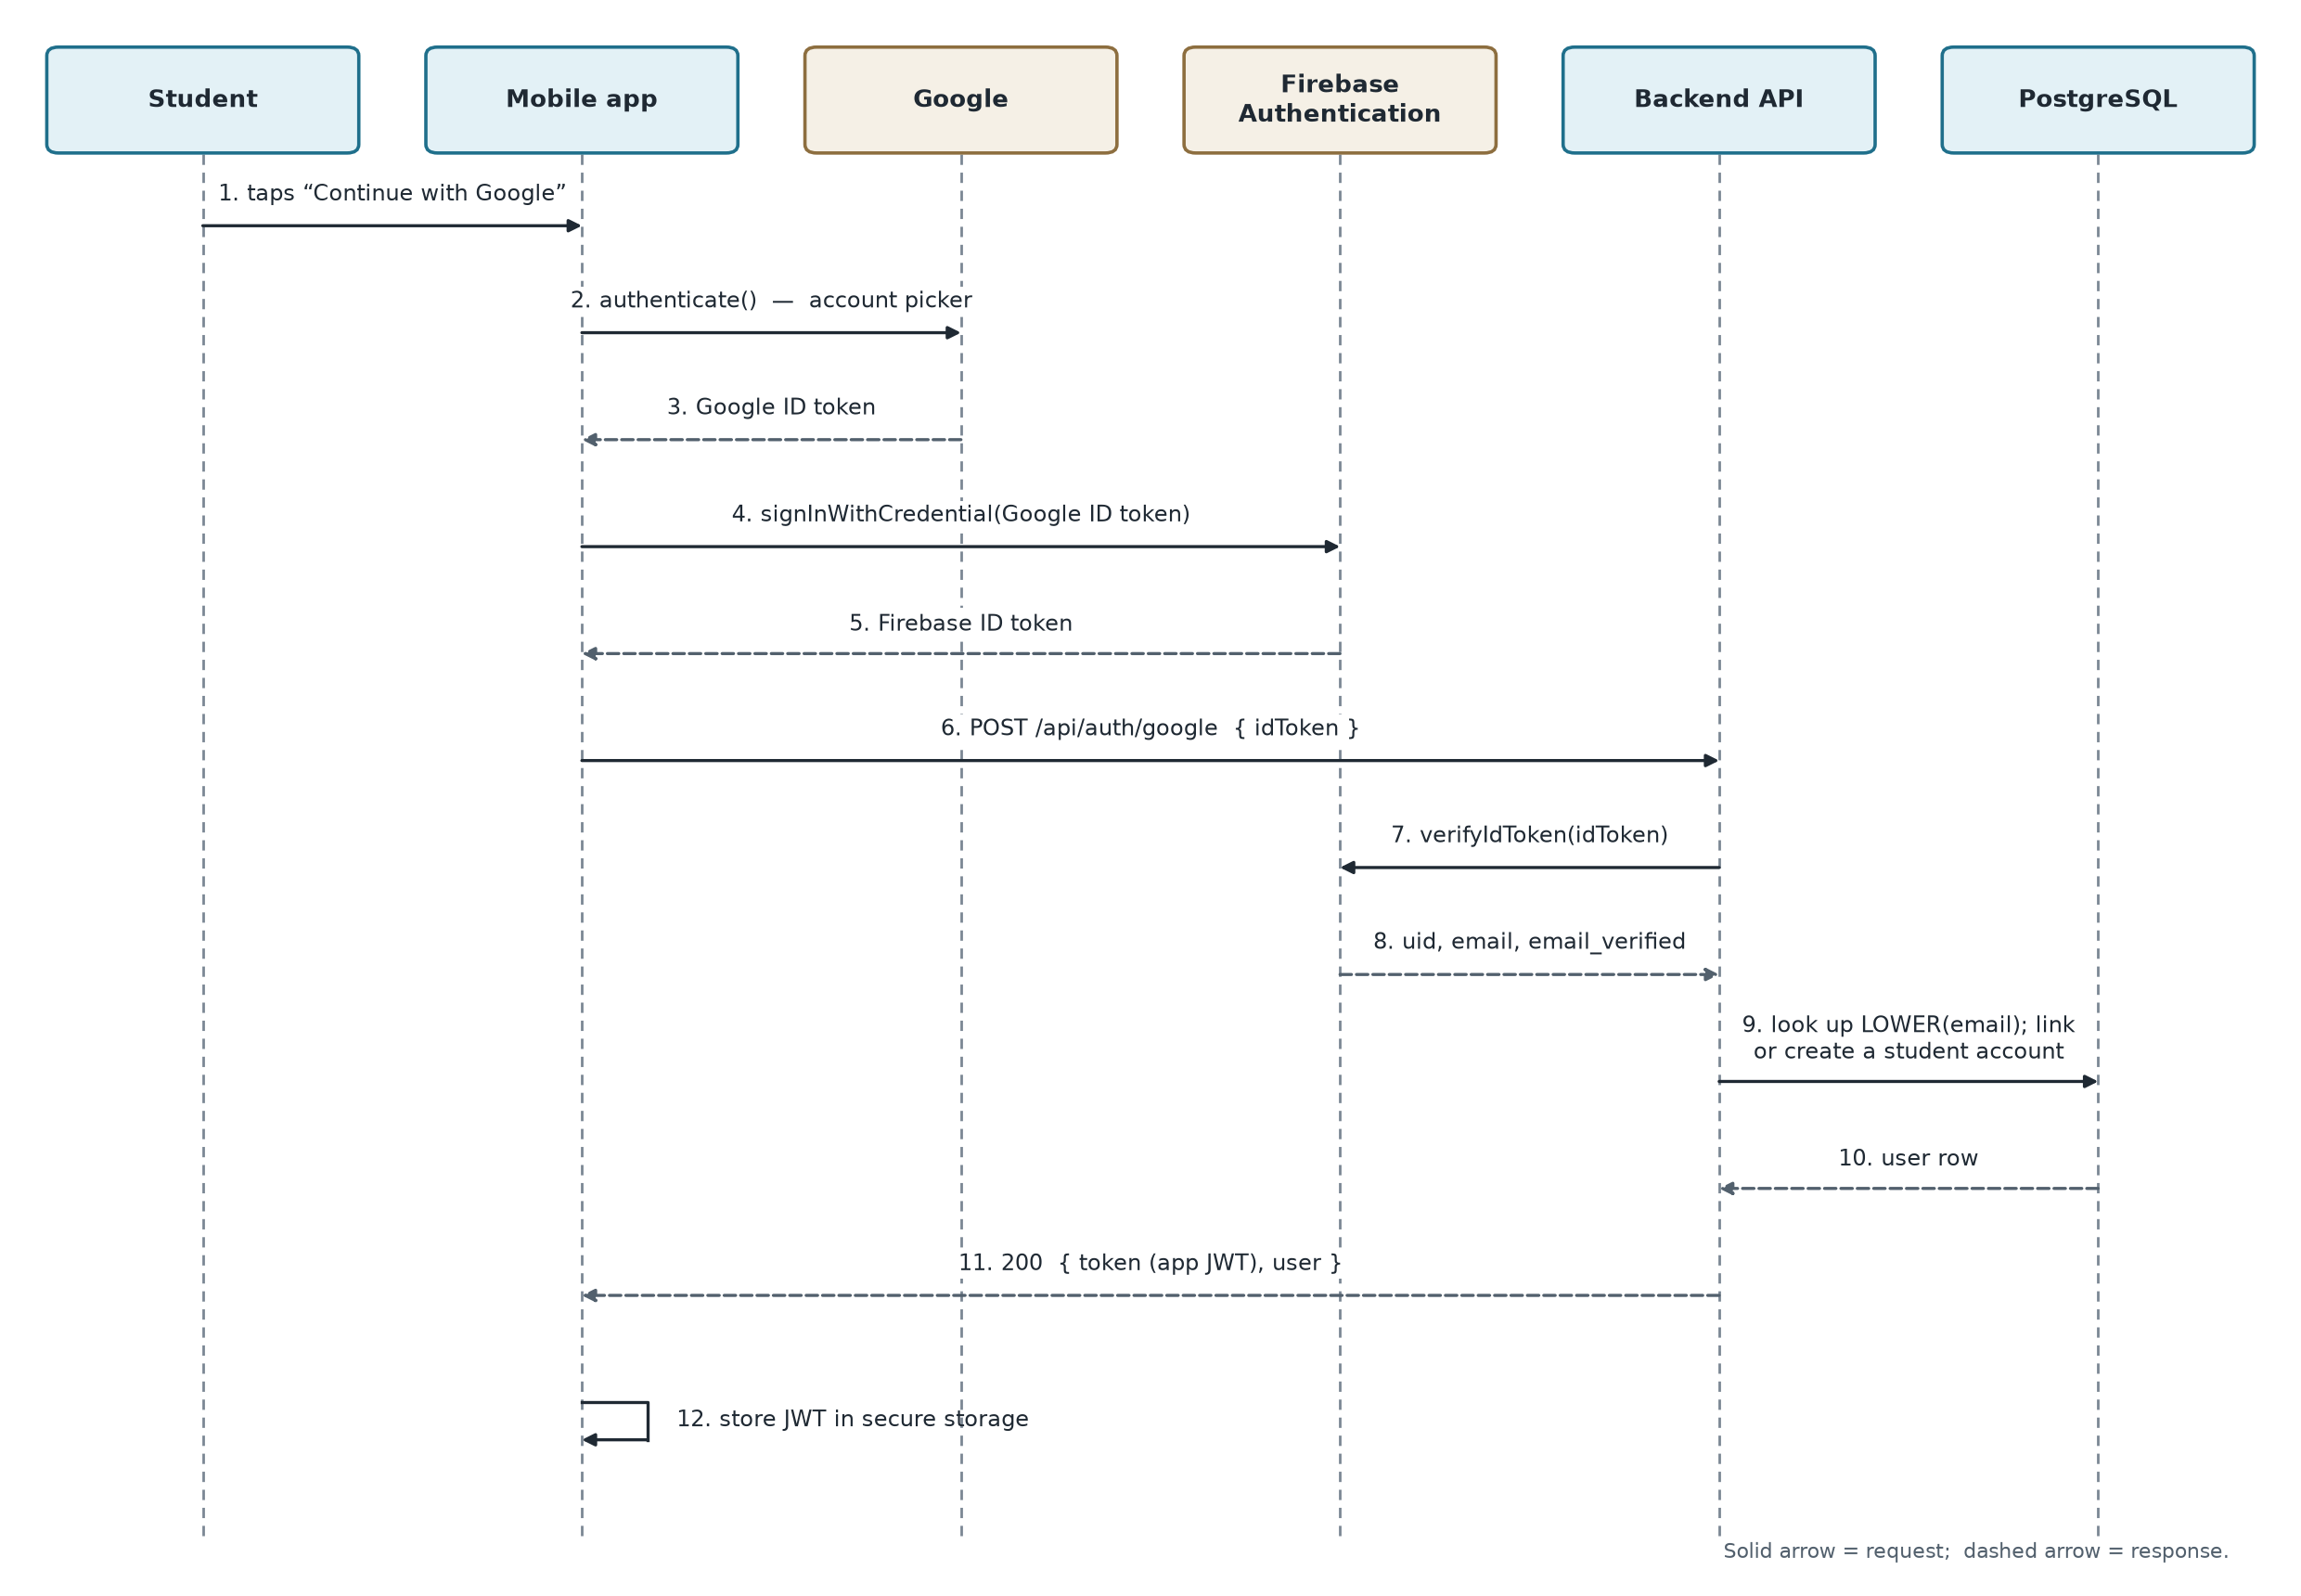
Figure 3.4: Google Sign-In sequence

3.4 Feature Selection
The features were selected from the requirements in Section 3.2, weighed against the time available, external dependencies, and relevance to the problem in Section 1.2; Section 1.3 sets out the resulting scope. Scoping was revisited iteratively rather than fixed up front. Between an administrator management panel and push notifications, the administrator panel was built first because it needed no external service. Push notifications and Google Sign-In were built and tested but deliberately left disabled pending Firebase console configuration outside the application's own code (PROJECT_AUDIT.md, Sections 2–3). The Student Hub's dues, shuttle and lost-and-found screens were deliberately kept on static, device-local demonstration data rather than integrating a real payment gateway, which was judged out of scope for the time available (Section 1.3). Apple sign-in and a guest mode appear on the sign-in screens but are not yet implemented (Section 5.3).

3.5 Experimental Setup

3.5.1 Development Tools and Environment
Table 3.5: Development tools and environment
Category | Tool / technology | Purpose
Mobile client | Flutter (Dart), Riverpod, Dio | Cross-platform app for Android and web; state management; HTTP client
Backend | Node.js, Express, Zod, bcryptjs, jsonwebtoken | REST API; request validation; password hashing; session tokens
Database | PostgreSQL | Relational storage (Table 3.4)
External services | Firebase Authentication and Cloud Messaging (firebase-admin); Google Gemini API | Google Sign-In; push notifications; AI assistant and past-paper extraction
Testing | flutter_test, node:test, end-to-end smoke script | Automated tests at three levels (Section 3.5.3)
Tools | Visual Studio Code, Android Studio and Android emulator, Git, Google Chrome | Editing; Android builds and emulation; version control; web testing
Deployment | Render (render.yaml) | Hosting configuration for the API, web build and database
Hardware | Windows 11 laptop, 7.7 GB RAM | Development and testing

3.5.2 Development Methodology
The system was built iteratively and incrementally, in the spirit of Agile development (Beck et al., 2001): working software was produced feature by feature rather than in large, infrequent releases. For each feature, the backend route(s) and database schema were implemented and tested first, followed by the corresponding mobile screens, state-management providers and widget tests — so that a feature's server-side contract existed and was verified before client code was written against it. Within the mobile client, a repository pattern separates API/storage access (e.g. AuthRepository, wrapping an AuthApi and a token store) from UI state, which is held in Riverpod AsyncNotifier/StateProvider controllers; this keeps a screen's widgets free of networking logic and makes the underlying repository replaceable with a fake in tests. A shared-fixture pattern guards rules that both the backend and the mobile client must agree on: the University of Ghana grading scale is defined once, in docs/grading-scale-ug.json, and both the backend's test suite and the Flutter client's parity test read that same file, so the two codebases cannot silently drift onto different grading rules (Section 2.3's finding that institution-specific conventions are often missed from generic tools was a direct motivation for keeping this rule in one place rather than duplicating it). A local-first pattern was used for data the student owns and edits constantly — the timetable and exams live primarily on the device, with the server's equivalent routes kept working as an unused, optional backup layer, because routing the dashboard through the server's (normally empty) timetable was found, during development, to risk replacing a student's real classes with nothing.

3.5.3 Testing Strategy
Testing is layered into three levels (Sommerville, 2016). Offline unit tests (node:test on the backend, flutter test on the mobile client) run without a network connection or database and check pure logic — the grading-scale calculations, the push fan-out logic against in-memory fakes, and individual screens' behaviour. Database/integration tests run the same logic against a real local PostgreSQL instance to catch anything a fake database could hide, such as a uniqueness constraint violation. End-to-end smoke tests run last, against a running API and database, and walk realistic user journeys (registration, login, creating and registering for an event, taking a quiz) the way a real client would, rather than calling internal functions directly.
The tests themselves were checked by mutation testing: for business logic judged important enough to double-check (event-deletion ownership, self-registration never granting an elevated role, the session-expiry flag, the Google sign-in cancel path), the real logic was deliberately broken, the relevant tests were confirmed to fail, and the code was then restored and re-verified. A test suite that cannot detect a deliberately introduced bug is not validating anything, so this step was treated as necessary rather than optional.

3.5.4 Evaluation Criteria
The system was evaluated against five criteria: functional correctness (the automated tests in Section 3.5.3 pass); objective coverage (each specific objective in Section 1.4.2 is traced to evidence, Table 4.2); security effectiveness (role enforcement and self-registration rules are tested, and Google sign-in tokens are verified against the live identity provider); resilience (offline and partial-failure behaviour is tested against simulated failures); and end-to-end behaviour (the application is run as a whole, not only screen by screen).
As verified on 24 October 2026 (PROJECT_AUDIT.md), the backend's offline unit suite passed 50/50, its database suite passed 14/14, and its end-to-end smoke suite passed 182/182; the mobile client's flutter test suite passed 366/366 and flutter analyze reported no issues. Two checks were done manually rather than by an automated test: a request carrying a garbage Google sign-in token was sent to the live Firebase project to confirm it is rejected with 401 (invalid token) rather than 503 (feature not configured) — proving the credential itself is live and correctly wired, not merely that the code compiles — and a debug Android build was produced to confirm the push-notification and Google Sign-In packages compile and link correctly on-device. These figures are a point-in-time snapshot; Chapter Four re-verifies them freshly rather than repeating this snapshot as if it still held unchanged.

3.5.5 Statistical Analysis
The evaluation uses descriptive counts only — the number of tests and checks that pass or fail — because its question is whether the system behaves as specified, not whether one group or design performs better than another. No hypothesis is tested, so no inferential statistics (significance tests, confidence intervals or effect sizes) are reported. This study does not include a user survey; Chapter Five recommends one.

CHAPTER FOUR
EXPERIMENTAL RESULT AND DISCUSSION

4.1 Introduction
This chapter presents the results of evaluating Campus Companion against the testing strategy described in Section 3.5.3, and discusses those results against the specific objectives set out in Section 1.4.2. All figures in this chapter were produced by re-running every test suite on 30 October 2026, specifically for this chapter, rather than carried over from an earlier snapshot — Section 3.5.4 noted that the figures reported there (from 24 October 2026) were a point-in-time snapshot to be re-verified, and that re-verification is what this chapter reports.

4.2 Test Results by Tier
The three automated test tiers described in Section 3.5.3 were each re-run against this codebase on 30 October 2026: the backend's offline unit suite and the mobile client's flutter test/flutter analyze without any server; the backend's database suite against a freshly reset local PostgreSQL instance; and the backend's end-to-end smoke suite against that same database with the API running. Table 4.1 reports the outcome of each.
Table 4.1: Automated test results, re-verified 30 October 2026
Tier | Command | Result
Mobile static analysis | flutter analyze | No issues found
Mobile unit/widget tests | flutter test | 371 / 371 passed
Backend offline unit tests | npm test | 50 / 50 passed
Backend database/integration tests | npm run test:db | 14 / 14 passed
Backend end-to-end smoke tests | npm run test:smoke | 182 / 182 passed

The four backend figures in Table 4.1, and the first run of the mobile suite (366/366), are unchanged from the 24 October 2026 snapshot reported in Section 3.5.4, six days earlier. That stability is itself a result worth noting: it confirms the suites are deterministic and repeatable rather than prone to intermittent failure. The mobile suite then grew to 371 tests, because regression tests were added for three defects found by running the application end to end (Section 4.4); all 371 pass. The smoke suite's authentication module included, as in the earlier run, a request carrying a deliberately invalid Google sign-in token sent to the live Firebase project configured for this app; it was rejected with HTTP 401 (invalid token), not 503 (feature not configured), confirming the Firebase credential itself remains live and correctly wired, not merely that the code around it still compiles. The debug Android build was also re-run on 30 October 2026: it compiled, installed on the Android emulator, and launched to the Welcome screen, confirming that the push-notification and Google Sign-In native packages still build and link correctly.

4.3 Discussion Against the Specific Objectives
Section 1.4.2 set out seven specific objectives. Table 4.2 summarises the evidence for each, and the paragraphs that follow discuss the more significant ones.
Table 4.2: Specific objectives and their supporting evidence
Objective (Section 1.4.2) | Evidence
1. Cross-platform client + backend, role-based auth incl. Google Sign-In | Smoke-tested role enforcement (403 for a student attempting a lecturer/admin action); live Google sign-in token verification (Section 4.2).
2. Local-first timetable, exams and alerts with .ics/CSV import/export | schedule_parser and ics_exporter unit tests (within the 371 mobile tests); local-first design discussed in Section 3.5.2.
3. Grade/GPA analytics on the UG scale | Backend grading tests and the mobile grading-scale parity test both check against the single shared fixture docs/grading-scale-ug.json (Section 3.5.2).
4. Campus-life features: events, clubs, locations, quizzes, digital ID | Smoke-tested event ownership/deletion rules and the full quiz lifecycle (Module 7, 28 checks); clubs and locations tested per PROJECT_AUDIT.md.
5. AI assistant resilient to partial backend failure | assistant_context_offline and related mobile tests (within the 371); tested against fakes, not yet against a live Gemini key or on a device (see Section 4.4).
6. Push notification integration via FCM | pushSenders offline tests and the device-token/preference smoke module (Module 3b, 25 checks); production delivery still gated behind a pending console step (Section 4.4).
7. Layered automated testing, incl. mutation testing | This chapter's own re-verified results (Table 4.1); the mutation-testing episodes recorded in Section 3.5.3.

Objectives 1 through 4 and 7 are supported by evidence that is both automated and, where relevant (Google sign-in, grading scale), checked against a live external credential or a shared cross-codebase fixture rather than only an internal fake. Objectives 5 and 6 are only partially demonstrated: the underlying code for both the AI assistant's resilience and push-notification delivery is implemented and tested against fakes, but neither has been exercised end-to-end against the real external service it ultimately depends on (a live Gemini API key for the assistant; a production Firebase deployment for push) — Section 4.4 discusses this distinction and its implications.

4.4 Discussion of Limitations Observed
Two gaps are visible once the objectives are checked individually rather than as a single pass/fail count. First, the AI assistant's offline-resilience logic (Objective 5) is proven correct against simulated failures of each backend data source, but the assistant has not been observed answering real questions through a live Gemini API key, nor used on a physical device — its tests establish that the logic is correct, not that the experience is good in practice. Second, push notifications and Google Sign-In (Objective 6, and part of Objective 1) are both fully built and tested against fakes and, for Google Sign-In, against one live credential check, but neither can deliver its real-world outcome (a notification arriving on a phone; a student actually completing a Google sign-in) until a small number of remaining steps are completed outside the application's own code — enabling the Google provider and registering a fingerprint in the Firebase console, and deploying the service-account key to the production server (PROJECT_AUDIT.md, Sections 2–3). These are configuration and deployment gaps, not defects in the tested code, but they mean Objectives 1 and 6 are only conditionally met as written: the code that satisfies them exists and is verified, but its real-world effect is not yet observable.
A further limitation is coverage depth rather than coverage presence: PROJECT_AUDIT.md notes that events, clubs, quizzes, locations, and the find-or-create-by-email logic in registration/login have no dedicated backend unit tests of their own and are exercised only by the end-to-end smoke suite. The smoke suite does catch regressions in these areas (as Section 3.5.3's mutation-testing episodes for event-deletion ownership demonstrate), but a smoke-only safety net is slower to run and gives a less precise failure location than a unit test would, which is a reasonable target for future work (Chapter Five).
Running the application end to end for the screenshots in Section 4.5 surfaced three defects that the passing automated suite had not caught. First, on a phone-width screen the dashboard's title was truncated to “Da…” because six unlabelled shortcut icons shared the top bar with it; the shortcuts were moved into a labelled grid on the dashboard (Figure 4.2a). Second, a rejected login (for example, a mistyped password) replaced the whole screen with a full-page error and a Retry button, so the login form and its explanatory message disappeared: the application's root screen treated any session error as a failure to restore a saved session. Third, finishing or skipping the profile step returned the student to the institution picker instead of continuing to the login screen, because only the topmost onboarding screen was closed. All three were fixed, and the second and third are now covered by regression tests that were first confirmed to fail against the defective code.
The second and third defects are instructive. Each screen involved already had passing widget tests, because each was tested in isolation; both bugs only appeared when the screens ran inside the application's real root screen and navigation stack. For that reason the new regression tests drive the application from its root rather than from the individual screen, and the observation is carried into Chapter Five's recommendations.

4.5 The Implemented Application
Figures 4.1 to 4.3 show the implemented application running against the local backend and database, signed in as the seeded demo student. The Android build was installed and launched on an emulator (Section 4.2), but the development machine (7.7 GB of memory) could not keep the emulator responsive for a full walkthrough, so these screenshots were taken from the same codebase compiled as a web build and shown in a phone-sized (412 × 915) browser window. Flutter draws every screen from the same widget code on both targets, so the screens are the same apart from the Android status bar. All data shown is real output from the running system; the only values entered by hand are the fictional demo student ID, level and programme in the optional profile, which feed the Digital Student ID card.
Figure 4.1 shows first launch: the Welcome screen, the institution picker that tailors the app's branding and grading rules, and the login screen. The Google, Apple and Guest sign-in buttons appear on both the Welcome and Login screens. At the time of writing, Google Sign-In awaits the configuration step described in Section 4.4, and Apple sign-in and guest mode are not yet implemented (Section 5.3); tapping a button whose feature is not yet available shows a short notice rather than doing nothing.
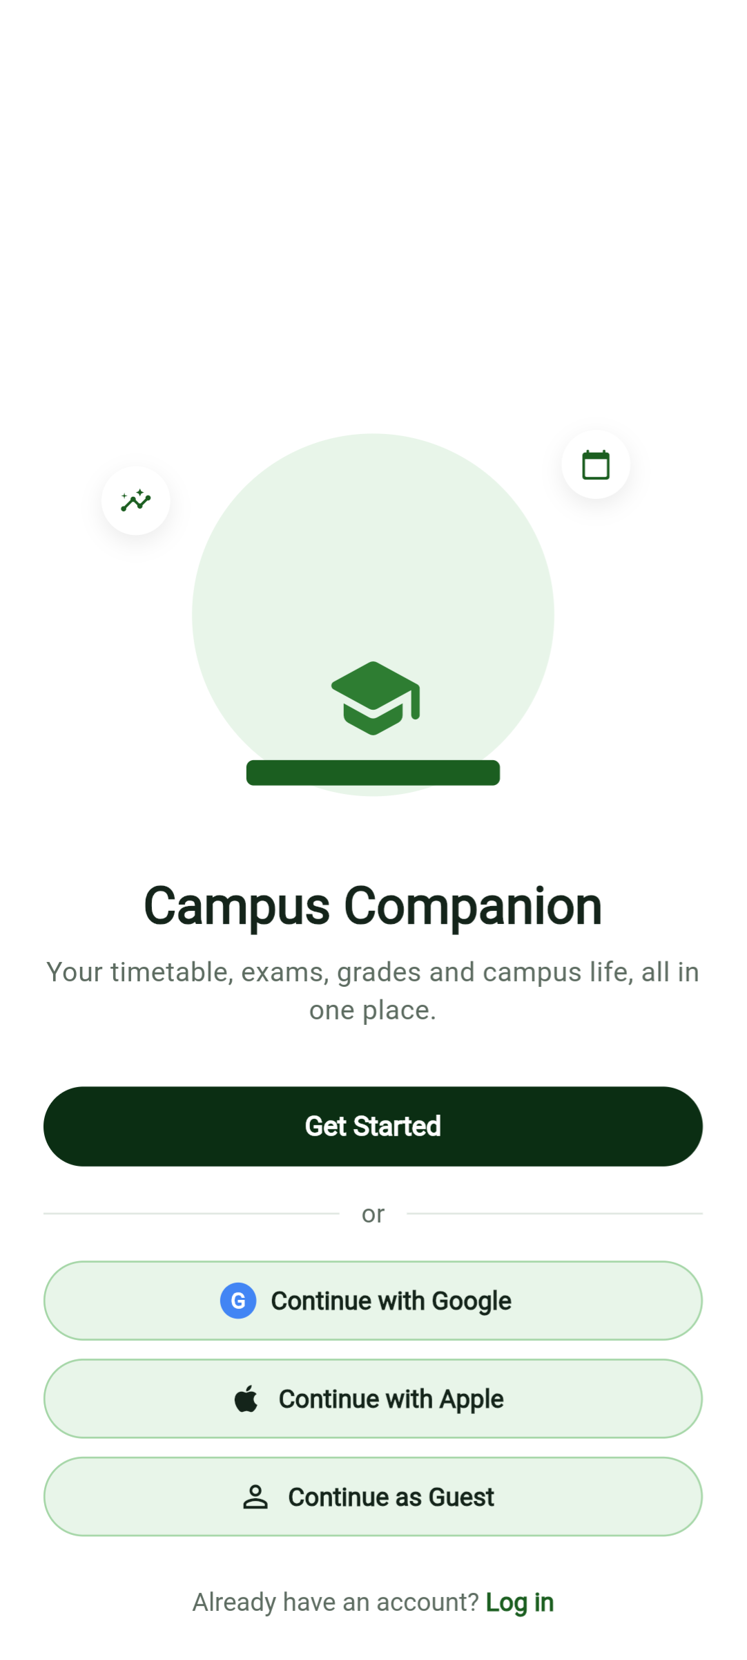  (a) Welcome | 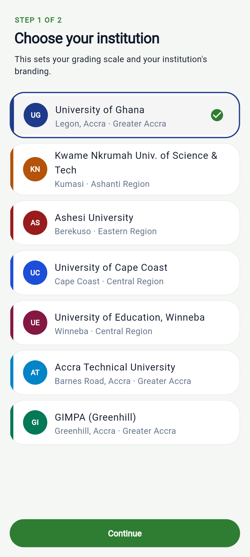  (b) Institution picker | 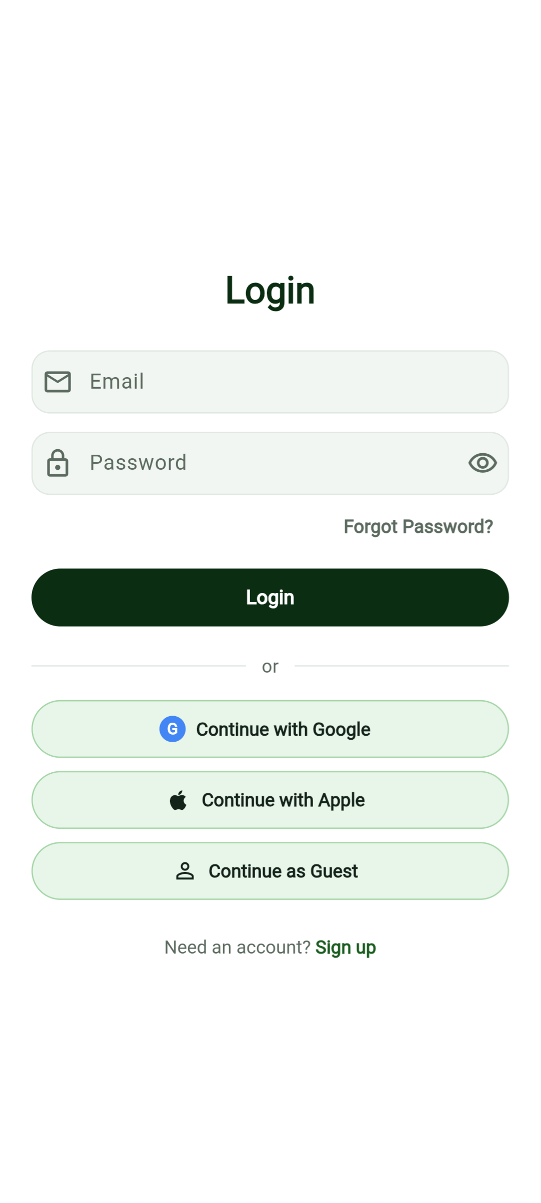  (c) Login
Figure 4.1: Onboarding and sign-in
Figure 4.2 shows the academic features after signing in. The dashboard greets the student by name with the day's brief, summarises classes, notices and events, lists the two announcements served by the backend, and offers labelled shortcuts to the remaining features. The Analytics screen computes a cumulative GPA of 3.64 (First Class Honours) from the demo student's stored grades using the University of Ghana scale, the same figure the backend's grading tests expect for this seeded student (Section 3.5.2). Asked “Calculate my GPA”, the AI Assistant gives the same answer; since this build has no Gemini key, the reply comes from the local rule engine and is labelled “via Local Engine” (Objective 5).
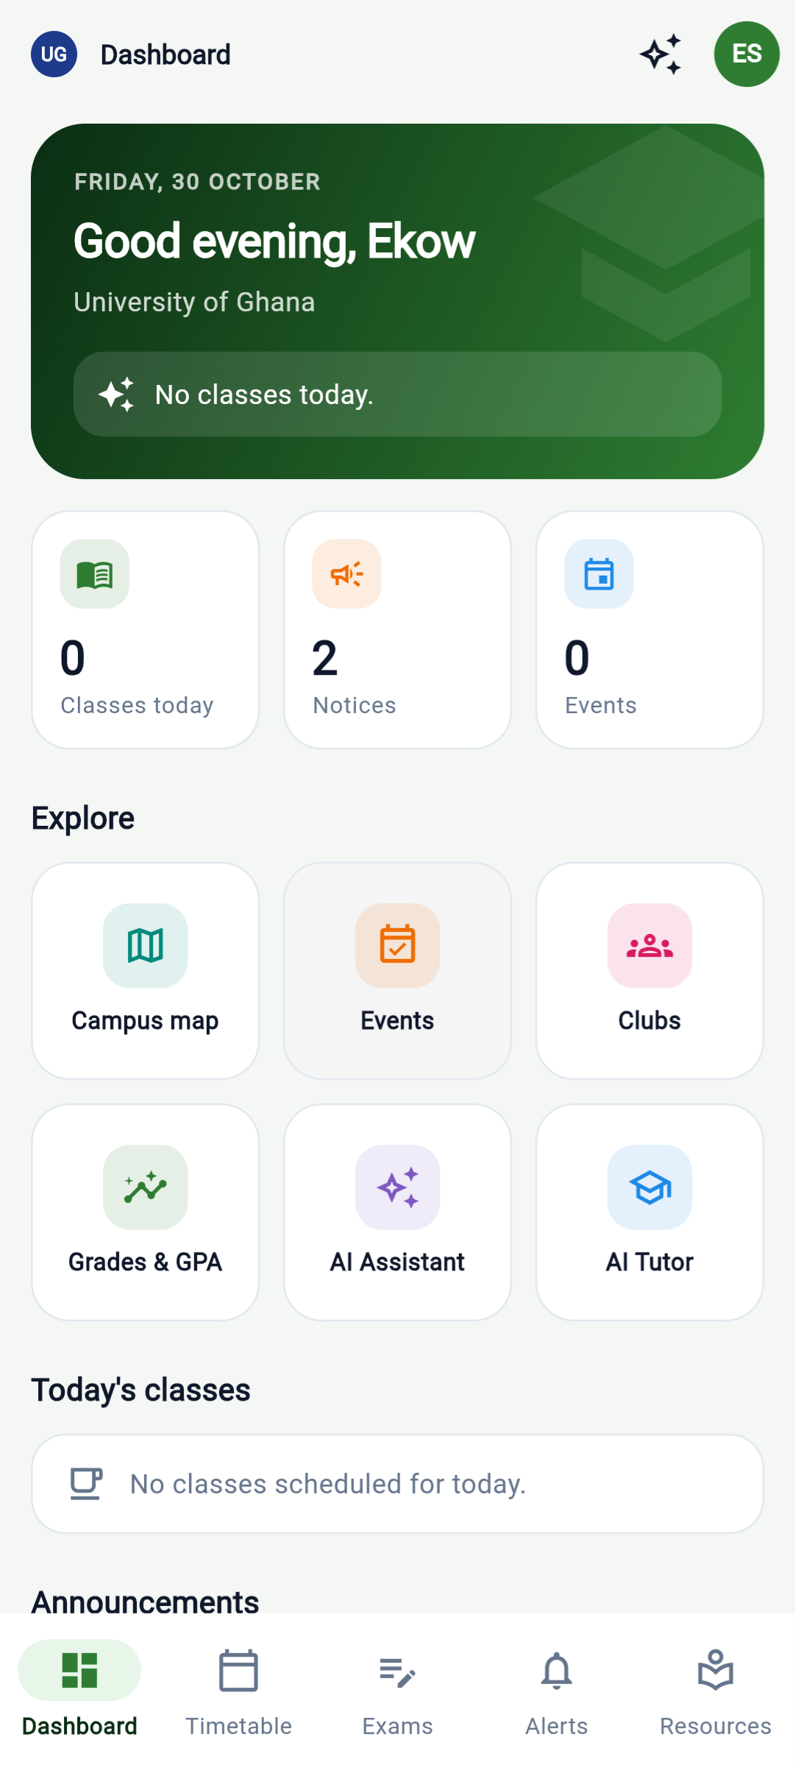  (a) Dashboard | 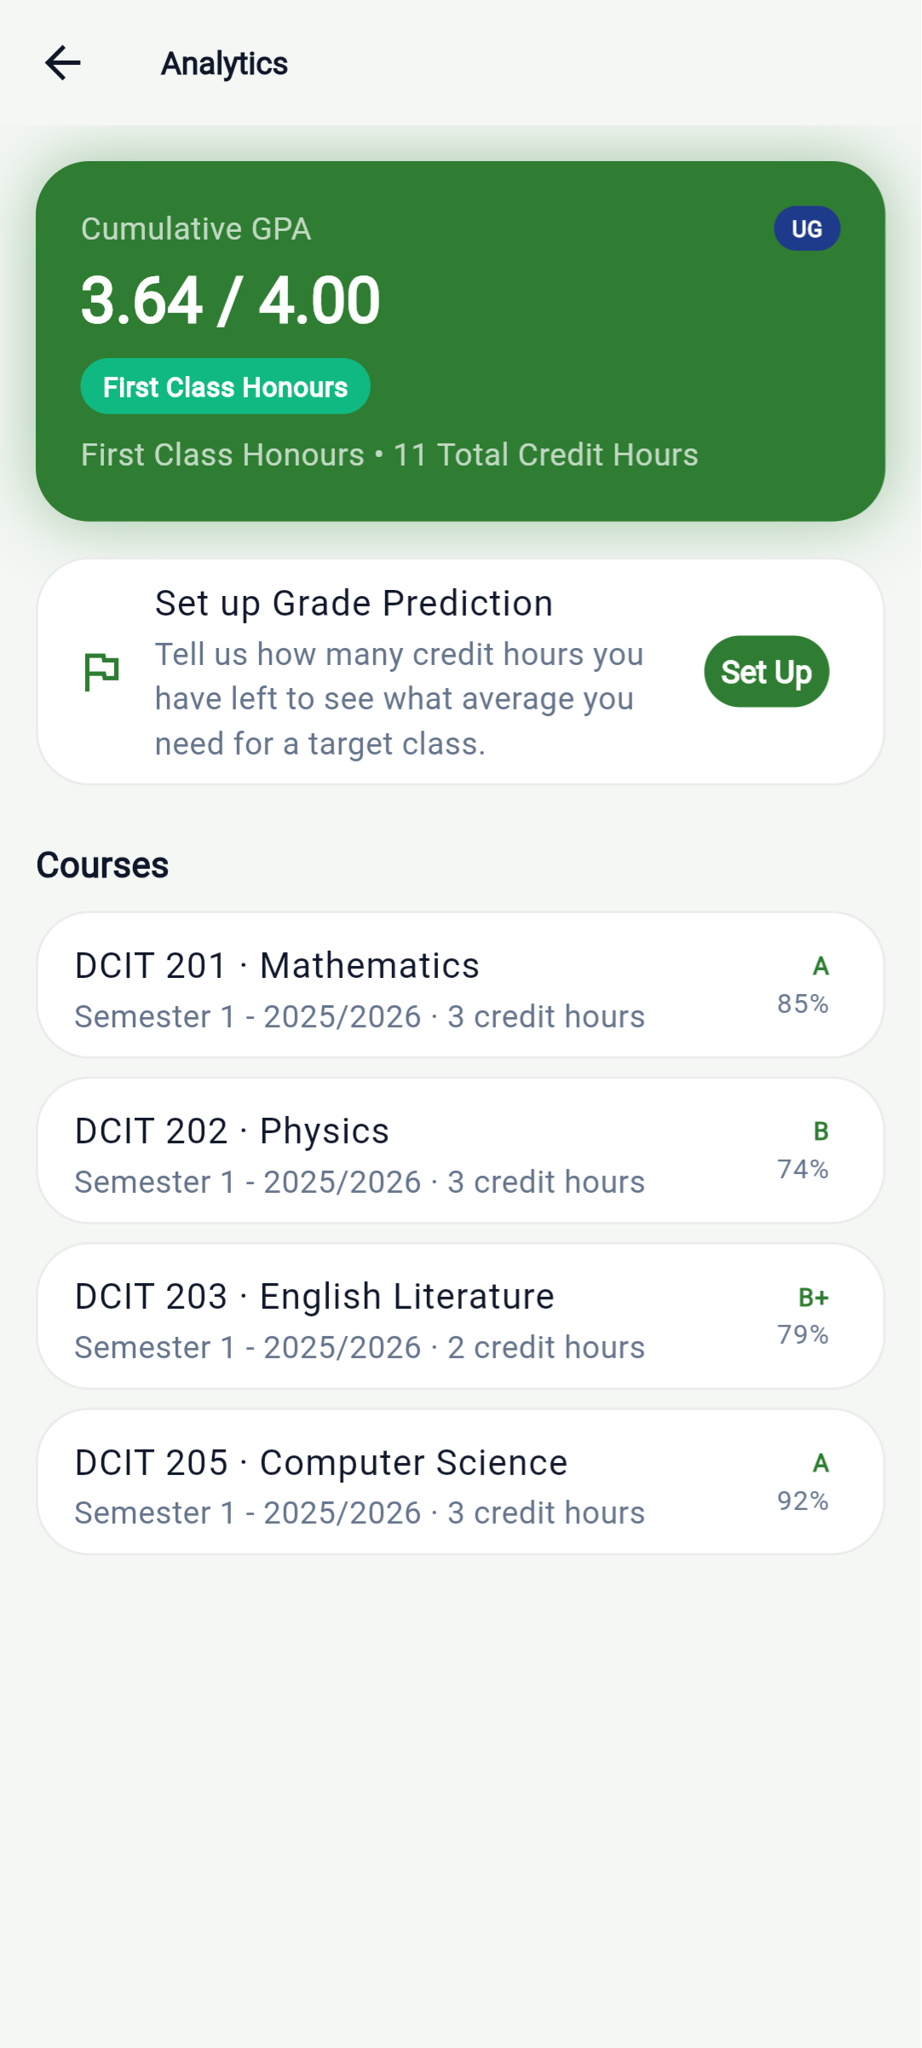  (b) GPA analytics | 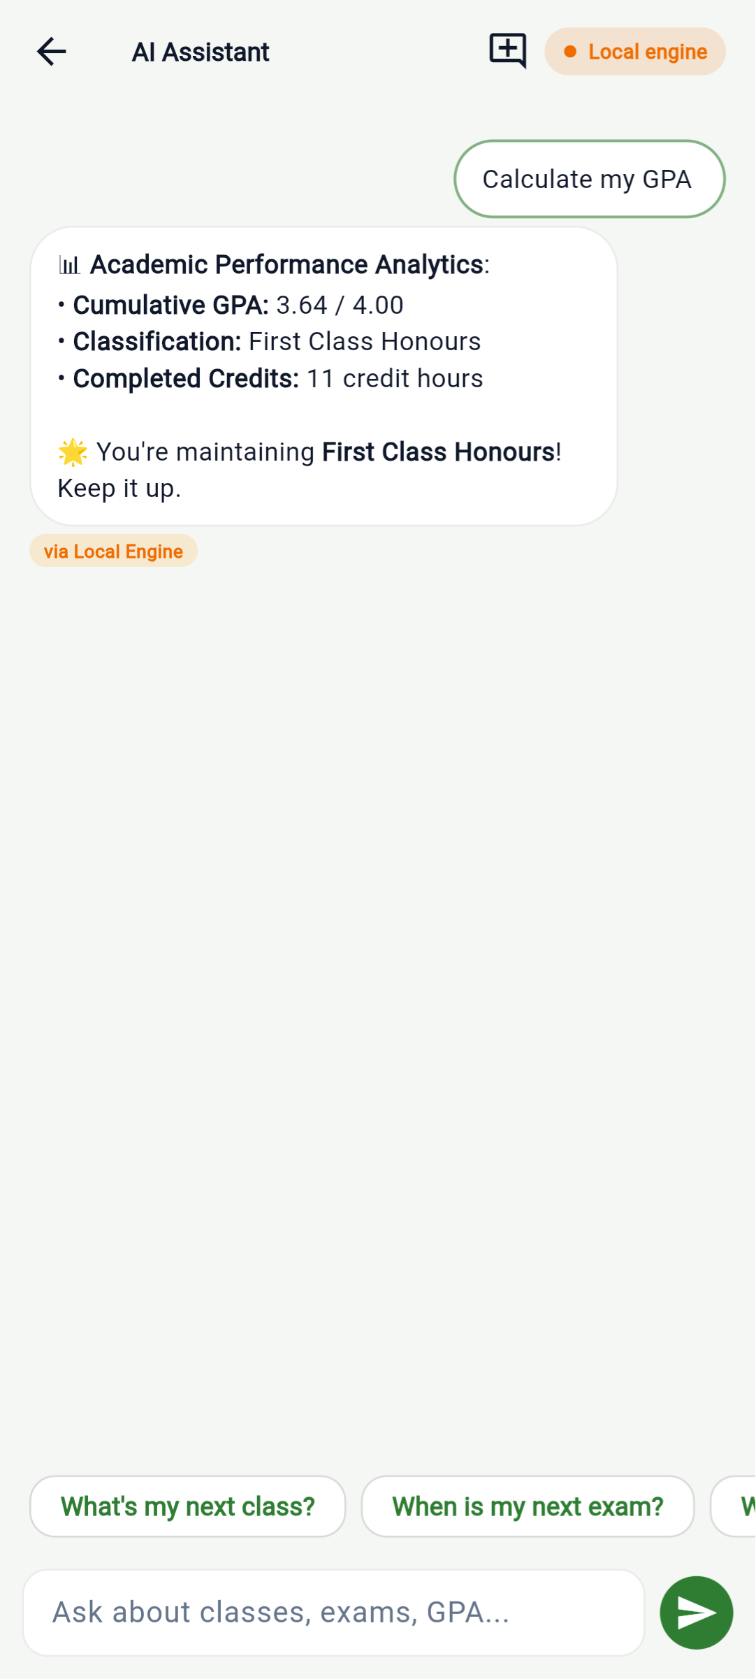  (c) AI Assistant
Figure 4.2: Academic features
Figure 4.3 shows the campus-life features: the campus-locations directory (with a map tab), the clubs directory with join buttons, and the Digital Student ID card with its scannable QR code.
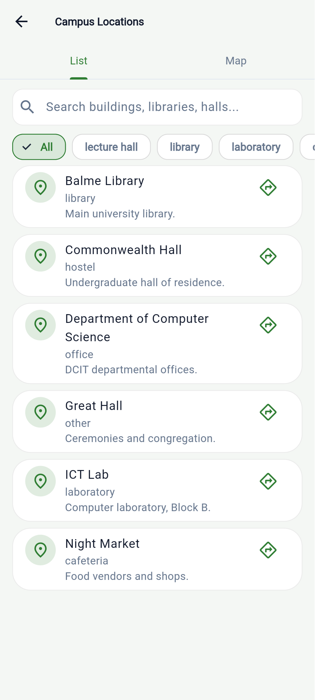  (a) Campus locations | 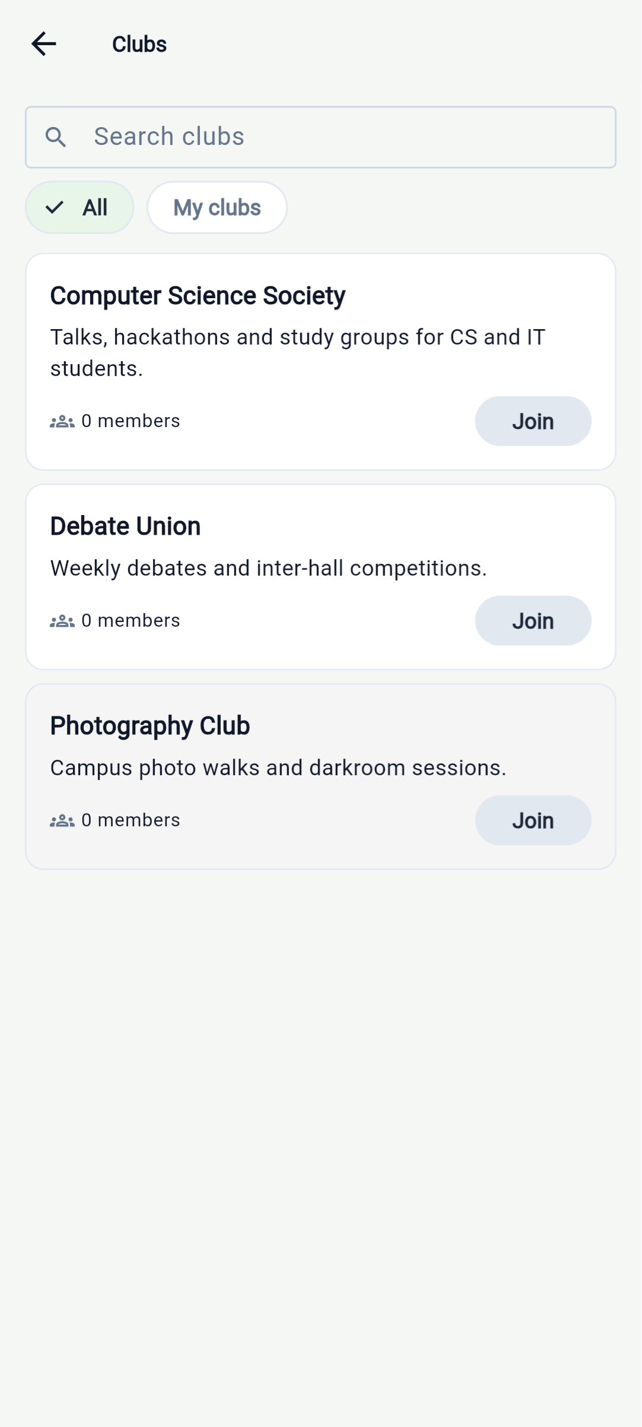  (b) Clubs | 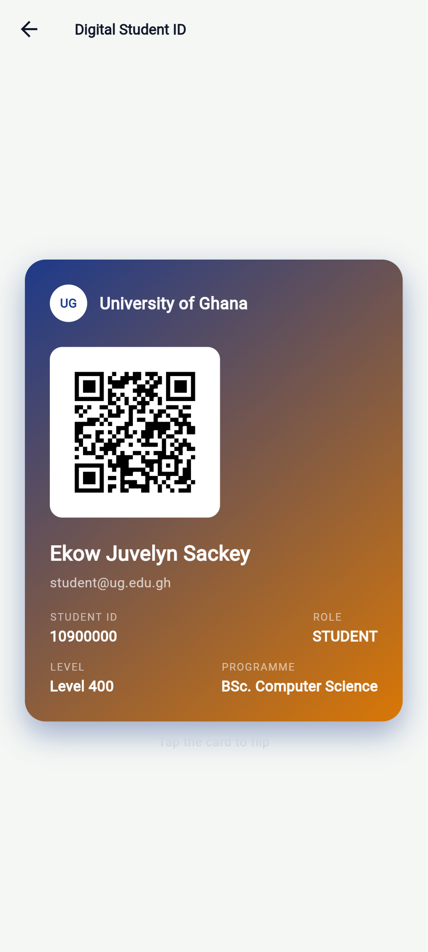  (c) Digital Student ID
Figure 4.3: Campus-life features

4.6 Summary
Re-running every automated test tier specifically for this chapter reproduced the independent snapshot taken six days earlier (Table 4.1), which is evidence the suites are stable rather than coincidentally passing; running the application end to end then exposed three user-interface defects the suites had missed, which were fixed and are now covered by regression tests (Section 4.4). Measured against the seven specific objectives in Section 1.4.2, five are fully supported by both automated tests and at least one live-credential or cross-codebase check; two (the AI assistant's real-world behaviour, and production push/Google Sign-In delivery) are supported at the code level but not yet observable end-to-end in production, for reasons that are configuration gaps rather than defects. Chapter Five concludes the study in light of these results.

CHAPTER FIVE
CONCLUDING REMARKS

5.1 Summary of the Study
This study set out to address the fragmentation of academic and campus-life tools available to Ghanaian tertiary students (Section 1.2): students already rely heavily on general-purpose mobile tools (Chapter Two), but none of those tools is built around the specific conventions of their institutions, such as the University of Ghana's grading scale. In response, this study designed, built and evaluated Campus Companion, an integrated mobile application (Flutter) and backend service (Node.js/Express on PostgreSQL) spanning authentication and role-based access, a local-first timetable and examinations module, grade and GPA analytics on the correct local scale, campus events, clubs, locations and announcements, a quiz module, a digital student identity card, and an AI assistant designed to remain useful even when parts of its backend are unreachable (Chapter One, Section 1.3).
The system was built iteratively, feature by feature, with the backend implemented and tested ahead of the corresponding mobile client code for each feature, and validated through a three-tier automated test strategy — offline unit tests, database-backed integration tests, and end-to-end smoke tests — reinforced by deliberate mutation testing of key business rules (Chapter Three). Re-running every tier specifically for this study (Chapter Four) produced 371/371 mobile tests, 50/50 backend unit tests, 14/14 database tests and 182/182 smoke-test checks, and five of the study's seven specific objectives (Section 1.4.2) were supported by evidence that included at least one live external check rather than only internal fakes.

5.2 Contribution of the Study
Revisiting the three contributions claimed in Section 1.5 in light of Chapters Two to Four: first, the literature reviewed in Chapter Two did not surface an evaluated system that combines personal academic organisation and campus-wide information services behind one authenticated, institution-aware account (Section 2.8); Campus Companion's combination of these two strands, built around the University of Ghana's actual grading scale rather than a generic one, fills that specific gap. Second, the AI assistant's design — reporting, source by source, which of its several independent backend data sources it could or could not reach, rather than failing an entire answer when one source is down — addresses a concern that is not the focus of the chatbot-in-education studies reviewed (Section 2.6), which evaluate whether chatbots help learning rather than how they behave when a service they depend on fails. Third, the test-driven development discipline demonstrated across this project — three test tiers, a shared cross-codebase fixture for a rule as consequential as GPA computation, and mutation testing used specifically to confirm that the test suite would catch a deliberately introduced regression — is documented here with concrete, repeatable results (Chapter Four) rather than asserted without evidence.

5.3 Limitations
Several limitations, most already flagged as they arose in earlier chapters, should be stated plainly together here. Two built and tested features — push notifications and Google Sign-In — are not yet observable in production: both depend on a small number of remaining steps outside the application's own code (enabling a sign-in provider and registering a fingerprint in the Firebase console; deploying a service-account key to the production server) rather than on unfinished application logic, but until those steps are completed neither delivers its real-world outcome to an end user (Section 4.4). The AI assistant's offline-resilience logic is verified against simulated failures but has not been exercised against a live large-language-model key or on a physical device (Section 4.4). Apple sign-in and a guest mode appear on the Welcome and Login screens but are not yet implemented; tapping either shows a short notice, and both are planned for completion before the project defence. The “Student Hub” shuttle, dues and lost-and-found features are simulated with static, device-local data and no real payment gateway (Section 1.3). The mobile client targets Android and web only; no iOS build exists. Several backend modules — events, clubs, quizzes, locations, and the find-or-create-by-email logic in registration and login — have no dedicated unit tests of their own and are exercised only by the end-to-end smoke suite, which is slower and less precise about failure location than a unit test would be (Section 4.4). Finally, a latent backend defect is documented but not triggered in current use: POST /schedule reads a userId from the request body that its own validation schema does not list, so the value is silently stripped and a class always lands on the caller's own timetable; this has no effect today because the mobile app is local-first and does not use the server timetable, but it would need fixing before that server-side timetable could be used as a cloud backup.

5.4 Recommendations for Future Work
- Complete the remaining console and deployment steps for push notifications and Google Sign-In, then verify delivery and sign-in on a real device rather than only through the live-credential check used in this study (Section 4.4).
- Exercise the AI assistant against a live large-language-model API key and on a physical device, to evaluate the quality of its answers rather than only the correctness of its fallback logic.
- Replace the Student Hub's static fixtures with real backend tables and routes for shuttles, dues and lost-and-found, including a genuine payment integration if dues payment is to be supported.
- Add dedicated backend unit tests for events, clubs, quizzes, locations and the registration/login find-or-create-by-email logic, to narrow the smoke suite's role to true end-to-end checks rather than the only safety net for these modules.
- Implement Apple sign-in and the guest mode already shown on the Welcome and Login screens.
- Run a usability survey with students at the University of Ghana, so that the evaluation includes users' own judgement of the application alongside the automated tests.
- Test user journeys through the application's root screen, not only screen by screen: two of the three defects found in Section 4.4 passed every screen-level test and appeared only when the screens ran inside the real application.
- Fix POST /schedule's handling of userId if the server-side timetable is ever to be used as a cloud backup for the (currently local-first) mobile timetable.
- Consider an iOS build, since the current client and backend architecture does not depend on any Android-specific capability apart from the push and Google Sign-In integrations, which have iOS equivalents in Firebase.

5.5 Conclusion
Campus Companion demonstrates that the fragmentation described in Section 1.2 can be addressed with a single, institution-aware application built on an architecture (Chapter Three) that keeps a student's personal academic data local-first where appropriate, treats server-verified identity and role as the only trustworthy source of authorisation, and degrades gracefully rather than failing outright when one of several backend dependencies is unavailable. The system's correctness is demonstrated with repeatable, re-verifiable automated tests rather than asserted (Chapter Four), and its remaining gaps are configuration and scope decisions that are explicitly documented rather than hidden (Section 5.3). Future work (Section 5.4) is primarily about completing deployment of features that are already built and tested, rather than about redesigning the system described in this study.

REFERENCES

[ APA 7th edition, alphabetical by first author. These 19 entries cover every source cited in this study. Each was independently verified (author names, year, venue) before being cited — none is invented. Confirm venue/DOI details against the original source before final submission, and consider managing this list in Mendeley or Zotero from here on. ]

Adzifome, N. S., & Agyei, D. D. (2022). Learning with mobile devices: Insights from a university setting in Ghana. Education and Information Technologies. https://doi.org/10.1007/s10639-022-11300-4
Afful, D., & Boateng, J. K. (2023). Mobile learning behaviour of university students in Ghana. Cogent Social Sciences, 9(1), Article 2204712. https://doi.org/10.1080/23311886.2023.2204712
Baras, K., Soares, L., Vale Lucas, C., Oliveira, F., Paulo, N. P., & Barros, R. (2018). Supporting students' mental health and academic success through mobile app and IoT. International Journal of E-Health and Medical Communications, 9(1), 50–64. https://doi.org/10.4018/IJEHMC.2018010104
Beck, K., Beedle, M., van Bennekum, A., Cockburn, A., Cunningham, W., Fowler, M., Grenning, J., Highsmith, J., Hunt, A., Jeffries, R., Kern, J., Marick, B., Martin, R. C., Mellor, S., Schwaber, K., Sutherland, J., & Thomas, D. (2001). Manifesto for Agile software development. https://agilemanifesto.org/
Chen, E., Pei, Y., Chen, S., Tian, Y., Kotcher, R., & Tague, P. (2014). OAuth demystified for mobile application developers. In Proceedings of the 2014 ACM SIGSAC Conference on Computer and Communications Security (CCS '14) (pp. 892–903). ACM. https://doi.org/10.1145/2660267.2660323
Essel, H. B., Vlachopoulos, D., Tachie-Menson, A., Johnson, E. E., & Baah, P. K. (2022). The impact of a virtual teaching assistant (chatbot) on students' learning in Ghanaian higher education. International Journal of Educational Technology in Higher Education, 19, Article 57. https://doi.org/10.1186/s41239-022-00362-6
Fielding, R. T. (2000). Architectural styles and the design of network-based software architectures [Doctoral dissertation, University of California, Irvine]. https://ics.uci.edu/~fielding/pubs/dissertation/top.htm
Hardt, D. (Ed.). (2012). The OAuth 2.0 authorization framework (RFC 6749). Internet Engineering Task Force. https://doi.org/10.17487/RFC6749
Jones, M., Bradley, J., & Sakimura, N. (2015). JSON Web Token (JWT) (RFC 7519). Internet Engineering Task Force. https://doi.org/10.17487/RFC7519
MyStudyLife. (n.d.). MyStudyLife: The ultimate student productivity tool. Retrieved October 31, 2026, from https://mystudylife.com/
Okonkwo, C. W., & Ade-Ibijola, A. (2021). Chatbots applications in education: A systematic review. Computers and Education: Artificial Intelligence, 2, Article 100033. https://doi.org/10.1016/j.caeai.2021.100033
OWASP Foundation. (2021). OWASP Top 10: 2021. https://owasp.org/Top10/
Provos, N., & Mazières, D. (1999). A future-adaptable password scheme. In Proceedings of the 1999 USENIX Annual Technical Conference, FREENIX Track (pp. 81–91). USENIX Association.
Samarin, N., Sanchez, A., Chung, T., Juleemun, A. D. B., Gilsenan, C., Merrill, N., Reardon, J., & Egelman, S. (2024). The medium is the message: How secure messaging apps leak sensitive data to push notification services. Proceedings on Privacy Enhancing Technologies, 2024(4), 679–696. https://doi.org/10.56553/popets-2024-0151
Sommerville, I. (2016). Software engineering (10th ed.). Pearson.
University of Ghana. (n.d.). Sakai learning management system. Retrieved October 31, 2026, from https://sakai.ug.edu.gh/
Wang, Y., & Yan, X. (2018). Research and implementation of wisdom campus system based on Android platform. In Proceedings of the 2017 7th International Conference on Education and Management (ICEM 2017) (pp. 151–154). Atlantis Press. https://doi.org/10.2991/icem-17.2018.33
Wollny, S., Schneider, J., Di Mitri, D., Weidlich, J., Rittberger, M., & Drachsler, H. (2021). Are we there yet? A systematic literature review on chatbots in education. Frontiers in Artificial Intelligence, 4, Article 654924. https://doi.org/10.3389/frai.2021.654924
Zhao, Y., & Pardo, A. (2017). Evolving the design of a mobile application to support transition to tertiary education. Frontiers in ICT, 4, Article 25. https://doi.org/10.3389/fict.2017.00025

