[Clique Basic Micro Fleece vest ontwerpen en bedrukken - Textieldrukshop](https://www.textieldrukshop.nl/clique-basic-micro-fleece-vest-ontwerpen-en-bedrukken/)

Micro fleece

€36,45 + 6.50 bezorging (of afhalen in Almelo)

[Basic Active Half Zip ontwerpen en bedrukken - Textieldrukshop](https://www.textieldrukshop.nl/basic-active-half-zip-ontwerpen-en-bedrukken/)

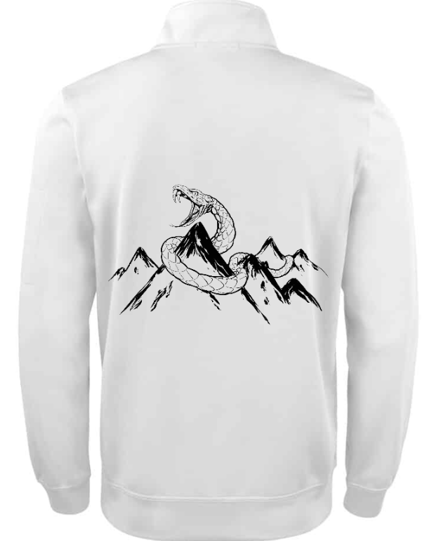

Polyester

€38,45 + 6.50 bezorging (of afhalen in Almelo)

[Basic Half Zip ontwerpen en bedrukken - Textieldrukshop](https://www.textieldrukshop.nl/basic-half-zip-ontwerpen-en-bedrukken/)

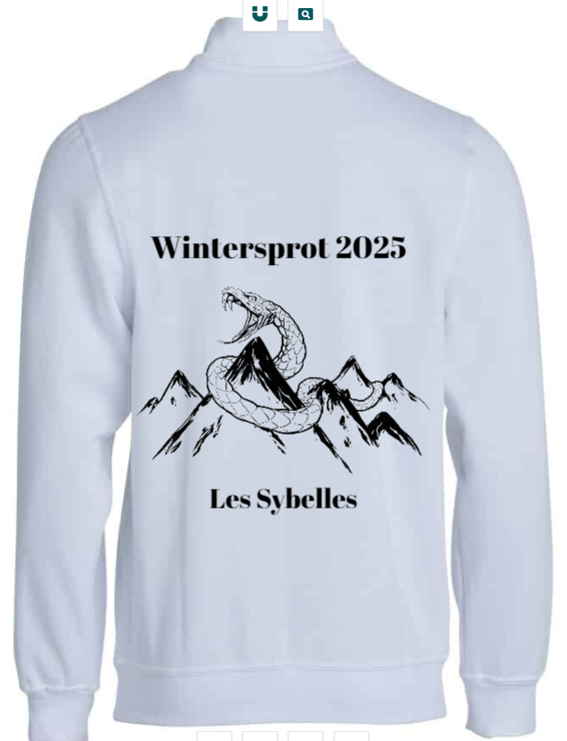

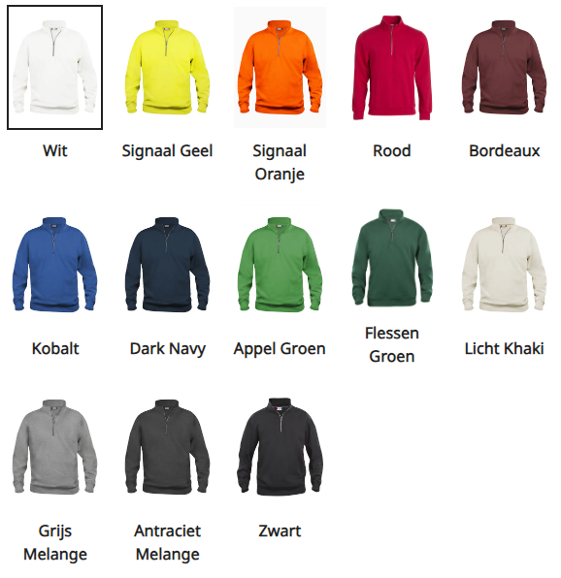

Katoenmix

€38,45 + 6,50 bezorging

[Ontwerpmodule 4.6 | Bedrukt.nl](https://www.bedrukt.nl/ontwerp/?product_id=2123&color=141754)

Sweaterstof

€45,45 + 6,50 bezorging