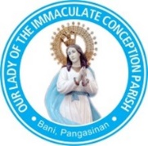
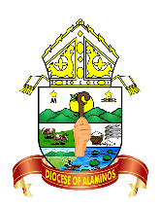
The Roman Catholic Diocese of Alaminos
Our Lady of the Immaculate Conception Parish
Poblacion, Bani, Pangasinan 2407 Philippines

Certificate of Marriage
BY THESE PRESENTS, THE UNDERSIGNED CERTIFIES THAT:

Name: _____________________________________ single (widower) ____________________
_______________years old. Son of _______________________________________ and
_____________________________________________________.
And
Name: _____________________________________ single (widow) ______________________
_______________years old. Son of _______________________________________ and
_____________________________________________________.

Were united in Holy Matrimony by Rev. Fr. ___________________________________________.
According to the rites of the Holy Roman Catholic Church and the laws of the Country. On _____
_______________________ at _____________________________________________________.

Being witness of the ceremony:
_______________________________________ and ____________________________________.

This certificate is issued based on the

official Marriage Record maintained by
Our Lady of the Immaculate Conception Parish.
Record No. ____________ Date Issued: __________________

Signed By:
________________________________
Parish Priest

