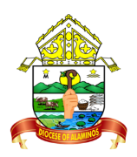
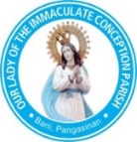
The Roman Catholic Diocese of Alaminos
OUR LADY OF THE IMMACULATE CONCEPTION PARISH
2407 Bani, Pangasinan

Certificate of Confirmation
This is to certify that
_________________________________
child of ______________________________________________________________________________
And _________________________________________________________________________________
baptized on __________________________________________________________________________
In the Parish Church of _________________________________________________________________.
Received
THE HOLY SACRAMENT OF CONFIRMATION
In the Parish Church of
OUR LADY OF THE IMMACULATE CONCEPTION
On ________________________________________________________________________
administered by the Most Rev. Fr. _______________________________________________,
sponsor was ________________________________________________________________.
This certificate is issued based on the official
Confirmation Record maintained by Our Lady of the Immaculate Conception Parish.
Record No. ____________ Date Issued: __________________

__________________________________
Parish Priest

