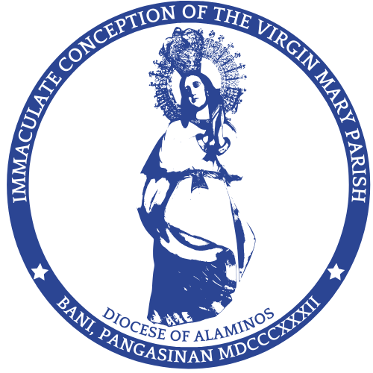
The Roman Catholic Diocese of Alaminos
IMMACULATE CONCEPTION OF THE VIRGIN MARY PARISH
2407 Bani, Pangasinan

Certificate of Baptism
This is to certify that

_________________________________________________

Child of _____________________________________________________ and

_______________________________________________________________ born on

the _________ day of _____________________.

WAS SOLEMNLY BAPTIZED
ACCORDING TO THE RITE
OF THE ROMAN CATHOLIC CHURCH

on the _____ day of ____________________________,

by the Reverend Father _________________________________________.

Sponsors: _____________________________________________________

_____________________________________________________

As This certificate is issued based on the

official Baptismal Record maintained by
Our Lady of the Immaculate Conception Parish.
Record No. ____________ Date Issued: __________________

This Certificate is issued on the ______ day of ______________________________.

Parish Priest

